Group B01-3: Cameron Jackson, Justin Dudtschak, Mohamad Radwan, Yawar Farhan

Why are we doing this test?

For the first prototype of the project, the team has a 3D world in Unity that contains a main menu, simple instructions on the user interface, and user movement via mouse, which will be translated to head movement in the VR mobile application. These initial steps are the foundation of the final project. It’s important to ensure these parts work effectively before moving on to more complicated features like implementing a BIM file, VR movement, an extensive main menu, and an interactive user interface. The tests outlined in this document will help the team understand whether each part of the prototype works or needs refining. These will help us know which parts of our plan can be used in future prototypes, and which parts need to be modified or removed.

Test Objectives Description

The objectives of the tests are:
- Ensure the user can enter and see the 3D world.
- Ensure the main menu screen is present and has some minor functionalities like selecting a button and moving to a new menu.
- Ensure the user can freely move around with the mouse.
- Ensure the user has simple prompts to instruct them.
The first prototype provided the team with a better understanding of unity and its capabilities/potential and gave the customer an initial idea of what they will get with the final product. In the client meeting where we demonstrated our first prototype, we showed that we have achieved an effective 3D world with a partial main menu, a good foundation for VR movement, and a couple UI instructions. In general, the first prototype demonstrated the building blocks of the project.
Through testing of the prototype we can determine:
- If the user has access to the 3D world.
- If the camera movement was implemented in a way that could translate to VR.
- If the main menu has selectable buttons that do something.
- If the UI instructions show up properly and are relevant.
While testing the camera movement, the team can evaluate the camera sensitivity, the speed of the forward movement, and the viability of our selected movement style for VR. Tests of the main menu will allow the team to decide what kinds of options should be available in the final main menu in VR and if certain features will be selectable or always on. Testing the UI instructions will allow the team to decide whether they want a separate mode for instructional purposes or interactive instructions on the UI at all times that change as the user completes actions.
While testing the camera movement in the 3D world, a successful test would mean the user can easily move the camera with the mouse and move the camera forward by pointing the camera down at a specified angle. This would mean that we could translate the movements to VR with some changes in the future. A failure would be if the movement was difficult to control/predict and would only be worse in VR. A successful main menu test would mean the user can view the menu and some of the buttons are selectable to view different screens. A failed test would mean the main menu looks bad and the buttons don’t do anything. A successful test of the UI instructions would mean that they appear on screen and they look somewhat user friendly. A bad test of the instructions would mean they don’t appear or look awkward on screen.

What is going on and how is it being done?

For prototype I the team has constructed a comprehensive prototype based on smaller focused prototypes that each team member produced. Originally the team decided to split up the workload by having each member build a focused prototype based on the important subsystems identified in the conceptual design. Once we discovered the ability to share a collaborative project on Unity we all combined our focused prototypes together. The team integrated the parts for the first client meeting because we wanted to show a full demonstration of the foundation of our project.
One member of the team was responsible for making the 3D world that allowed the user to look around with the mouse and move forward when the camera was pointed down at a certain critical angle. This aspect of the project was tested multiple times until the team was comfortable with how the camera looked around, the critical angle of movement, and the speed that the camera moved forward. Shown below is a demonstration of how the camera did in fact move forward effectively and the mouse controls worked well.
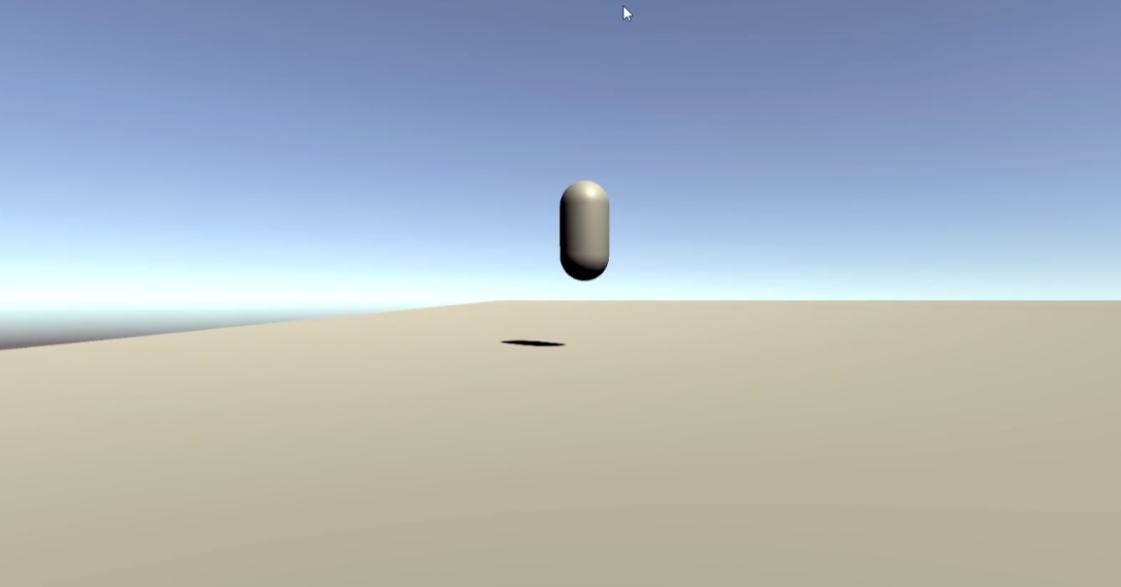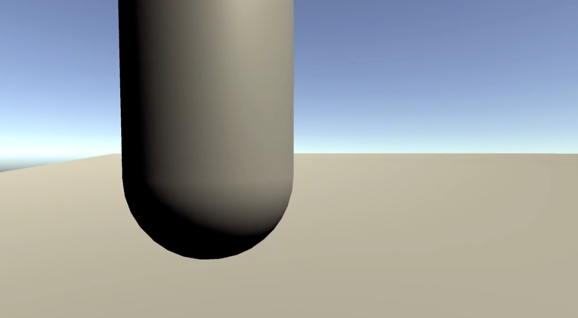
Another member of the team was tasked with creating the main menu that the user would be greeted with at the beginning of the program. This aspect was tested by entering play mode and testing the different buttons available on the screen in many combinations to test the menu’s abilities and durability. The images below show how the different buttons guided the user through the menus.
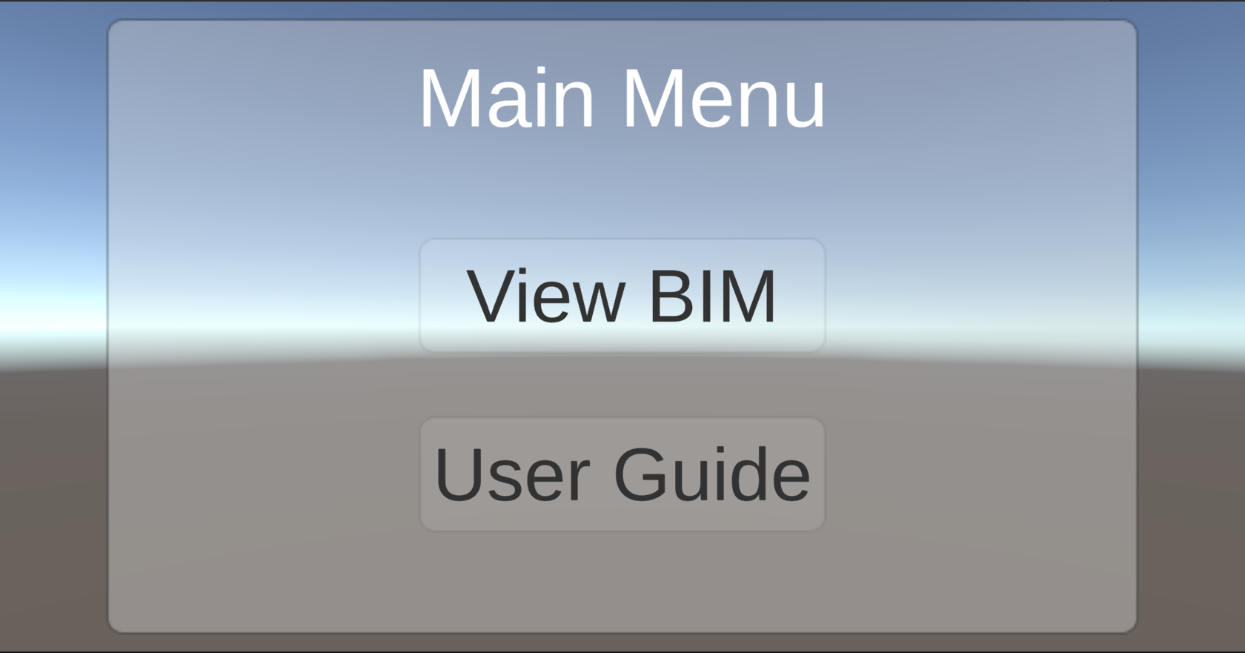
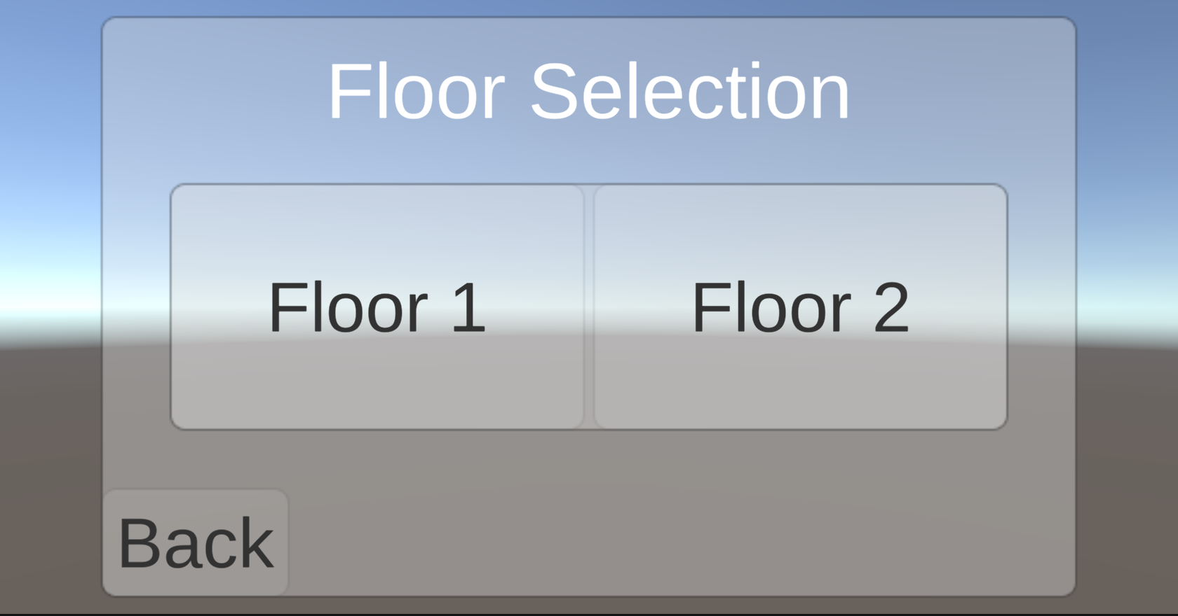
A third member worked on making instructions appear on the UI to prompt the user. These were tested by entering play mode and following the instructions to see if they would respond correctly to user input. Below is an example of the type of instructions that were shown on the UI.
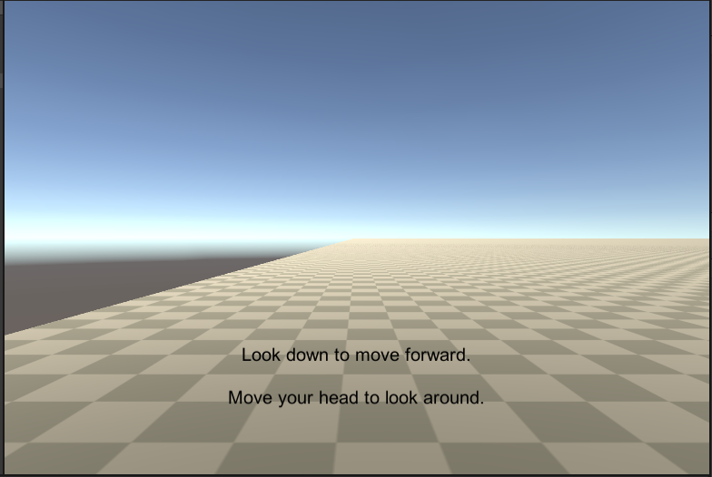
For the testing of prototype I, the results of the tests are largely qualitative and there aren't specific measurements being made. The tests are generally graded based on how comfortable and user-friendly the program feels to the tester.
For testing prototype I, the only materials required are the teams’ computers so there is no additional cost. We anticipate production of the whole project to cost nothing.
Leading up to prototype II the team has to continue developing the software in Unity. By prototype II, the team hopes to have successfully imported the BIM file of the STEM building, refined camera movement and the beginnings for VR movement, a main menu with many working buttons and capabilities, and a more comprehensive set of instructions that will make the user more familiar with the software.

When is it happening?
The testing of the prototype will be repetitive and often because the team makes small changes and tests each one when it is completed. Each focused prototype is tested for their own individual expectations and the comprehensive prototype is tested to ensure that the different subsections integrate well together. Testing of the separate parts can occur independently but the comprehensive tests have to wait until the prototype is combined into one.
The results of the tests are necessary before the team moves on to larger milestones like importing the BIM file of the STEM building or preparing the camera movement for VR. We must ensure that the more foundational parts of prototype I are solid before implementing and testing the more complex aspects of prototype II. In addition to the tests we carried out, the feedback from our client indicated that we have a promising prototype and that we are on the right path.

