Design Criteria and Target Specifications

Project Deliverable C

GNG1103[A03]
Team A10
October 8, 2020

Part I: Introduction
In Deliverable B, information from the first client meeting was used in order to obtain a list of interpreted needs. In this document, the interpreted needs are used to put together a list of prioritized design criteria including functional and non-functional requirements along with limitations or constraints where they are applicable. The design criteria will provide an outline of the explicit requirements that this project must meet.
In addition to these criteria, this document will also contain a more comprehensive version of the benchmarking table seen in Deliverable B. This will allow us to analyze the strengths and weaknesses of each service while deciding which features can be compromised on and which features are necessary to keep the client satisfied.

Part II: Requirements and Constraints
Functional requirements:
- Tracking drone (interactive map)
- Arrival confirmation
- Customer verification (for taking order)
- Customer service (contact JAMZ support or restaurant, 5-star reviews)
- Translation of several languages
- Simple functionality
- Shopping cart
- Member login
- Menu item selection
- Scheduled delivery

Non-functional requirements:
- Aesthetics (colour scheme, fonts, potentially logo and name, etc.)
- Categorizing restaurants (by cuisine, delivery time, customer reviews, price, dietary restrictions, etc.)

Constraints:
- Cost ($100)
- Limited to android OS
- Cannot be used without internet

Part III: Translating Interpreted Needs to Design Criteria
# | Need | Design Criteria | Priority
1 | Application has a tracking feature and must confirm delivery for the user and the restaurant | - Google maps should be embedded into UI, to be displayed after order is confirmed | 2
2 | Customer service numbers and reviewing options is displayed during the duration of the delivery process | - After ordering, a review option will pop up under or above the tracking map.  - Before ordering, restaurant reviews will be visible along with customer service numbers | 3
3 | Application is accessible to suburban areas and cater to local businesses | - Notify client of drones available radius of travel | 4
4 | Application can operate in multiple languages | - Possibly embed google translate into the UI (not ideal) | 5
5 | Application is extremely practical and easy to use | - Friendly and easily navigated UI with tabs for: explore/search, recommended, cart, and account | 2
6 | Application contains 'shopping cart' to which food from restaurants is added/removed | - Can only shop from 1 restaurant at a time (flat delivery rate fee)  - Calculate cost as items are added/removed | 1
7 | Application is able to make an 'account' which includes accessibility and allergy information | - Allow customization of profile, including allergies, preferences, card information, etc. | 3
Scale used here is with 1 being the most important and 5 being the least important

Part IV. Benchmarking
Let Green = 3; Yellow = 2; Red = 1
 | Reviews and customer service | Re-ordering saved orders | Rewards for loyal customers | Order Tracking | Scheduled Orders | Total:
Skip the Dishes | Restaurants are clearly rated out of 10. Allergies and intolerances are displayed also. | Users can re-order favourite meals from history | Point system that could be redeemed for discounts | Real-time order tracking and live GPS order tracking | Order up to 4 days ahead. | 44
UberEats | 5 star system is used to rate user feedback with restaurants | Past orders are saved to order history and can be easily reordered | Discount codes and promotions given out to customers occasionally. | Real-time order tracking and live GPS order tracking | Order up to 6 days ahead. | 39
DoorDash | 5 star system is used to rate user feedback with restaurants | Previous orders are saved to history and can be reordered | Referral system, refer more users get discounts | Real-time order tracking | Order up to 6 days ahead. | 32
Importance: | 4 | 3 | 2 | 5 | 1

As indicated by the UI Benchmarking, Skip the Dishes is the best option out of the three competitors, having a rating system for the restaurants themselves alongside the delivery service.

Part V: Design Specifications
Design Specifications | Relation (>,<,=) | Values | Units | Verification Method
Functional
Requirements
Tracking  Drone | = | Yes | N/A | Test
Arrival  confirmation | = | Yes | N/A | Test
Customer  review | = | Yes | Rated of 5 | Test
Translation  to multiple languages | > | 2 | Official Languages in Canada | Test
Simple Functionality | < | 4 | Sections per screen | Test
Shopping Cart | = | YES | N/A | Test
Customer Retention | > | 30 | (s) | Test
Constraints
Cost ($100) | < | 100 | $ | Planning cost
Limited to android OS | = | Yes | Android | Test
Cannot be used without internet | = | Yes | N/A | Test
Non-Functional Requirements
Font | = | Yes | Helvetica | Test
Colour scheme | = | Yes | Monochrome Orange | Test
Categorization | > | 4 | Cuisine, delivery time, customer reviews, price | Test

Part VI. Conclusion
Through developing specific target specifications and benchmarking our solutions and alternatives, we believe that creating an app similar to Skip the Dishes would be the ideal solution for our client. Through analysis of the needs of the client we have found that the key focuses are on the application containing a shopping cart, customer feedback, and that it is easy to navigate and use. Our team will also have to accommodate the constraints such as cost and compatibility with certain devices. We confidently believe by continuing to analyze and expand on these ideas while also making accommodations for the constraints, we will satisfy the needs’ of our client and create a successful final product.

Part VII. Gantt Chart
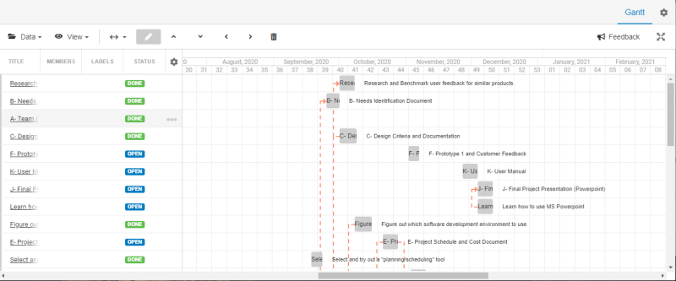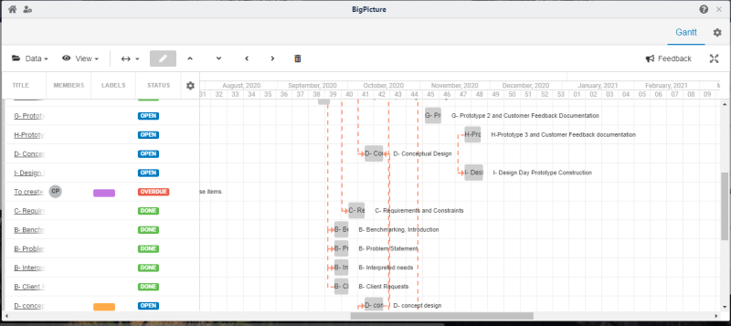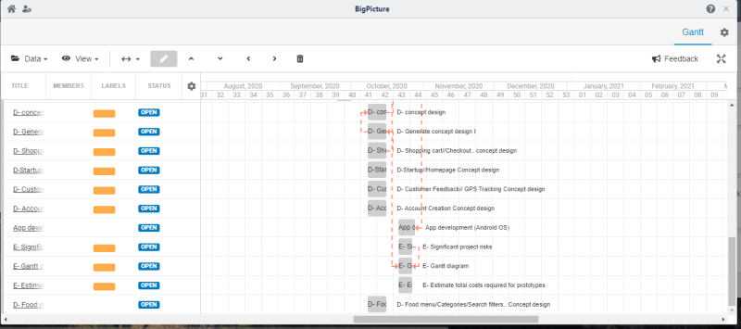
Link: https://trello.com/b/0B17rdkU/gng1103-a10

