Project Plan and Cost Estimate
Team: Cameron Jackson, Justin Dudtschak, Mohamad Radwan, Yawar Farhan

Introduction

In this deliverable, we will develop a project plan to ensure the successful completion of our three project prototypes in a timely manner. The project plan will include the tasks necessary to complete each prototype, in addition to the task owner, duration, due date, and dependency (if applicable). We will also include a Gantt chart that properly organizes all the tasks, milestones and their dependencies. Moreover, we will discuss the potential risks in this project and how we plan to mitigate them with contingency plans. Lastly, we will talk about the cost of materials and software involved in our project. This deliverable will help us understand the different aspects of managing a project, including task assessment and assignment, and finding the costs for components of a project.

Project Plan
Task ID | Task | Owner | Estimated Duration (days) | Due Date | Depends on Task ID
1 | Make a simple, working VR world in Unity | Everyone | 1 | 2020-11-4 | N/A
2 | Create Main Menu page and user interface with printed text | Mohamad | 3 | 2020-11-4 | 1
3 | Print text onto the user’s view to prepare for training module | Cameron | 3 | 2020-11-4 | 1
4 | Test prototype 1 | Everyone | 2 | 2020-11-4 | 1,2,3
5 | Deliverable F: Prototype I and Customer Feedback | Everyone | Milestone | 2020-11-05 | 4
6 | Refine the user interface including selectable boxes | Mohamad | 2 | 2020-11-11 | 5
7 | Test different methods of movement in VR | Yawar | 3 | 2020-11-11 | 5
8 | Refine the training mode with clear usage instructions | Cameron | 2 | 2020-11-11 | 5
9 | Have the ability to import BIMs into the VR world | Justin | 3 | 2020-11-11 | 5
10 | Test prototype 2 | Everyone | 2 | 2020-11-11 | 6,7,8,9
11 | Deliverable G: Prototype II and Customer Feedback | Everyone | Milestone | 2020-11-12 | 10
12 | Finalize user interface | Mohamad | 3 | 2020-11-20 | 11
13 | Finalize the training module | Cameron | 3 | 2020-11-20 | 11
14 | Finalize user movement and abilities | Yawar | 3 | 2020-11-20 | 11
15 | Import real BIMs to test the final prototype | Justin | 3 | 2020-11-21 | 11
16 | Test prototype 3 | Mohamad | 1 | 2020-11-24 | 12,13,14,15
15 | Deliverable H: Prototype III and Customer Feedback | Everyone | Milestone | 2020-11-26 | 16

Gantt Chart
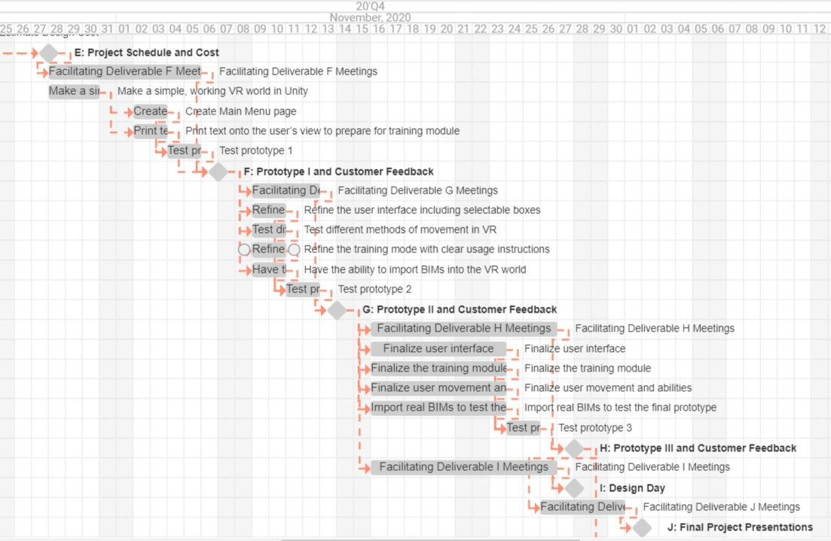
Project Risks and Contingency Plans

The main risks that would affect this project are cost, time, and technology. The cost risk is small but somewhat unpredictable for this project as we don't have to worry about any materials or cost upfront. The budget is $50 but the project could cost nothing, meaning no risk at all. We won’t know until later on when the software is being finalized. Time, however, is a significant risk. Developing an app/software can take a long time and if we start to fall behind schedule for our deliverables we will need a contingency plan. The contingency plan for time entails a time/benefit analysis to help prioritize certain features of our plan over others to streamline our work. Given the time constraint, we will determine how to maximize the quality of our product. Another significant risk for this project is the technology factor. We will be exploring the various relevant features in Unity, a new tool to use for all of us, and utilizing these features to make our product of the highest quality possible. Using new technology can be difficult and we may have trouble implementing each of our subsections together into one cohesive system. To account for this risk our contingency plan will include working on deliverables early and ensuring that we have time to make the technology for our prototypes work.

Project Cost

As of now there are no costs associated with the project. The Unity software we will need is free to use for students. However, Unity has some features that we may choose to buy from the Unity Assets Store. These features aren’t essential to the project but they could provide additional cosmetic benefits or improvements to user-friendliness. The add-on features from the asset store that we might be interested in are all about $5 each. Additionally, we may choose to buy cardboard VR goggles to test our prototypes. These goggles are $15-20 each. Overall, the cost for finishing the project could cost up to $40 but shouldn’t exceed that.

Concluding Remarks

In this deliverable, we created a rough project plan in order to successfully complete the three prototypes we need to create and improve on. The project plan included the necessary tasks in a table as well as a Gantt chart. The plan also indicated the owner, estimated duration, due date and dependency of each task.
We also discussed some potential risks we may encounter and how to mitigate them. Namely, the cost of finishing the project, the time constraints of each deliverable, and using new technology to create a complex system of software. Then, we identified contingency plans to combat these risks. We will do our best to learn the various relevant features of Unity, a new tool for all of us, to help us efficiently make our product of the highest quality possible.
Lastly, we discussed the cost of our project. We concluded that the main things we may need to buy are cardboard VR goggles and assets from the Unity Assets Store. For now, we do not see the immediate need to buy any of these, and we simply will start working on our first prototype using the free Unity software. If we do need to purchase anything in the future, it would not nearly exceed $40.

References

The cost of cardboard VR Goggles
https://arvr.google.com/cardboard/get-cardboard/

