Prototype II and Customer Feedback

Introduction:

In this deliverable, we will be covering the development of our second prototype. The second prototype is used to test the most critical component of our system, the water pump. To test this prototype we will be measuring the height the water can be pumped to, and the time it takes to fill a tank. We have received insightful customer feedback from a potential client regarding this prototype. We will be covering an in depth analysis of the responses from our potential clients about this prototype. We will use the information from creating this prototype to re-evaluate our previous schedule and design, and to plan for future iterations.

Prototype Guidelines:

In this prototype, we will be building the water pump which will distribute the water to all the plants. To help us build a better pump, we did research on designs that were already on the market. Our design is made from plumbing material only. The pump is made of ABS pipes which go inside one of the others. The pipe inside the other one would have a plug at the end to create suction while pulling, and pressure while pushing down. At the end of the pipe there would be a T shaped fitting to allow water to come in from one side and out from the other. This will be possible using one way valves placed in the opposite direction on each side. On one side when you pull on the pump the valve would open and let the water in, while the other would be pulled shut. When pushing on the pump it would be the opposite valve that would open to let the water flow out. All the pipes and valves will be connected together using fitting, ABS cement and teflon.

Prototype Test Plan:

This prototype tests the pump, the most critical component of our system. To ensure the system will function we need to be able to pump water from the bottom of the system to the top. To test this, we are measuring the maximum height the water can reach. We decided to only measure a maximum of six-meters because of budget constraints and the fact that our final product will only be about 1 meter in height. So testing if our pump is capable of pumping six-meters of tubing that is bent and dented then our system should be functional.

In our prototype testing we will be observing whether or not the water flows through the six-meter flex pipe. Before conducting our test, and building our prototype we need to do research and modeling the different parts of our system such as the type of tubing, the type of pipes, the diameter of the pipes and tubes, and the height at which we plan to test our system. We need to research which stores carry the required pipes and tubes that offers the best price. We made a sketch model of our system and the height it would need to be but also a simple sketch on our pump labeling the different parts.

Before the testing can be made there are a few tasks that must occur before that. Before we are ready to test our prototype, we must first buy all the required material to build our prototype which will take a couple of hours then we must build the prototype which will take the rest of the day. After having completed the following tasks, we must build a testing plan to ensure that we know what we are testing and the success criteria for our test. When all the above tasks are completed, we can test our prototype which will take about an hour to fully complete the test and record our results.

The reason for which we have chosen to prototype the air pump is since it is the most critical system in our whole system. If the air pump were to fail, then the whole system would also fail because the air pump is used to flow the water/nutrient solution throughout the system and if it were to fail then the plants would no longer receive the solution and would lead to the plants dying. The air pump also oxygenates the water as it flows through the system so it the air pump were to fail then the water would be ineffective for plant growth.

The reason for we have decided to make a PVC air pump because primarily it would be cost effective since we only need to buy the pipes and connectors then build the pump ourselves. Secondly, we require a manual pump as there is no electricity in the refugee camps to operate an air pump. After having considered these facts, we concluded that a homemade PVC air pump would be the best option.

For this prototype we had given ourselves a budget of 30$. Unfortunately we were unable to find some of the materials we were looking for which caused us to go over the budget by a little. First we needed pipes which cost 4.83$ for 2 feet of 2 inch pipe. The other pipe of 1-½ inch we were able to find for free. Next we needed 2 check valves of 8.97$ each. Then to connect everything we needed fitting. All the fittings combined they cost 15.92$. All this material comes up to 38.69$. Although we did go over our budget it was not by very much. Also, we bought other material for testing but this material will be used to build our third prototype which means that the cost of those materials will go in the prototype 3 budget.

The testing process will go as followed, we will first build the air pump after having bought all the required materials, mentioned in the previous paragraph, then we will take our prototype outside where it will not matter if water spills everywhere. We will take two large pales, about 1 gallon, then fill one of them up with water until it almost reaches the top. We will fit a rubber flex tube to one end of the air pump and put the open end of the tube inside the empty pail. We will then place the other end of the pump inside the pail with water then pump water from one pail to another. While the water is being pumped, another person will be timing the person, how long it takes him to pump all the water the pump can pump. We then take the water that has just been pumped and put it in cups to measure how many litres it pumped in the time. We then repeat the test 2 more times to make sure our results are consistent and that none of the tests were a fluke. We then record our results and perform simple mathematics to solve the pumping rate per minute.

The results of the tests are required before the submission date of this deliverable but it is mainly required to build our third and final prototype. The results are required before the third prototype because only after testing and determining that our most vital system is functional, the Air Pump, we can then move forward to build our final prototype.

We have also created a miniature Gantt Chart using Microsoft Project which allowed us to schedule our tasks for this deliverable and assign tasks to group members. Please refer to Gantt Chart for our deliverable schedule.

Figure 1: Water pump
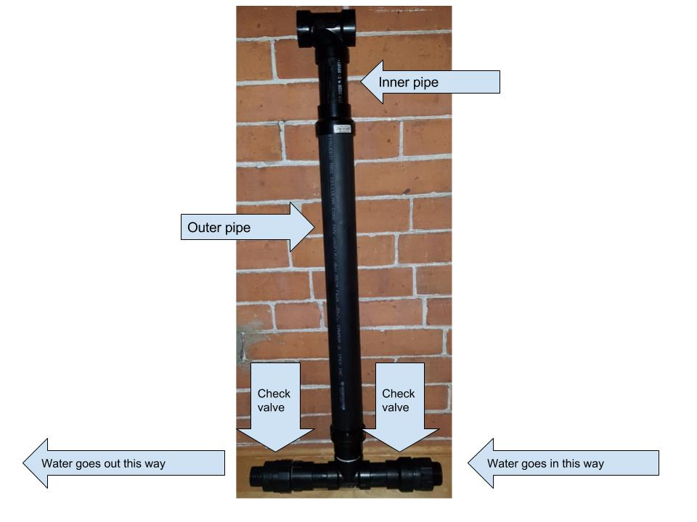

Prototype Result

This prototype could fail due to three main factors, the stability of the system, the water flow in the system, and the design of the plant holder. In this prototype, actual pipes are used instead of straws, which produced extra pressure on the joints. The system might be distorted or even collapse due to the force acting on the joints. Besides, the water can fail on flowing through the system. Based on the height of the system and the maximum velocity of flow the pump can create, the pump might not be powerful enough to pump the water to the highest point of the system, so the water fails in cycling in the system. Also, the water flow could also fail in cycling due to the leakiness of the air pump or the pipes. The pressure inside would be the same as the pressure outside, and the low pressure would make the water fail to rise up. Once these problems are solved, water can theoretically cycle through the system. However, the plant still can’t get water if the holder is too high for the water flowing to reach the plant. In this case, although the system works, the prototype fails in delivering the water to plants.

As mentioned above, the results could be: the system collapses, water fails to flow in the system, as well as the water fails to contact with plants. In these cases, if the system collapses or distorted, we may consider a firmer or lighter material to build the prototype, and this material should be determined based on the cost and amount we need. If the water didn’t flow through the system, the leakproofness of the pump should be checked first, and then check if the pump is powerful enough to move all the water. Then we decide if we need to change to another pump or fix the pump for the next test. If the system works but the plants didn’t get any water, we should select another idea of design for the holder to let the roots be in contact with the water. Basically, if the prototype collapsed, we should consider another type of material or the structure of the system. If the root didn't get water in the test, we should test the water flow without the plants, and see if the water can go through the system or not. If the water actually gets through the system, then we need to come up with another design for the holder; if not, then check the leakproofness of the pipe and the pump.

A successful criterion for the test is after one water cycle, the plants roots contacted with water, and the prototype didn’t collapse for sure. That is, not only the system can work successfully but also the plants can reach the water. The criteria for the failure test are the system falls down, and the roots didn't contact with water. Specifically, if the roots didn’t get water, the failure could be either the design of holder or the problem of the pump.

Prototype Analysis:

Our selection was based on the pump since it was essential to keep the entire system up and running. The pump took some time to assemble since some of it required buying and setting up the pipes required to make the pump instead of buying an expensive one. During the process of building the pump O rings were used to ensure the pumping process was smooth and that the pump was airtight. By testing the pump we ensure that our system will provide the nutrient solution needed to support the plants in the system.

First of all we tested to see if the water would flow through a six-meter bent and dented flex pipe. This was a true or false test if it could flow through all six-meters then the test was successful and if it couldn’t it had failed. After testing the pump 5 times we concluded that the test was successful. If the test had failed we would have retried the test at a lower max height. We tested to see the max height of the system, but it had exceeded expectations and was able to pump through all six meters of tubing. Our system is expected to be approximately one meter in height. Therefore, our pump was successful and we are able to move on to our next test. We have recorded a video of the testing process which we have uploaded to Blackboard, so please refer to the video for a visual representation of the testing process.

Table 1: Prototype 2 flow rate test

Trial | Water (L) | Time (s) | Flow rate (L/min)
1 | 7.334 | 36 | 12.22
2 | 7.314 | 35 | 12.54
3 | 7.286 | 38 | 11.50
Average | 7.311 | 36.33 | 12.09

The second test of our prototype is to determine the average time it takes to pump water. This test is not necessary for the system to function, but it is useful information for the user. This test will determine if the pump will be easy to use for our user.

We completed three tests and compiled the results as shown in Table 1. We calculated flow rates in case of changes to the length of piping, and the amount of water needed to fill the water tank at the top of our system. We had filled the pails with water and tested to see how long it would take someone to transfer water from one pail to another. After conducting three trials of the experiment, the average volume of water we pumped was 7.3L on an average of 36.3 seconds. We then concluded that the average flow rate of the pump is 12.1L/min. The water pumps fast enough therefore, the work required to pump water is acceptable for users to maintain the system manually.

Customer Feedback:

Our prototype was well-received however, our client had a few concerns and suggestions. The client was concerned about filtering water before using it in the system and how our system will recycle and filter the water that is already being used in the system. Other than those concerns our client complimented our design choices. The client was satisfied with the dimensions of our system and the capacity of plants it is estimated to grow. The client was impressed with the fact that our design does not require electricity.

To address our client’s concerns we considered solutions already in place at the refugee camp and new solutions. Previously, students created a filtration system to reuse the wasted water from showers, and cleaning. We believe that the solution already in place will be sufficient in supplying clean water to our system. However, we should consider solutions for other potential customers that may have a shortage of clean water. One suggestion from our client was to have a membrane to remove dirt from the water before use.

Apart from presenting our prototype to our client we asked some questions for future prototypes. Our questions focused on the dimensions of their caravans and whether it could support the weight of our system. We discovered that the caravan is large and sturdy enough for our system. With these clarifications we can design a cheaper system that relies on a wall to support our system rather than building additional supports. Another question we asked was whether the families are willing to share a hydroponic system. The client answered that it was a good idea that they could share it. This enables us to build a larger system that would be cheaper for the refugees overall.

Reference To Previous Work:

After completing the prototype there are obvious adjustments we will need to make. First of all, prototype 2 went over our budget as described in deliverable E Project Schedule and Costs. Similar to prototype 1 the prototype took a shorter time than expected while gathering feedback, testing, and analysis took longer than expected. Our solutions and adjustments will be described in the next section of this deliverable.

Based on our feedback most of our design criteria has been addressed. Key functional requirements and constraints have been tested and approved by our client. Our system proves that it can function without the use of electricity. Our system is simple and easy for the client to use, the dimensions and cost are within our limits, the system recycles water, and the client approves of the aesthetics of our design with horizontal piping. Based on our design criteria we will still need to test a simple filtration system and test whether the system will be able to endure high temperatures.

What We Need to Do in the Future:

After completing our second prototype we have come across some complications that needs to be addressed in the future to ensure a smooth and successful prototype III. These complications include customer feedback problems, budgeting and the overall design of our system.

For the next prototype we plan to get feedback at an earlier stage because this will allow us to consider implementing the improvements given to us from our potential client. Also, making an appointment with clients at an earlier stage allows us to reschedule in case the client is unable to attend for an unexpected reason.

Since we have gotten feedback from our client at a later stage of our prototype we were unable to implement the improvements, but we plan to make the necessary changes to our third and final prototype such as incorporating the idea of a water filtration system and a support system against the caravan.

We will adjust our budget plan since, we have gone over our budget by about $10.00 for this prototype. We must make adjustments to the future prototype so that we do not surpass our budget limit. One solution we plan to implement it to not purchase a tote for our water tanks. Instead we will continue using the pails that we were using for free. This will effectively nullify the excess costs of this prototype.

The next step of our project is make the third and final prototype. Our final prototype will be the whole system and we will use our knowledge and understanding of our first and second prototype to build. This prototype will be used to the test the overall function of our system as a whole. We will be testing to see if the system will be able to keep the water flowing throughout its body and allow the cultivation of the planted agriculture. This involves making a prototype plan to ensure that we spend our time and budget effectively while building our prototype. Once the prototype is completed, we will test it and analyze the results. We will also need feedback to find improvements that will make the user experience better.

Conclusion:

Our prototype successfully completed all tests. Overall, our prototype was well-received by our client despite a few concerns. Any concerns have been addressed or will be solved by our next prototype. After completing this prototype, our schedule and budget plans will need to be adjusted to complete our product in a timely manner and within our budget. Since our prototypes have been successful, we will need to finalize the dimensions of our system.

