Prototype I and Customer Feedback

Project Deliverable F

GNG1103[A03]
Team A10
October 22nd, 2020

Introduction
Prototyping is important since it simulates what the final product will look like. It helps in evaluating and testing the design to make sure that it is actually attainable and helps in clarifying any possible production costs or constraints. This deliverable highlights the different aspects of the first prototype of the food delivery application for JAMZ. The application will be analysed and broken down into its individual components. Additionally, this document outlines the prototyping test plan for each component as well. The prototype will be complete when our test objectives are reached and the desired application components are functional. Since this is the first iteration, certain details involving visual aesthetics and other cosmetic features will not be prioritized.
The prototyping will be broken down into three sections; loading screen, startup, home screen,

Testing
Test ID | Test Objective  (Why) | Description of Prototype used and of Basic Test Method  (What) | Description of Results to be Recorded and how these results will be used (How) | Estimated Test duration and planned start date  (When)
1 | We are conducting this test to get a better understanding of our design. The goal is to visualize our design concepts into actual development code. With doing this we are able to see a visual early-stage /frame of the app and exchange ideas while communicating areas for improvement. | We experimented with two different app development softwares: “Android Studio”, and “React Native”. Comparing functionality and developer interface between them. React Native was decided as the app development software to use, simply for the development interface is much more friendlier and the components are all together. | Evaluating both app development softwares for pros and cons relating to our required project goal. The desired result would be adequately learning and familiarizing with the chosen software development tool ‘React Native’ in contrast to Android studio. | Duration of this test is the last week of October to November 7
2 | For Test #2 we would be able to receive substantial feedback from our clients displaying a low fidelity of the app. This would give us a good first-hand informative feedback from the client, enabling us to adapt while testing. | The prototype available would be a focused prototype. It will contain partial aspects of the overall app. This includes a working loading startup screen, A sign-in/Sign up launch page, and finally a search button prompting users for what they would like to eat. These are all components of what the finalized app would have but are still subject to improvement/ change. | Success for this test would involve new improvements and modifications to the focused prototype components. New improvements should provide a smoother user experience and a more accurate representation of our design concepts. | November 7- November 10. Timeslot for Feedback with the Jamz client is designated to November 10th (on Brightspace)  For this testing to occur, Feedback from the Clients is necessary in order to
3 | With this test, the goal is to locate and eliminate any potential risks that would hinder progress for future prototypes. We will aim to measure the overall performance of the low fidelity app we had developed for prototype I, comparing it to our specified standards. | During this test, functioning components of the app are needed. This is so real feedback can be acquired and implemented. Benchmarking the current prototype with successful delivery apps is also needed. Cost should be little to none. | There should be little to no bugs in relation to the low fidelity app components created this far. Minor bugs and areas for more modifications will be noted to be fixed in future prototypes. Information retrieved from this step will be important in deciding what components need extra attention for the project. | Duration of this test is the last week of October to November 10

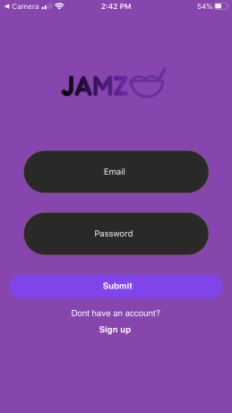
Prototype I
Sign in/App Launch Page

This page is what the user initially sees when launching the app. Ideally, we want some graphic designs merged with the background to add flash to the app and maintain the user’s interest. After inputting email and password, the code checks to see if this passcode and email match to allow all the credentials to be transferred (if they do not match, it will just display the email and password inputted when the ‘submit’ button is pressed). The ‘Sign up’ text button will navigate the user to the Jamz website where they can create an account there, inputting their name, email, password, and card information.

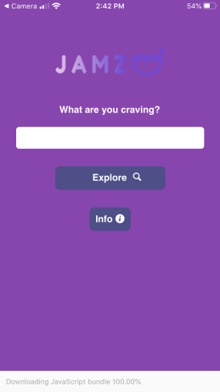
Search function/Button for explore page

This page is what the user sees after signing in/initially what the user sees if they have saved their credentials. It features a search bar to directly search for any food you’re craving (Saving some time if you already know what to order), as well as a explore button that will navigate you to the restaurants and main page within the app. Similar to the Sign-in page, more graphic designs will be implemented to peak the user’s interest and keep it aesthetically pleasing. The last button on the bottom is labelled ‘Info’ and will lead to another page mostly consisting of contact information, FAQ’s, and what the company/app is all about.

Application Flow-Chart for User Navigation

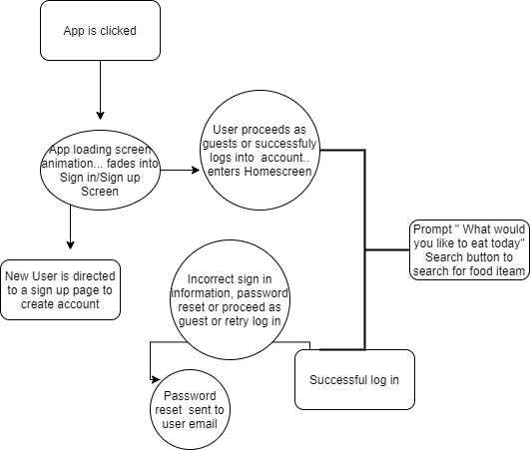

Potential User Feedback
In order to make sure that the application is up to our client’s standards in terms of user accessibility and efficiency, we took feedback from potential users about what they would want in their ideal food delivery application. By receiving different opinions on different features, our group will be able to establish what features we need to modify, improve on, or keep as they are.

Unfortunately, all our potential users consist of the same demographic (university students). Although this does aid in some ways, it is also detrimental in others. Most of the people who were surveyed for their opinion said that their ideal food delivery application was SkipTheDishes, which was a good starting point for us since the clients said that it was what they want their application to resemble the most.

The first most important feature that most people seemed to absolutely require was that the application is easy to use. Our goal is to make the application as straightforward as possible so that the customer needs to make the least possible amount of clicks before the food that they want to order is already on its way. Additionally, UberEats’ tracking system was mentioned a lot since their map is interactive and easy to follow.

Most other features were about aesthetics, and although those suggestions have been taken into account, they were not paid much attention to since this is only the first prototype and the goal is to begin making it functional.

Conclusion
In conclusion, after successful development of the required components for prototype I, which includes: a fully functioning loading screen, startup homepage and search bar, further testing is required. This is to receive adequate feedback and locate errors in efforts to improve the applications functionality and adapt while testing. A successful testing would greatly advance our prototype I, preparing us to enter the phase of Prototype II with new, fresh ideas allowing us reduce the potential for error while maximizing the applications performance in relation to the clients requests.

Trello Link: https://trello.com/invite/b/0B17rdkU/b922098ba73025695bf662f9ad70b7f8/gng1103-a10

