Project Deliverable D: Conceptual Design
GNG 1103- Engineering Design
Faculty of Engineering- University of Ottawa

Group A10
Larry Renaud
Trinity Bates
Shambhavi Asthana
Mathias Urdanivia
Clinton Paul-Chinka

Submission Date: October 15, 2020

Abstract:

The following document is the conceptual design for team 10 in lab section A for GNG1103 in the 2020 Fall Semester at the Faculty of Engineering in the University of Ottawa.
This document utilizes concepts centered on our team’s problem statement, design criteria, and Benchmarking with the purpose to collect multiple ideas and concepts and evaluate which meets our client’s needs.

Table of Contents:
Contents
Abstract: ii
Table of Contents: ii
Table of Figures and Tables iii
Report 1
Part I: Introduction 1
Part II: Research 1
Part III: Benchmarking (Technical and User) 1
Part IV: Problem Statement 2
Part V: Design Solutions 2
Part VI: Design Criteria 8
Part VII: Conclusion 9
Bibliography 9
Appendices 11

Table of Figures and Tables

Figure 1 Design A for Homepage 5
Figure 2 Design B for Homepage 5
Figure 3 Design for Account Creation 6
Figure 4 Design for Categories of Food 7
Figure 5 Design A for the Shopping Cart 7
Figure 6 Design B for Shopping Cart 8
Figure 7 Design for GPS Tracking 8
Figure 8 Design for the Order Process 9
Figure 9 Design for Customer Feedback 10
Figure 10 Flow Chart for Purchases 12
Figure 11 Flow Chart for Customer Feedback 13
Figure 12 Flow Chart for operating the Application from Home Screen to Choosing Goods 13

Table 1 Design Criteria for the User Interface 11

Report

Part I: Introduction

With the spread of COVID-19 food delivery sales have been at an all-time high, increasing their profit margin exponentially since people have been forced to stay in their homes for safety reasons. But there has always been a human error with delivery services, whether that be arrival time or customer service. Conveniently, JAMZ food delivery services have expanded the delivery means by having AI deliver your food, via drones. This solves the issue of late delivery due to traffic (and having the food arrived cold) and bad delivery service. Thus, the problem presented to us is the need for an application with a friendly UI to connect users with the food they love. In this deliverable, we will expand on the reasons for such a service, the design criteria, and our solutions to make the application and UI simple, efficient, and inviting.

Part II: Research

After listening to the client’s presentation, we arrived at an understanding of our client’s requests. The client’s requests all revolve around the concepts of having a customer feedback system as well as an attractive interface for their app, Jamz. For the customer feedback, they requested a 5-star rating system, customer support, and a help page to aid in navigating the app. In terms of the interface, they requested a very simplistic design such as a menu item selection. The interface must also include efficient notifications about the location of the drone as well as the expected delivery time and location.

Part III: Benchmarking (Technical and User)

There are several food delivery services that already exist. We gathered information from the three most successful services (UberEATS, SkipTheDishes, and Door Dash) to benchmark and compare technical features that were stated in the client’s needs and to be included in the application. The clients also mentioned that out of the currently existing services, they would like their application to be most similar to SkipTheDishes.

We compared delivery fees, surge pricing, and reviews of these services and discovered that SkipTheDishes has the lowest delivery fees (4-7%) as opposed to Door Dash and UberEATS (7-15%). SkipTheDishes also leads with the lowest surge pricing fees and all three services have an average rating of 4.6/5. With this data, it is understandable to see why SkipTheDishes is favored for the app to be modeled after. Important technical features stated by the clients ordered from greatest of importance include; Shopping cart, Functionality, Tracking + Arrival time, Customer Service, Member Login, Accessibility, and Multiple Languages feature.
With regards to Tracking and Arrival time, the application has a tracking feature and confirms delivery for the user and the restaurant. It also confirms when the user is away from the drone, so the drone can take off safely. JAMZ app, like many other customer-oriented apps, has a customer service feature, where users can actively get help and rate their experiences with different restaurants. The application is accessible to suburban communities and caters to local businesses, providing accessibility. Also, the app can translate into at the very least two languages, being the official languages of Canada, English, and French. An important technical aspect of the app is its simple functionality. The app should not be complicated to use for the average technology user. Also, the application should have a member login feature for users that use the app frequently and want the utmost experience with the app. A shopping cart is required to store user items to proceed to the transaction.

Part IV: Problem Statement

The goal is to design a food delivery application that uses autonomous drones to safely deliver food to the customer. The application must be easy to navigate and accessible to rural, suburban areas. Ensuring these will provide a guide that provides and accurate representation of what the client needs.

Part V: Design Solutions

Designs of Homepage/ Startup:
Designs of the homepage and start-up encompass what the app will look like when first launched as well as the main page of the application, where restaurants are shown.
In this figure, Figure 1, it has what the start-up page could look like when a user with an account has opened the app.
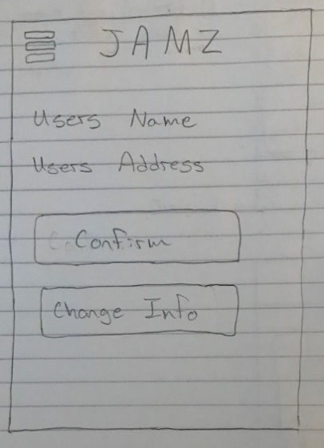
Figure 1 Design A for Homepage

In this figure, Figure 2, it has what the UI will potentially look like after the customer has logged into the app or is using it as a guest.
Figure 2 Design B for Homepage

Account Creation:
Account creation includes obtaining information like: Name, address, payment method (for faster checkout).
In this figure, Figure 3, it shows what the UI for creating an account will potentially look like.
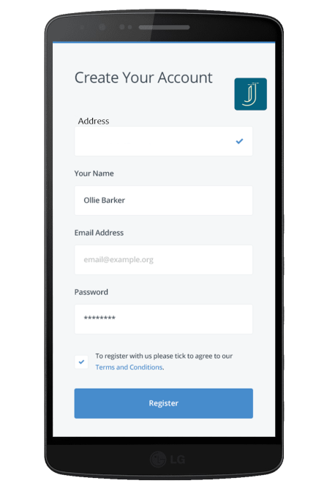
Figure 3 Design for Account Creation

Categories of Food:
Upon opening the app, the user is suggested different categories of food and cuisines. There is also a search bar for a more specific item search.
In this figure, Figure 4, it displays what the different categories of food are as well as restaurants associated with said food categories.
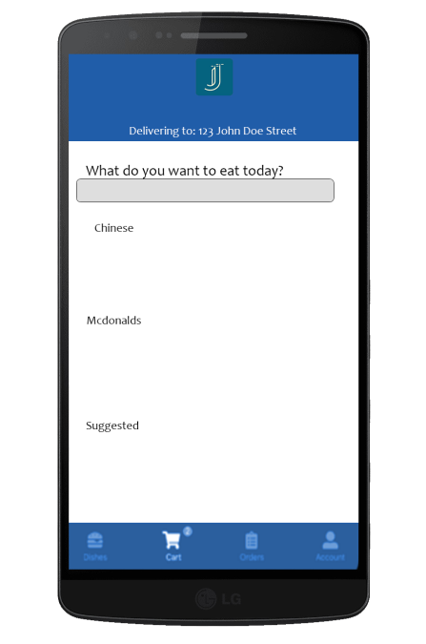
Figure 4 Design for Categories of Food

Shopping Cart and Checkout:
The shopping cart is where items are stored and available to purchase. The “Checkout” is where payment for items occur and where confirmation occurs.
In this figure, Figure 5, it shows what one of the possible “Checkout” pages will look like.
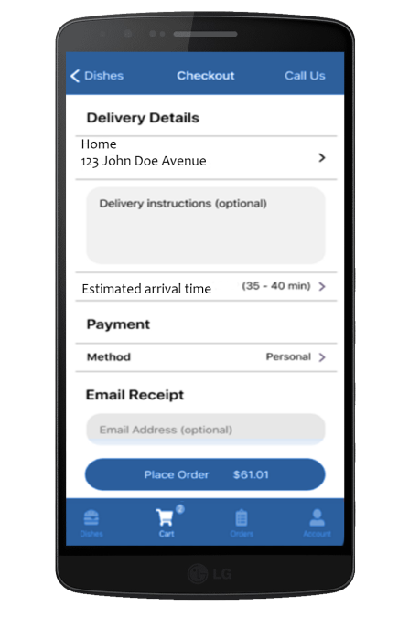
Figure 5 Design A for the Shopping Cart
In this figure, Figure 6, it shows an alternative to what the “Checkout” process will look like.
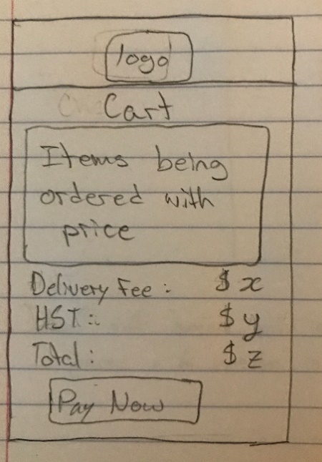
Figure 6 Design B for Shopping Cart

GPS Tracking:
The GPS tracking sketches show what the application will look like after items are ordered and the goods are being delivered.
In this figure, Figure 7, it shows one of the possibilities that the Google Maps API will look like within the application.
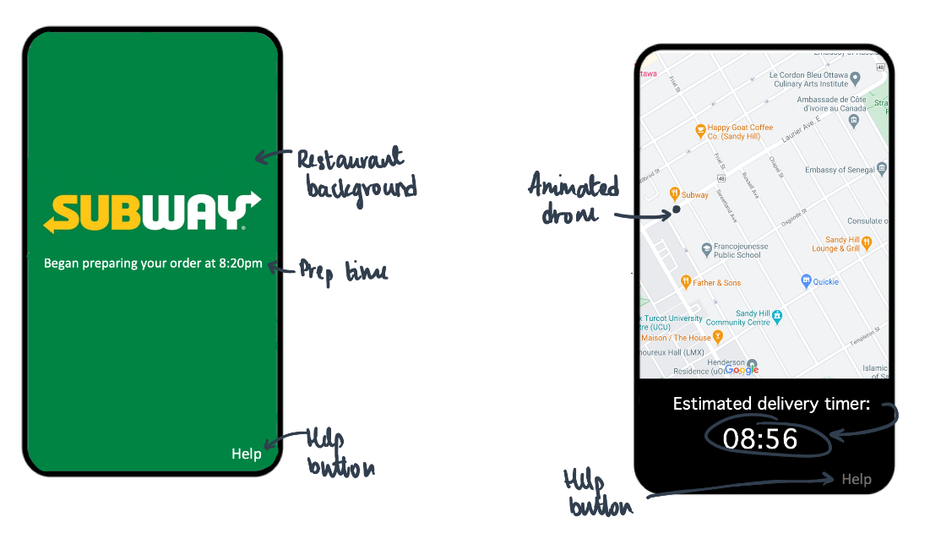
Figure 7 Design for GPS Tracking
In this figure, Figure 8, it has what order progress could look like when the food is being prepared and delivered.
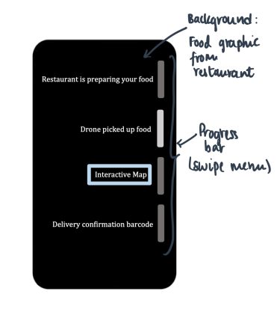
Figure 8 Design for the Order Process

Customer Feedback:
The customer feedback UI encompass rating and reviewing the restaurant by possibly leaving a comment along with a rating out of 5 stars.
In this figure, Figure 9, it has the option to review the restaurant after the drone has delivered the goods. This could possibly be within the same section as the Google Maps API or could be moved to its own section.
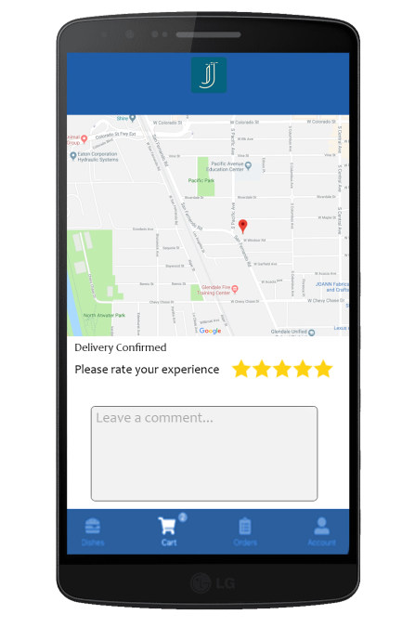
Figure 9 Design for Customer Feedback

Part VI: Design Criteria
In this table, Table 1, it describes the design criteria needed for creating the customer User Interface. This table uses a scale which prioritizes the lower numbers (1 being the most important).
# | Need | Design Criteria | Priority
1 | Application has a tracking feature and must confirm delivery for the user and the restaurant | - Google maps should be embedded into UI, to be displayed after order is confirmed | 2
2 | Customer service numbers and reviewing options is displayed during the duration of the delivery process | - After ordering, a review option will pop up under or above the tracking map.  - Before ordering, restaurant reviews will be visible along with customer service numbers | 3
3 | Application is accessible to suburban areas and cater to local businesses | - Notify client of drones available radius of travel | 4
4 | Application can operate in multiple languages | - Possibly embed google translate into the UI (not ideal) | 5
5 | Application is extremely practical and easy to use | - Friendly and easily navigated UI with tabs for: explore/search, recommended, cart, and account | 2
6 | Application contains 'shopping cart' to which food from restaurants is added/removed | - Can only shop from 1 restaurant at a time (flat delivery rate fee)  - Calculate cost as items are added/removed | 1
7 | Application is able to make an 'account' which includes accessibility and allergy information | - Allow customization of profile, including allergies, preferences, card information, etc. | 3
Table 1 Design Criteria for the User Interface

Part VII: Conclusion

This document essentially discusses the basis for the conceptual design of the application. Initially the application was broken up into ‘pages’ for the user to interact with, and we brainstormed ideas for what the interface for each page should look like. This was elucidated on in Part V of the document. There weren’t too many obstacles with this report since we didn’t have any criteria that contradicted itself. Eventually, we finalized its major design aspects corresponding to the client needs that we identified.
As for recommendations for future work, some things we decided to work on include: troubleshooting the application when things go wrong, a way to confirm that the user is away from the drone for takeoff, and the ability to order as a guest.

Bibliography

Huang, K. (2019, January 16). 10 frameworks to help you measure success in design. Retrieved October 16, 2020, from https://uxdesign.cc/how-to-measure-success-in-design-f63f96a0c541
Sematext. (2020, September 13). 20+ Key UX Metrics Any Product Manager Must Measure. Retrieved October 16, 2020, from https://sematext.com/blog/ux-metrics/
Chung, M. (2019, July 02). Case Study: Foodogo Food Delivery App. Retrieved October 16, 2020, from https://medium.com/@glitchytest/case-study-foodogo-food-delivery-app-bc2fee451474

Appendices
Flow charts for a few concept ideas.
In this figure, Figure 10, it explains how a customer will purchase items from a restaurant and then receive said items.
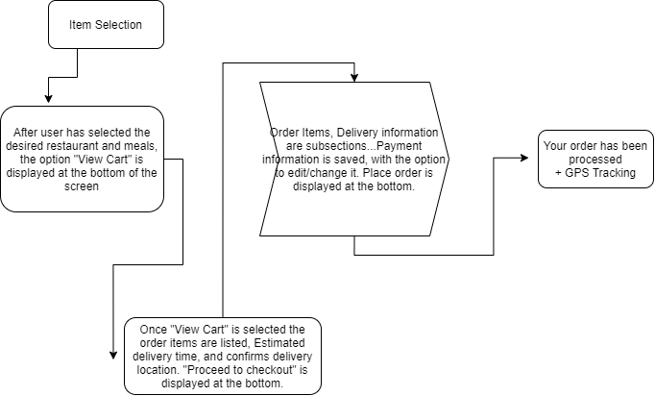
Figure 10 Flow Chart for Purchases

In this figure, Figure 11, it explains how customer service will work whether choosing to leave a review or not.
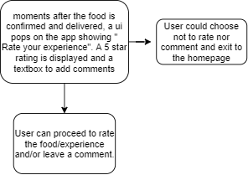
Figure 11 Flow Chart for Customer Feedback
In this figure, Figure 12, it goes over how the app will function from opening the app from the phone’s home screen. It then goes into how a customer will order food from the application

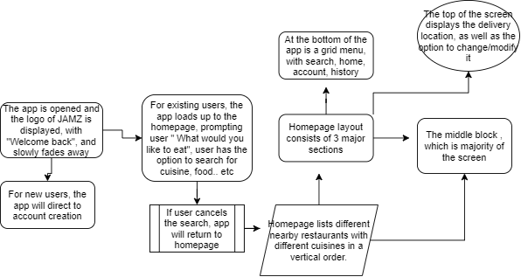
Figure 12 Flow Chart for operating the Application from Home Screen to Choosing Goods

