GNG2101
Design Project Progress Update

<GNG 2101 E3. 4>

Submitted by:
<Jasem Alenezi, 300230705>
<Maanashan Rudranantha, 300318691>
<Gong (Victor) Feng, 300176400>
<Lemuel Douglas, 300286474>
<George Osariemen Omoregie , 300325739>

<29-02-2024>
University of Ottawa

Table of Contents
Project Deliverable Report Instructions i
Table of Contents ii
List of Figures iii
List of Tables iv
List of Acronyms and Glossary v
1 Introduction 1
2 Business Model Canvas and DFX 2
2.1 Business model and sustainability report 2
2.2 Design for X 4
3 Problem Definition, Concept Development, and Project Plan 6
3.1 Problem definition 6
3.2 Concept development 12
4 Detailed Design and BOM 18
4.1 Detailed design 18
4.2 BOM 23
4.3 Project plan update 24
5 Conclusions 25
6 Bibliography 26

List of Figures
Insert your list of figures here (right-click to update this field).

List of Tables
Table 1. Acronyms vi
Table 2. Glossary vi

Introduction

In this project, we embark on a journey to create a client-specific solution that blends machining, 3D printing, and electronics to address a significant challenge face by Maeve D. a 6- year-old girl with arthrogryposis.

Project background:
The user’s primary difficulty lies in independently managing bathroom activities, specifically pulling down and pulling up her pants. The main obstacle is her limited flexibility and hand strength, preventing her from reaching around to the back to facilitate clothing adjustments.

Design Objective:
Our task is to design a portable device tailored to user’s needs, allowing her to independently pull down and pull up her pants during bathroom visits. The device must feature a releasable clamp, operable by the user, capable of securely holding onto clothing while maintaining the strength to pull up. To enhance usability, an adjustable handle and potentially an electronic solution may be incorporated. The device must be lightweight, waterproof, small, and highly portable, ensuring adaptability as the user continues to grow. The design should be intuitive, easy to maintain, and capable of fitting into a backpack.

Client Preferences:
- The user prefers leggy and sweatpants, and never in jeans.
- The device must be adjustable to accommodate her growth.
- The user can handle 5-10 lbs of weight.
- Her favorite color is purple, and she has a fondness for bunnies.

No previous attempts have been made to address this specific challenge. This project represents a groundbreaking effort to develop a bathroom assist device uniquely tailored for a 6-year-old girl with arthrogryposis, focusing on her limited hand strength and limb mobility.

Business Model Canvas and DFX

Business model and sustainability report
- Product Overview: A wearable device designed to assist individuals with limited forelimb mobility in managing their clothing in the bathroom, thereby enhancing their independence and privacy.
- Target Market: Our primary focus is on individuals with disabilities or mobility issues impairing forelimb usage, including the elderly and those in rehabilitation centers, hospitals, and pregnant women.
- Unique Selling Point: The device stands out by increasing independence and privacy for the disabled community, with a design that emphasizes ease of use, adaptability, and reliability.
- Reasons for Choice: This product fills a crucial gap in assistive devices for personal hygiene and clothing management, significantly improving users' quality of life and fostering independence.

Triple Bottom Line Business Model Canvas

How (Key Activities)
- The design and production involves not just the initial design and manufacturing of the device but also iterative improvements based on continuous user feedback. Activities include prototype development, user testing sessions, and engaging with users through pilot programs. It also entails selecting materials that are durable, comfortable, and suitable for easy wear, ensuring the device meets regulatory standards for safety and accessibility.
- Establishing a given team to focus on integrating cutting-edge technologies such as: AI and high-end sensors. That to enhance the device's capabilities. This team would also analyze user feedback for insights into usability improvements, additional features, and integration with other devices or platforms. Establishing partnerships with academic research centers can accelerate innovation and ensure the device stays at the forefront of technology.
- Developing marketing strategies that highlight the unique benefits of the device, using channels most frequented by the target customer segments. This includes digital marketing, social media, collaborations with influencers in the disability community, and participation in medical conferences and trade shows. Performing a detailed competitive analysis helps in identifying market gaps and positioning the product effectively against competitors, emphasizing its unique value propositions.

What (Value Propositions):
- Enhancing independence and privacy through real-world testing and feedback from potential users, including individuals living with mobility impairments and professionals in occupational therapy and rehabilitation. Highlighting user testimonials and case studies can effectively communicate this benefit, addressing a critical need for dignity and autonomy in personal care.
- Offering a range of customization options, such as adjustable fit, user-friendly interfaces for varying levels of tech proficiency, and interchangeable components for different tasks, ensures the device is appealing to a broad audience. This could involve developing an app that allows users to adjust settings according to their preferences or offering services to tailor the device's functionality for specific user requirements.
- Distinguishing the product in the market involves demonstrating its reliability through quality certifications, user success stories, and endorsements from medical professionals. Safety features, such as emergency alerts or integration with health monitoring systems, can further enhance the product's appeal. Showcasing the technological advancements of the device, such as its energy efficiency, precision control mechanisms, and seamless integration with other smart devices or platforms, positions it as a leader in innovation within the market.

Who (Customer Segments):
- Individuals with disabilities affecting hand, forelimb mobility.
- Elderly with limited mobility in their forelimbs.
- Injured people in rehabilitation centers and hospitals.
- Pregnant women.
- People who want to do a social experiment.

How Much (Cost Structure and Revenue Streams):
- Beyond the initial costs of market research, R&D, and marketing, considering the ongoing costs of customer support and after-sales services. Manufacturing costs can vary significantly based on materials, technology involved, and the complexity of the product. It's also important to factor in the costs associated with maintaining partnerships, quality control, and compliance with regulatory standards.
- In addition to direct sales and subscription services, we should consider licensing the technology to other companies, offering customizable versions of the product for different markets, and even creating a marketplace for apps that enhance the product's functionality. Revenue can also come from data analysis services, provided with ethical guidelines and are strictly followed.

Key Partners:
- Disability Advocacy group, not only for feedback but also for co-developing programs that can provide the product at a discounted rate or for free to those in severe need. This partnership can enhance the product's credibility and reach.
- Medical Professionals, beyond authorizations these professionals can contribute to the product's development by providing clinical data, participating in research studies to prove efficacy, and integrating the product into therapy and rehabilitation programs.
- Manufacturing and Distribution Partners, establishing relationships with suppliers who can provide sustainable and high-quality materials. Also, consider partnerships with tech companies for the integration of advanced technologies.

Key Resources:
- Investing in continuous training and development for the team to keep up with technological advancements. Collaboration with universities and research institutions can also bring fresh insights and innovations.
- Developing a flexible manufacturing process that can be easily adapted to produce customized versions of the product. This includes investing in smart manufacturing technologies that allow for efficient production runs and high-quality outputs.
- Exploring new distribution channels such as e-commerce, partnerships with insurance companies, and government programs. Additionally, developing a direct-to-consumer approach that leverages digital marketing and social media to reach a wider audience and build a loyal community around the product.

Core Assumptions:
  - Assumption 1: Sufficient demand exists among people with forelimb mobility issues.
  - Assumption 2: The product can be produced at a viable cost.
  - Assumption 3: The device will be accepted and recommended by healthcare professionals.
Feasibility:
  - The assumptions are realistic given the identified market need and the potential for partnership with healthcare providers.
  - Findings from the 2017 Canadian Survey of Disability (CSD) indicate that more than half of Canadians experiencing mobility disabilities require at least one workplace accommodation, highlighting a substantial demand for the product.
  - Comparable items on Amazon are price below $100, making them easily accessible and affordable for customers.

Sustainability Report
 | Social Impact | Environmental Impact | Economic Impact
Positive | The device significantly enhances the autonomy of individuals with mobility deficiencies, enabling them to perform daily tasks with less or no assistance from others. This improvement in independence can lead to increased self-esteem, better mental health, and more active participation in social and community activities. | Committing to environmental sustainability involves using biodegradable, recycled, or sustainably sourced materials and minimizing the carbon footprint of manufacturing and distribution processes. This could include initiatives like renewable energy in production facilities, efficient logistics to reduce transportation emissions, and packaging made from recycled materials. Highlighting these efforts in communications can strengthen the brand's image as environmentally responsible. | The development, manufacturing, and distribution of the device can stimulate job creation in these sectors. This includes not only direct employment opportunities but also indirect jobs in related services such as software development, customer support, and maintenance. Highlighting partnerships with local businesses and commitment to fair labor practices can further enhance the economic benefits.
Negative | While the device empowers users, there's a nuanced risk it could inadvertently reduce human interaction if users or their support networks see it as a complete substitute for human care assistance. | The production and eventual disposal of electronic devices contribute to e-waste, a growing environmental concern. Implementing a take-back or recycling program for the device can help mitigate this impact. Designing the device with modularity for easy repair or upgrade can extend its lifespan and reduce the need for complete replacements. Providing information on proper disposal methods for the device and its components. | The device may be financially out of reach for some potential users, particularly those without insurance coverage or in lower-income class. Addressing this challenge could involve developing a sliding scale pricing model, seeking subsidies or grants to lower costs for eligible users, and working with insurance companies to include the device in their covered products. Additionally, creating a nonprofit arm to donate devices to those in need can help alleviate the cost burden and ensure wider accessibility.

Design for X
Functionality
- The device must incorporate mechanisms or features that can grip, pull, and release fabric without causing discomfort or damage to the clothing. This could involve adjustable grip settings for different fabric types and strengths. Ensuring the device can handle a variety of clothing styles and sizes is critical. Mechanisms might include robotic arms with soft yet firm gripping surfaces or fabric-friendly clamps that are easy to maneuver.
Simplicity
- The device should feature a simple, intuitive interface that allows users to operate it with minimal instructions. Consideration for users with cognitive impairments means buttons should be large, clearly labeled, and possibly employ tactile feedback. Voice commands or gesture-based controls could offer alternative operation modes, making the device accessible to individuals with varying levels of technical proficiency and physical ability.
Mobility
- Ensuring the device is lightweight and compact enough for easy transport, yet durable for daily use in diverse settings. It could feature a foldable or modular design for ease of carrying in a bag or wheelchair. Battery life should be long enough to support a full day's use, with easy charging options. The device's adaptability to different toilet and bathroom configurations without requiring installation or modifications is also important.
Safety
- Incorporating waterproof materials and electronics is just the start. The device should have failsafe mechanisms to prevent accidental operation. The design must also prevent pinching, squeezing, or other injuries during operation, with emergency stop features accessible. Making the device fully waterproof ensures that it can withstand exposure to water and high humidity, common in bathroom environments. This involves not only selecting the right materials but also sealing joints and protecting input and output ports. Waterproofing extends the device's lifespan, protects against malfunctions due to moisture, and ensures easy cleaning and maintenance.

Adaptability
- For a device that's likely to be used by individuals over a significant period, including children who are growing, adjustability is key. This could mean adjustable straps, extendable arms, or modular components that can be swapped out or adjusted as the user's size and needs change. Software updates could introduce new functionalities or improve existing ones, ensuring the device adapts to the evolving needs of its users.
Incorporating these principles into the design and development process underscores the commitment to creating a product that is not just innovative but truly responsive to the needs of its users. Each principle supports the goal of enhancing independence and quality of life for individuals with limited forelimb mobility, ensuring the device remains a valuable aid in their daily lives.

Problem Definition, Concept Development, and Project Plan

Problem definition
Problem definition
To design a portable, easy-to-use device that assists an arthrogryposis user in managing pants independently in the washroom. The device should accommodate the user's limited forelimb flexibility and strength, ensuring it's lightweight, possibly foldable for easy transport. Through creative design and user testing, including feedback from user and user, a mechanism can be developed that allows easy gripping and manipulation of pants without reaching around the back. This might involve mechanical aids like clamps with long, user-friendly handles or wearable solutions with built-in assistance, made from durable, skin-safe materials. The design process will prioritize the child's growth, making adjustments easy.

Needs/Problems:

- Independence
-The primary aim is to foster the user independence by enabling her to go to the bathroom alone. The device should eliminate the need for assistance from adults promoting independence and privacy.
- Portability
-The design must prioritize portability, ensuring the device is both lightweight and compact enough to be easily carried by user. This includes considerations for a design that can fit into a small bag or backpack.
- Adaptability
-As children grow quickly, the device must be adaptable to the user physical growth and development. This could involve adjustable components or modular designs that can be easily updated or replaced.
- Usability
-Usability is crucial for encouraging consistent use and ensuring the device is a helpful aid rather than a source of frustration. This means designing with an intuitive interface, possibly incorporating ergonomic handles or controls that are easy for small hands to operate. Visual or tactile feedback could also be beneficial, aiding in the correct operation of the device by a child with limited mobility or strength.
- Adjustability
-The device's adjustability is vital for its effectiveness in aiding the user to both pull up and pull down pants of varying styles and sizes. This may require innovative mechanisms that can securely grip different fabrics without causing damage, as well as the ability to adjust the grip or extension length based on the clothing and the user's needs now.
- Durability
-Given the environment in which the device will be used, durability is a key concern. Materials chosen must be waterproof and resistant to wear and tear from regular use. This ensures the device's longevity.

Customer Statement | Interpreted Needs | Importance
Preferably portable (if she can also use it at home that’s fine) | Portable, she can use the product in other places. | 3.5
Limited shoulder range | The product focuses on helping the user with her reach | 5
Slightly limited muscle strength | The product helps the user to pull up and pull down her pants | 4
The bum area is the hardest part to get | The product focuses on helping the user reach her behind | 5
It would be nice if it could fit in a backpack | The size of product fits in backpack or makes the product foldable. | 3
She doesn’t have any allergies to any material. | The product can be made with any material | 1
It would be nice to have a little independence for her | The product enables the user to go to the bathroom by herself | 4
Had an issue with a device, the clip was easy to put on, but she can’t take out the clip by herself | The product makes use of a clamp that enables the user to unclamp from her pants by herself | 5
She usually wears leggings. and jogging pants. She rarely wears jeans or stuff with buckles | The product is tailor-made for leggings and jogging pants | 5
If it can grow with her that’s great | The product can be used by the user during and after her growth | 4
She’d love the device to be personalized, not a necessity | The product is designed with aesthetics that please the user | 2

Target Specifications: Functional Requirements
Metric ID Number | Design Specifications | Ideal Values | Marginal values | Units | Verification Method
1 | Adjustable part | = Yes | = Yes | N/A | Test
2 | Clamp | = Yes | = Yes | N/A | Test
3 | Triggers | = Yes | = Yes | N/A | Test

Target Specifications: Non-Functional Requirements
Metric ID Number | Design Specifications | Units | Verification Method | Ideal Values | Marginal Values
1 | Aesthetics | N/A | Analysis | Rabbit Stickers, purple, | Stickers, color
2 | Material | N/A | Test/Analysis | Carbon fiber | Aluminum and polymer
3 | Safety | N/A | Test | No sharp parts, harmless clamps | No sharp parts, harmless clamps
4 | Product Life | Years | Estimate | >= 20 | >= 5

Target Specifications: Constraints
Metric ID Number | Design Specifications | Units | Verification Method | Ideal Values | Marginal Values
1 | Weight | lbs | Analysis | =< 5 | =< 10
2 | Size (Height) | in | Analysis | =< 12 | =< 14
3 | Size (width) | in | Analysis | =< 7 | =< 7.5
4 | Waterproof | N/A | Test | =Yes | =Yes
5 | Cost | $ (CAD) | Estimate | =< 50 | =< 85

Bench Marking 3.1. Technical Bench Marking
Tools Metrics | Importance Weight | Wilming Robotic Exoskeleoton (WREX)  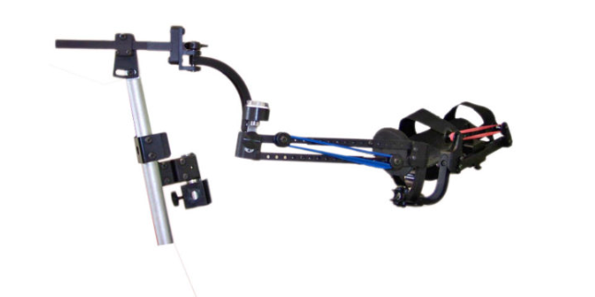 | Assistive Artistic Device:  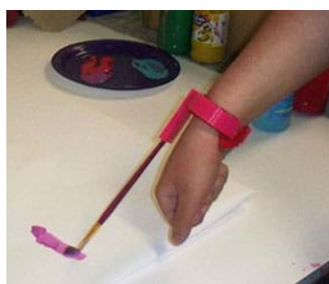 | Dorking Donner Tights Aid  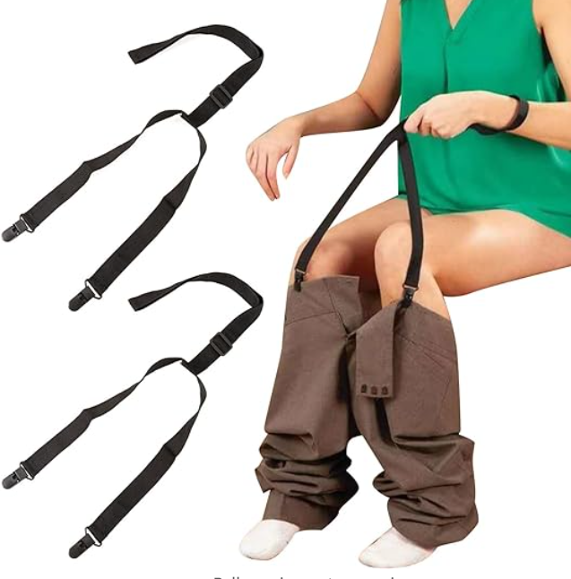 | Clip and Pull Dressing Aid  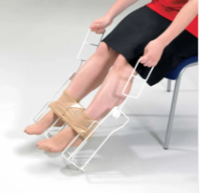
Weight | 3 | 5lbs | 0.25 lbs | 0.25 lbs | 0.15 lbs
Size | 4 | 6’’ to 10’’, it also can be customized. | Can be customized | 380 mm width by 560 mm height with handle by 130mm | Adjustable27-41 In
Cost | 5 | $2,227.23 | <$5 | $63 | $27.39
Ease of use | 4 | Medium Requires additional support to wear | Easy to put on and use | Hared Requires additional support to wear | Hared Requires additional support to wear
Effectiveness | 5 | Support in doing normal activities and may even help in rehabilitation of said medical condition | Assist in drawing, painting. | It is effective in general but not in the user’s case | It is effective in general but not in the user’s case
Material | 5 | Acrylonitrile butadiene styrene (ABS) | Acrylonitrile butadiene styrene (ABS) | Nylon and Plastic | Nylon and Plastic
Durability | 4 | No Data | No Data | No Data | No Data

3.2 User Benchmarking
Tool Metrics | Importance Weight | 1 | 2 | 3 | 4
Time | 5 | Saves time by eliminating the use of outside help when doing activities. | Saves time by eliminating the use of outside help when doing activities while rehabilitating the medical condition. | Save time since it only connects clamps to pants. | It would take more time to adjust the device to a good shape for pants.
Ease of use | 4 | While both require external support to put on, WREX gives the user the ability to do multiple activities. | Device is easy to use but only for a specific activity | Device is easy to use, only need to connect the clamps to pants | The implementation is a bit complex for the user, since it needs to adjust each part of the device to fit various pants
Durability | 5 | ABS is not the most durable material, but it allows for the use of redesign | ABS is not the most durable material, but it allows for the use of redesign | Nylon and Plastic can last for decades with good maintenance. | Nylon and Plastic can last for decades with good maintenance.
Comments |  | This device can be designed with the highly understanding of the user’s habits, body conditions, since the joints need to be adjusted all the time to find the best approach and position to guide the movement of the user. It might be too complex for us, since we do not have the medical background, and we have not enough time to know the habits of the user. | This device is not designed for bathroom activities, but we can use the idea to use the device to expand the range of the arms. | The reviews of the device are “it is not working”, we highly doubt, the device can pull up the pants, since there are not clams in the sides or back. We feel we can use the clamps, since it is easy to use, and it works to some extends. | This device is complex, and the size is too large. It’s designed for dressing. We can simplify it since we only need to pull up and down pants, so that we can reduce the complexity and size of the device.

Subsystems Breakdown

Hook/Clamp
  - Needs to securely grip clothing without damaging it. Should be operable with minimal force. In addition, it is lightweight and durable. Moreover, ergonomic and safe for skin contact, possibly with a rubberized or magnet finish for extra grip.
Triggers/Handle
  - Fit user’s hand comfortably.
  - Activate with limited force.
  - Prevent accidental activation.
  - Easy to press, with limited strength.
  - Ease to reach.
  - Confirm activation.

Adjustable Part
- Enables the user to change the size of the device as she grows.
- Enables the user to fit the device in her backpack.

Integration and Interaction of Subsystems
The way these subsystems interact with one another must be secured by the design. For example, the clamp should be intuitively controlled by the trigger or handle. The motor, if it is used, needs to be coordinated with the clamp and wire system in order to deliver the appropriate force for pulling up pants without damaging it. To ensure that the user can use the device successfully, comfort design is quite important, especially when it comes to the grip, triggers, and hand extensions.

If we can
All moving parts, including the motor and clamp, must have emergency release mechanisms because safety is the top priority. Adults should have easy access to the battery system for replacement or charging, but it should be protected from user’s unintentional access.
Durability and maintenance should also be considered in the design of each subsystem. The device is used in a bathroom, therefore the materials selected should be durable and resistant to wear and damage.

Concept development
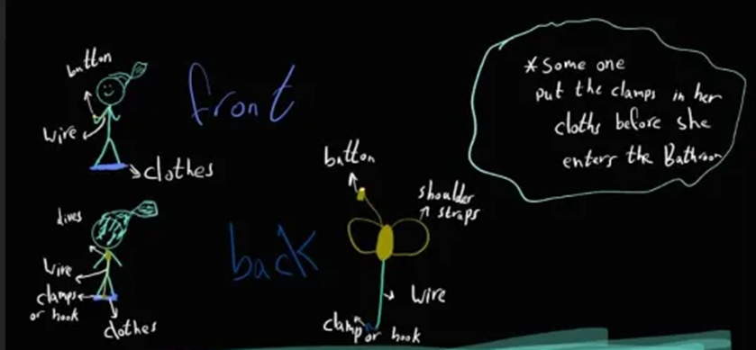

Prototype #1
The proposed device is a portable, backpack-like apparatus designed to assist the user in managing clothing during bathroom visits. It incorporates a wire mechanism connected to a clip or hook, which attaches to clothes. Upon pressing a button, the wire activates, lifting clothes either up or down as required. The key advantage of this system is that it automates a significant part of the process, enhancing independence by doing the bulk of the work, all while maintaining portability and ease of use. However, there are notable disadvantages, including partial dependence on the device for the task, which might not fully foster manual dexterity and self-reliance. Additionally, being an electronic device, it introduces complexities such as the need for regular charging, potential technical malfunctions, and the requirement for ongoing maintenance, which may pose challenges for a young user.

Evaluation of Device Features
Modular Hook/Clamp Mechanism
This component scores high in alignment with specifications, particularly in its ability to securely and gently grip clothing. Its modular design allows for adaptability with different types of clothing and sizes, which is crucial for the user. Enhancing the ease of operation so user can use it with limited hand strength, and ensuring the mechanism is robust and durable.
Lightweight Motor and Efficient Battery System
An electronic system, while adding some complexity, offers significant benefits in terms of the ease of use and independence it provides. It's particularly valuable given User's limited hand strength. Selecting a lightweight motor that is powerful enough for the task but not overly so. The battery system should be long-lasting, easy to recharge or replace, and safely enclosed.
Adjustable and Comfortable Shoulder Straps
Comfort and adjustability are key for a device that User will potentially wear for extended periods. The shoulder straps are crucial for distributing the weight of the device evenly. Using breathable, skin-friendly materials for the straps and ensuring they can be easily adjusted to fit User as she grows.

Evaluation with Target Specifications
- The device makes use of a clamp.
- The device has an adjustable part to enable the user to continuously use the device as she grows.
- Depending on the material the device it made with and its dimensions then the device is light weight.
- Producing the device won’t cost more than $85.
- The device has no parts which could harm the user.
- The product can be made of any lightweight material.
- The device will use electrical parts; however, it will be waterproof.

Prototype#2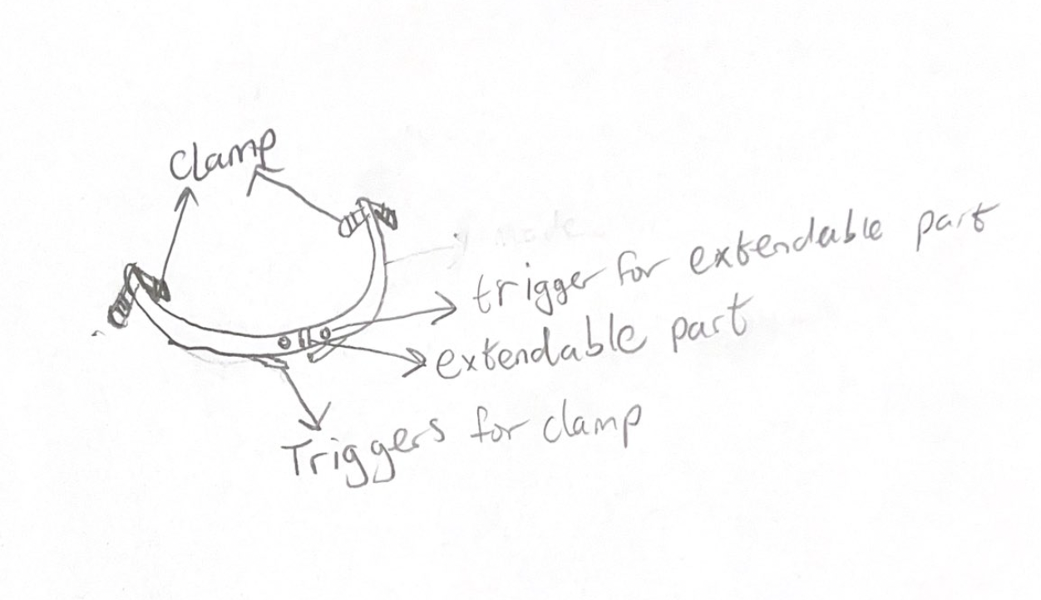
This device consists of a lightweight bar with clamps attached to each end. Each clamp is connected to a trigger which can make the clamps to close or open. It also has an extendable part which also has triggers which adjusts the size of the device to the user’s hip size. This device works by having the clamps being adjusted into position to grab the user’s pants on the sides using the bar. Once in position, the user can either pull up or down her pants while holding on to the clamp triggers to keep the clamps closed. The adjustable part of this device is able to adjust the size of the device as she grows. The main drawback of this device is that due to the users limited shoulder range, she might not be able to get the clamps in position by herself, she may still need help getting the clamps attached.

Evaluation with Target Specifications
- The device makes use of a clamp and triggers.
- The device has an adjustable part to enable the user to continuously use the device as she grows.
- Depending on the material the device it made with and its dimensions then the device is light weight.
- Producing the device won’t cost more than $85.
- The device has no parts which could harm the user.
- The product can be made of any lightweight material.
- The device does not make use of any electrical parts that might make it not waterproof.

Prototype #3:
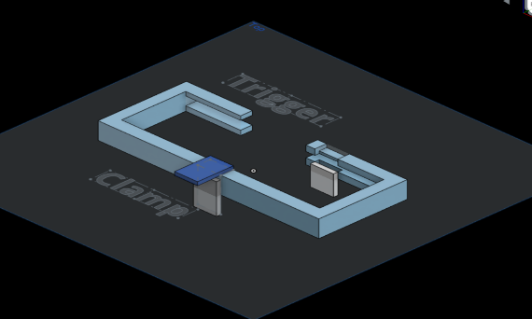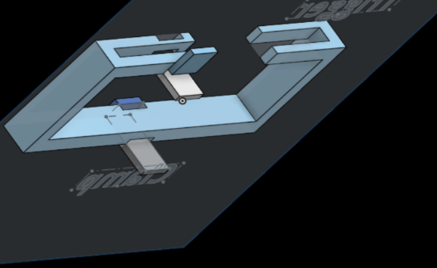

The device contains a lightweight rectangular circle with 2 clamps – one is in the back, the other one is in the front, two clamps are connected to the triggers in the front. The triggers control the clamp to close and open. The trigger is like the bicycle brake, the third step is to use trigger to close the clamp. Then repeat the steps for the clamp in the front. After that, the user can pull down and up her pants without moving her hand to the side or back.
- The first step would be to put the bar around the body.
- The second step is to squeeze the back clamp into the pants.
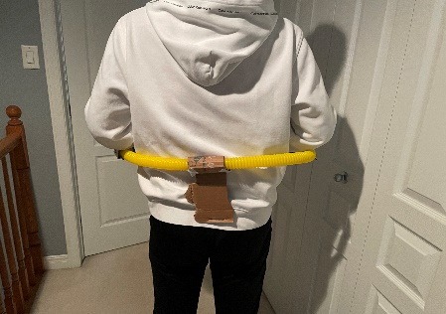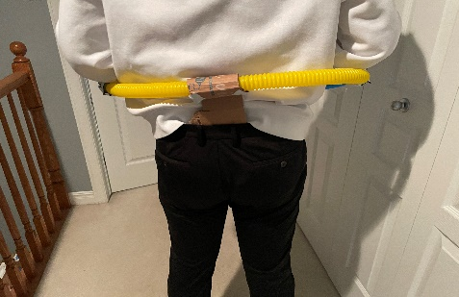

Evaluation of the device:
- The lightweight bar addresses the limited strength of the user.
- The clamp and trigger mechanism addressed the limited range of shoulder, so that user does not need to move her arm to the side or back.
- The rectangular circle is adjustable, so the user can adjust the device according to her size.
- The length of device is aligned to the waistline of the user, and the device is foldable, which addresses the requirement of portability.
- The device does not use electricity, so it is waterproof and safe to use in the bathroom, and we can make round edges for the device to prevent the user hurt herself.

Final decision

 | Prototype 1 | Prototype 2 | Prototype 3
Independence | No, the client needs to help the user to attach the clamps to the pants before going to washroom | Yes, the user can grasp the pants in the side without moving hand to the side or back. | Yes, the user can grasp the pants in the back without moving hand to the side or back.
Adjustable | Yes, the clamps can be pulled up and pulled down. | Yes, the device has adjustable parts which can increase the size of the frame. | Yes, the device features adjustable components that can expand the frame size.
Portability | Yes, the model of the device is a backpack. It can be carried by the user. | Yes, most parts of device are produced by 3D printer, so the weight is light, and the adjustable parts can decrease the size of frame, which can make it fit in the backpack. | Yes, most of the device components are 3D-printed, resulting in a lightweight design. Additionally, the adjustable parts enable the frame size to be reduced, allowing for easy portability in a backpack.
Safety | No, the device is electric based, it has safety issue while using in bathroom. | Yes, the device is mechanic based, and the edge parts will be polished to make them unsharp. | Yes, the device operates mechanically, and the edges will be polished to ensure they are not sharp
Usability | Yes, the user only needs to press the button to make the clamps pull up or pull down. | Yes, the user only needs to press the trigger to open or close the clamps. | Yes, the user simply needs to press the trigger to operate the clamps, opening or closing them as desired.
Durability | No, the electric device may not last long. | Yes, the device is made by carbon fiber, it can last for long time with proper maintenance. | Yes, the device is constructed from carbon fiber, ensuring longevity with proper maintenance.
Complexity | Yes, the electric circuit and the power system can be complicated, it is not easy to determine how much power we need in this system. | No, the clamps and adjustable are straightforward, the most challenge part is the connection of the trigger and clamps. | No, the clamps and adjustable are simple to use, with the most challenging aspect being the connection between the trigger and the clamps.

Based on the evaluation, the prototype 1 has strong safety issue, which is not be considered if the issue cannot be solved, the prototypes 2 and 3 are similar, the difference are the positions of the clamps and the trigger mechanism. Therefore, we decided to combine prototype 2 and 3 to move forward.

Challenges in following deliverable:
- The positions of the clamps.
- The connection of the clamps and the triggers.

Detailed Design and BOM

Detailed design
Clint meeting feed-back
The feedback from the second client meeting highlighted two main aspects of the prototype designs that were favored. The suggested design is a semicircular device featuring two clamps or hooks, which remain closed by default. These clamps can be opened via a button or trigger mechanism attached to the main body, which should simplify the process for the client to attach pants to the device. The client expressed satisfaction with the concept development and showed enthusiasm for the second and third prototypes we proposed. Additionally, the client is willing to offer further feedback and insights into the user's requirements outside of scheduled meetings.

Detailed design
We begin with three subsystems: Trigger, Clamp and Adjustable parts:
- To design a trigger and clamp, we use bicycle brake as benchmark: the cable is pulled when we press the trigger. Then the force is transferred to the other end of the cable, which closes the clamp.

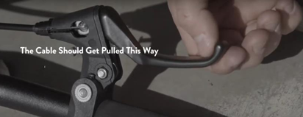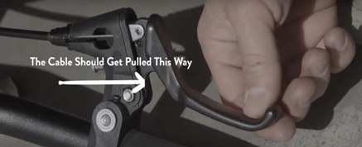

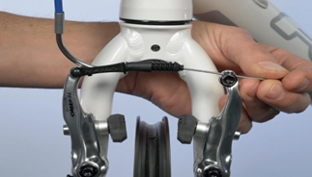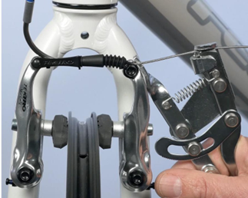

Based on that we designed our subsystem of trigger and clamp:
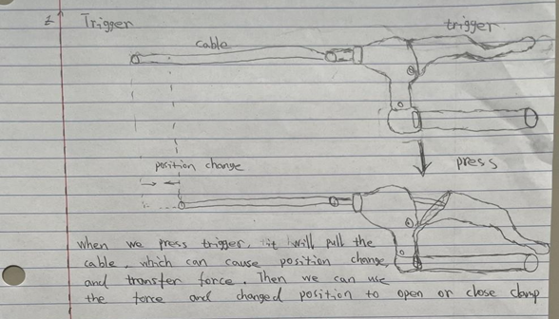
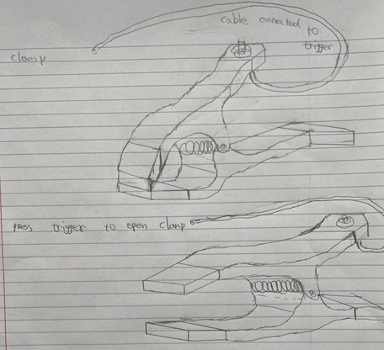
- To create adjustable part, we utilized extendable bar as benchmark: when the spring is pressed, we can subsequently increase the length of the product.
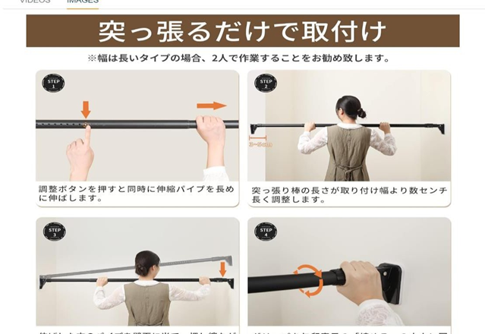

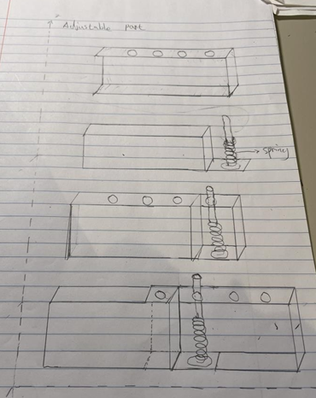

Next, we assemble the subsystems together to obtain an overview of our product:
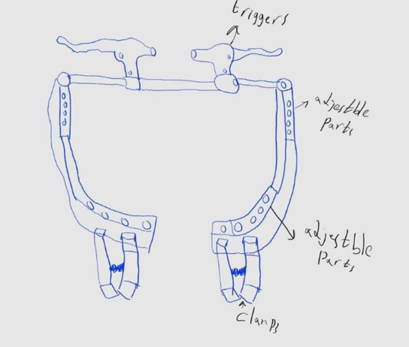

The user of our product has a waist length of 67cm so we will adjust the size of our device to match that. The user has a current leg length of 67cm, so our device is designed to raise her pants through that distance (and possibly more as the client intends for the user to make use of the device as she grows). She has a forearm length of 14cm which we are going to use to estimate her reach around her body (even though we plan to keep the triggers close to her to make her able to comfortably reach the device’s triggers).

Project Management: Skills, resources, time, and critical assumptions
list of skills and resources that will enable us to create our design.

  - Access to a 3D Printer for Prototyping: This is for iterative design processes, allowing for rapid prototyping, testing, and modification of designs efficiently.
  - Experience in 3D Modelling: Skill in 3D modelling software for creating functional designs. This skill enables the team to visualize on device components before printing, saving time.
  - Ability to Conduct Tests and Record Observations: Testing prototypes is critical to evaluate design performance against predefined criteria by record observations, analyze data, and draw conclusions.
  - Creative Thinking: Looking at problems from new angles, imagining new solutions This mindset helps in overcoming design challenges.
  - Research Capabilities: Effective research skills enable the team to benchmark against existing products and combine best practices into the design.
  - Fast Delivery Time or Access to a Well-stocked Shop: Having a reliable supplier that stocks all necessary materials and components can ease the development process.
  - Time Management Skills: Both individual and team time management skills are crucial for meeting project deadlines and milestones. Efficiently allocating time to different tasks, setting realistic goals, and prioritizing activities can greatly enhance productivity and project outcomes.
  - Leveraging Team Strengths: A successful project outcome often relies on the ability to utilize each team member's strengths and expertise. By assigning tasks based on individual skills and interests, the team can work more effectively and achieve a higher potential.

-If additional skills or resources are required, such as higher 3D printing skills or specialized materials, plans will be made to gain these, possibly through workshops, online courses, or consulting with industry professionals (TAs).

The time required to implement our design.
Phase 1: Finalizing the Concept (By February 12)
- This initial phase involves finalizing the design concept, specifications, and functionality. It's critical that both groups have a clear understanding of the overall project goals, how the subsystems will integrate, and the technical requirements for each component.
Phase 2: Development of Subsystems (February 13 - March 15)
Group 1: Clap and Trigger System
- Begin with detailed 3D modeling of the clap and trigger mechanisms. This involves specifying materials, dimensions, and the interaction between components. Then, prototyping, which helps identify design flaws or inefficiencies. Finally, testing to ensuring reliability and functionality under different conditions.
Group 2: Adjustable and Foldable Mechanism
- This task focuses on creating a mechanism that allows the device to be adjustable and foldable. It involves complex considerations for user factors, structural, and ease of use. Prototyping these mechanisms by their durability, user-friendliness, and the integration with other parts of the device.
Phase 3: Integration and Final Prototype Completion (March 16 - March 18)
- With both subsystems developed, the focus shifts to integrating them into a single, cohesive prototype. This involves ensuring compatibility, functionality, and seamless operation between the clap and trigger system and the adjustable, foldable mechanism.
- Prepare to present the completed prototype, documenting its design, functionality, and the process followed to achieve the final product. This includes detailed records of testing results, design iterations, and the rationale behind design decisions.
Assumptions About User Interaction and Usability
- Prototype Not User-Friendly
  - A product that is too heavy could be difficult to use or carry, limiting its practicality.
  - The effectiveness of the product could be compromised if it fails to secure itself to various fabrics securely.
  - Protecting the user's clothing is paramount.
- Availability of Materials
  - Assuming that all necessary materials will be readily available and provided promptly might overlook potential supply chain delays or shortages.
- Device Longevity and User Growth
  - Anticipating user growth and ensuring the device ages well are crucial for long-term satisfaction and usability.
- Durability
  - Durability is essential for user trust and product reliability.

BOM
Item # | Description | Quantity | Unit Cost (CAD) | Extended Cost (CAD)  (For students) | Extended Cost (CAD) (For Non- students) | Link
1 | A pair of Bicycle Brake  Levers | 1 | $16.49 | $16.49 | $17.45 | Brake levers
2 | A bag of 5  pieces of clips | 1 | $10.76 | $10.76 | $10.76 | Clips/clamps
3 | 3-D  printing | 1 | $0 | $0 | $120.00
4 | A pack of 200 springs | 1 | $14.6 | $14.60 | $14.60 | Springs

Project plan update
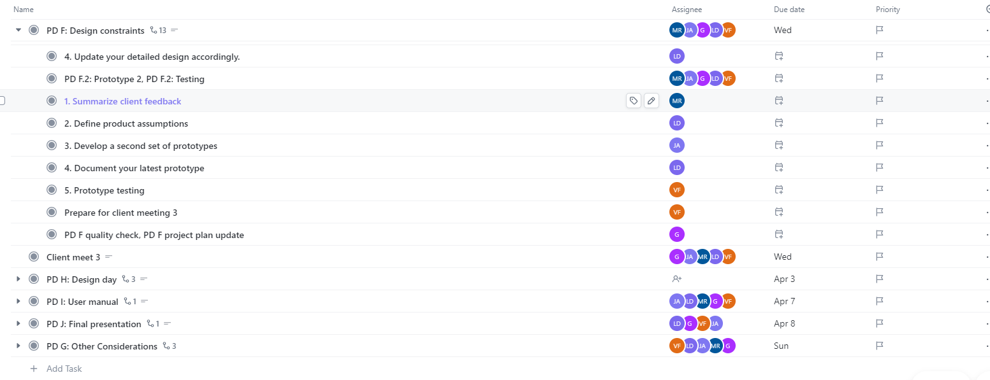
For PD F
- We will have two meetings one in Saturday on the other in Sunday. Saturday we will write the document and plan for Sunday. In Sunday we will test our prototypes and document them, and plan for new ones.

For the client meeting 3
- we will prepare a quick presentation, and the prototypes that we have tested. Also we will ask for feedback from the client. Potentially we will ask the client to take the prototype with him and tested himself.

For design day
- we don't know yet who will be available at that day. However, we are sure that at least someone be there.

-Out of strategies to actively preform our plan is to utilize every lab session, TBD class, weekend if we needed. However, some of us will have midterms, assignments, or any other life problems. So, we must be flexible and do whatever we can when we can.

Conclusion

In summary, we have come to an agreement on a design that closely reacts to the needs and preferences of the user and client. Our design mechanism was chosen in response to feedback from the client is opening the clamp by using triggers as explained previously. This method keeps the project within budgetary restrictions while simultaneously guaranteeing cost-effectiveness and satisfying customer objectives. We can make necessary adjustments to our design in response to feedback from prototype testing. This allows us to immediately resolve any defects that are detected without incurring additional costs. In addition, we are able to realize our prototype because of the STEM facility's extensive equipment and resources. By utilizing current technology, we can develop a product that will improve its user's independence and quality of life. Our dedication to providing a practical, user-friendly, and economical solution is demonstrated by this thoughtful integration of simplicity client-centered design.

