Deliverable E: Project Plan and Cost Estimate
GNG1103G - Engineering Design
University of Ottawa
Group 7

Client Meeting 2 Reflection
This client meeting was very helpful as it helped us determine more precise details about our project. Before this meeting we had misunderstood what exactly was to be created for the project as we thought it was about both the graphic design and creating the dashboards,however, our client made it clear to us that we were only to focus on creating the dashboards. Our client also gave us some details on how the dashboards should work. For example, they said that everything in our dashboards should be very easily configurable. Specifically for the crowd prompts dashboard they said that the user should be able to change the preset crowd prompt for each button game-to-game meaning we must incorporate this ability into the crowd prompt dashboard.

Final Design Ideas
Crowd Prompts
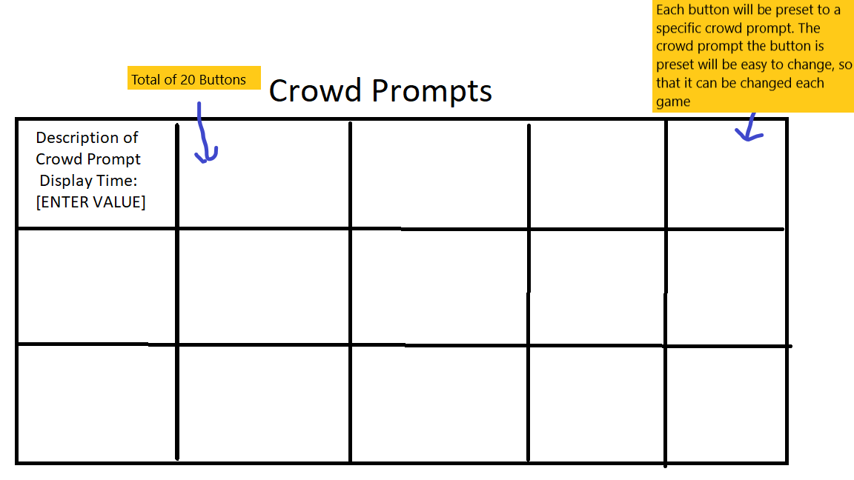

Goalie Matchups
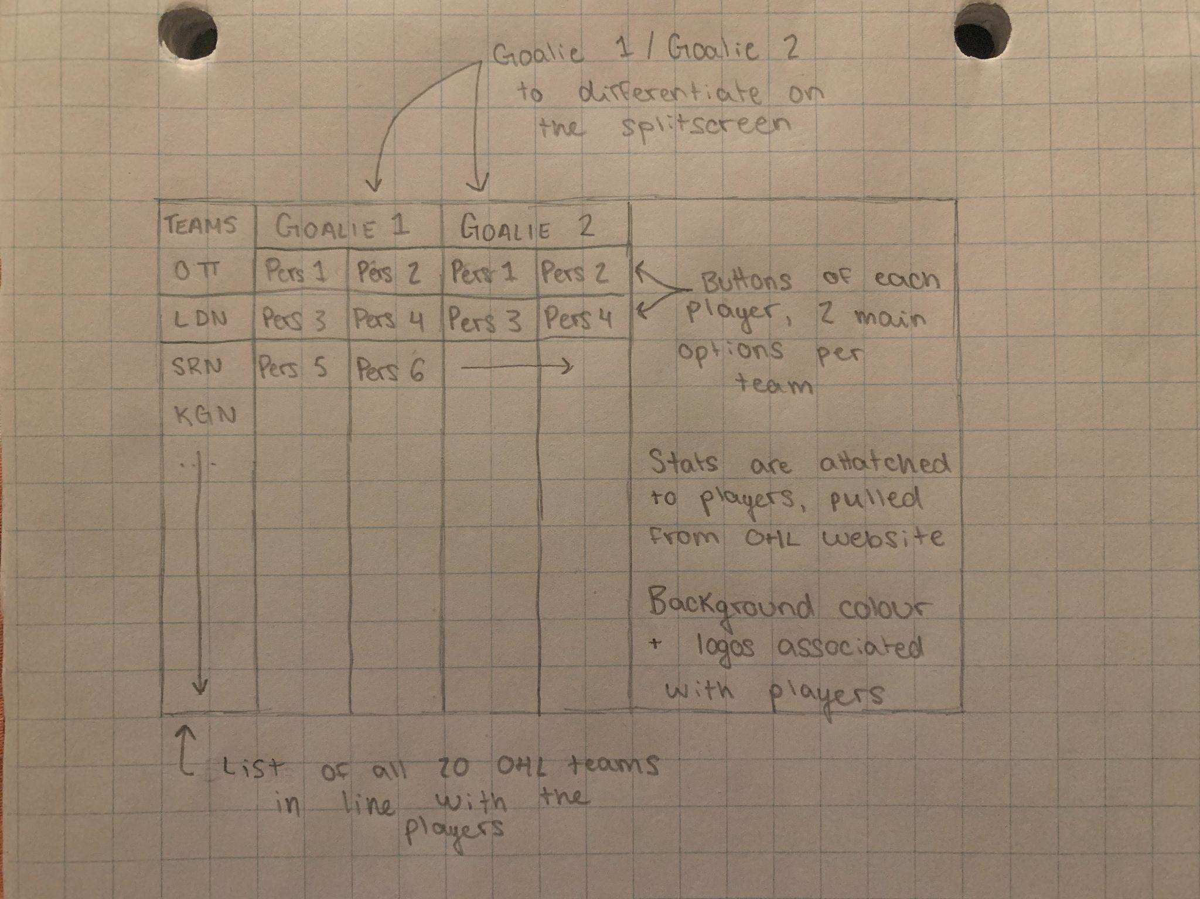

Three Stars
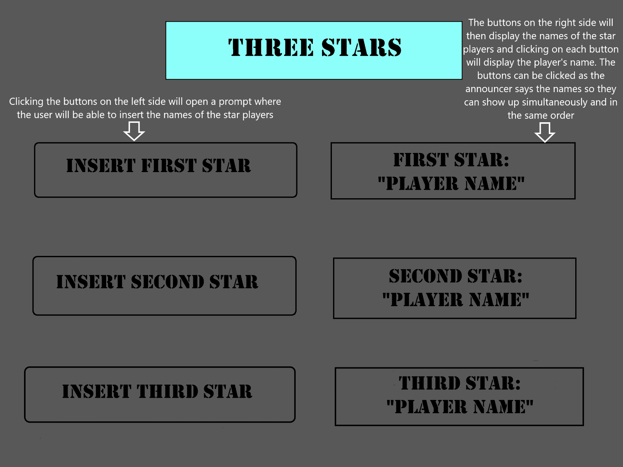
Birthdays

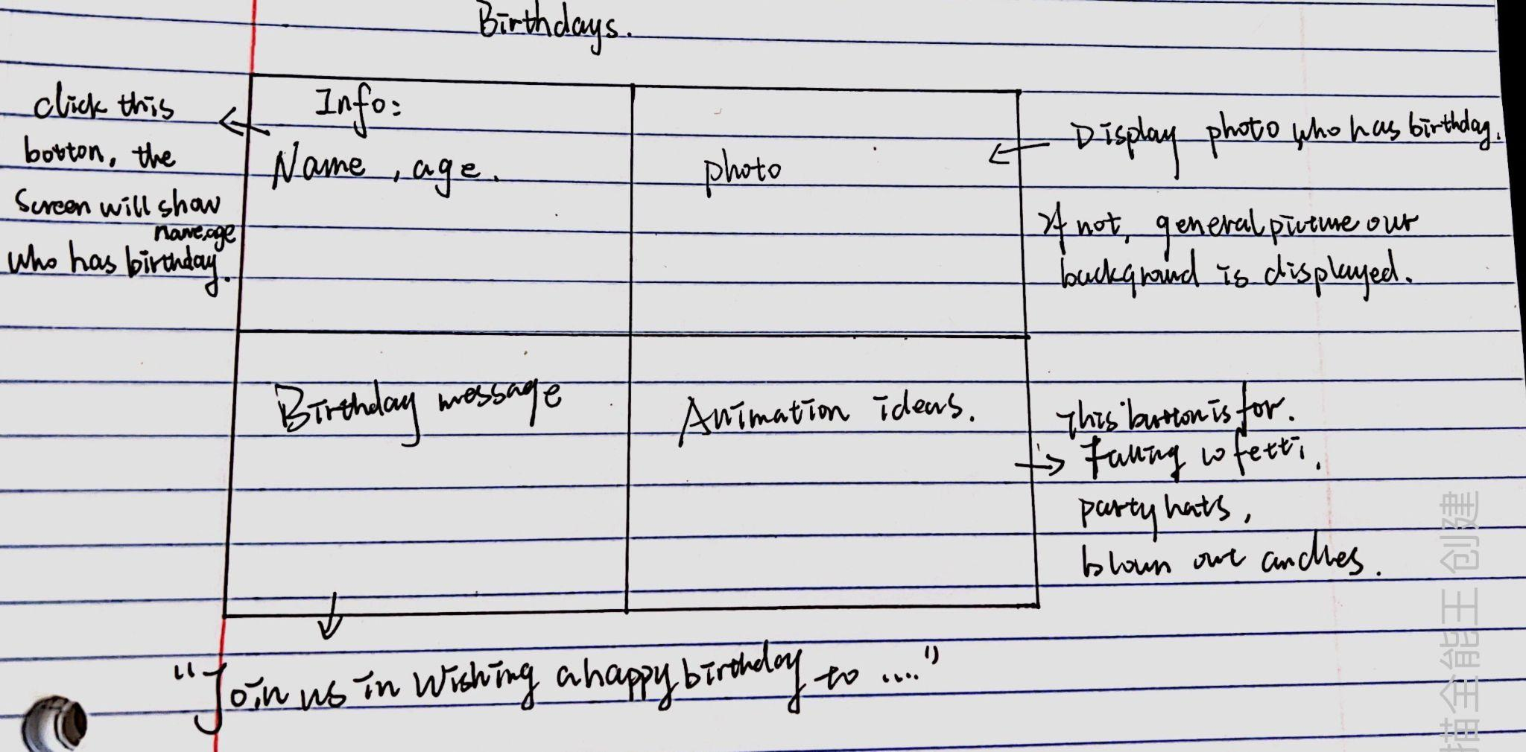

Project Plan/Schedule

Prototype 1 (November 4th) - Create the visual aspect of each design on the Dashboard software including a description of how the design will function. Each member will be designing a unique Dashboard for a specific part of the project (3 stars, crowd prompts, etc) for a total of four different dashboards. This prototype will only include the proposed dashboard, it will not yet be programmed to function.
Tasks
- Audrey- Create the dashboard for the Goalie Matchups section. (1 week)
- Roan- Create the dashboard for the Crowd Prompts section. (1 week)
- Usman- Create the dashboard for the Three Stars section. (1 week)
- Yinhao- Create the dashboard for the Birthdays section. (1 week)

Prototype 2 (November 11th) - Have four functional but not finalized dashboards, one for each chosen component of the project with which to receive feedback and adjust as needed. These dashboards should be able to execute the proper commands to expression while remaining simple. This prototype will have been programmed to carry out the necessary commands of the dashboard. Also, feedback from the first prototype will be used to make adjustments to the design of the dashboard.
Tasks
- Audrey- Add functions and tweak the design of the dashboard for the Goalie Matchups section. (1 week)
- Roan- Add functions and tweak the design of the dashboard for the Crowd Prompts section. (1 week)
- Usman- Add functions and tweak the design of the dashboard for the Three Stars section. (1 week)
- Yinhao- Add functions and tweak the design of the dashboard for the Birthdays section. (1 week)

Prototype 3 (November 25th) - Create our final, working prototypes based on the feedback received from Prototype 2. It will include a final version of each of the four dashboards previously created (Goalie matchups, Birthdays, Crowd Prompts, and Three Stars) and will be done in order to receive final feedback before finalizing our product.
Tasks
- Audrey- Tweak the dashboard for the Goalie Matchups section. (2 weeks)
- Roan- Tweak the dashboard for the Crowd Prompts section. (2 weeks)
- Usman- Tweak the dashboard for the Three Stars section. ( 2 weeks)
- Yinhao- Tweak the dashboard for the Birthdays section. ( 2 weeks)
Project risks

Risk | Solution
Dashboard not being capable of performing the task we came up with in our design. | Tweaking our design so that Dashboard is capable of performing the task.
Not having sufficient time between prototypes 1 and 2 to create our dashboards. | Reach out to our teammates for help if we fear we will not finish our respective tasks on time.
Group conflicts | Work together as a team to solve the conflicts.
Having to completely change a design due to critical feedback that it must be done differently. | Other group members assisting, so that the new design can be created quickly
Losing data or forgetting to save files. | Building on a google drive folder.

Test Plan
- To test our dashboards we will use feedback from our group partners, and also the people from Ross Video.
- We will also be able to test that the functions we create for our dashboards work using the Dashboard application.

