Deliverable H: Prototype 3 and Customer Feedback
GNG1103G - Engineering Design
University of Ottawa
Group 7

Test Plan for Prototype 3
To test prototype 3 we will use a very similar test plan to the one we used for prototype 2, however, we will test the new features to our dashboard. Therefore, prototype 3 will be tested by creating a list of tasks which relate to be completed for each dashboard. The list of tasks will be based on testing the new features which have been added to each dashboard. These tasks will then be given to several different people while timing them to see how long it takes them to complete each task. Before we perform the test we will create a goal for how long we would like the person to complete each task based on what we think would be a reasonable amount of time for Colin to perform these tasks. After this we will be able to analyze if the new features we added are easy enough to use and what functions may need to be altered to make the dashboard easier to use. We will also test how our dashboards work with expression in the makerlab to make sure they function properly with expression. Those results will not be included in this report, however, since we need to wait until our lab time on friday to test this. The goal for this prototype is to be able to complete our dashboards so that they perform all the necessary functions and so that these functions are easy to perform.

Crowd Prompts - Roan Schooley:

Picture of Prototype:
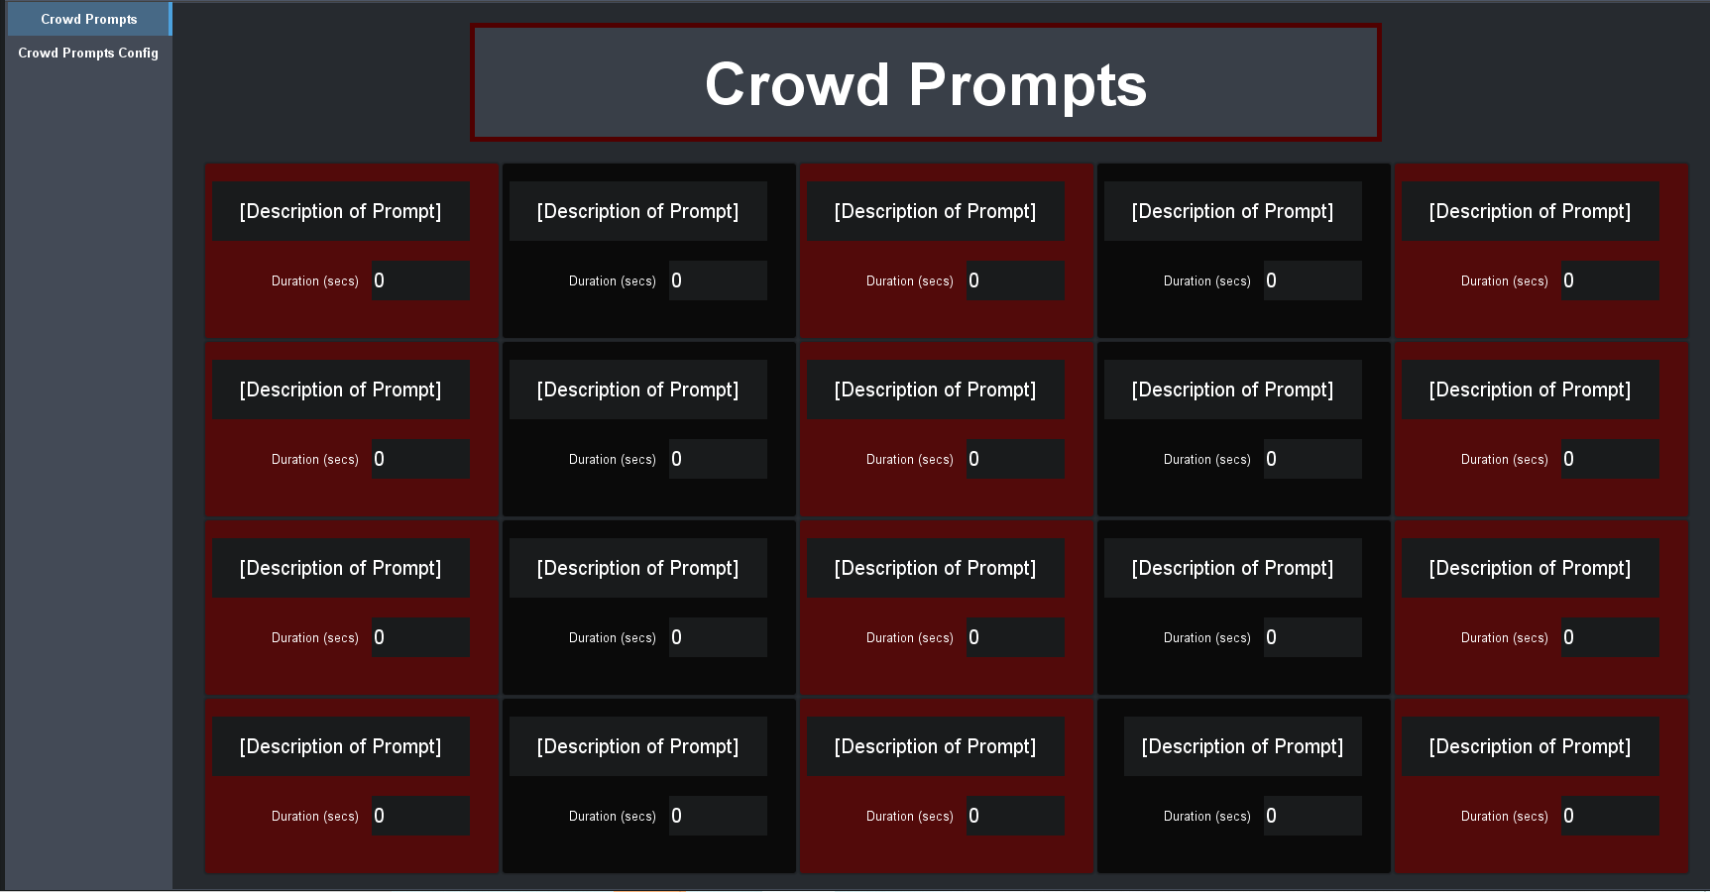

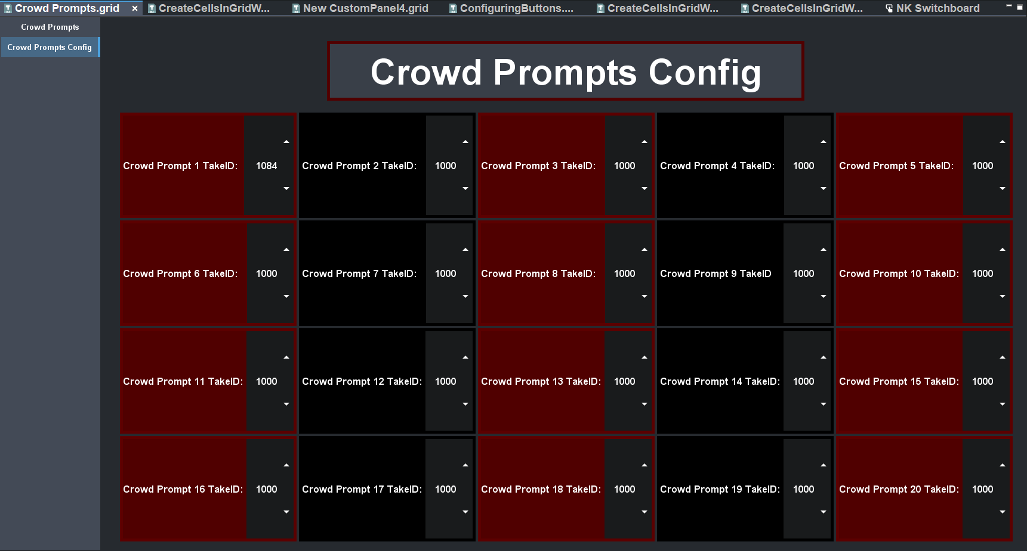

What is New?:
For prototype 3, I separated the panel into two separate tabs, one of the tabs being the control panel, and the other being the config panel. The control panel is similar to prototype 2, however, I removed the widget which allows one to change the number of buttons as it was too difficult to incorporate into the dashboard. The config panel is completely new and allows one to change the take id for each button on the control panel.

Prototype test result:

 | Task: Create a fictional crowd prompt description  Goal:10 secs | Task: Assign the take id to be 1021 for the fictional prompt  Goal: 10 seconds | Task:Display this crowd prompt on to the jumbotron  Goal: 3 seconds
Person 1 | 8.1 seconds | 7.2 seconds | 2.2 seconds
Person 2 | 6.5 seconds | 8.5 seconds | 1.0 second
Person 3 | 7.2 seconds | 4.2 second | 1.5 seconds

Analysis:
In conclusion, these test results show that each function of my dashboard is easy to perform as everyone who was tested was able to perform the tasks before the target time. The next task is to complete this dashboard is to test it using Xpression in the next lab time, and then combine it into one dashboard with the rest of my partners dashboards. Lastly, it must be noted that I am not planning to change the design of my dashboard after testing this prototype, however, once the graphics from Xpression are given to the class, I may have to remove or add functions.

Birthday - Yinhao Li

Picture of Prototype: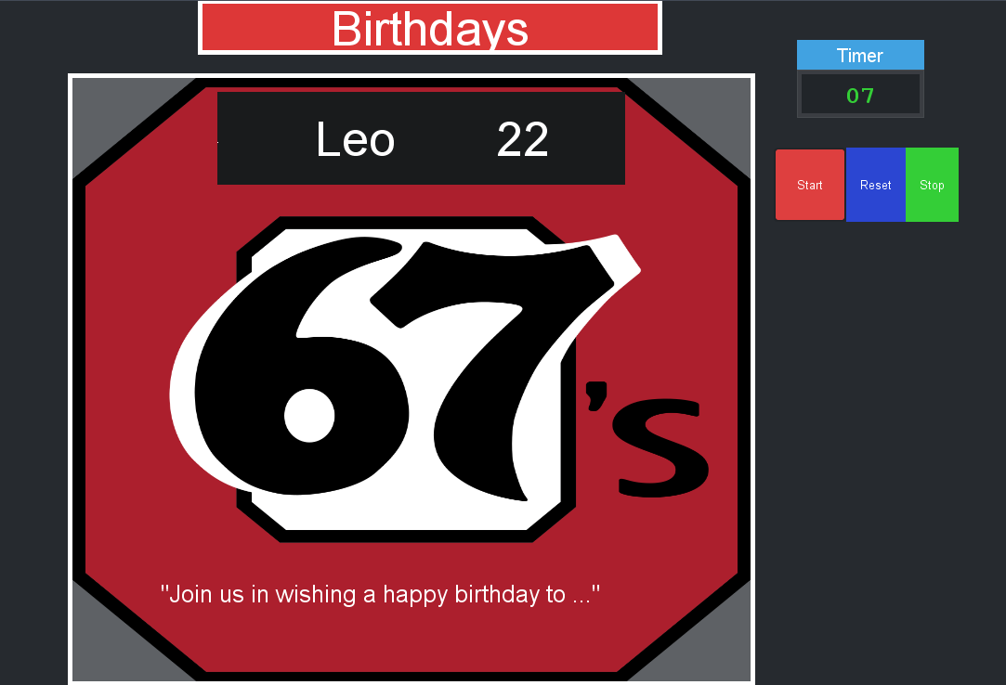

What is New?:

For Prototype 3, I changed the background to Ottawa 67’s logo. The background is also changeable. It can be changed to a photo of someone who has a birthday. The name, age and birthday messages can be set as required. Timer can show the time that is required for the whole process.

Prototype test result:

 | Task: Change people name and age  Goal:4 secs | Task: Display the photo  Goal: 4 seconds | Task: Press start, reset and stop button  Goal: 3 seconds
Person 1 | 3 seconds | 4 seconds | 2 seconds
Person 2 | 2.5 seconds | 2 seconds | 2 seconds
Person 3 | 3 seconds | 3 seconds | 2.5 seconds

Analysis:
To sum up, the results of the test show that buttons and content of my dashboard is easy to understand and use. The next step is going to use the Xpression. Just get the graphic from xpression, I will combine my part with my teammates, and prepare the design day.

3 Stars - Usman Khan

Picture of Prototype:
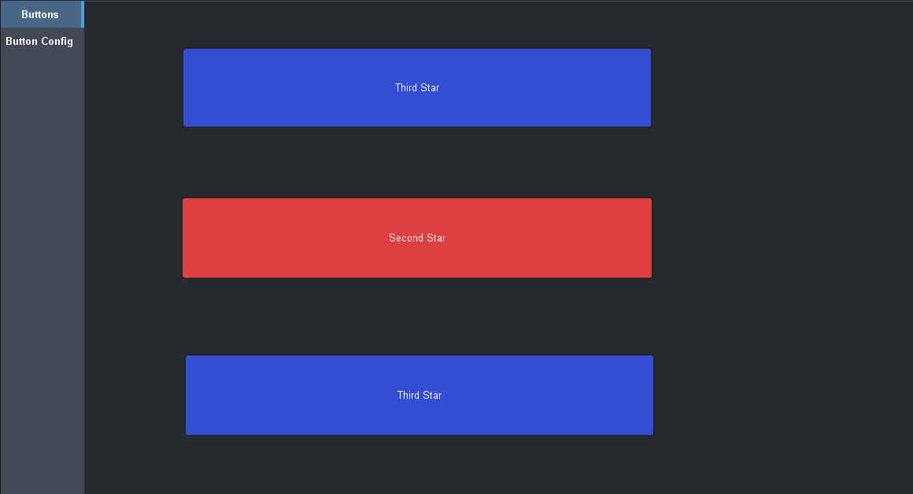
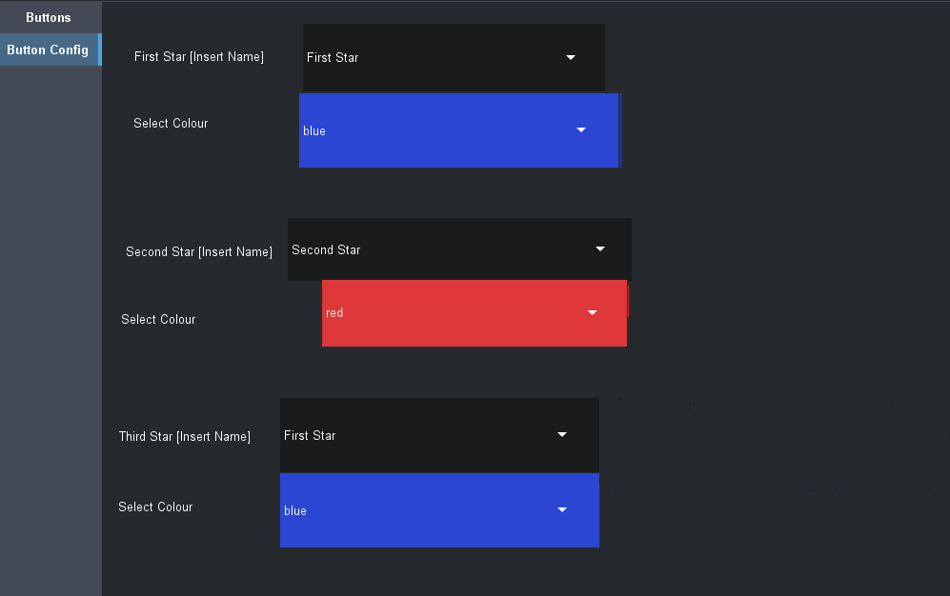

What is New?:
This prototype is not much different from the last one. The overall visuals of the DashBoard endured some very slight changes since the last one. Functionally, this DashBoard has two tabs: one that displays the three star players’ names, and one that allows the user to configure the name of the star players and their team colours. This prototype contains a dropdown style menu for choosing the team colours of the star players; whereas the last prototype did not have this style of button, so this was a new feature in the third prototype. Overall, any of the minor functional flaws from the last prototype were corrected in this one. The DashBoard runs smoothly and it serves the purpose it is intended to without any problems.

Prototype Test Result:
 | Task: Switch Between Two Panels  Goal: 8 Seconds | Insert Player Names and Change Colours:  Goal: 25 seconds | Understand The Difference Between Two Panels  Goal: 10 seconds
Person 1 | 4 seconds | 22 seconds | 15 seconds
Person 2 | 6 seconds | 17 seconds | 8 seconds
Person 3 | 6 seconds | 24 seconds | 11 seconds

Analysis:
Overall, the test results showed that the users were able to understand and use the prototype without having any prior knowledge about its function. Therefore, the prototype is considered successful as the goal was for the users to be able to use the prototype without having to explain to them beforehand. After the testing, the users were able to explain the purpose of the prototype themselves, meaning that it is clear for any potential users. The final step of this process will be to link the DashBoard into Xpression in order to create an output that can be displayed at Ottawa 67’s games

Goalie Matchup - Audrey MacKay-Barr

Picture of Prototype:

What’s New?

A lot has changed between the last prototype and this one, not only in the cosmetic aspect but many of the control features as well. Two tabs have been added to separate the controls and ease the process for the user. The “Goalie Roster” tab allows for the user to input the names and statistics of the goalies on the roster for the teams playing that night. It was decided to be something that is input by the user rather than from a set list of stats, because they are constantly changing after every game and must be rapidly configurable. Then, the “Game Day” tab is used for the actual controls during the game. You are able to search the goalies based on either their name or number, and their statistics from the goalie roster will appear with it. From there, you just have to select start or stop to run the Dashboard.

Prototype test result:

 | Task: Create a fictional player and populate the dropboxes  Goal: 20s | Task: Search for and select the created player  Goal: 5s | Task: Start and stop the run time of the Dashboard  Goal: 3s
Person 1 | 11s | 2.2s | 1.3s
Person 2 | 15.7s | 4.1s | 2.4s
Person 3 | 21.3s | 3.7s | 1s

Analysis:
Based on the test results and the feedback received based on the recent changes, it seems as though the new style allows for easier editing for the user. It’s very clear what is needed in order for the Dashboard to work and the proper steps to be done. A concern by one of the users was brought up about the input of data, and that there is the possibility for user error there. Although that is a valid concern, having the user input the data is the most reliable and fastest solution.

Gantt Chart

