TEAM CONTRACT GNG1103
Section # G02 Team # 7

Team Members:
1) Audrey MacKay-Barr
2) Usman Khan
3) Yinhao Li
4) Roan Schooley
5) _______________________________

Team Procedures
1. Day, time, and place for regular team meetings:
Wednesday, 1:00-2:00pm on Zoom

2. Preferred method of communication (e.g. e-mail, cell phone, Facebook, Blackboard Discussion Board, face-to-face, in a certain class) in order to discuss the project and to inform each other of team meetings, announcement, updates, reminders, problems:
Email and cellphone.

3. Decision-making policy (by consensus? by majority vote?):
Majority Vote.

4. Method for setting and following meeting agendas (Who will set each agenda? When? How will team members be notified/reminded? Who will be responsible for the team following the agenda during a team meeting? What will be done to keep the team on track during a meeting?):
We will assign each person tasks for the week during our weekly meetings, and this will be up to each team member to stay on top of. In the future when Wrike or alternative becomes available we will use that.

5. Method of record keeping (Who will be responsible for recording & disseminating minutes? How & when will the minutes be disseminated? Where will all agendas & minutes be kept?):
Our online work will be done on google drive, in a shared folder which saves automatically, and in person our notes will be written down and shared with all members.

Team Expectations Work Quality
1. Project standards (What is a realistic level of quality for team presentations, collaborative writing, individual research, preparation of drafts, peer reviews, etc.?):
The level of quality of work will be determined by the entire team after reviewing and approving that it is good.

2. Strategies to fulfill these standards:
All individual work will be presented to the rest of the team during weekly meetings. This will give everyone an opportunity to understand the work that everyone has been doing, and also give the opportunity to review the work they have done to make sure the quality is good enough.

Team Participation
1. Strategies to ensure cooperation and equal distribution of tasks:
Each member will be assigned with tasks to complete during the meetings. Team members will be able to volunteer for performing the tasks they wish to complete. We will also share ideas on a regular basis to ensure cooperation within the group.

2. Strategies for encouraging/including ideas from all team members (team maintenance):
All members will be encouraged to give input, ask questions and speak every meeting. We will each be given a few minutes every meeting of free speech to say what is on their mind.

3. Strategies for keeping on task (task maintenance):
We can set a 3 or 5 minute timer. It will help us maintain focus on our task each meeting/ or help us to get back on task.

4. Preferences for leadership (informal, formal, individual, shared):
The style of leadership in our group will be informal, and shared with all members. We will each take turns in leading tasks and deliverables.

Personal Accountability
1. Expected individual attendance, punctuality, and participation at all team meetings:
Each member of the group is expected to attend each meeting. If they cannot, they should let the group know in advance. Tasks will be distributed equally and everyone is expected to complete their tasks on time.

2. Expected level of responsibility for fulfilling team assignments, timelines, and deadlines:
Every member of the team will be responsible for completing their assigned tasks on time, if they require extra time or assistance, they will communicate this to the group in advance so they might get help.

3. Expected level of communication with other team members:
Each member is expected to actively communicate with the rest of the team throughout the week.

4. Expected level of commitment to team decisions and tasks:
Each group member should be highly and equally committed to team decisions and tasks. Since we are sharing leadership, each member should take initiative during the project.

Consequences for Failing to Follow Procedures and Fulfill Expectations
1. Describe, as a group, how you would handle infractions of any of the obligations of this team contract:
The TA or Prof will be notified of the infractions, and they will also be expected to catch up on their work by the next week.

2. Describe what your team will do if the infractions continue:
If infractions continue, it will be requested that they be removed from the group or given a lower grade than the other members.

***************************************************************************
a) I participated in formulating the standards, roles, and procedures as stated in this contract.
b) I understand that I am obligated to abide by these terms and conditions.
c) I understand that if I do not abide by these terms and conditions, I will suffer the consequences as stated in this contract.

- date sept. 22, 2021
- _____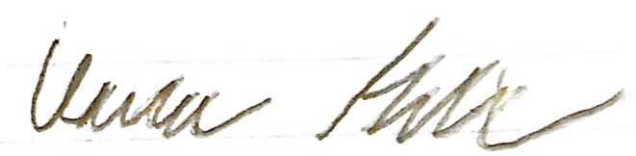______________________date___2021/09/22_____
- ___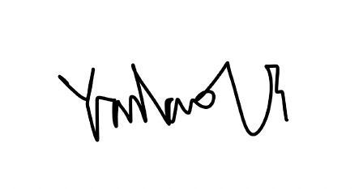________________ date 2021/09/22

4)
date_2021/09/22__

5)___________________________________________________date__________________

