Deliverable G: Prototype 2 and Customer Feedback
GNG1103G - Engineering Design
University of Ottawa
Group 7

Test Plan for Prototype 2
To test prototype 2 which focused on developing the functionality of our dashboards, we will test how easy it is to perform the functions related to each dashboard. This will be tested by creating a list of tasks to be completed for each dashboard, then giving this list of tasks to several different people while timing them to see how long it takes them to complete each task. Before we perform the test we will create a goal for how long we would like the person to complete each task based on what we think would be a reasonable amount of time for Colin to perform these tasks. After this we will be able to analyze if the dashboard is easy enough to use and what functions may need to be altered to make the dashboard easier to use.

Fan Birthdays - Yinhao Li:

Picture of Prototype:
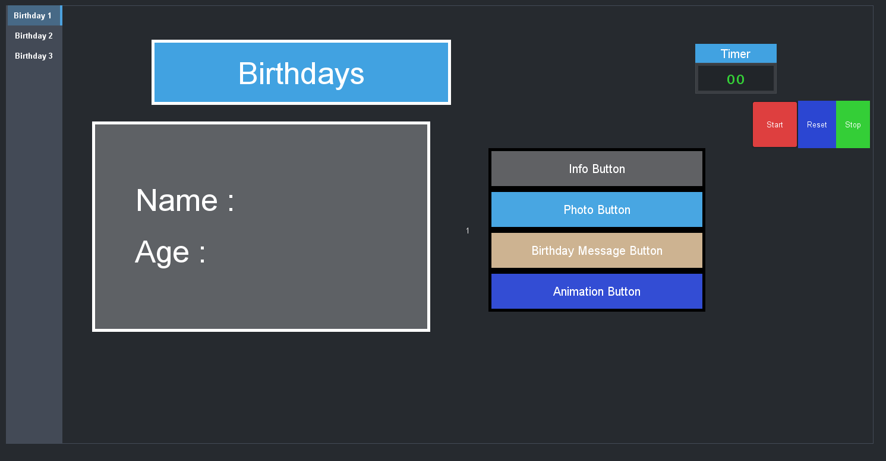

What Is New?
For this prototype, there are some changes to the visual aspects of the dashboard. In order to let users have a better experience, I set up a timer which has three buttons ( Start, Reset, Stop).
This way the user can understand how long it takes to control all the tabs with the buttons. Also, there are 3 birthday tabs on the left hand of Dashboard, in case there is more than one fan celebrating his/her birthday in the game.I am still working on fetching up to data information from an online resource or locally stored file. I will figure that out on the next prototype.

Prototype Test Results:

 | Task: Using four buttons to control all content  Goal: 10s | Task:Switch between different tabs of fans birthday  Goal: 3s | Task:Adjust the duration, birthday message remains on screen  Goal: 5s
Person 1 | 8s | 2s | 3s
Person 2 | 7s | 2s | 4s
Person 3 | 8s | 3s | 3s

Analysis
Overall, this prototype test was successful as every person tested time to achieve goals and the purpose of all the buttons and tabs are very quickly and stably. The only problem is three birthdays tabs on the dashboard. If there are more than three people celebrating their birthdays in the same game, I have to find a method that adds a table that can fetch up to data information from an online source. This will be a challenge for the next prototype.

Crowd Prompts - Roan Schooley:

Picture of Prototype:
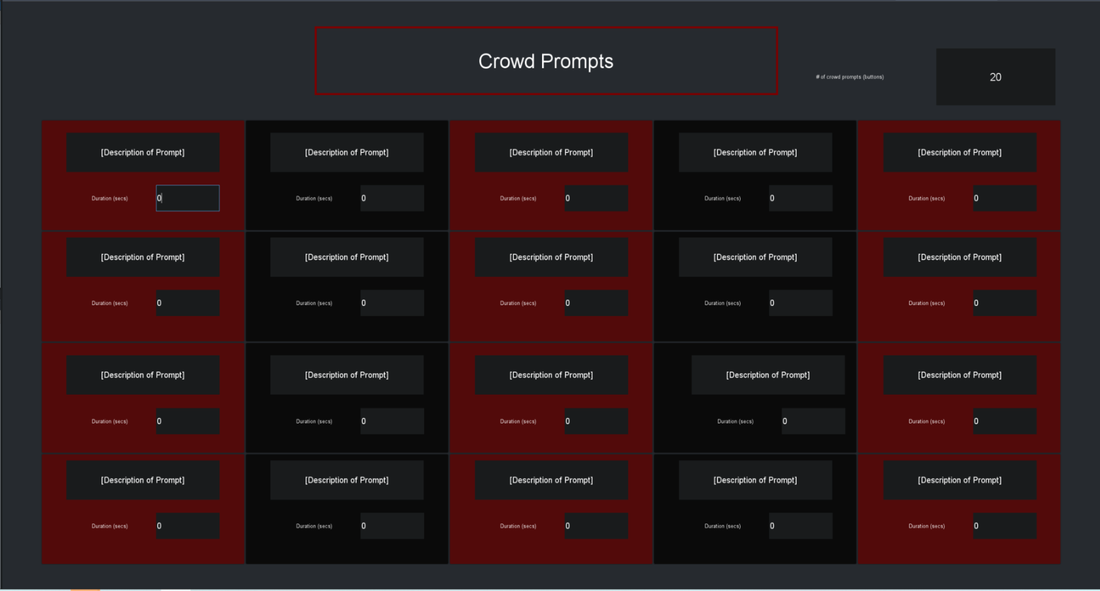
What Is New?
The visual aspect of the dashboard was not changed at all for this prototype, however, several other things were changed. In the previous dashboard all of the prompt description labels, and duration widgets were set to the same OID, therefore, when you entered a value in one of the prompt description labels or duration widgets, it was also entered in the rest of them. To fix this issue I created different OID’s for each prompt description label and duration widget. I slightly changed the duration widget as well, so that instead of clicking up or down to change the number of seconds the prompt is displayed for, it can now just be typed in manually. I believe that this will make the duration widget quicker to use. I also took the constraint off of the duration widget so a crowd prompt may be displayed for an infinite amount of time. Lastly, I still have not figured out how to hide buttons, so the number of buttons widget still does not work. If it is not possible to hide buttons this widget can always be removed, and the buttons which are not assigned to a specific crowd prompt can just be ignored.

Prototype Test Results:
 | Task: Create a fictional crowd prompt description  Goal:10 secs | Task: Adjust the duration so this crowd prompt remains on screen for 10 seconds  Goal: 5 seconds | Task:Display this crowd prompt on to the jumbotron  Goal: 3 seconds
Person 1 | 7.3 seconds | 3.7 seconds | 2.2 seconds
Person 2 | 8.9 seconds | 3.1 seconds | 6.2 seconds
Person 3 | 5.1 seconds | 2.2 second  s | 1.5 seconds
Analysis:
Overall, This prototype test was very successful as everyone was able to complete the tasks quickly. The only issue was that one person did not understand how to display the crowd prompt, however, I believe that it is pretty straight forward as you just have to click a button. In conclusion, I do not think any adjustments have to be made to the design or the functions so far unless further feedback is received from the ross team.

Three Stars - Usman Khan:
Picture of Prototype:
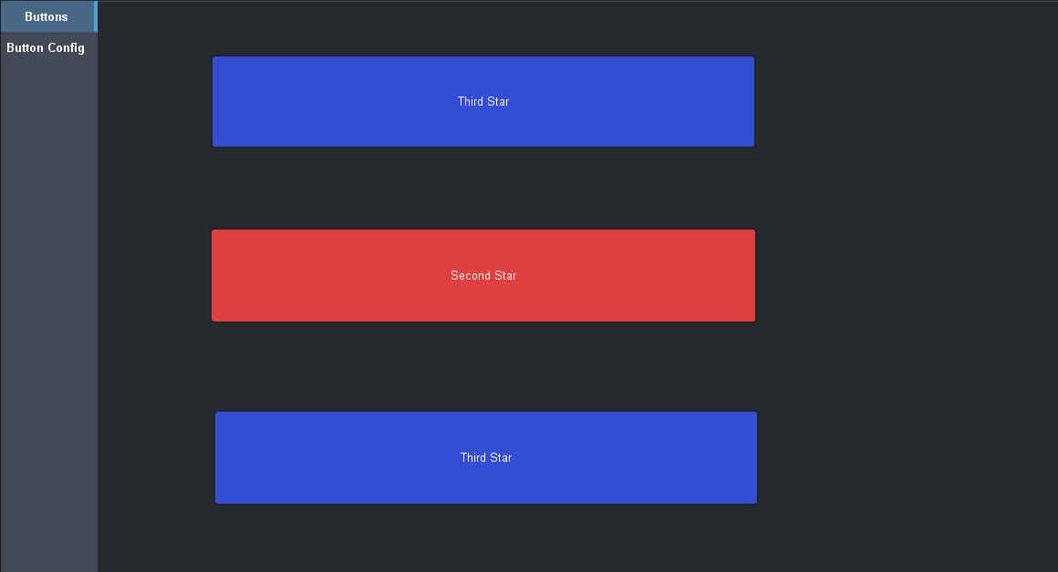
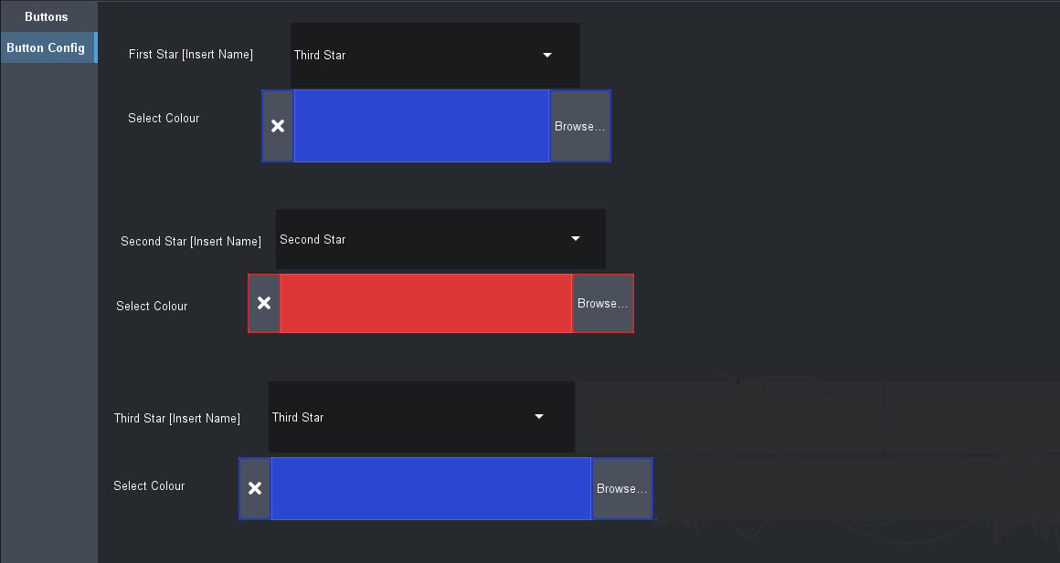

What Is New?
For the second prototype, a change was made to the idea behind how the dashboard would. The first prototype would have three buttons that would open a menu once you click on them. This menu would allow you to configure the properties of the button (the name of the player and their team colour). Now, there will be a separate panel for the buttons themselves and the configuration of the buttons. The two screens are displayed in a menu where they can be accessed. The change was made because there were some functionality problems with the initial design. It was harder to make pop-up menus for the configuration of each of the buttons. This design was harder to execute and it was also slightly less efficient as compared to the new design. The new design makes it easier to edit the buttons quickly and it is also more clear for the user. The parameters of the dashboard make it so only the button configuration panel is the one that needs any editing. The other “Button” panel will change automatically when the configuration one is altered.

Prototype Test Results:
 | Task: Insert Player Names and Change Colour  Goal: 30 seconds | Task: Understand the Purpose of Dashboard  Goal: 10 seconds | Task: Switch Between Two Panels  Goal: 8 seconds
Person 1 | 25 seconds | 15 seconds | 5 seconds
Person 2 | 22 seconds | 9 seconds | 5 seconds
Person 3 | 28 seconds | 11 seconds | 7 seconds

Analysis:
For the testing of this prototype, three new people were asked to use the dashboard. The users had no prior experience or knowledge about the dashboard. The test aimed to discover if the users could figure out the use of the dashboard on their own without needing any explanation. Due to the simple design, the goal was for the users to be able to work with the prototype without knowing what it was. From the results, it’s clear that the users were able to understand and carry out the intended function of the prototype as they were mostly able to complete each test within the desired time.

Goalie Matchup - Audrey Mackay-Barr:
Picture of Prototype:
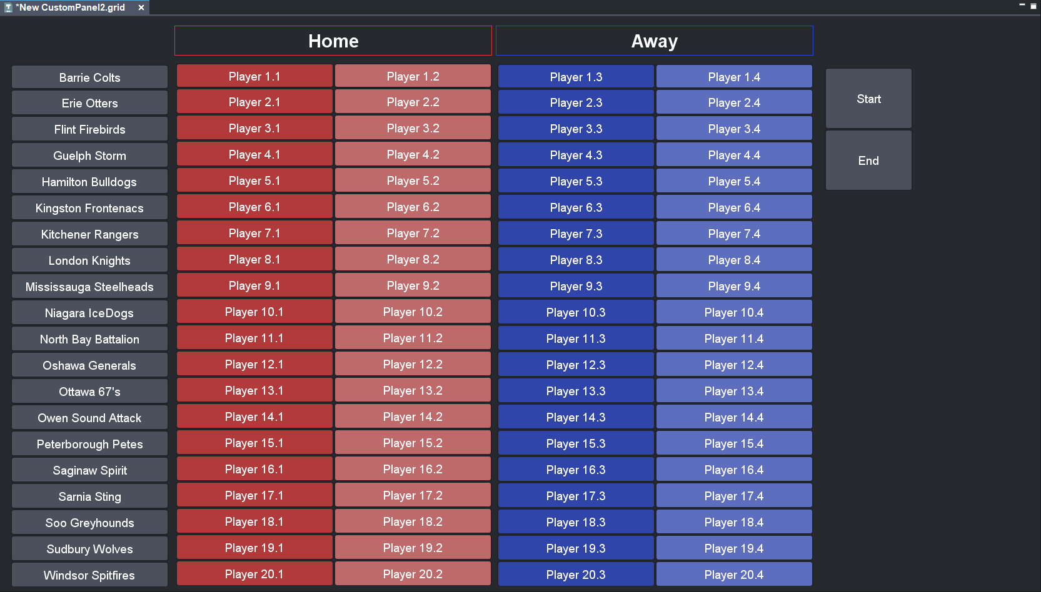

What Is New?
The recent changes that have been made to this dashboard are the inclusion or the start/end buttons as well as drop down features on each button for selected goalies. The addition of the start and end buttons are what will begin and terminate the actual display features to Xpression, once the player selection has been made. It will allow the user to directly dictate the run time without having to choose a set duration for how long it will be displayed. It was chosen that this was a better design than run time, because typically goalie matchups are displayed right before the play starts. If the play was to start a little early or a little late, the goalie matchup would cover the screen for the correct amount of time the viewers are waiting. The dropdown feature was also chosen to be added to the goalie selection button because it will more easily allow for changes between goalies to be made depending on who may be playing that day. Many teams in the OHL have a number of goalies exceeding 2, therefore the dropdown buttons can allow for each team to have all of their goalies be options.

Prototype Test Results:

 | Task: Switch between two goalies on one button  Goal: 5 seconds | Task: Start/End the duration of the Dashboard  Goal: 3 seconds | Task: Combine that actions to (in theory) display the end product  Goal: 15 seconds
Person 1 | 2.6 seconds | 2.4 seconds | 11.3 seconds
Person 2 | 4.7 seconds | 3.5 seconds | 12.8 seconds
Person 3 | 3.0 seconds | 2.3 seconds | 13.5 seconds

Analysis:
The overall consensus for this Dashboard is that the main ideas are clear and easy to understand. With very little explanation, the users are able to realize the purpose of each feature and assume what it will do ahead of time. That being said, one of the main critiques about this design remains the ability to choose the goalies. It can be difficult to know exactly where to look for certain teams as the list of options is still very plain looking without clear distinctions between each team.

Test Plan For Prototype 3
For prototype 3, tests similar to the ones for the second prototype will be carried out to test the overall function and usability of the dashboard panels. However, prototype 3 is the final prototype, therefore the goal is for it to be completely finished and ready for use. So, there will likely be more tests carried out for the third prototype. Unlike the first two prototypes, prototype 3 should be designed as a final product, so it should be free from any major design/functional errors. The tests for prototype 3 will be specific and they will ensure that every aspect of the dashboard works as intended. Hopefully, the tests will highlight any flaw there is with the design of the prototype. This way, all problems can be addressed during testing, and subsequently resolved before the design is finalized. The method of testing will be the same for prototype 3, the prototype will be given to users and their use of the dashboard will be analyzed, and they will be asked to provide feedback,

Wrike Gantt Chart
