Deliverable D
CONCEPTUAL DESIGN

Georges el-sabbagh
Student Id: 300160171
Nawaf abdalah
Student Id: 3343698

bashe ahmed
Student Id: 4814856

habil warsame
Student Id: 5687928

christian padrones
Student Id: 300188992

Table of Contents
Table of Figures 3
Abstract 4
1.0 Intro 4
2.0 Conceptual Design 4
2.1 George’s Concept 5
5
5
2.2 Christian Padrones 6
2.3 Bashe Ahmed 7
2.4 Habil Warsame 7
2.5 Nawaf Abdalah 8
3.0 Global Concepts 9
3.1 Simple Concept 9
3.1 complex Concept 11
In App Options 14
4.0 Conclusion 18
5.0 References 18

Table of Figures

Figure 1 APPCYCLE - Log in page 4
Figure 2 APPCYCLE - Configuration page 4
Figure 3 APPCYCLE - Log in and scan page 5
Figure 4 APPCYCLE - Educational Game 6
Figure 5 APPCYCLE - Inquiry Page 6
Figure 6 APPCYCLE - MySchedule 6
Figure 7 APPCYCLE - Accuracy bar and Goals bar 7
Figure 8 APPCYCLE - Sketch of system language settings 8
Figure 9 APPCYCLE - Sketch of Location Services 8
Figure 10 APPCYCLE - Reporting Issues 8
Figure 11 APPCYCLE - App icon 9
Figure 12 Refer to figure 1 9
Figure 13 Refer to figure 2 10
Figure 14 Refer to figure 11 10
Figure 15 Refer to figure 3 11
Figure 16 APPCYCLE - sign-up page 11
Figure 17 APPCYCLE - Setup Page 12
Figure 18 APPCYCLE - Welcome Page 12
Figure 19 APPCYCLE - MySchedule 13
Figure 20 APPCYCLE - Take a Picture 13
Figure 21 APPCYCLE - Where it goes 14
Figure 22 APPCYCLE - Tutorial 14
Figure 23 APPCYCLE - Drop Off 15
Figure 24 APPCYCLE - Inquiry Page 15
Figure 25 APPCYCLE - Global Complex Concept Structure 16

Abstract

The following document provides individual conceptual designs from all group members based on past deliverables and the problem statement. The designs are combined to create two global concepts. The conclusion will determine which global concept is best suited for this project.

Intro
In this deliverable, we have come up with five individual conceptual designs. Each member wrote a conceptual design based on past deliverables, mainly deliverable C with the design criteria. The conceptual designs were agreed to be listed without judgment of the group and collectively used for two global concepts. We decided to have simple and complex approach to our global concepts.

Conceptual Design

2.1 George's Concept

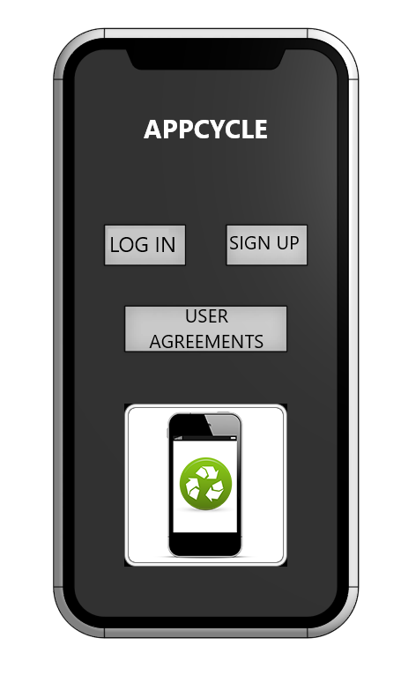  Figure 1 APPCYCLE - Log in page | 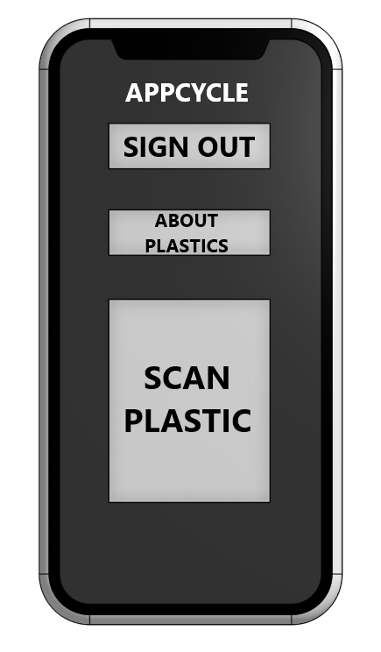  Figure 2 APPCYCLE - Configuration page

- User Friendly | The design illustrated above Is simple and not cluttered with excessive amounts of buttons, making it very user-friendly. Large buttons are also used to demonstrate large text. The colors are not too bright, making it easy on the eyes.
- Configuration | The App only consists of two screens, providing a simple configuration. This includes the first page where a log-in or sign-up option is available before accessing the App. There is also a User Agreements tab to ensure users have accepted our agreements.  On the second page, once logged in, you will see three options. The first is the "SIGN OUT" option, which simply signs the user out of his account. The second is the "ABOUT PLASTICS," which educates the user on recycling. Lastly is the "SCAN PLASTIC" by the simple push of a button, the user will be prompt to his camera to scan the barcode on the plastic product.
- Education | Under the "ABOUT PLASTICS" tab, the user will be educated on many different recyclable plastics facts. For example, information about the plastics numbers and their meaning are listed. This is usually the triangle with the number inside of it.

2.2 Christian Padrones
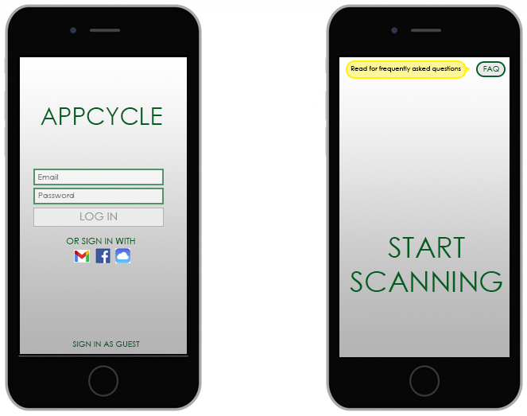
Figure 3 APPCYCLE - Log in and scan page

- User Friendly | To ensure the consumer is not overwhelmed by a chaotic design, the App's overall theme/design should be as simplistic as possible. Using complementary colors instead of contrasting colors can help the user navigate the App easier. Also, by using fewer buttons, the user can quickly scan the item without going through multiple steps. It is best to have a design where the user can quickly scan the desired item for correct bin sorting.
- App Startup | The user will be able to login with a created account or sign in using an existing Google, Facebook, iCloud, etc., account. Although there will also be an option to sign up as a guest. The guest option is to also provide quick access to scan their item.
- Question Section | The App will also include a Frequently Asked Questions section. There will be a small notification that prompts the user where the FAQ section is located on the first startup by a new user. This can help the user understand the basics of our App, and get general questions answered immediately.

2.3 Bashe Ahmed

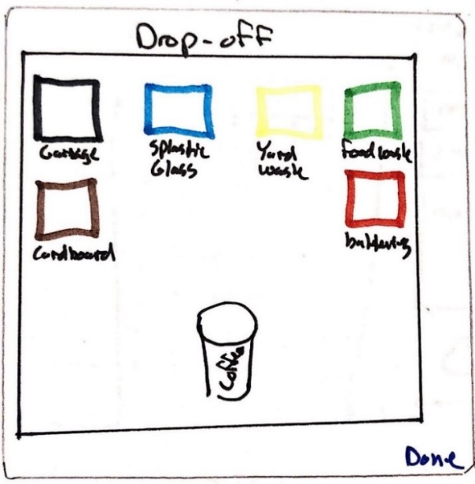  Figure 4 APPCYCLE - Educational Game | 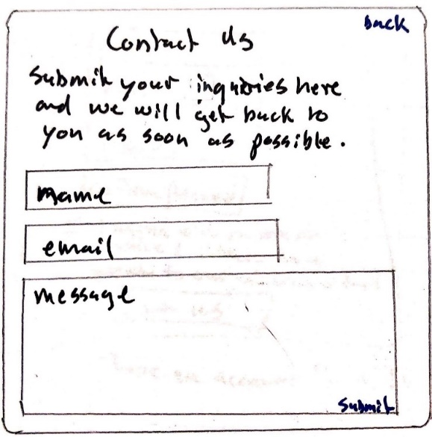  Figure 5 APPCYCLE - Inquiry Page | 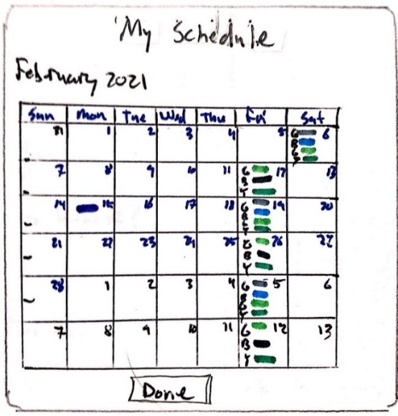  Figure 6 APPCYCLE - MySchedule

- Educational Games | The Education page is an interactive educational game. The player drags and places different recyclable items into the correct bin.
- Inquiry Page | The Inquiry page gives our users a place to reach us and ask the question.
- Schedule | The schedule page gives our users a calendar view of all upcoming collection days, as well as what items are being recycled

2.4 Habil Warsame

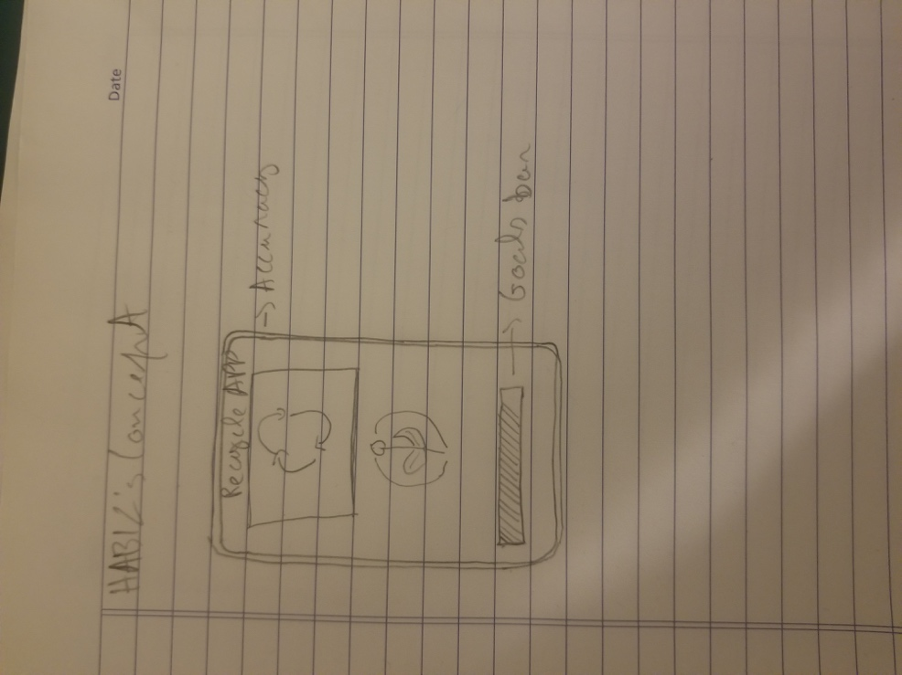
Figure 7 APPCYCLE - Accuracy bar and Goals bar
- User friendly | Our App doesn't have login information, so all the user has to do is open the App to use it. You can increase or decreases the font size
- Goals | The bar at the bottom of the App lets you know how much of your item got recycle, and if there is an unrecyclable item, it shows you the percentage of it.
- Accuracy | At the top of the App, a window pops out and shows us an illustration of the item. The item is scanned it analyzes how much of that item can be recyclable in percentage.

2.5 Nawaf Abdalah

Figure 8 APPCYCLE - Sketch of system language settings | Figure 9 APPCYCLE - Sketch of Location Services | Figure 10 APPCYCLE - Reporting Issues

- Compatibility | The central aspect of this App to be functionally accessible to any platform. Using Android or Macontaish, whichever preferably accept by our consumers. The App will be available in the App store and play store. Also adding the feature of multiple languages to be more accessible to our consumers. The App will have a tap on the setting to pick the preferred language.
- Location | Initially, the App will be covering the Ottawa region. This feature will be activated via using the device GPS by turning on the location Tap. This will allow the App to detect the consumer location.
- Performance | A back-end system will be installed to provide us both consumer's feedback and any App's defects.

Global Concepts

3.1 Simple Concept

The App is first launched from your smartphones home screen by clicking the icon below.
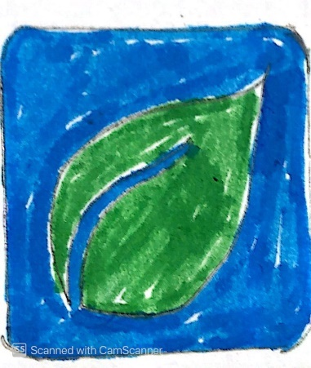
Figure 11 APPCYCLE - App icon
Once launched, that App will ask you to sign in. If you don't have an account, there will be an option to sign up on the bottom left-hand side. There is also an option in case you have forgotten your password. As for the signup, you are only required to provide your name, email, and password and an agreement with our user policies.
Figure 12 Refer to figure 1
Once in the main page of the App you will be able to either scan or click on the "about plastics" tab, as seen below. The scan tab will simply allow the user to scan the bar code provided on the plastics. Once scanned, the App will prompt you to an info page informing if the material or product is recyclable. In the "about plastics" tab, the user will be shortly informed on the triangle numbering method generally found on plastics, followed by some interesting recycling facts.
Figure 13 Refer to figure 2

3.1 complex Concept

Like the simple concept, the App is first launched from your smartphone home screen by clicking the icon below.
Figure 14 Refer to figure 11
Also, like the simple concept, the App will ask you to sign in. If you don't have an account, there will be an option to sign up on the bottom left-hand side. There is also an option in case you have forgotten your password. As for the sign up, you are only required to provide your name, email, and password and an agreement with our user policies.
Figure 15 Refer to figure 3
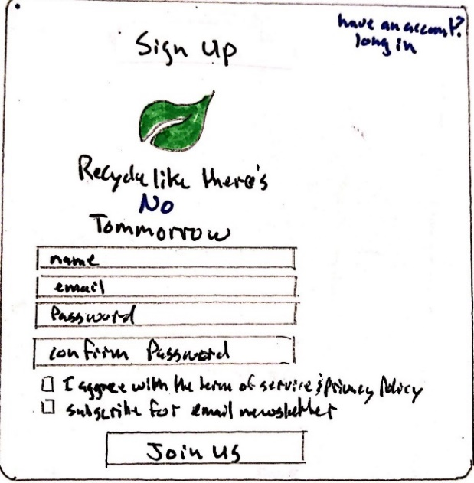
Figure 16 APPCYCLE - sign-up page

After creating an account, you are then prompted to a setup page to enter in preferences, as seen in the figures below. The location will be used to identify local standards for recycling. The ocmmunications tab will allow the user to choose his preference for the app interface.
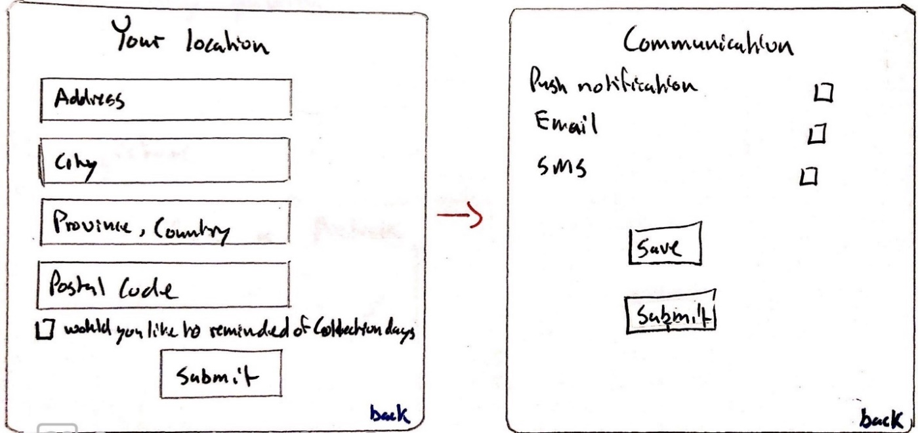
Figure 17 APPCYCLE - Setup Page
Following the setup, you will finally have access to a wide range of options such as; My schedule, Take a Picture (scan), What Goes Where, Tutorial, Games, and Inquiry.
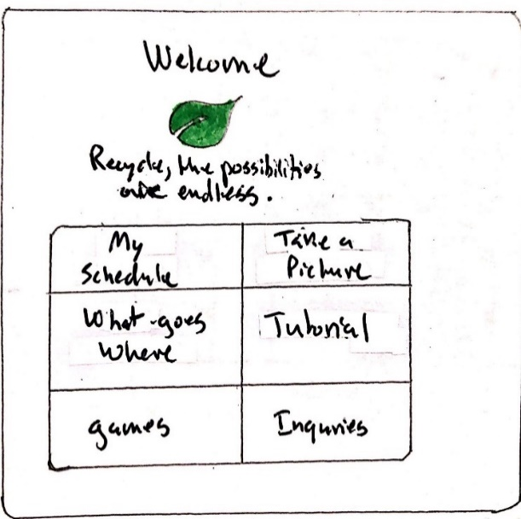
Figure 18 APPCYCLE - Welcome Page

In App Options
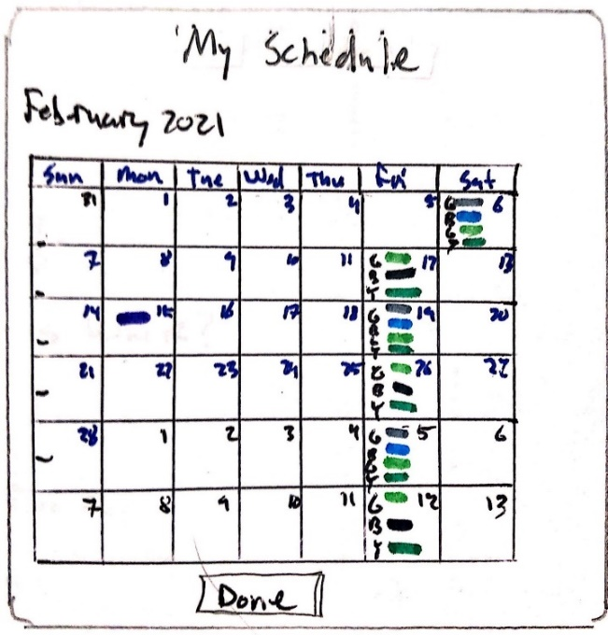  Figure 19 APPCYCLE - MySchedule | The schedule page gives our users a calendar view of all upcoming collection days and what items are being recycled.
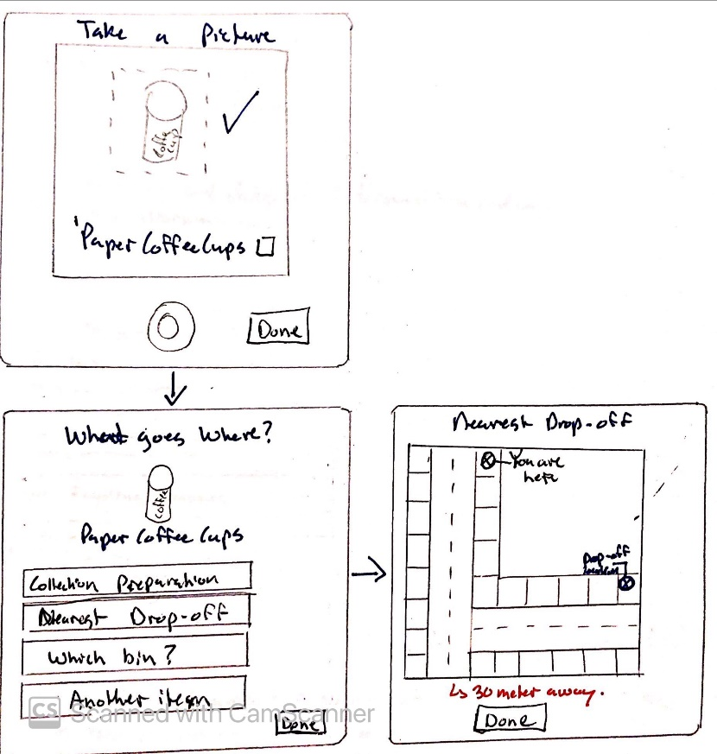  Figure 20 APPCYCLE - Take a Picture | The take a picture give the user the option to take a picture of the items they are unsure of how to recycle. The App provides the user with instruction on how to prepare, how to recycle, and where to dispose of the item.
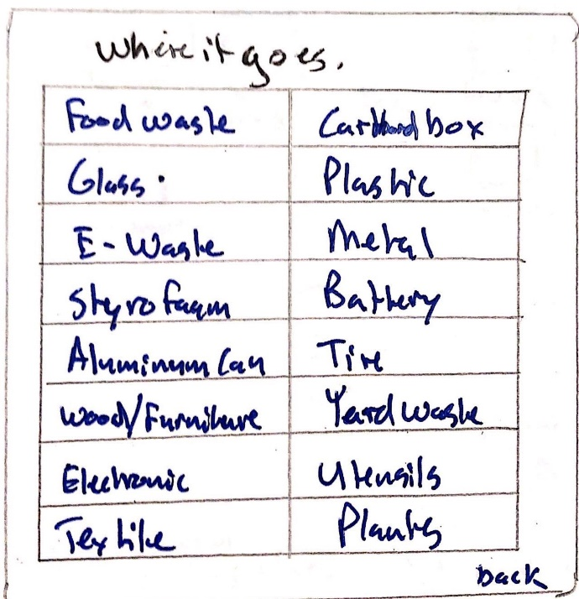  Figure 21 APPCYCLE - Where it goes | The "Where it goes" page users the collection preparation, drop-off and any other pertinent information for any recyclable items.
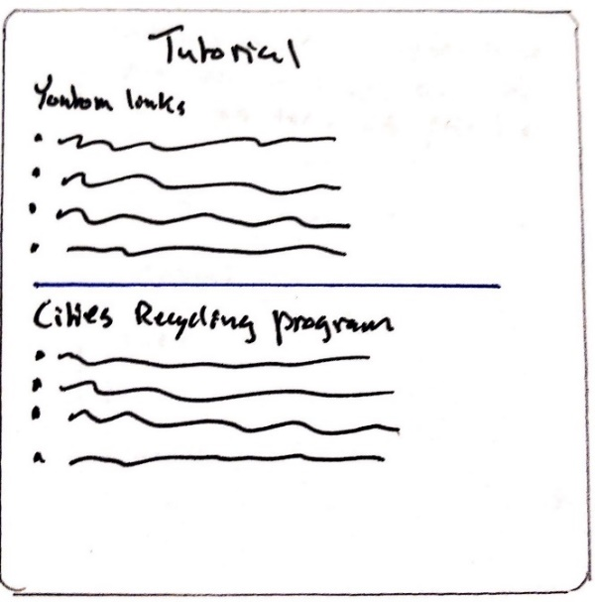  Figure 22 APPCYCLE - Tutorial | The Tutorial page provides links to YouTube for informative video tutorials to explain recycling and government website for specific requirements for your location.
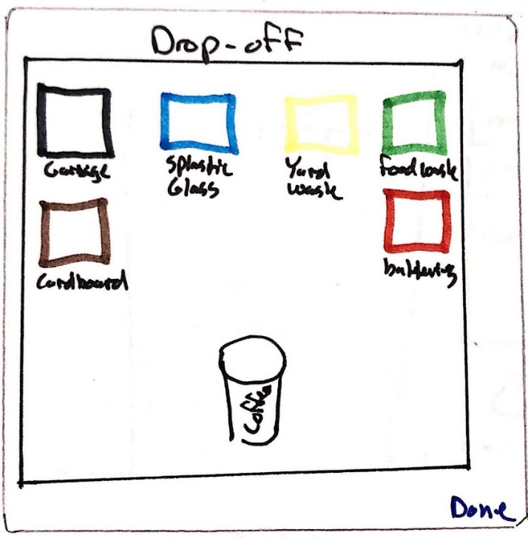  Figure 23 APPCYCLE - Drop Off | The Education page is an interactive educational game. The player drags and places different recyclable items into the correct bin.
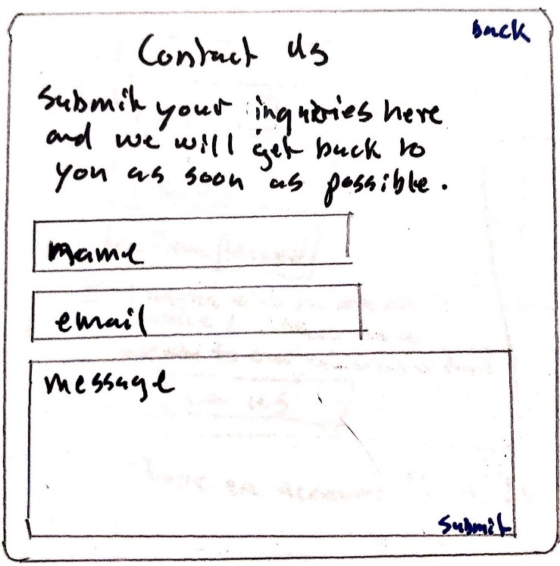  Figure 24 APPCYCLE - Inquiry Page | The Inquiry page gives our users a place to reach us and ask a question.

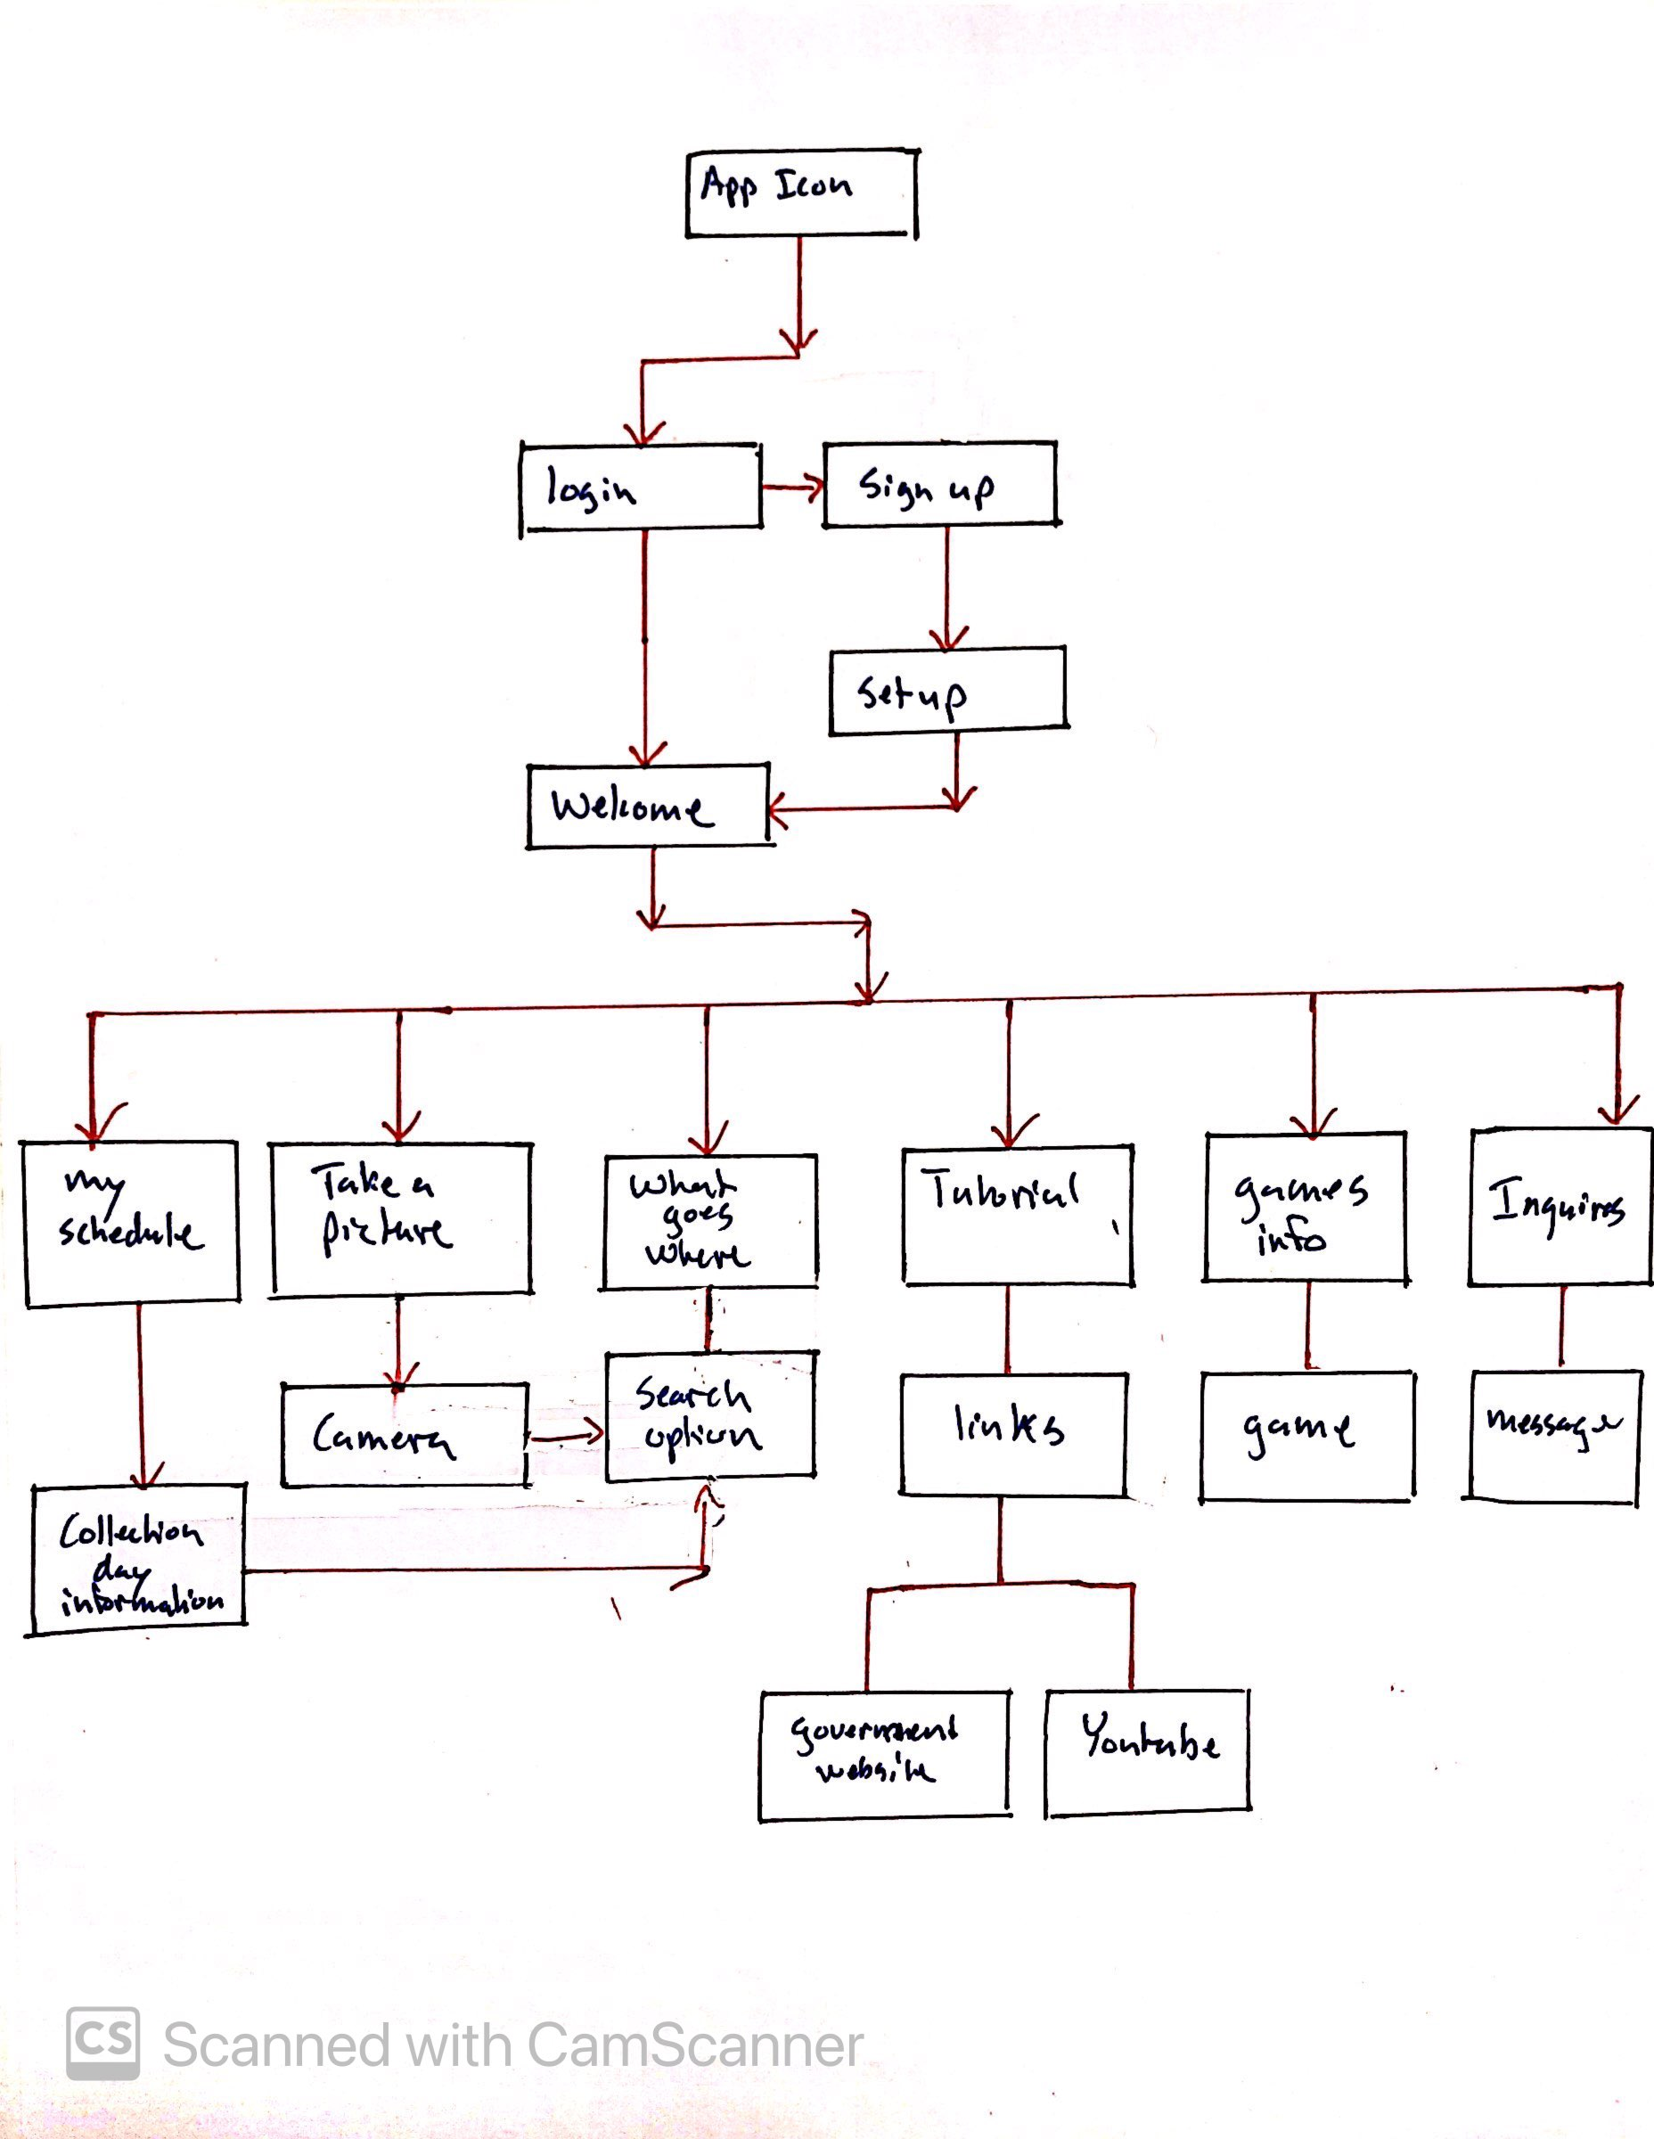
Figure 25 APPCYCLE - Global Complex Concept Structure

Conclusion

After carefully examining all data, we decided to use the simple concept. This is our first app for recycling, and we won't capture the most people in a specific demographic. Anytime you make an app complex with a multilayer step, you lose the older generation since some are technically challenged, and others are outright Luddites. While some studies have shown that the older generations are more predisposed to recycling, it hasn't always led to definite results. That's why we decide on making our app a simple one to deliver a minimum practical product for our first App. Subsequently, when people get use to the simple app, we can add more viable options by targeting keys demographics with a variant version of the app.

References

No references were used in this deliverable.

