Business Model Canvas. What’s Your Business:_____Accessibility Design Company_________________________________
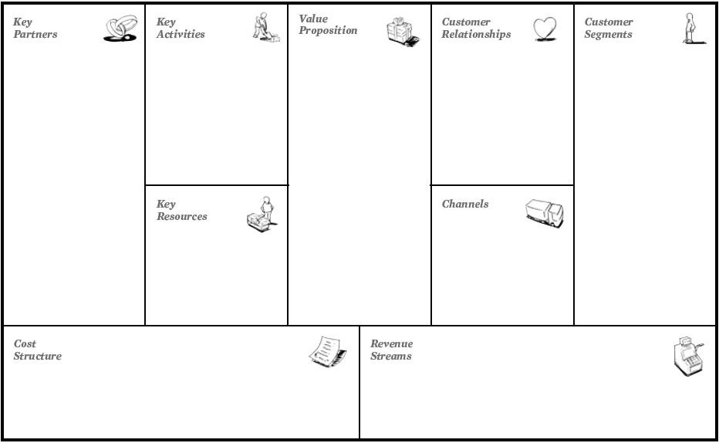
Hospitals

People that suffer from disabilities.

Online and in person meetings.
PCB Design
Software Design
3D Modelling

Sales and licensing of products
Warranty
Marketing
Staff
Manufactures
Reach customers through networking sites.
Build relationships with hospitals.
Accessibility electronics platform
Design and manufacture a product for people suffering from disabilities.
Reach the target demographic.

Plastic Manufactures

Electronics Provider

PCB Manufacture

