Project Deliverable C: Feasibility Study

GNG 2101
Oct.1st, 2020
Group B33

Uncertainties, Risk Assessment, and Feasibility Study [C3]
- Although this project has many aspirations for surpassing expectations, there are various challenges on the way of development. These include:
  - Integration of camera/sensor - Feeding the images captured on camera to an AI description app and then representing the text for the software to read aloud provides software problems (at the current level our group is at, it might not be possible to include this feature)
  - Navigating around crowds of people - A big issue is how the camera and software will identify people instead of inanimate objects, and how to deal with crowds of people and lineups.
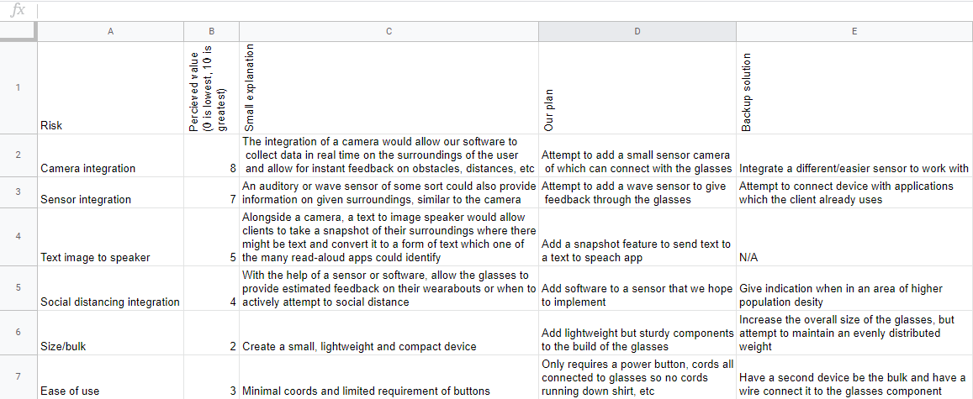
  - Arrangement of electronic components on glasses - Considering the electronic components of this project will contain a camera, bluetooth, and a battery, it’ll be difficult to arrange these in a way that completely eliminates all of the bulkiness, but we’ll attempt to maximize the cleanliness and lightweight capabilities by choosing to use certain materials, and upgrading components to be smaller.

- Our selected accessible smart glasses concept is mostly feasible with a few caveats. We may lack the ability to deliver on a product that is capable of navigation and collision avoidance purely via imagery. However it is feasible to produce a relatively simple aid that can direct the wearer and warn them whether there is anything in their path using vibrational motors on either side of the eyewear arms and the option to switch to bone conduction voice directions. Including both of these hardware components may risk exceeding our $100 budget. Our TEFOS evaluation is as follows:
  - Technical - This concept is technologically possible as a close range obstacle avoidance device and a hardware accessory to pair with existing navigational systems such as Google Maps.
  - Economical - The hardware components will be the largest expense of this project and we need to omit features to meet the $100 budget.
  - Legal - Given that this is a student development project with very restrictive deadlines and budget constraints, this device would be an experimental prototype and the user should treat it as a supplementary navigation aid.
  - Operational - We are confident that the Minimum Viable Product will have operational capabilities that meet the client’s expectations.
  - Scheduling - We plan to produce an experimental prototype before our 3rd and final client meeting and a final operational device presented at design day.

