MUSIC4ALL
CanStrum and CanChord User Manual

Updated: November 27, 2018

CanStrum CS-1-1 User Guide

Please note...
CanStrum is still in the beta-testing stage of development. If any bugs or system failures occur, please contact our quality assurance department at 1-519-379-4870 (note that this is not a toll-free number).

Setup

First Step - Advanced Setup
Disclaimer: As this is the more technical component of the setup, it is advisable to have a Music4All technician perform this stage of setup.

CanStrum comes with software for your computer. To install this software on an Apple computer, enter the following three commands in the terminal:
- sudo mkdir /var/lock
- sudo chmod 777 /var/lock
- sudo cp lib/librxtxSerial.jnilib /System/Library/Java/Extensions/
  - (from mus-x directory)
Now the software will be able to communicate with the CanStrum device.
Support for Linux and Windows devices is in development.

Standard Setup
With the advanced step completed, we can start connecting and calibrating your CanStrum device.

Your CanStrum device should come pre-soldered to a microcontroller board. In the bag will be the timing belt (item number 122), two-screw belt attachment (item number 111), two small screws (M3 size, item number 126) and 8 command strips (item number 118).

Attaching the timing belt
- Remove the belt from the package (122), and ensure there is no break in the belt.
- Place the belt onto the shining stainless steel gears ensuring that the teeth of the belt face into the gear so that the gear may drive the belt around.
- Take the two-screw belt attachment (111) and run the two small M3 screws (126) through the two holes both from the same side.
- Place the two-screw belt attachment into place on the pick holder (which is the plastic component that slides on the two shafts). Ensuring that the timing belt is located between the two screws, fasten them into their holes until the belt is not able to move independently of the pick holder.

Mounting CanStrum onto the guitar
- Place the device onto the guitar with the belt side of the device towards the neck of the guitar. The belt should lie approximately where a guitarist would run the pick across the strings.
- For each pair of command strips, attach velcro sides together. Peel off the protective film on one side of each command strip pair, and stick two pairs on either of the device’s bases.
- Peel remaining films off of the command strip pairs, and stick the device onto the guitar in the same position as in step 1.
- Give the command strips adhesives 5-10min to set.
- Now the device is mounted. The device may be removed by pulling the top tab of each command strip to separate the velcro pairs. This allows a user to play the guitar without CanStrum. To reattach the device, line up the velcro pairs and press the device onto the guitar using the bases for leverage. With the velcro connected once more, the device is mounted and ready to go!

Connecting the device to your computer
- With the included usb cable, attach one end of the chord to your computer and the other to the corresponding input on the UNO board.
- With the included power cable, attach the two prongs to a wall socket and the other end to the UNO board in the corresponding input.

How to operate CanStrum
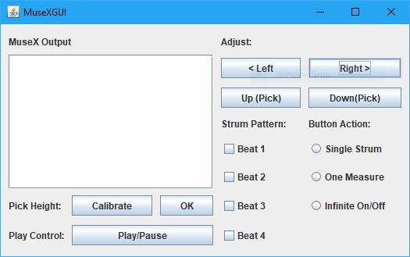
Open CanStrum.jar to begin. A window will appear in your desktop similar to the one pictured below. A description of each button is included below.

CanChord CC-1-1 User Guide

Please note...
CanChord requires 3D printed components. For assistance with 3D printing please refer to the user manual for your printer.

Setup

Standard Setup
The CanChord device comes with 3 3D printable files, 10 3mm diameter springs, 10 gel pads, and 2 3m fasteners and nuts. You will need: a 3D printer and accompanying slicing software, filament (standard PLA is recommended), and hot glue.

Printing the components
- Open and print 1 CCright and 1 CCleft component. Allow to cool and remove all support structures generated by the slicing program.
- Open and print 10 CCbutton components. Allow to cool.
- Test the print quality by attempting to join the interlocking clips on the top and bottom of CCright and CCleft together. If they do not interlock check your print settings for consistency between prints and repeat printing until a set of right and left components interlock appropriately.

Assembling the components
- Glue a gel pad to the narrow end of each spring and allow to cool.
- Determine the chord arrangement desired referring to the included chord diagram or to a guitar chord chart.
- Disconnect the right and left components and slide the springs through the holes in the components to match the desired chord configuration. The gel pad should be on the inside of the components.
- Push the springs up so that the gel pad rests against the top of the components and the spring sticks up from the top of the components.
- Glue a button to the top of each spring and allow to cool.

Mounting CanChord onto the guitar
- Push the buttons up such that the gel pads rest against the top of the right and left components.
- Slide the right and left components on to either side of the guitar neck at the top and clip the right and left components together
- Align the buttons with the frets and add additional gel pads to the inside of the components to ensure a snug fit careful not to have the gel pads interfear with the strings.

How to operate CanCan
- Simply press the buttons which correspond with the chord you wish to play!

