Project Deliverable E: Project Plan and Cost Estimate
GNG 1103C – Engineering Design
Faculty of Engineering – University of Ottawa

Completed by Group C11:

Cédric Bohémier - 300081078
Alyssa Gomez – 300322778
Lilia Lahssaini-Benhima – 300286444

Table of Contents
Introduction 3
Concept Explanation 3
Detailed Design Drawing 4
Bill of Material 4
Project Risk and contingency plans 6
Risk 1: Time constraint to finish on time. 6
Risk 2: Development problems in the prototyping 6
Risk 3: Extensive testing 6
Prototype Test Plan 7
Conclusion 8
Wrike Snapshot: 8

Introduction
In the previous deliverable D, we identified 3 possible scenarios that would satisfy our client’s needs, which is to support the ban against killer robots. After presenting the option chosen during our first individual meeting with Mines Action Canada, we developed a different idea focusing on the use of ID pins to convey the detrimental effect killer robots would have on society. In this deliverable, we expand on our original design into a detailed concept explanation and drawing, provide a list of equipment and bill of materials to estimate the cost of the project. We also discuss the risks associated with the creation of our project and the contingency plans placed to minimize those risks. Finally, a prototype test plan is included to organize the next steps taken in the development of the VR simulation.

Concept Explanation
Our second client meeting's purpose was to present the two most promising concepts. The feedback received from the clients then served to help distill down to a final concept. The first idea was the one we developed in deliverable D. Namely, a VR experience that would contrast how things would change from a “regular” warzone to a world were killer robots are legal in a state of war. However, within a single minute there is a risk that it is too much information to digest to the user, and the message might be unclear. Another touchy subject we would have had to deal with was how are we – university students in our twenties – in anyway qualified to highlight how killer robots would change war. There is a serious risk of us mis-representing this very real-world problem in a way that would be cliché, diluting or outright discrediting our pitch. Further, if a VR experience has many different things the user can focus on, this will lead to different people coming out with different takeaways. Of course, because within a single minute they may not have focused on the same elements of the simulation. The purpose of the product should give as close to a homogenous experience to everyone to amplify effectiveness.
Our second proposition was to pick a single way people would adapt to killer robots. The strength of this approach is it makes the message much more coherent to the user. We chose a simple idea that intuitively feels like a very logical societal decision: giving citizens identification badges that can be read by robots. We expanded on the idea and proposed to the clients to explore a satirical approach. We propose a world where Autonomous Killer Robots (AKR) are deployed, and the only way for citizens to be protected against their own country's AKR is to always have the badge clearly showing. Because of this, companies have started advertising products to enhance the readability of the badges. These take the form of cleaning products, LED strips around the badges, magnifying glasses that can be installed in front, etc.
The VR experience would therefore present to the user an alley way that the user has to navigate. To guide the user, they will be instructed to get to the end of the alley way to get a coffee or a drink from a vending machine. On the way there, they are exposed to both visual and auditory media. Posters are plastered on the walls – excessively- advertising products that promise to ensure your badge being readable. Government issued messages are played on a loudspeaker system, instructing you to always wear your badge, ensuring the user understands what is at play.

Detailed Design Drawing
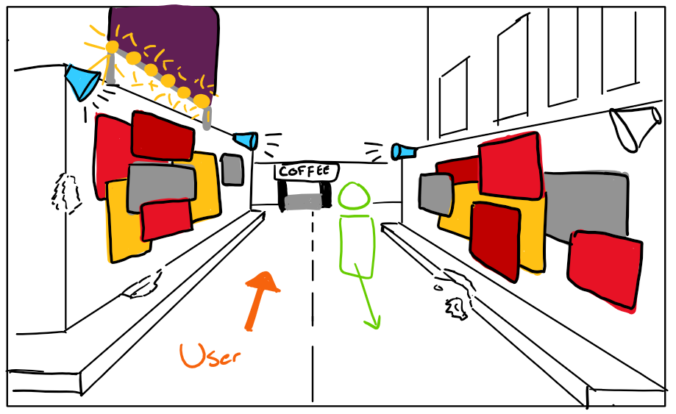

Bill of Material
List of Equipment categorized by type:
Type of equipment | Equipment
Hardware | - Oculus VR headset  - Computer/ laptop
Software | - Unity  - Blender (for backgrounds)  - Visual Studio
Background Assets | - NPC city characters  - Billboards  - Buildings  - City landscape  - Vending machines  - ID pins
Animations | - Character movements
Audios | - Radio broadcast  - Car sounds (honks)

List of all materials that will be used and their associated costs:
Item number | Item description | URL/Source | Quantity | Unit Price
1 | Oculus VR Set | Oculus Rift - Windows VR Headset : Amazon.ca: Video Games | 1 | N/A
2 | Computer/Laptop |  | 1 | N/A
3 | Unity | Unity Real-Time Development Platform | 3D, 2D, VR & AR Engine | 1 | 0$
4 | Blender | 3.0 — blender.org | 1 | 0$
5 | Visual Studio | Visual Studio Code - Code Editing. Redefined | 1 | N/A
6 | NPC city characters | Toon City People | Characters | Unity Asset Store | 5 | 23$
7 | City landscape |  | 1
8 | Buildings | Building Apartment | 3D Environments | Unity Asset Store | 3 | 0$
9 | Billboards |  | 7 | N/A
10 | Vending machines | Vending Machines / 42+ Assets | 3D Props | Unity Asset Store | 3 | 15$
11 | Character movements | Everyday Motion Pack Free | 3D Animations | Unity Asset Store; Walking Motions Pack 1 | 3D Animations | Unity Asset Store | 3 | 10$
12 | Car sounds | Vehicle - Essentials | Transportation Sound FX | Unity Asset Store; Free General Ambience Sounds | Urban Ambient | Unity Asset Store | 1 | 0$
13 | Radio broadcast |  | 1 | N/A
14 | ID pins |  | 5 | N/A
 |  |  | Total: | 48$

Project Risk and contingency plans

Risk 1: Time constraint to finish on time.
There is a significant risk associated with the time constraints for completing the project on time. It will be a challenge to meet all the specified criteria and implement all our desired components into the VR experience. As of now, there is only one month remaining to create the final project, until the scheduled design day.
To minimize this risk, we will make sure we divide the tasks of our project equally to optimize the efficiency of the team. We will set a clear deadline for each task to be finished and review and reassess as needed during each team meeting, held on Monday. That way, we will be able to follow the progression of our project closely and make sure to finish our project before design day. Also, we will prioritize the creation of the essential components of our project, such as the city landscape where the VR environment is set and the ID pins, the concept our message revolves around. Working on these critical elements will ensure that a minimum viable product will be ready to present for design day.

Risk 2: Development problems in the prototyping
Furthermore, there is a concerning risk of encountering development issues as we are prototyping our VR project. Our team does not have prior experience working in VR and several aspects may be harder to develop, such as coding for scripts and animations. Because of that, there is a possibility that we’ll find some of our project ideas more challenging to implement due to technical difficulties. It's important to account for the time required to troubleshoot technical issues and resolve any unforeseen complications.
To address this risk, our team will invest time to develop our VR skills outside of the resources provided by the course, such as tutorials online, web forums and other relevant resources found. It will help us become more proficient in VR development and improve the quality of our project. We will also dedicate ourselves to the project timeline for testing our prototypes. This will help us identify and address technical bugs early and fix them to rectify the problems as we go through our development process.

Risk 3: Extensive testing
There is a slight risk regarding the testing phase of the VR project. To make sure we deliver a high-quality VR simulation, extensive testing and quality assurance will be performed, since they are vital to confirm we have reached our design criteria. However, this phase could be time-consuming, depending on the number of developing issues that arise. As we add elements to our simulation, continuous verification and refinement of the code would be necessary to make the user experience seamless.
To address this risk effectively, we will establish a clear stopping criteria and our accepted level of fidelity to restrict the number of tests that will have to be conducted for us to be satisfied with the quality of our product. We will also look for potential user feedback to have a better understanding of the quality of the VR simulation. It will help us identify issues and provide insights on the areas we need to focus on during the later stages of development.

Prototype Test Plan

Test ID | Test Objective  (Why) | Description of Prototype Used & of Basic Test Method  (What) | Description of Results to be Recorded and how these results will be used  (How) | Estimated Test duration and planned start date  (When)
1 | To show the risks of killer robots | Prototype one and two will be used. The test will be to see if our project met the client’s needs. | We will record the results by seeing whether it was achieved or not. The results will be used by reviewing the user meeting notes. | The test will span over both prototypes. This will grant us the opportunity to make sure that we stay on the path and follow the client's needs.
2 | To allow the users the chance to experience this environment | The second prototype will be used. The test will be that the user is able to see everything in the environment clearly. | We will record the results by seeing if this was achieved or not. The results will be used to see if any changes must be made to the coding. | This will be done during the second prototype because prototype one will allow us to work on specific details. So that in prototype two we can make sure everything is working smoothly.
3 | To demonstrate the clarity of ID pins | The first prototype will be used and will feature the landscape with at least 2 NPC characters implemented with ID pins on. The test will be that the ID pins are clearly visible and distinct on the character as the user walks around | We will record the results by noting if this was achieved or not. We will also join a snapshot of the ID pins along with the results, as it is a visual test. | We will start this in the first phase of our prototype, as it is the main element used to demonstrate our message. It will be done repeatedly throughout the development of the first and second prototype and should last 15 seconds because it would simulate the duration our user would spend looking at the ID pin.
4 | To verify that the NPC characters move accordingly | The second prototype will be used and will feature the landscape and all NPC characters. The test that we run will highlight any troubleshooting issues or bugs in the code. | The results will be flagged in the Visual Studio code and will be copy pasted in a separate document. These results will be used to understand where our issues are so that they can be fixed. | This will be done during the second phase of our prototype to make sure all additional characters run smoothly in the simulation. We will run this test for the duration of our simulation, which is 1min and we will perform it multiple times during the development period of the second prototype.
5 | To see if the user can walk around in the environment | The second prototype will be used and will feature all the finalized aspects. The test preformed will allow us to see if any coding must be changed or fixed. | The results recorded will be of snapshots at different angles of the user camera and of the debugged code of the moving camera. These results will be used to demonstrate if the user can observe the environment freely and any changes will be made accordingly. | This test objective will span over the second phase of prototyping. We will need to make and make sure that in the VR world, the user will be capable of moving around using the hand pieces linked to the headset.
6 | To confirm that the radio broadcast and other audios run smoothly | The first prototype will be used to layer audio and a radio broadcasting on top of each other. The test will be used to adjust the sounds so that it is at an appropriate level. | The results will be recorded when the prototype is in game mode. The results will be used to see if further adjustments need to be made. | This will be done throughout the first phase of the prototypes. The test will run to make sure that the overlapping sounds do not clash and work when exported.
7 | To see if the writing on the billboards is legible | We will use the third prototype to complete this test, since all billboards should be placed and finished at that point. The test will be to make sure that the billboards are visible from the users’ perspective. | The results recorded will feature snapshots of the billboards through the user camera on Unity, as well as a description of what is seen on each billboard and how it’s perceived. Our potential users will give us feedback on that aspect and it will be used to improve any element flagged by them. | This will be done throughout the last prototyping phase and should last 15 seconds to make sure the information is clear and legible under a short period of time, since the simulation will last 1min.

Conclusion
The goal of this deliverable was to present the detailed design of our project and to identify the materials we need to buy to realize it. Using the feedback provided by our client, we can start developing our first prototype, which will focus on the general landscape, introducing new characters and sounds to the scene and working on the creation of ID pins. As we move forward into the next deliverable, we will review the testing of our first prototype and keep on developing our final project following the plan outlined.

Wrike Snapshot:
https://www.wrike.com/workspace.htm?acc=4975842#/folder/1228092453/timeline3?viewId=216635005

