Deliverable G – Prototype 2
Client Feedback
1-seeing of the cleaning robot might explain that creating robots is not a good thing because it will effect the mental health of people.
2-seeing the flashback dialogue should be done in such a way that the user should get into the mental state of the actual POV, and therefore it will have to be slowly dragged in conversation that will convince the viewer of triggering flashback. The viewer is not in that state of mind of being traumatized.
3-More has to be put into why the robot is doing what is doing, by explaining what is dragging the robot to do what is doing.

A simple analysis of critical components or systems
Unity is a critical component of this project as it is what we’re using to create the simulation and it is the engine we’re using to run it. This is crucial to the project as otherwise; everything would have to be coded from scratch and drastically increase the difficulty of the project. Microsoft visual studio is a critical component as it is where the team will code scripts that are being applied to our simulation. This will allow the robots and the world to move and will control where the user’s field of vision can go. The assets within unity are important systems to the project as they allow us to fill the world with things such as cars and buildings. The world would be bland without the unity assets.

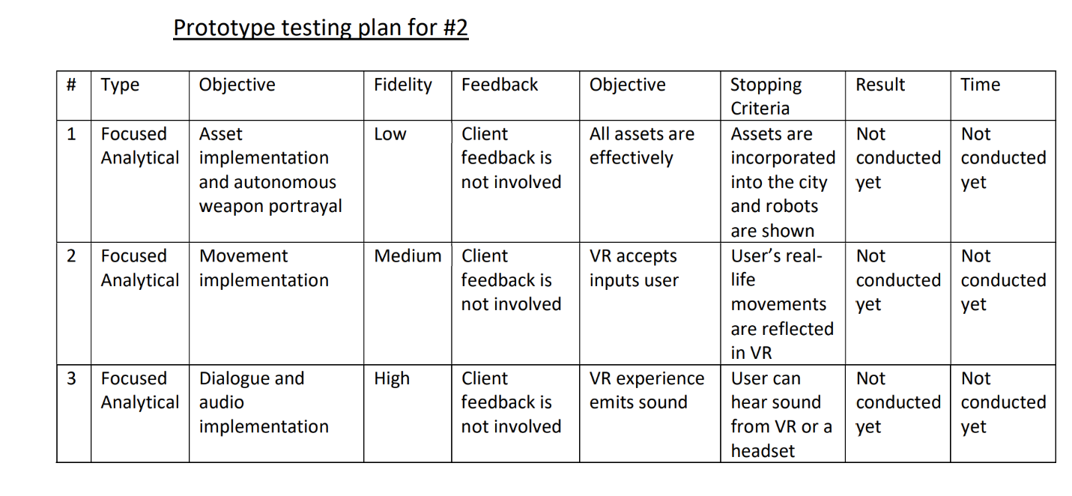

Comments from potential users and client
1) The setting doesn’t look very realistic. Hard to imagine being immersed in the environment.
2) The therapist’s office and flashback idea is interesting, and seeing cleaning robot is a nice touch.
3) The city looks big but I’m not sure how you’re going to have someone explore everything in just 3 minutes.

