GNG 2101
Design Project User and Product Manual

<Group E1.3>

Submitted by:
Noor Al-lafta 300301892
Sara Elmalky, 300333601
Fatma Abdo, 300278634
Ibrahim Ghamlouche, 300331686
Ali Sherry, 300239471
Liana Chu, 300287510

03/04/2024
University of Ottawa

Table of Contents
1 Introduction (Fatma) 1
2 Overview (Sara) 2
2.1 Conventions 3
2.2 Cautions & Warnings 3
3 Getting started (Ibrahim or Ali) 4
8.1 Configuration Considerations 5
8.2 User Access Considerations 5
8.3 Accessing/setting up the System 5
8.4 System Organization & Navigation 6
8.5 Exiting the System 6
9 Using the System (Noor) 7
10 Troubleshooting & Support (Liana) 8
10.1 Special Considerations and Precautions 8
10.2 Error Behaviors 8
10.3 Maintenance 9
10.4 Support 10
11 Product Documentation (Ali or Ibrahim) 10
11.1 <Subsystem 1 of prototype> 11
11.1.1 BOM (Bill of Materials) 11
11.1.2 Equipment list 12
11.1.3 Instructions 12
11.2 Testing & Validation 12
12 Conclusions and Recommendations for Future Work (Fatma) 13
13 Bibliography 14
14 APPENDIX I: Design Files 15
15 APPENDIX II: Other Appendices 16

List of Tables
Table 1. Acronyms vii
Table 2. Glossary vii
Table 3. Referenced Documents 10

Introduction

This User and Product Manual (UPM) provides the information necessary for users that are in need of an accessibility device, specifically ones that use a wheelchair, to effectively use this device and for prototype documentations. This document first states the overview of the overall design and contains cautions and warnings targeted for the usage of the device. It then states a general “procedure” in which it sub-states the set up, the operation and the exit of the device. Further on, configuration and consideration of the device is stated in a manner where it explains the how and where the device should be going. Set up, access, System Organization & Navigation, Exiting the System, Using the System, and additional usage is stated in full details to ensure the user is well educated. Each one of these Sections further breaks down into fine details so that it is all clear. troubleshooting was taken into account in case the user runs into a technical issue. it includes error behaviour, maintenance and support. Lastly, this document documents a section called product documentation. This part breaks down all the components and allows the user to visualize the different components the device is made out of. This ties into the troubleshooting section since it gives a clearer idea of where and how to troubleshoot it.
At the end of this document, an appendix is included with all the different deliverables and presentations of the design.

Overview

The problem of individuals falling and needing assistance to return to their wheelchairs is a significant challenge in healthcare and daily living for people with mobility issues. When someone falls and is unable to get back into their wheelchair without assistance, it can lead to frustration, loss of dignity, and even potential injury if they attempt to move without help. Relying solely on caregivers for assistance with these tasks can be burdensome and may not always be immediately available.

The fundamental needs of the user in this scenario are safety, ease of use, comfort, and portability. Safety is paramount, requiring stability during the lifting process and secure positioning when transitioning back into the wheelchair. The device should be intuitive and straightforward to use, minimizing physical effort for both the individual needing assistance and their caregivers. Comfort is essential, with considerations such as padding and support to minimize discomfort or pressure points during the lifting process. Portability ensures that the device can be easily transported and stored, allowing for use in various environments and situations.

Our device stands out from others in its simplicity, affordability, and versatility, making it accessible to a wide range of users. Designed to cater to many individuals with varying needs, it offers a straightforward solution to the challenge of assisting individuals who have fallen and need help returning to their wheelchairs. Not only can it lift heavy weights safely and effectively, but its intuitive design ensures ease of use for both users and caregivers alike. Moreover, our focus on affordability ensures that this vital assistance is within reach for those who need it most, addressing the problem of accessibility to essential mobility aids. By combining these key aspects – simplicity, affordability, versatility, and robust lifting capacity – our device provides a comprehensive solution that meets the needs of many individuals while offering an effective and economical answer to the challenge at hand.

Our device addresses the critical issue of individuals with disabilities being unable to return to their wheelchairs after falling, a problem that poses significant risks of injury and compromises their independence. With a winch technology that minimizes the need for external assistance, our product promotes user autonomy and enhances overall well-being by reducing fall-related injuries, which can be severe and costly. The device employs an electric winch attached to a pull-up bar, allowing users to be lifted safely with minimal effort. It's designed to be portable and user-friendly, resembling a pull-up bar that can be easily moved and installed in indoor areas. Its user-centered design ensures accessibility for individuals with various disabilities while remaining affordable and intuitive to use. The device's simplicity and effectiveness make it a practical solution for enhancing mobility and safety for wheelchair users.

Cautions & Warnings
Before using the prototype, users should be aware of certain cautions and warnings to ensure their safety and the proper functioning of the device:

1. Weight Limitations: Users should be informed of the maximum weight capacity of the device to prevent overloading, which could lead to malfunction or injury.

2. Proper Installation: Ensure the device is securely installed and anchored according to the provided instructions to prevent accidents or damage.

3. User Training: Users and caregivers should receive proper training on how to operate the device safely to avoid misuse or accidents.

4. Inspection and Maintenance: Regularly inspect the device for any signs of wear or damage and perform maintenance as needed to ensure optimal performance and safety.

5. Remote Control Safety: Users should be cautious when operating the remote control, ensuring it is used responsibly and kept out of reach of children to prevent accidents.

6. Emergency Procedures: Provide clear instructions on what to do in case of emergency, including how to stop the device and safely assist the user.

7. Medical Considerations: Users with specific medical conditions or mobility issues should consult with a healthcare professional before using the device to ensure it is appropriate for their needs.

Regarding waiver use or copy permissions, if the prototype includes any proprietary technology or intellectual property, users may need to obtain permission or sign a waiver before using it. The process for obtaining permissions or waivers would depend on the specific circumstances and agreements involved. Typically, this would involve contacting the owner or developer of the technology and following their guidelines or requirements for use. Users should carefully review any terms of use or licensing agreements associated with the prototype and comply with any necessary procedures to ensure legal and ethical use.

Getting started

Setup:

- Select Suitable Door: Choose a sturdy door with sufficient structural support to hold the pull-up bar and support the weight of the individual being lifted.
- Mount the Pull-Up Bar: Securely attach the pull-up bar to the door frame according to the provided instructions, ensuring it is level and stable.
- Connect the Electric Winch: Attach the electric winch to the pull-up bar using the provided mounting hardware and ensure it is securely fastened.
- Attach Sling to Winch: Connect the sling to the hook of the winch, ensuring it is properly secured and positioned to support the individual.
- Power On the Winch: Plug in the electric winch to a power source and switch it on, ensuring it is ready for operation.

Operation:

- Position Wheelchair: Position the wheelchair beneath the pull-up bar, ensuring it is aligned with the sling attachment point.
- Assist Individual into Sling: The personal aid person assists the individual into the sling, ensuring they are comfortable and properly positioned.
- Activate Winch: The personal aid person operates the winch using the provided controls, lifting the individual off the ground and towards the wheelchair.
- Guide Individual into Wheelchair: As the individual is lifted, the personal aid person guides them into the wheelchair, ensuring a smooth transition.
- Lower Sling: Once the individual is safely seated in the wheelchair, the winch is deactivated, and the sling is carefully lowered to the ground.

Exit:

- Secure the Winch: Switch off the winch and disconnect the power source to ensure safety when not in use.
- Remove Sling: Carefully detach the sling from the winch hook and store it in a safe location.
- Detach Wheelchair: If necessary, detach the wheelchair from the pull-up bar and move it to the desired location.
- Store Equipment: Store the pull-up bar, winch, and any associated equipment in a secure and accessible location until needed again.
- Close Door: Close the door to ensure the safety and security of the space where the system is installed.

Configuration Considerations
Configuration:

Pull-Up Bar: Mounted securely to a door frame, the pull-up bar provides the anchor point for the system.
Electric Winch: Attached to the pull-up bar, the electric winch is the mechanism responsible for lifting individuals.
Sling: Connected to the winch, the sling provides a comfortable and supportive seat for the individual being lifted.
Wheelchair: Positioned beneath the pull-up bar, the wheelchair serves as the destination for the individual after being lifted.

Graphical Depiction:

Image: Pull-Up Bar System Configuration

Alternative Text: A diagram illustrating the configuration of the pull-up bar system with labelled components including the pull-up bar, electric winch, sling, and wheelchair.

User Access Considerations
User groups for the pull-up bar system with an electric winch include individuals with disabilities, personal aid persons, maintenance personnel, administrators, and designers/engineers. Accessibility restrictions vary: individuals with disabilities need upper body strength and communication skills, personal aid persons require training, maintenance personnel need technical knowledge, administrators must understand accessibility regulations, and designers/engineers should prioritize inclusive design.

Accessing/setting up the System
- Select Suitable Door: Choose a sturdy door with sufficient structural support to hold the pull-up bar and support the weight of the individual being lifted.
- Mount the Pull-Up Bar: Securely attach the pull-up bar to the door frame according to the provided instructions, ensuring it is level and stable.
- Connect the Electric Winch: Attach the electric winch to the pull-up bar using the provided mounting hardware and ensure it is securely fastened.
- Attach Sling to Winch: Connect the sling to the hook of the winch, ensuring it is properly secured and positioned to support the individual.
- Power On the Winch: Plug in the electric winch to a power source and switch it on, ensuring it is ready for operation.

System Organization & Navigation
Main Component:
1. Pull-Up Bar: The pull-up bar serves as the central component of the system, providing a sturdy anchor point for mounting the winch and supporting the weight of the individual being lifted.

Accessories or Attachments:
2. Electric Winch: The electric winch is attached to the pull-up bar and serves as the primary lifting mechanism for raising individuals off the ground. It includes features such as a motor, gearbox, and control panel for operating the winch.

3. Sling: The sling is attached to the winch hook and provides a supportive seat for the individual being lifted. It typically consists of adjustable straps and padding for comfort and security during the lifting process.

Connections:
4. Mounting Bracket for Winch: The mounting bracket for the winch is securely attached to the pull-up bar, providing a stable connection point for the winch. It is typically designed to accommodate the weight and dimensions of the winch, ensuring a secure and reliable mounting setup.

5. Electrical Connections: Electrical connections include the power cord of the electric winch, which plugs into a standard 110 V electrical outlet.

6. Attachment Points: Attachment points on the pull-up bar and winch allow for a secure connection of the sling, ensuring it remains in place during lifting and lowering operations. These attachment points may include hooks, loops, or carabiners for easy attachment and adjustment of the sling straps.

7. Control Interface: The control interface on the electric winch allows users to operate the system safely and efficiently. It typically includes buttons or switches for lifting, lowering, and stopping the winch, as well as indicators for power and status.

Exiting the System
1. Lower the sling using the winch controls.
2. Safely transfer the individual out of the sling.
3. Power off and disconnect the electric winch.
4. Detach and store the sling.
5. Secure winch controls if applicable.
6. Remove and store any used wheelchair.
7. Close the door if mounted on a door frame.
8. Inspect and maintain the system.
9. Store all components securely.
10. Document the procedure for future reference.

Using the System
This section provides detailed, step-by-step instructions on how to use the device's various functions and features.

4.1 Setting up the device:
- Attach the pull-up bar winch system: rest the support bar on top of the door frame trim.
- prepare the sling chair: make sure the sling is in its flat position on the floor ready for the fallen person.
- positioning the person: gently place the fallen person on the chair.
- Secure the straps: make sure to secure all the straps on the chair to ensure stability and safety during transportation.
- Attaching the hook: Attach the winch hook to the designated points on the chair.

4.2 Using the winch control:
After the fallen person is situated in place we can use the winch remote control for the lifting process.
- Plug the winch in an electricity plug.
- Lifting the person: Use the buttons on the remote control to initiate the lifting process. The sling will start lifting slowly off the ground. Monitor the operation closely.
- Position the wheelchair: After there is enough distance between the person and the ground roll the wheelchair under the person. Lock the wheelchair in place.
- Lowering the person: once positioned correctly use the remote control to lower the person gently in place.
- Remove the straps: once the person is in their chair safely remove the sling straps and put on the wheelchair straps if applicable.
- The sling chair can be left under the person for easy access.

4.3 Additional usage:

In situations where the fallen person is not close to a door frame the sling can serve an additional purpose. Steps 2-3 can be followed from section 4.1 “setting up the device” then the caregiver can use the chair to pull the person under the door frame.
In case two caregivers are present they can lift the person using the chair sling using the two straps on either sides.

Troubleshooting & Support

Special Considerations and Precautions
When using the lifting device, basic safety precautions should always be followed to reduce the risk of fire, electric shock, and injury, including the following:
- Do not operate the device near flammable or explosive substances.
- Only use the device for purposes stated in the user manual.
- Do not operate the device or have cord in water.
- Unplug device when not in use or when dismounting.
- Keep the device indoors and in a dry environment.
- Do not use or operate the device with third-party attachments or modifications.
- Avoid placing fingers or any body parts into the moving parts of the device.

Error Behaviors
Do not continue the use of the device when it is displaying unusual behaviours. Please consult the Troubleshooting Guide to target problems with the device.
Troubleshooting Guide
SYMPTOM | POSSIBLE CAUSE | SUGGESTED REMEDY
Motor is not turning on | Defective remote control | Replace remote control.
 | Unplugged device | Plug in cable flush against supported plug.
 | Battery Failure | Replace the battery.
 | Defective motor | Replace motor.
Winch is suddenly too slow | Battery is depleted and aged | Replace battery.
 | Unsupported amount of current or voltage | Check plug and source that 120V is supported.  Check if cord connection is secure and flush against the plug.
 | No connection to battery | Check the battery component for corrosion or aging.  Replace battery.
 | Too much friction against cable, worn down cable | Lubricate winch with winch grease and oil. Replace cable.
Winch is only moving in one direction | Defective control box | Repair or replace control box.
 | Cable is tangled or knotted | Untangle and rewire the winch cable.
Door attachment (pull-up bar) is loose | Disengaged or loose screws | Tighten screws
 | Excessive load on pull-up bar and screws | Check for damage on attachment and screws. Replace screws or pull-up bar attachment.

Maintenance
Follow these instructions to correctly and safely care for your lifting device. Please remember:
- Keep the device indoors and in a dry environment.
- Always unplug the device before dismounting, cleaning, or disassembling.
- Do not get water into the motor of the winch attachment.
- Always keep fingers out of moving parts and the motor housing area during maintenance.
- Use a damp cloth with water and soap to wipe away dust and dirt. Do not use any flammable cleaning solution.
- Lubricate the winch with winch grease and oil when the smoothness of the lift has decreased. The condition of the cables should be checked periodically.
- Do monthly checks on the clutch action, tightness of screws & bolts, and electrical connections. Ensure that the winch is fully engaging and disengaging. Inspect the device parts for damage, degradation, and excessive wear if the winch does not fully engage and disengage. Replace parts as needed.
- Consult the Troubleshooting Guide if the device is performing unusually.

Support
[Due to the inability of current team members working on this device to give technical support in the future, this was written as if we are a company.]
If the Troubleshooting Guide does not successfully diagnose a problem with the device, we recommend seeking assistance from a qualified professional, repair center, or contacting our technical support team. Please refer to the contact information found on our webpage.
Please consult the FAQ on our webpage for answers to commonly asked questions and any additional information before contacting our representative team. The representative team is able to provide assistance on specific queries, troubleshooting assistance for technical problems encountered using the device, and any other related concerns.
For email contact: Please clearly state your device model, the detailed description of the problems encountered and under what circumstances or situations the problems occur. A technical support representative will work with you to provide troubleshooting assistance remotely within 24 hours.
For phone contact: The representative team is available from 10AM to 5PM on weekdays. Please clearly state your device model, the detailed description of the problems encountered, under what circumstances or situations the problems occur and your contact information through voicemail. A technical support representative will work with you to provide troubleshooting assistance remotely within an hour of the initial call with a call back.

Product Documentation

<Subsystem 1 of prototype>

BOM (Bill of Materials)
 | Link | Price (CAD)
Pull-up bar | https://www.amazon.ca/dp/B00IDAPK5E?ref=ppx_pop_mob_ap_share | 29.97+tax
Electric Hoist | https://www.amazon.ca/dp/B07T3KWJWK?ref_=cm_sw_r_apin_dp_7VNGRN4QTP4VB6W131MN&language=en-CA&th=1 | 149.99+tax
Sling | https://www.amazon.ca/dp/B072KGY3NV?starsLeft=1&ref_=cm_sw_r_apan_dp_9VER7QR3DM01KZR1VFJN | 61.58+tax
Total Cost |  | 241.54+tax

Equipment list
- Philip screw driver
- Wrench

Instructions
- Screw the handles of the pull-up bar to the main bar using the screws given in the box and labeled for the specific holes. Secure bolts with a wrench.
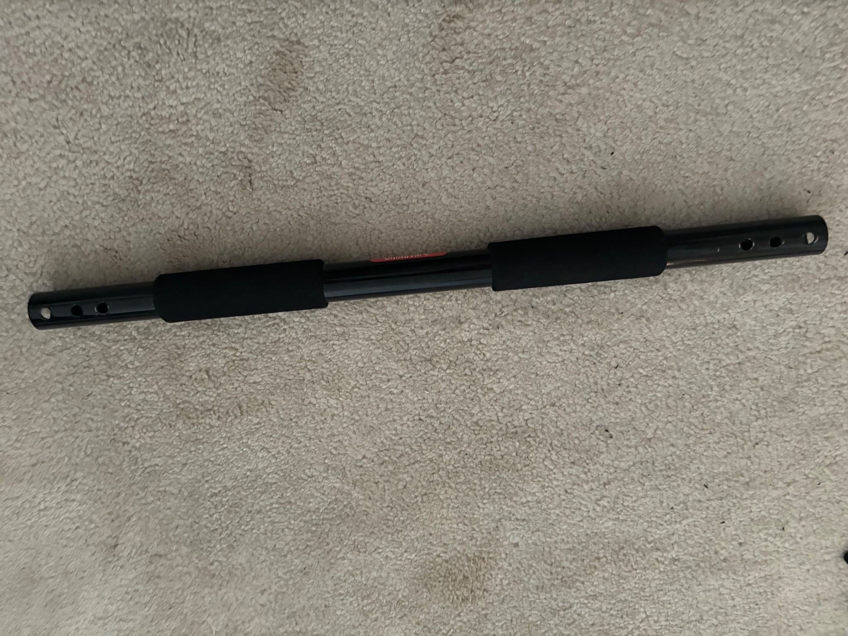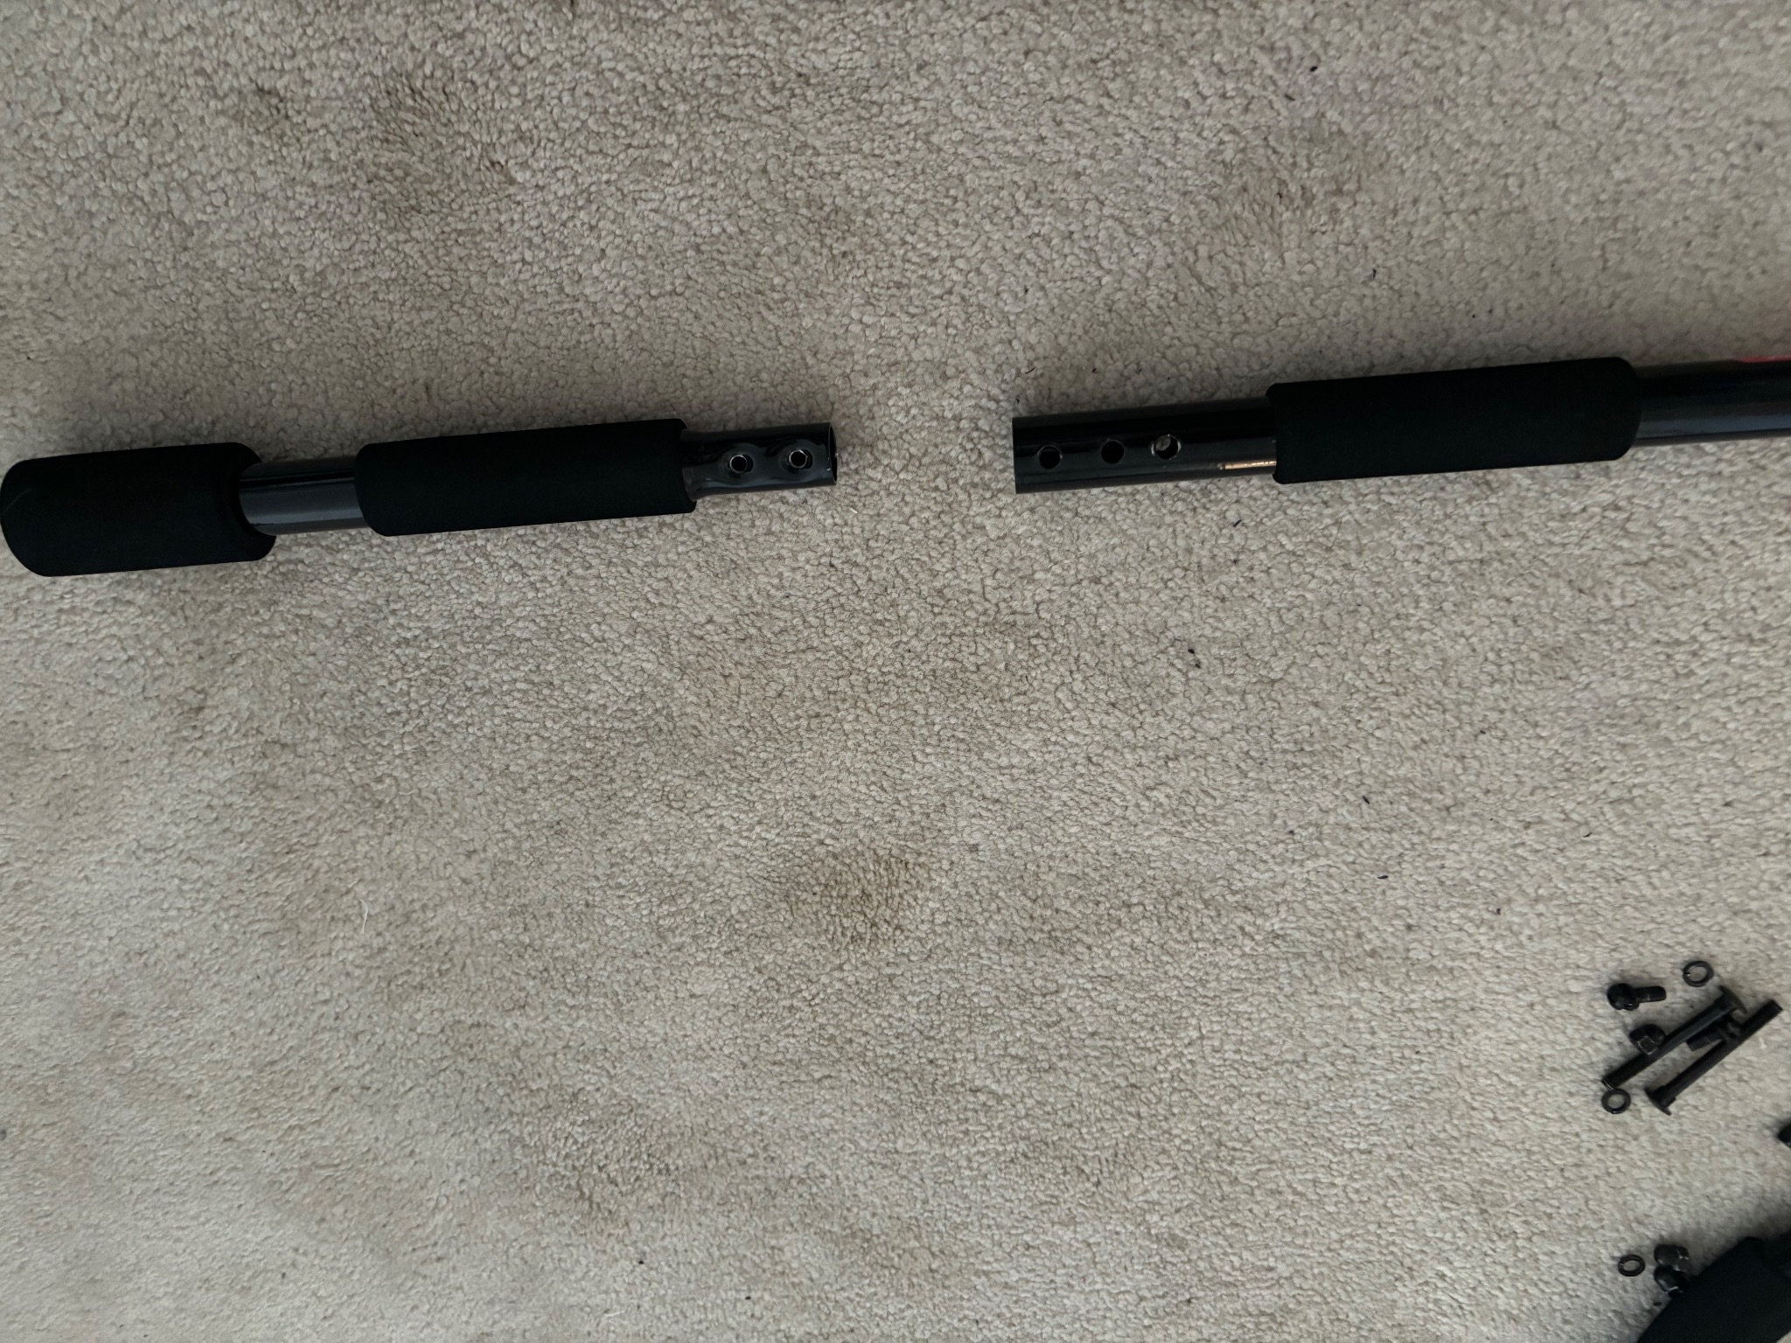
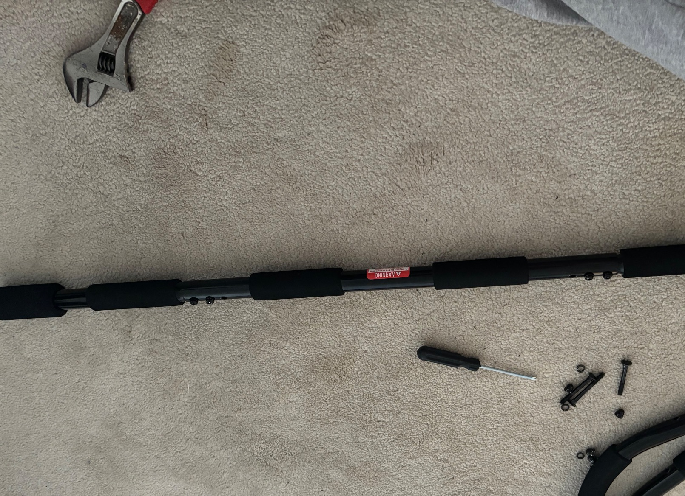
- Screw the extension bars (curved ones) to each side of the bar in the remaining holes and tighten bolts using a wrench making sure the alignment is straight.
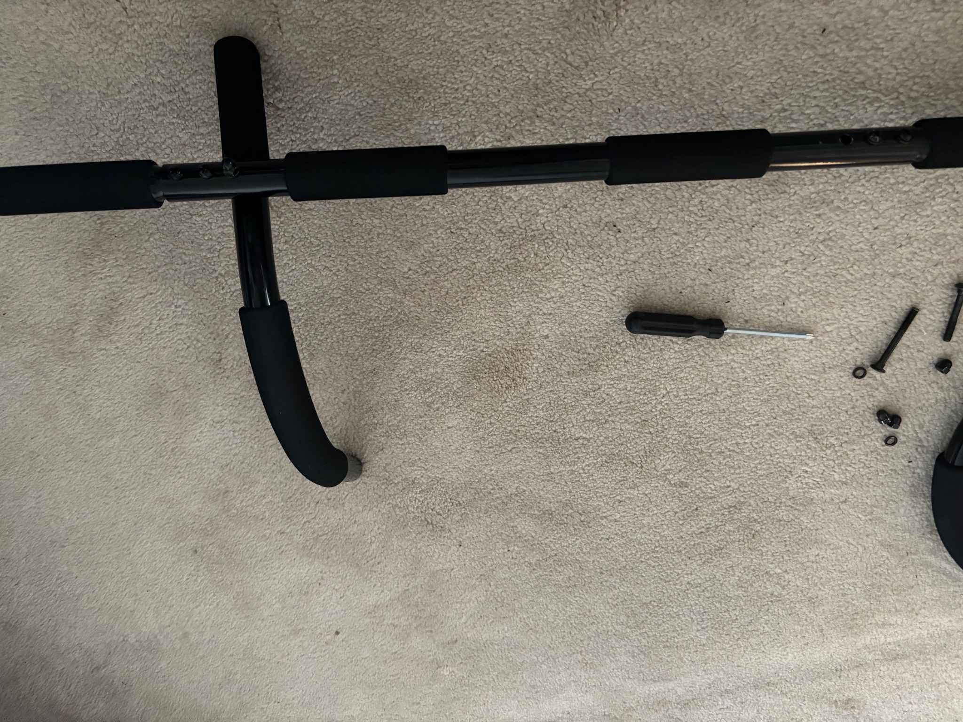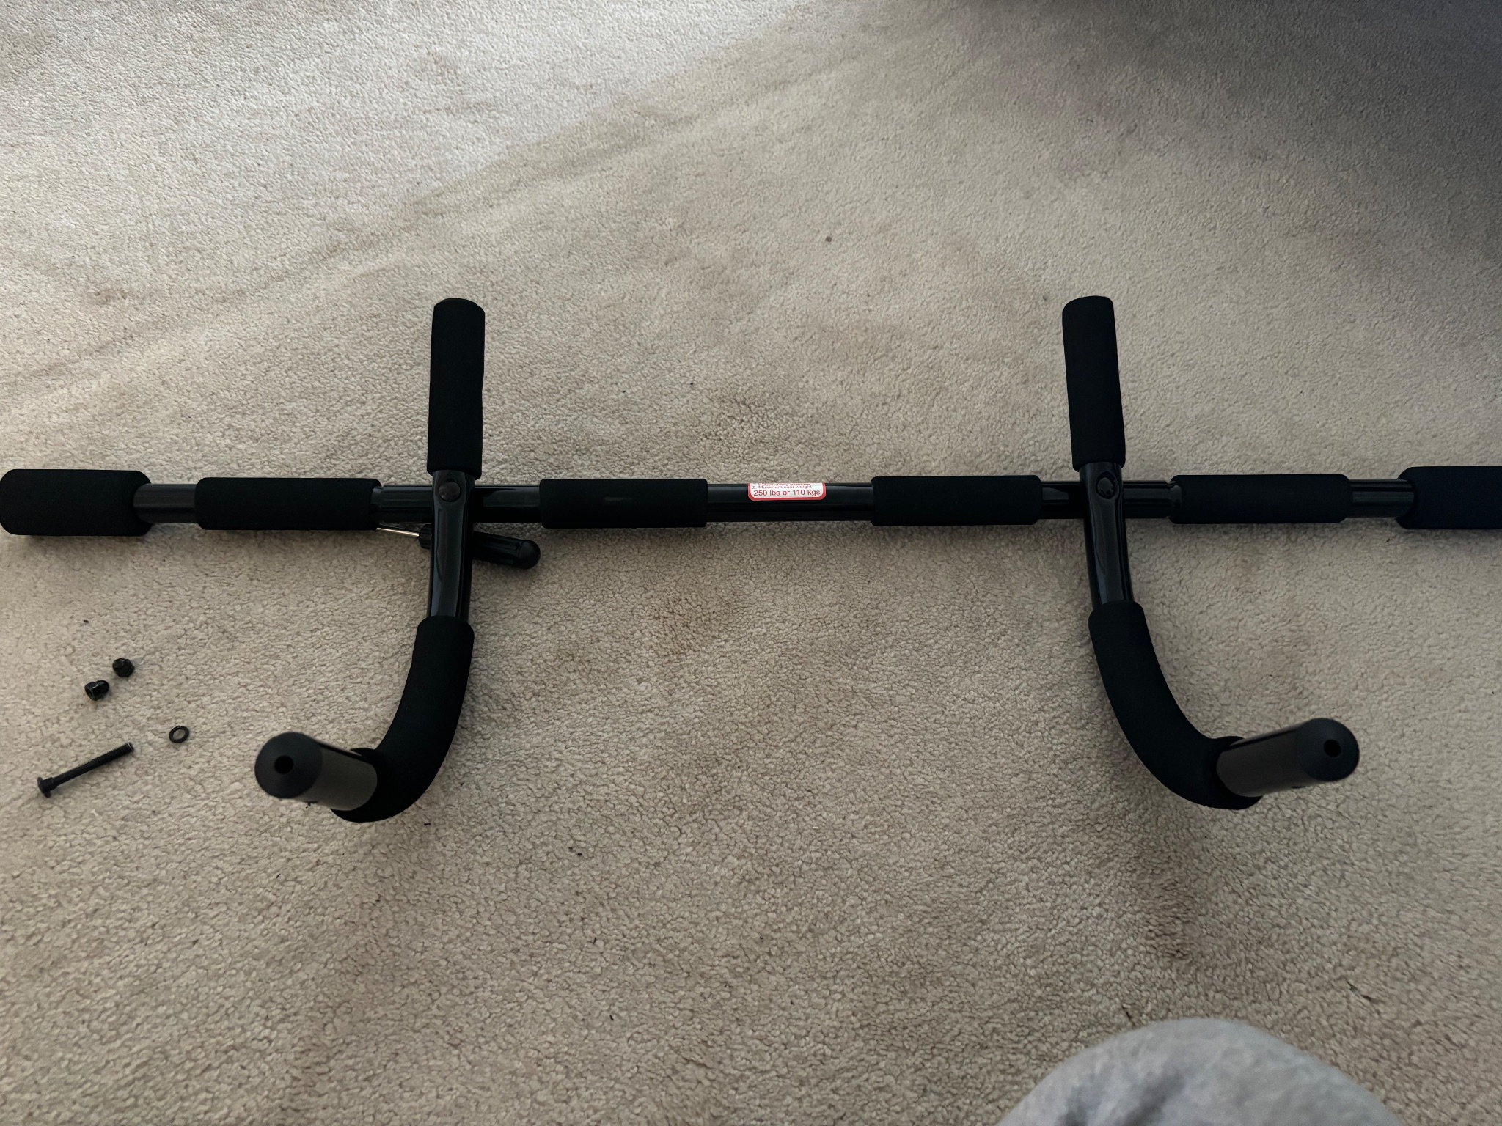
- Screw the door ledge part to the extension part and tightening using a wrench.
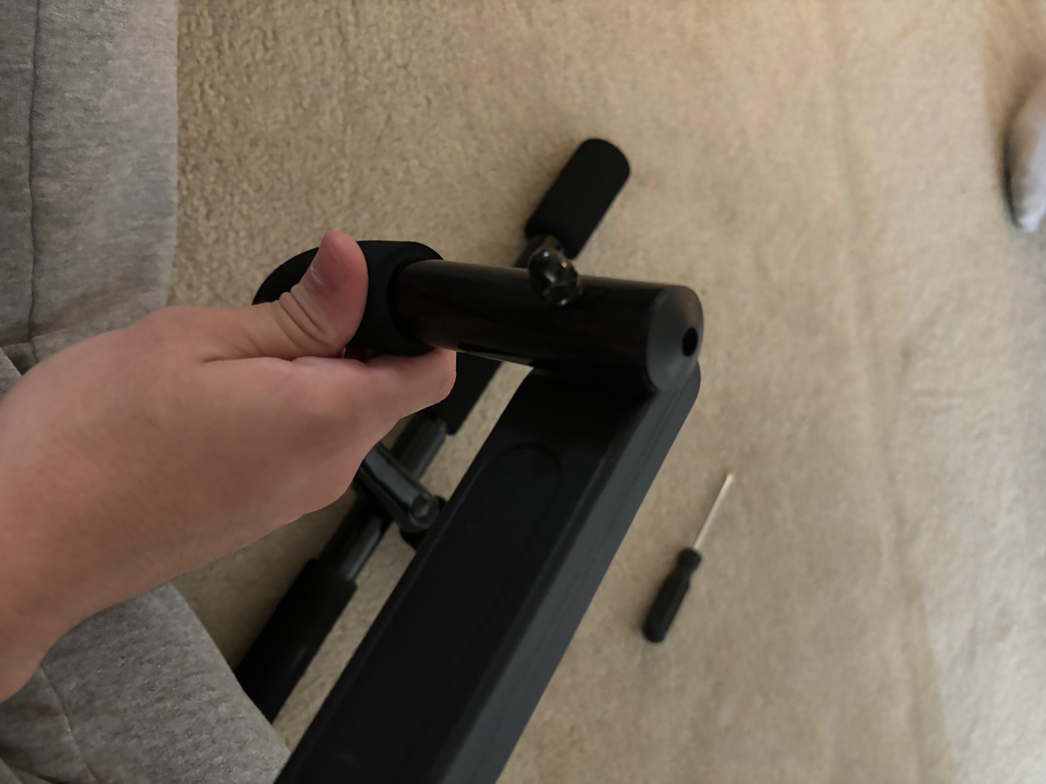
- Place the clamps of the hoist on the middle part of the pull-up bar in the desired direction and screw the given screws into the hoist using a wrench.
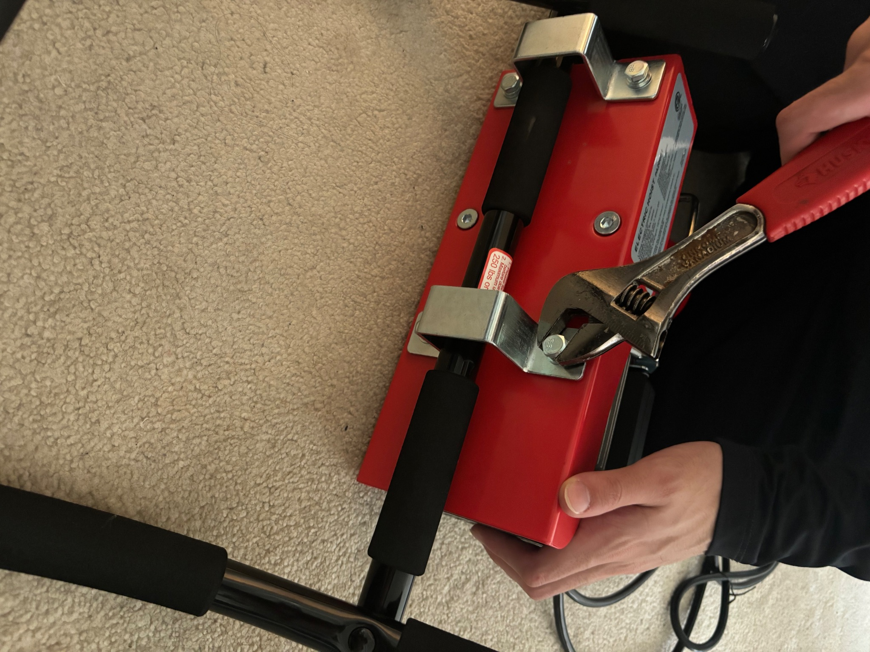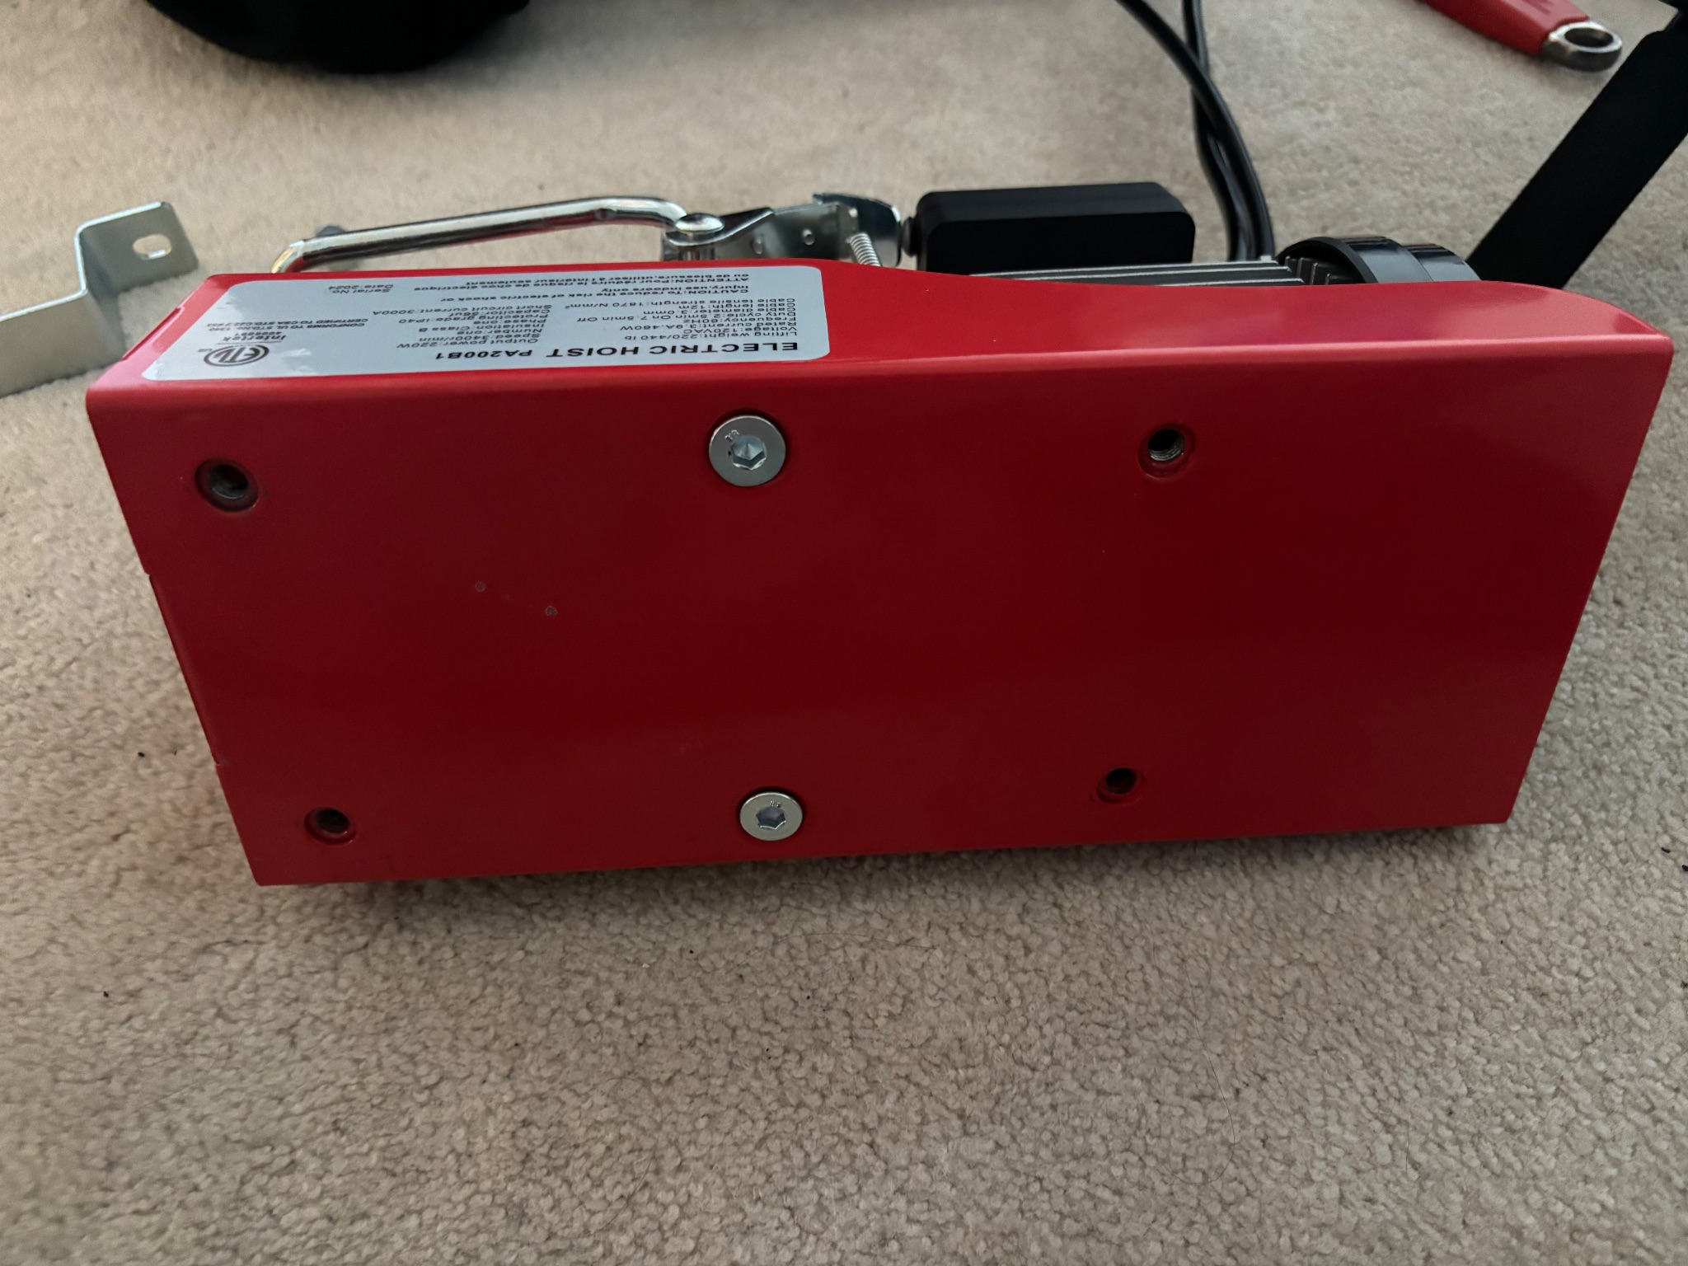

Testing & Validation
Several tests have been done on the product including weight testing, durability, and speed tests to make sure the product is safe to use.
For weight and durability, we attached a sling to the contraption and used the product lifting different people with different weights and rocking back and forth to test stability and durability.
The following pictures show the testing process:
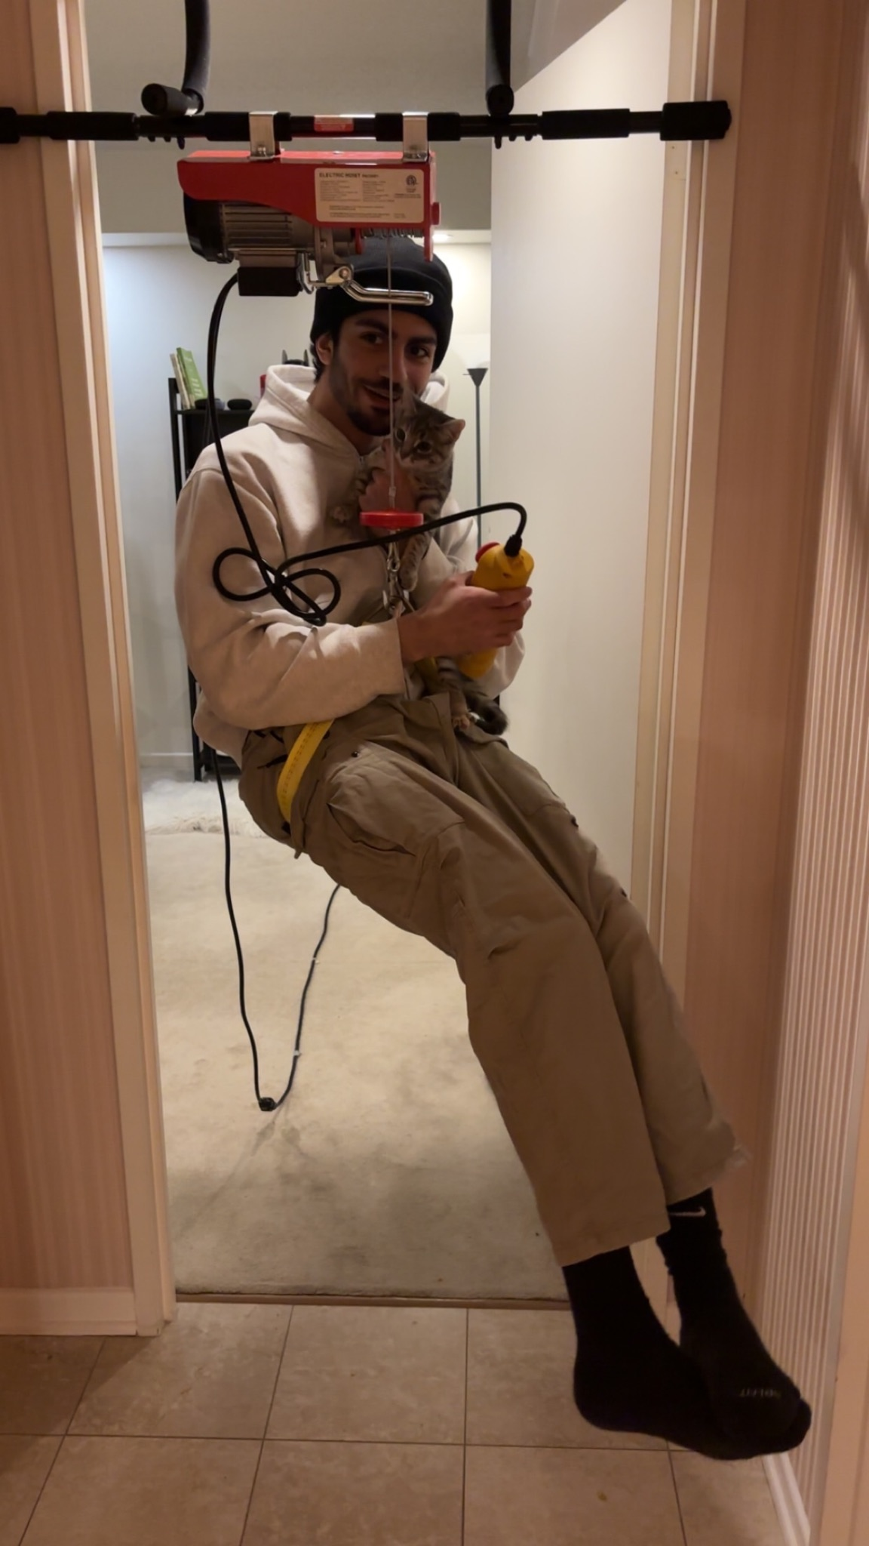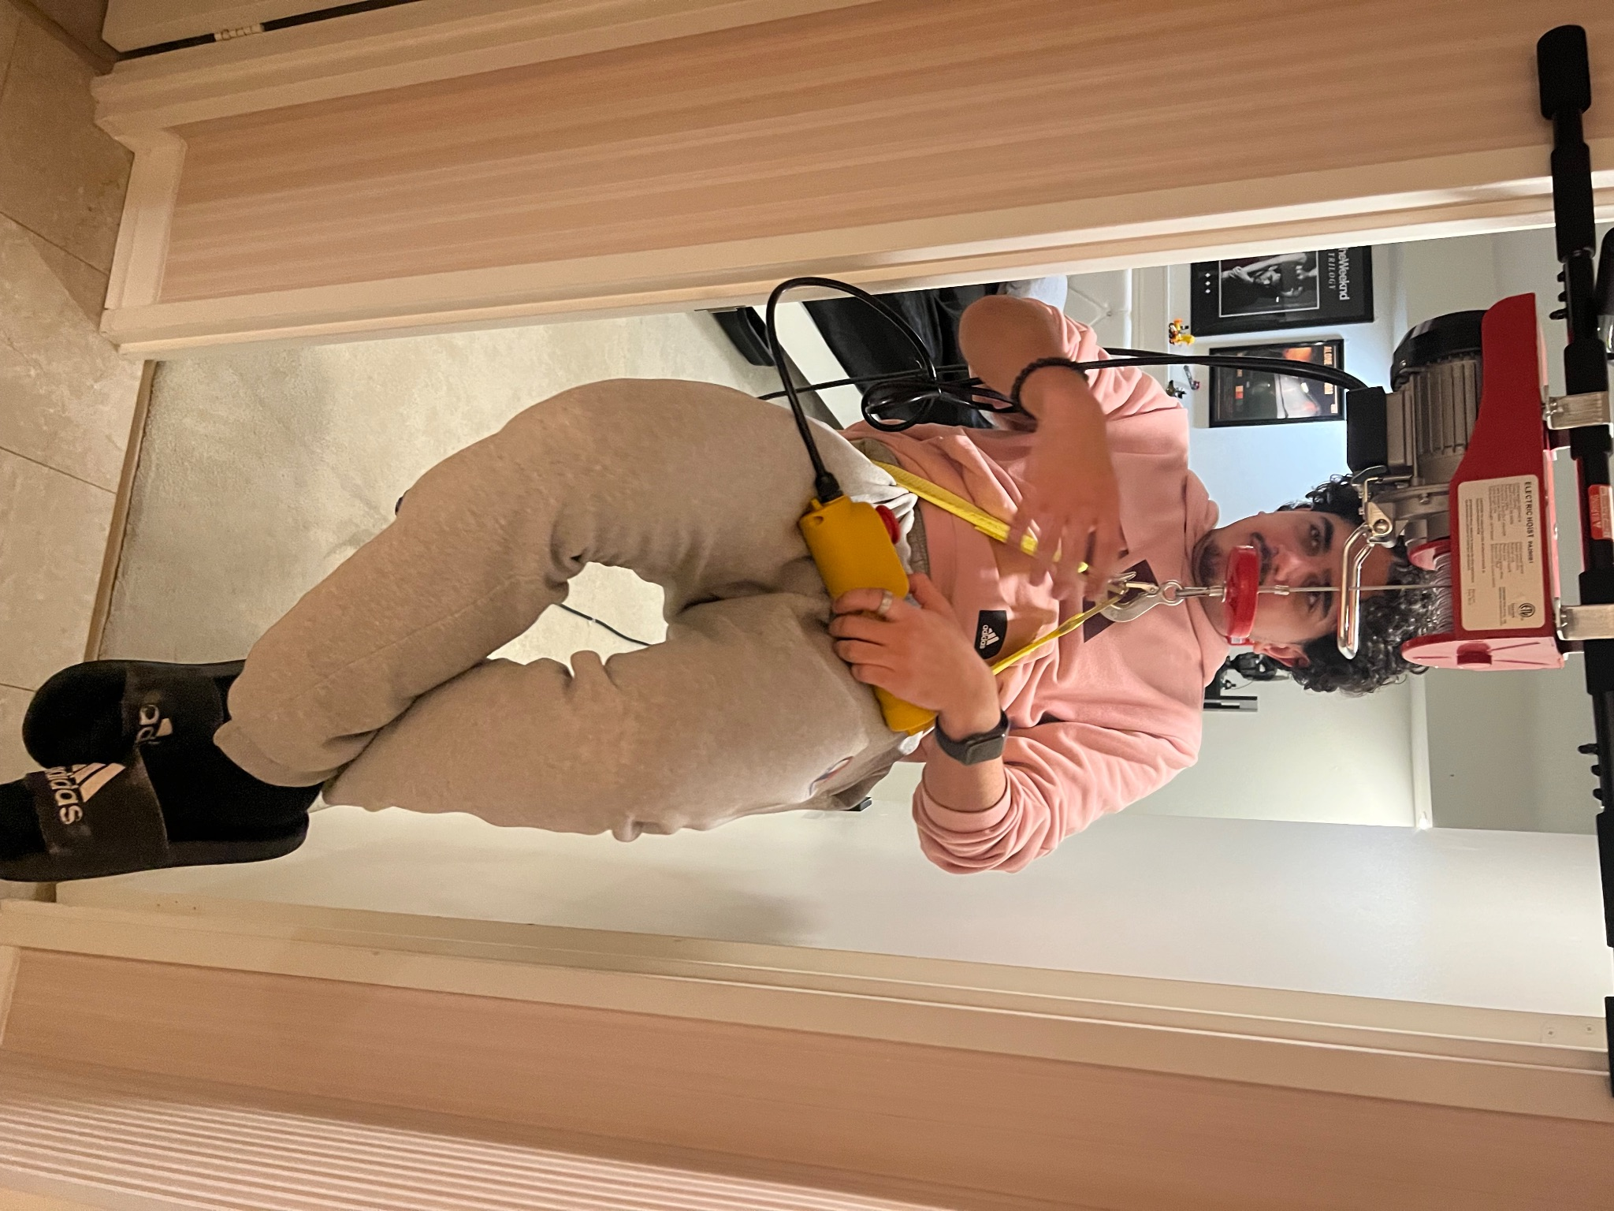
These pictures show the testing being done on two different people with different body weights and were shown to be stable with minimal to no rocking and shaking.
Moreover, speed was tested using a stopwatch averaging around 8 seconds to lift a person from the ground to the top.

Conclusions and Recommendations for Future Work

During the process of designing this device, various lessons were learned. The major lesson was to set clear boundaries with the client. In other words, being straightforward with the client. Setting clear boundaries with clients is crucial for a smooth and successful collaboration. Moreover, setting clear boundaries leads to a more efficient process of design since everyone is on the same page. Another lesson that was learned during this project was to prioritize and select a few constraints to not overload ourselves with a bunch of different criteria. At first, we wanted to satisfy a good chunk of constraints but we later became aware that it was nearly impossible to do so.
Some productive avenues that we’ve encountered were adaptability and time efficiency. During our unexpected design change, we were able to achieve a product that the client would be satisfied with within a short amount of time. We've come up with an idea and implemented it right away by splitting up work and managing our time wisely.
Like any other project, it could always be improved. That being said, if the time for this project was extended we would’ve taken into different aspects of the design, for instance, liability and safety measures. These are all measures that should be in a device but due to time and the sudden switch of the design we weren't able to think too much about it.

APPENDICES

APPENDIX I: Design Files
MakerRepo link to our project.

Table 3. Referenced Documents
Document Name | Document Location and/or URL | Issuance Date
Project Deliverable A - Team Contract, Client Meeting Preparation and Project Management Skeleton | Deliverable A GNG 2101.docx | 2024-01-14
Project Deliveriable B - Business Model Canvas + DFX | Deliverable B | 2024-01-28
Project Deliverable C - Problem Definition, Concept Development, and Project Plan | Deliverable C | 2024-02-12
Project Deliverable D - Detailed Design and BOM | Deliverable D | 2024-02-12
Project Deliverable E - Prototype 1, Project Progress Presentation, Peer Feedback and Team Dynamics | Deliverable E (4).docx | 2024-02-12
Project Deliverable F - Design Constraints and Prototype 2 | _Deliverable F (1).docx | 2024-02-14
Project Deliverable G - Other Considerations | _Deliverable G (1).docx | 2024-04-03
Project Deliverable H - Design Day Pitch and Final Prototype Evaluation | https://drive.google.com/drive/u/0/home?ths=true | 2024-04-03
Project Deliverable I - Video and User Manual | User_Manual.docx | 2024-04-10
Project Deliverable J - Final Presentation | Finale presentation | 2024-03-30

