GNG2101
Design Project Progress Update

<GROUP 1.3>

Submitted by:
Noor Al-lafta 300301892
Sara Elmalky, 300333601
Fatma Abdo, 300278634
Ibrahim Ghamlouche, 300331686
Ali Sherry, 300239471
Liana Chu, 300287510

<22/03/2024>
University of Ottawa

Table of Contents
1. Introduction 5
2. Sustainability Report and DFX 5
2.1. Business Model Canvas 5
2.2. Sustainability report 5
2.3. Design for X 6
3. Problem definition, Client needs, Problem statement 7
3.1. Problem definition 7
3.2. Client needs 7
3.3. Problem statement 8
4. Detailed design and BOM 9
4.1. Detailed Design 9
4.2. BOM 10
5. Prototype 1, Project Progress Presentation, Peer Feedback, and Team Dynamics 14
5.1. Prototype 1 14
5.2. Progress Presentation 16
Presentation Link 16
6. Gantt Chart Update (Deliverable E) 16
7. Design Constraints and Prototype 2 17
7.1. Non-Functional Design Constraints 17
7.2. Prototype 2 18
7.2.1. Client feedback 18
7.2.2. Product assumptions that need to be tested 20
8. Updated Prototype 24
9. Gantt Chart Update (Deliverable F) 25
10. Economics Report 26
10.1. Cost Classification 26
10.2. 3-Year Income Statement 26
10.3. NPV Analysis 26
10.4. Assumptions Made 26
11. Intellectual Property Report 26
12. Gantt Chart Update (Deliverable G) 26
13. Design day pitch 27
14. Video and user manual 27
15. Conclusion 27
16. Bibliography 27

Introduction
In this document, we delve deeper into crucial concepts that play a major part in the design process. A sustainability report and DFX have been summarized and listed out in a fashionably mannered way. The sustainability reports were split into positive impacts and negative impacts. It further discusses effects such as social, environmental and economic impacts. The DFXs have also been listed out with a brief explanation to them. The DFX’s indicate all the different factors that as a team we’re taking into consideration. This ensures that the product meets diverse criteria.
In the subsequent section, it is addressed the foundational aspect of any project, which is defining the problem at hand. The problem statement involves a systematic exploration of the client’s needs, which serves as the basis for crafting a precise problem statement. This section outlines the methods and considerations involved in identifying and prioritizing client needs. The problem statement sums up the essence of the identified issues and serves as a guiding path for the different phases of the project in a concise and focused manner.
Lastly, a detailed prototype and BOM has been conducted in this document. It addresses the practical aspects of the project execution, exploring detailed design process and the creation of a BOM (Bill of Material). This section also delves deeper in the examination of methods and tools employed to translate the conceptual design into tangible and feasible plans. The Bill of Material (BOM) translates all the components and materials that are necessary for the project.

Sustainability Report and DFX

Business Model Canvas
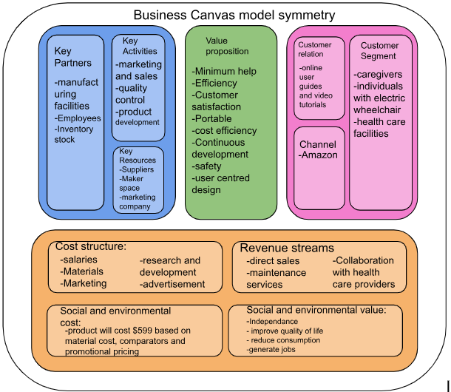

Sustainability report
Table 3: sustainability report
 | Positive Impact | Negative Impact
Social | - More independence for users to lift themselves when fallen. This avoids the need to reach out to anyone to help out.  - Improved quality of life by reducing barriers users may face in mobility. A user interface with simple controls and clear feedback mechanisms. | - The possibility of reducing the need for caregivers and social work which would decrease human interaction.  - Possible unethical sourcing and manufacturing of material.  - While it produces great accessibility, they may also pose financial challenges for those who cannot afford them or lack access to adequate healthcare resources.  - The need for new wheelchairs to accommodate worsening disabilities can sometimes lead to delays in having necessary equipment, as individuals navigate This delay can impact accessibility and mobility, potentially limiting individuals' participation in various activities
Environmental | - Reduced need to buy new wheelchairs to accommodate worsening disability.  - The usage recycled parts (when possible) minimizes environmental impact | - Manufacturing process of the device could increase waste and increase environmental footprint and increase the environmental waste. This aid would harm the environment which would eventually harm the user.
Economic | - Cost reductions from less injuries and less need for a constant caregiver. For example if someone a caregiver won’t have to be present all the time. This would decrease the need for the caregiver to be there and will reduce the cost.  - Due to growing need and demand for accessibility devices, jobs can be generated in manufacturing, design, and transportation | - Depending on the cost of the device, there may be economic and cost accessibility barriers for the target demographic. It may be out of budget for the user. This all depends on the materials used and how costly they are.

Design for X
Table 4: DFXs
 | DFX | Explanation
1 | Design for safety | - Lift is used to help fallen individuals on their own so that no injury is encouraged if the person were to have help outside of the device.  - Needs to be reliable enough to prevent any injuries and accidental falls  - Will not cause any sort of harm to the user. Therefore a clear user manual will be provided to prevent any misuse of the device.  - Hazards
2 | Design for portability | - Device need to be brought to any room, environment and space to make the user experience admirable.  - Device needs to be moved by anyone, meaning lightweight and therefore facile for the user to use it or if bystanders need help.  - Compact; which facilitates the usage of the device.
3 | Design for accessibility | - The device can be used by a wide range of individuals (so that more ranges of disabilities could use it),  - Can adapt to the disability since disabilities change over time (get worse or better).  - Cost is reasonable and aligns with the financial needs of the targeted audience to ensure the complete success of the product and the access of the tool to the population in need.  - The design would be crafted in such a way that it considers the utmost disability scenarios, ensuring that it seamlessly accommodates not only severe impairments but also caters to individuals with minor disabilities. Meaning almost anyone in the realm of disabilities could use it.  - Ergonomics: The device is comfortable and used for extended periods.
4 | Design for maintainability | - The device needs to last for a long time, so that the user benefits from it and that the compartments don't have to be replaced regularly (decreasing cost as much as possible).  - The device needs to handle going outside, other levels in the house  - Adapt to different environments  - Easily maintained by user/ caregiver  - Power efficiency needs to be at a good level so that it lasts longer and prevents the need to swap around the components.
5 | Design for ease of use | - Users can lift themselves with limited help/alone  - Helpers should also easily use devices to lift user

Problem definition, Client needs, Problem statement

Problem definition
The client would like us to create a user-friendly and adaptable device to assist individuals lift themselves when fallen. The mechanism should be designed to accommodate individuals with varying mobility/disabilities, ensuring a safe lift process with as few transfers as possible. Consideration should be given to the ease of use for the person transferring and any caregivers involved (preferably the person should be able to use it on their own). The solution should consider different settings where individuals may have fallen and as a result be portable, of appropriate size, and should be adjustable to accommodate individuals with different physical abilities and needs. Additionally, the device should prioritize safety, stability, and minimal physical strain on both the user and the caregiver during the lift.
Our team will also need to define the main target audience and scope of the design the device is for. At the moment, the scope of the design is small and focused on our client specifically.

Client needs
Table 5: Client Needs
 | Client statement | Interpreted need | Ranking
1 | Lift someone who has a disability up alone (if possible with one arm/hand) or with limited help | Device provides independent help or minimal help. | 5
2 | Small in size | Minimal space occupied by the device and as compact as possible. | 3
3 | Device should be able to go up and down the stairs and possibly outside. | Easily compatible and portable with the user's lifestyle. | 4
4 | Low cost and available for everyone. | Inexpensive, and affordable | 2
5 | Usable for support workers no matter the strength. | The device is usable by any support worker despite their physical limitations. | 5
6 | Could be accessible and usable for different people with different disabilities. | The product is suitable for different types of disabilities and adapts to changes in disability | 3
7 | Safe and reliable. | A robust quality and safety control measures throughout the manufacturing process. | 5
8 | The individual in care varies in size and the product needs to be able to securely withstand the user. | Lift someone of, at least 250 lbs. | 2

Problem statement
KPC Capability Inc. seeks a solution for individuals with limited mobility or one functional hand/arm, addressing the absence of a device for minimal work lifting. The challenge is to create a tool that ensures safety and portability which aligns with the client's mission.

Detailed design and BOM

Detailed Design
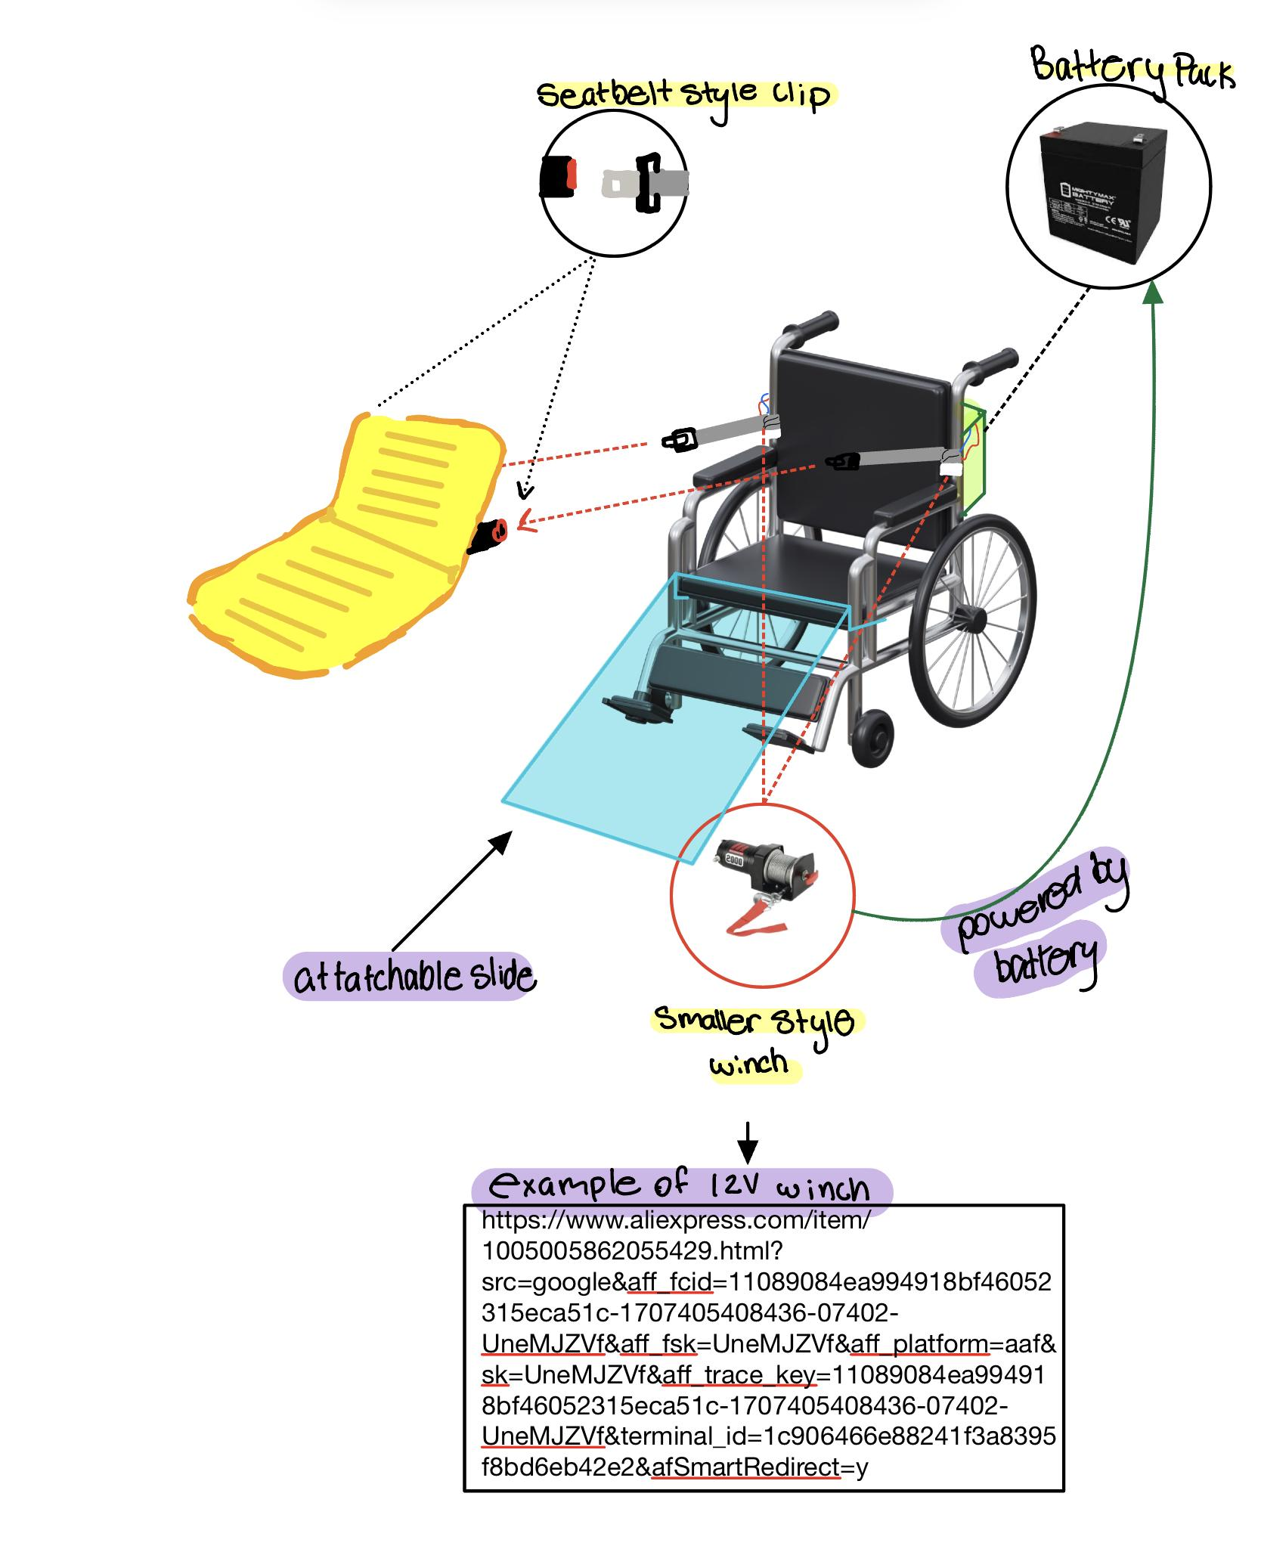

Inflatable chair example:
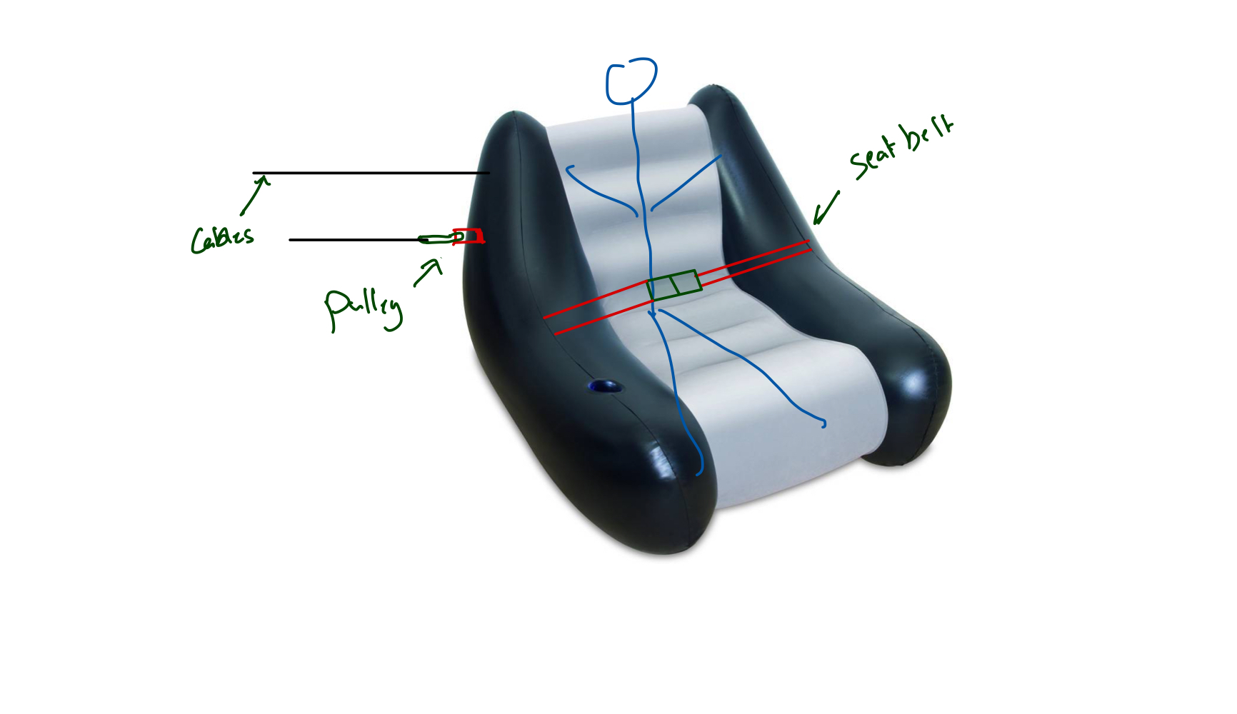
How the concept works:

BOM

Sub-System | Item | Description | Unit of measure | Quantity | Unit Cost | Total Cost | Link/Where to Obtain
Slide | Wooden Planks | To make slide component (used for demonstration purposes, preferably made of plastic) | # of units | 4 | $0.00 |  | Brunsfield
 | Vinyl Sheet | To smooth out and reduce friction on wood | m | N/A | N/A |  | don’t need for the first prototype, TBD at a later time
 | Screws | To screw the wood together and possibly hinges onto wood | # of units | 10 | $0.00 |  | brunsfield
 | Hinges (TBD) | Based on feedback from 3rd client meet, possibly make slide foldable using hinges | # of units | N/A | N/A |  | don’t need for the first prototype, TBD at a later time
Headrest Attachment | Solidworks | To model the attachment | N/A | N/A | $0.00 |  | uottawa vmware server
 | 3D Printer | To print out attachment (The reason for 3D printing is bc the part will be customized to the one wheelchair we have dimensioned) | N/A | N/A | $0.00 |  | makerspace
 | Sand Paper | To smooth out 3D printed part | grit | 2 | $0.00 |  | makerspace
Winches | Winches | To pull weight up the slide onto wheelchair | m | 2 | $24.56 | $55.51 | Amazon
 | Square Metal Bar | To connect 3D printed part to the winches and to extend outward on both side for winch | m | 1 | $1.00 | $1.00 | https://makerstore.ca/shop/ols/products/metal-bars-brunsfield
 | Screws, brackets, clamp | To mount winches to metal bar and 3D printed part (this will not be structurally secure due to weak 3D printed part, but used for demonstration purposes of final prototype) | # of units | 10 | $0.00 |  | brunsfield
 | Adhesive or cable ties | Possibly needed to secure the attachments together | # of units |  | $0.00 |  | makerspace or from home
 | 6-pin power connector/adapter | To connect winches to power source on wheelchair | v | N/A | N/A |  | N/A
 | Wiring/Adaptors | Possibly needed to make sure the 6 pin power adaptor is compatible with winch and battery, if not need adaptor | v | N/A | N/A |  | N/A
General | Drill | Used to drill holes in 3D printed part that match the headrest holes to fasten part to headrest | N/A | 1 | $0.00 |  | makerspace
 |  | Used for the metal bar that holds the winches
 |  | To screw the slide together
 | Saw | To cut wood | N/A | 1 | $0.00 |  | makerspace
 | Screwdriver/Wrench | For building prototype | N/A |  | $0.00 |  | makerspace
Sum of cost |  |  |  |  |  | $56.51
SUM OF COST FOR 1ST PROTOTYPE |  |  |  |  |  | $27.75

Prototype 1, Project Progress Presentation, Peer Feedback, and Team Dynamics

Prototype 1
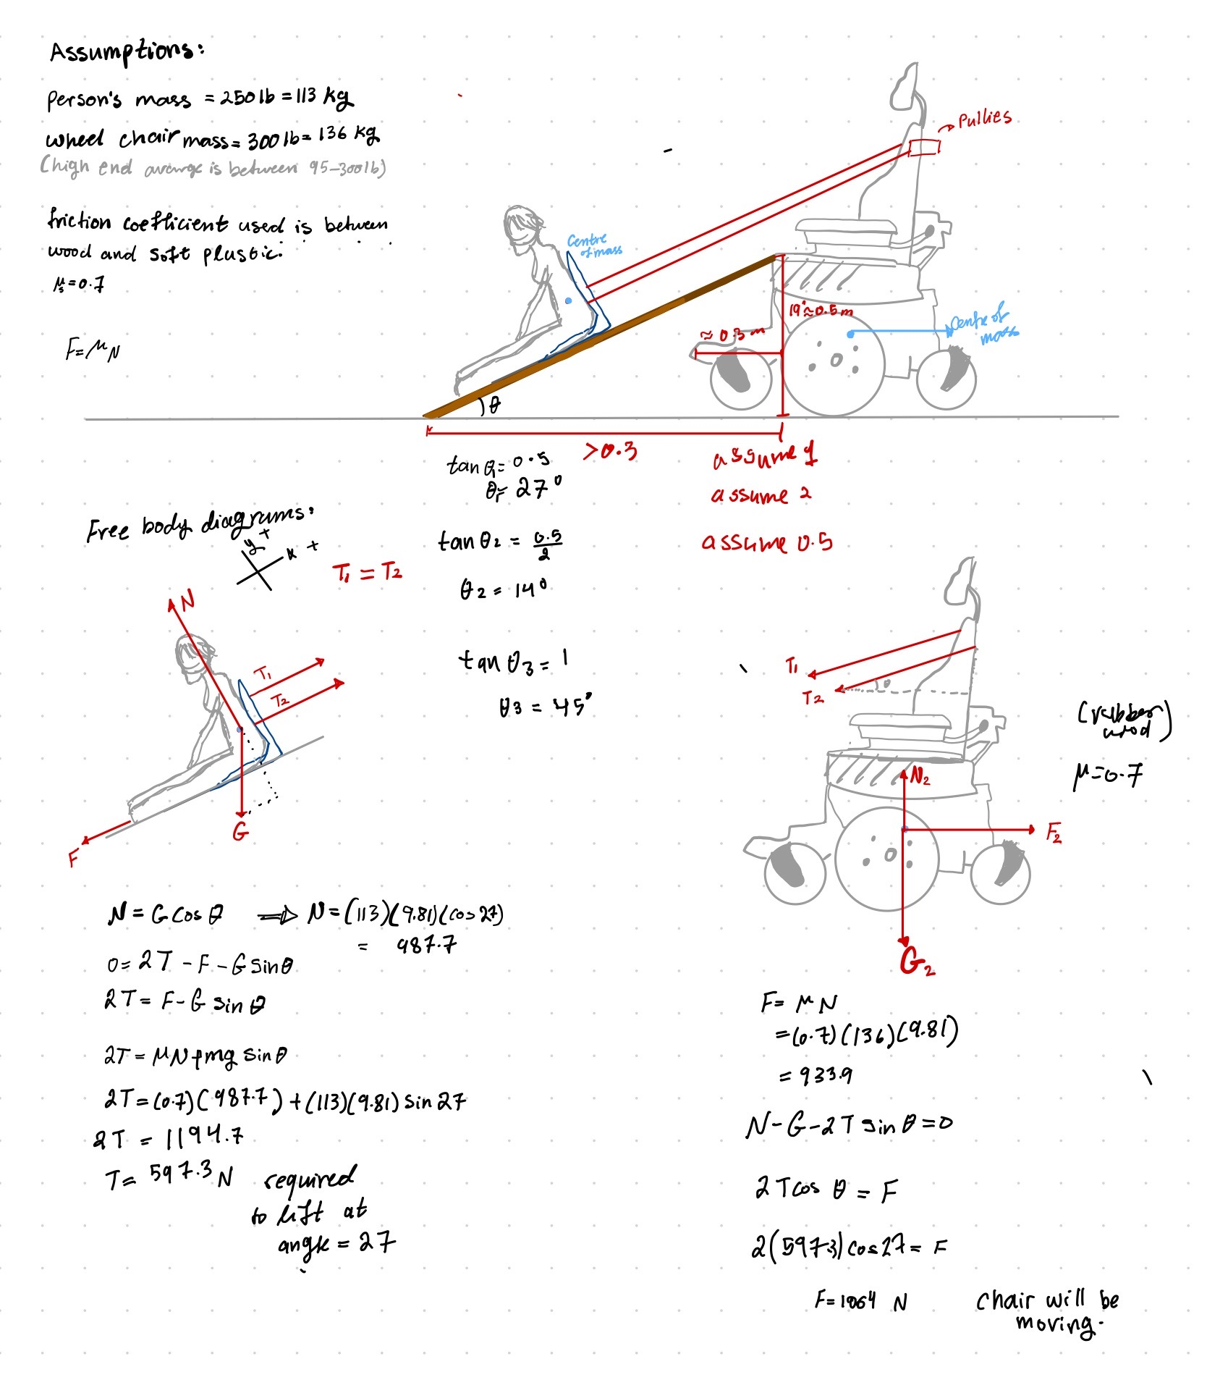
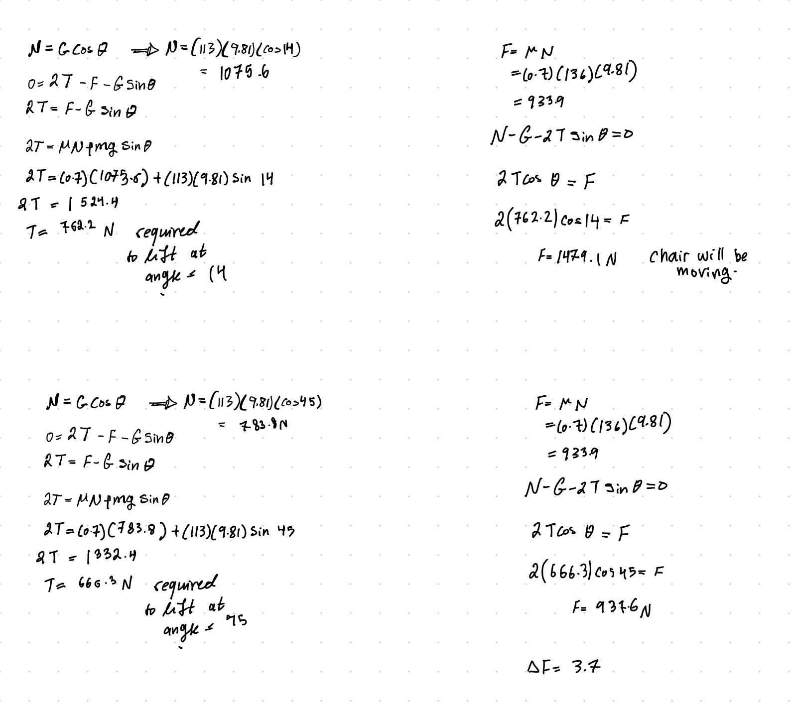
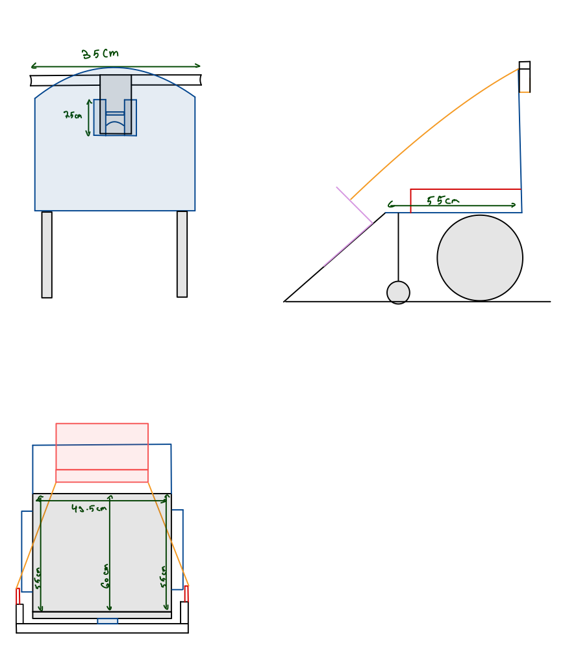
Updated Draft of Design

Progress Presentation

Presentation Link

Gantt Chart Update (Deliverable E)
Deliverable E Update:
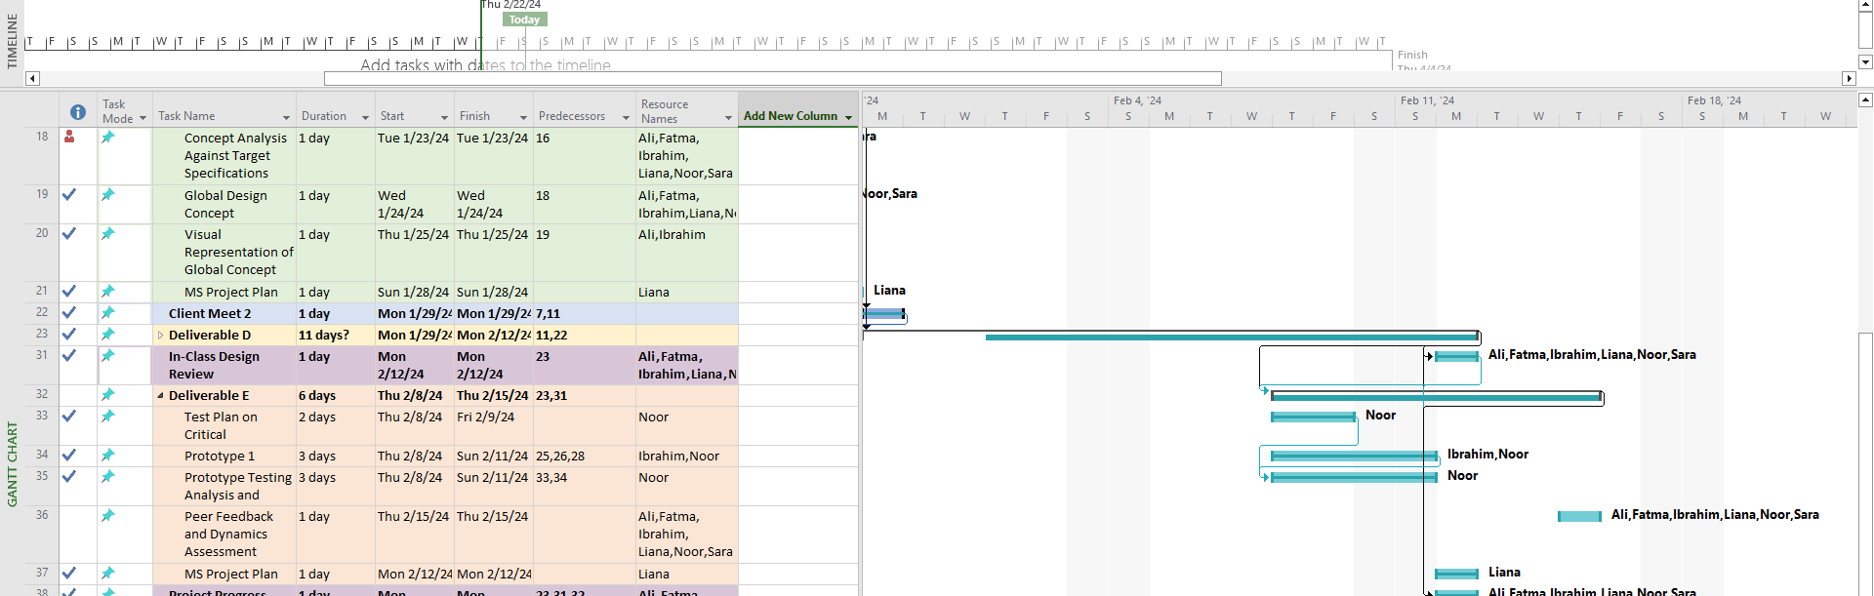
PDF Snapshot of Full Gantt Chart:
https://drive.google.com/file/d/1PI6jqSI2E9WGB_3GmRDij9ms8PFoBS2F/view?usp=drive_link

Design Constraints and Prototype 2

Non-Functional Design Constraints

Non-functional constraints | Changes to be made | Effectiveness of changes
Portability  -The headrest piece is small and attached to the wheelchair. However, for the slide, the original idea was to have it fixed in shape. Now the slide | The slide is too big to be portable. There needs to be a change done to the slide for it to move easier. Hinges will be added to the legs. | Before the hinges were added the minimum length of the slide when moving it around was 23 inches. After the hinges were added, the minimum length of the slide when moving it around is 2.4 inches.  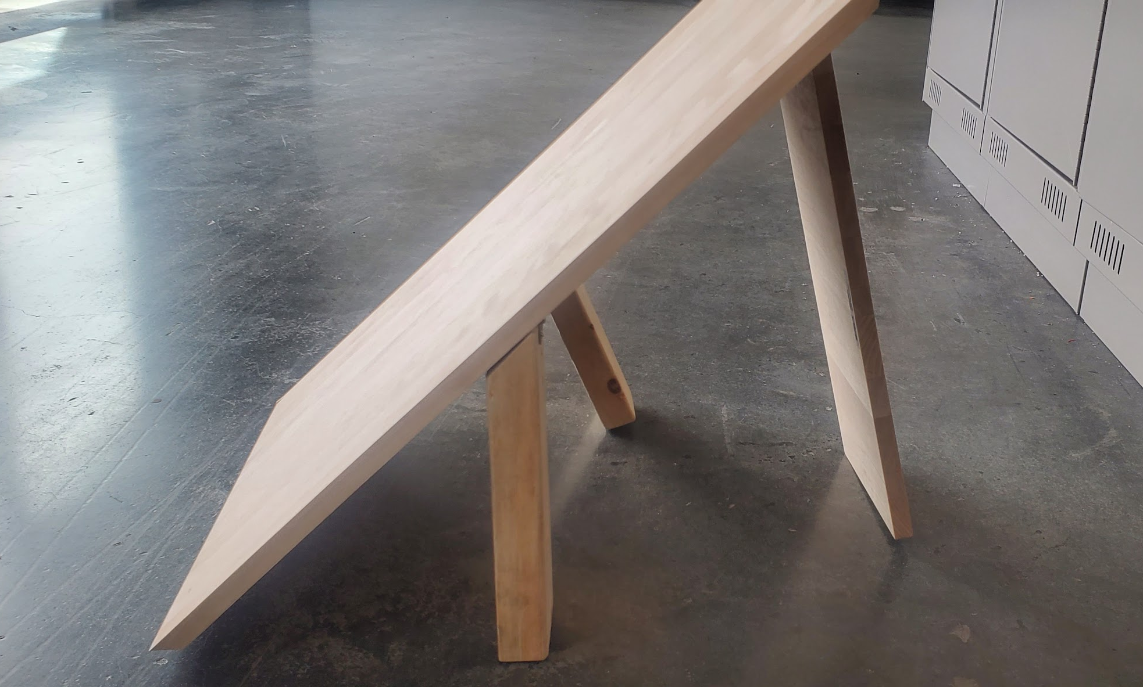  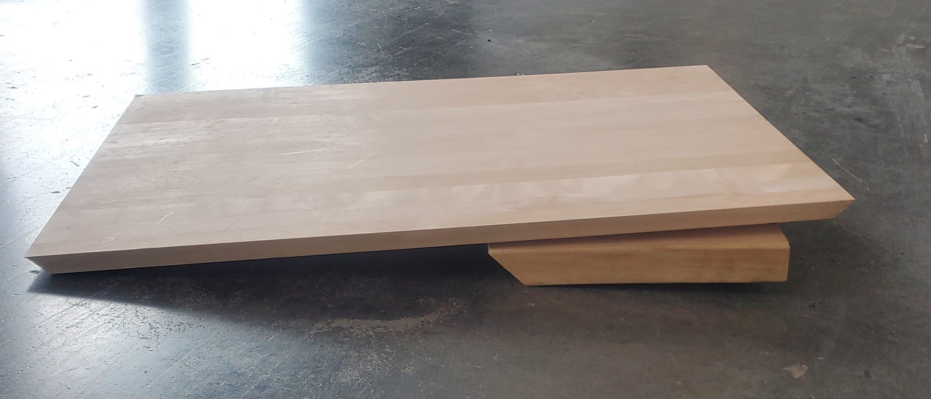
Safety | The slide when opened is not stable enough when pulling a weight up. There needs to be a stabilizer on the slide when it is opened so that the slide will not move during its use.  Also, originally the design had four legs as its base to hold up the slide. It is not stable enough, so we added a back.  Video showing the slide. | A base with a slot will be added under the slide so that the back of the slide can be slotted into it and be stabilized.  The back of the slide makes the slide much more stable but the base with the slot will increase its stability.

Prototype 2

Client feedback
Since the previous client meeting, we have maintained contact through email with the client and the company, receiving important feedback on our updated design.
Based on the detailed design from deliverable C, our client Rebecca, and her team Bob, Andrew, and Mallory shared some of their thoughts on what they liked:
- The Design is clever and has the potential to work for users with a variety of disabilities and in a variety of situations/places
- The simplicity of the design and function
- The safety: The person with disabilities (PwD) is never in the air and stays on the ground
- Device could potentially be easy to use or versatile (multi-function)
- Device could potentially have a low-cost
- Device has a small footprint/Portable: Easy to store and transport device
Rebecca and her team also had some concerns that need to be addressed:
Feedback | How we addressed feedback
Strength and smoothness of board: the slide component needs to be very thin but strong, like existing transfer boards. The slide must also be smooth to reduce friction. | For the purpose of the prototype, wood will be used. For the final product/device it would be preferable for the slide to be made of hard plastic, such as HDPE plastic in order to keep it thin and light, but still strong. HDPE plastic is also a fairly affordable and common material to manufacture.
Attaching slide to the wheelchair: how will we safely and easily secure the slide to the wheelchair? | The slide design is still in development as the second prototype is focused on the winch (testing and attaching). So far we are thinking about either making it compatible or attaching it to the seat using the handlebars or clips that could be attached to the chair seat. This section will be updated as we progress.
Attaching the pulley mechanism: Because 95% of wheelchairs have handle bars, would looping the pulleys to the handle bars work? | From our in-person meeting with a KPC team member, we examined and assessed an example power wheelchair. We determined that handle bars would not be high enough, not stable/sturdy enough to hold winches and that the measurements of the handle bars vary too much from wheelchair to wheelchair. We have developed a newer detailed design involving the attachment to a headrest sent to the client for additional feedback.
Sling/chair: Does the sling have to be inflatable? It’s an extra cost and may cause problems. It needs to be easy to put on and take off but still strong. There are some models like this Transfer chair. | Our newest detailed design no longer includes an inflatable component to the sling/chair. We agree that it was an added complication to both the user, the designer, and the manufacturer. The final design will use the chair the client provided as it is affordable, offers good support, and has multiple uses. As for the prototype, we will be using a bag with weights in it to cut back on the cost.
Cost: are there any ways to reduce the cost? Is the winch needed? Are there different versions? Manual & non-manual? | For the prototype and budget, the team has chosen to use a manual winch instead of the more costly electric winches. This also reduced the need for charging and the attachment to additional adapters. Depending on the client, the final device could be made with a manual or electric winch.
Universality: To make the device be more usable for people with 2 good arms, there could be hole handles along each side so that they could shimmy up the board. If the slide was too slippery, it could be difficult, so maybe one side has non-slip strips along it? | This relates to the design of the slide. It will be improved and taken into consideration in our next focused prototype.
Multi-function: Could the device serve another need? | Although it would be beneficial if the device could serve another function, the team has determined that the scope of usage of the device will stay focused on lifting a person up. This is because of time constraints and due to prioritizing the ranked metrics and target specifications that we stated in Deliverable C.
Market: Does anything like this device exist already? | Several devices that we looked at lift, pull, and transfer patients from the ground, as seen in benchmarking in Deliverable C, but there are no devices that exist in the market similar to our design. It would be an addition to the market for people with different disabilities to use potentially.
After receiving this feedback from the detailed design, we improved the detailed design as seen in deliverable E and updated some of our constraints that determined that our design cannot be used individually and requires at least one care-giver. Feedback from Rebecca is as follows:
Feedback | How we addressed feedback
Winch headrest attachment: Is the chair’s back strong enough? Where would it be attached? | Our newest detailed design includes the headrest attachment attached to the original slot of the original wheelchair headrest. For this device to function, we assumed that the original headrest would be removed to be replaced for this device.

Product assumptions that need to be tested

Assumption | Relation to DFX
Cranking the winch is easy and doesn’t need much physical effort. | Design for accessibility: making sure the winch can be used by everybody regardless of their physical ability. The winch needs to be smooth and easily operated by everybody.  Design for safety and ease of use:
The winch can pull heavy weight from a height of at least 1 meter (the height of the headrest/back of the wheelchair) | Design for safety and ease of use: Test the winch's capability to pull the required weight easily without it getting stuck.
winch locking mechanism works smoothly | Design for safety and ease of use; We need to ensure that the locking mechanism is both fast and easy to operate in case of emergencies.
Headrest attachment will be used to attach the winch to the wheelchair | Design for safety and ease of use: The headpiece needs to be strong enough to be able to pull the required weight and be stable enough so the winch can be mounted on it.

    - Prototype Testing

Focus | Target Specifications | Critical Product Assumptions and Objective | Description of Prototype used and of Basic Test Method | Description of Results to be Recorded and how these results will be used
Winch | Weight capacity = 200lb | Can the winch pull a heavy weight from a height of at least 1 meter (the height of the headrest/back of wheelchair) | Focused physical prototype.  Was tested in Brunsfield to help fix it in place, scrap wood was used to act as a slide, and a bag with the weight was used as the chair.  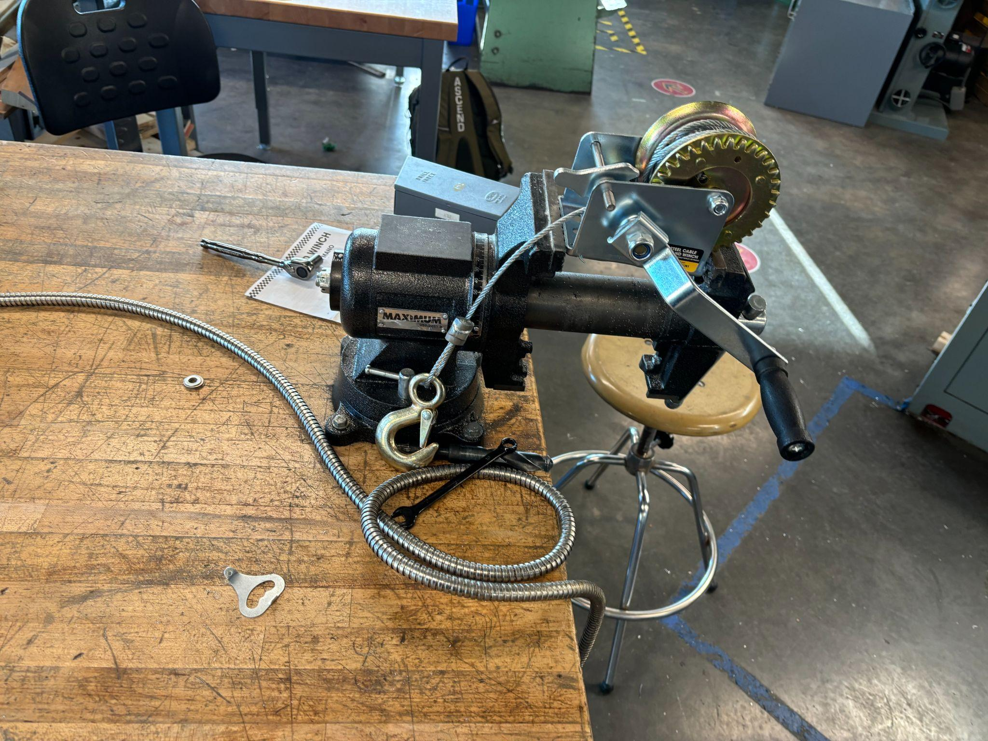 | The winch had several problems as it was not the best quality. The CEED members helped us fix it and get it working properly.  The test was successful in showing that the winch can both lift a significant weight without any wooden support and on wooden support at an angle of around 45°.  Cranking the winch was very easy, with a limited amount of force needed to control it.  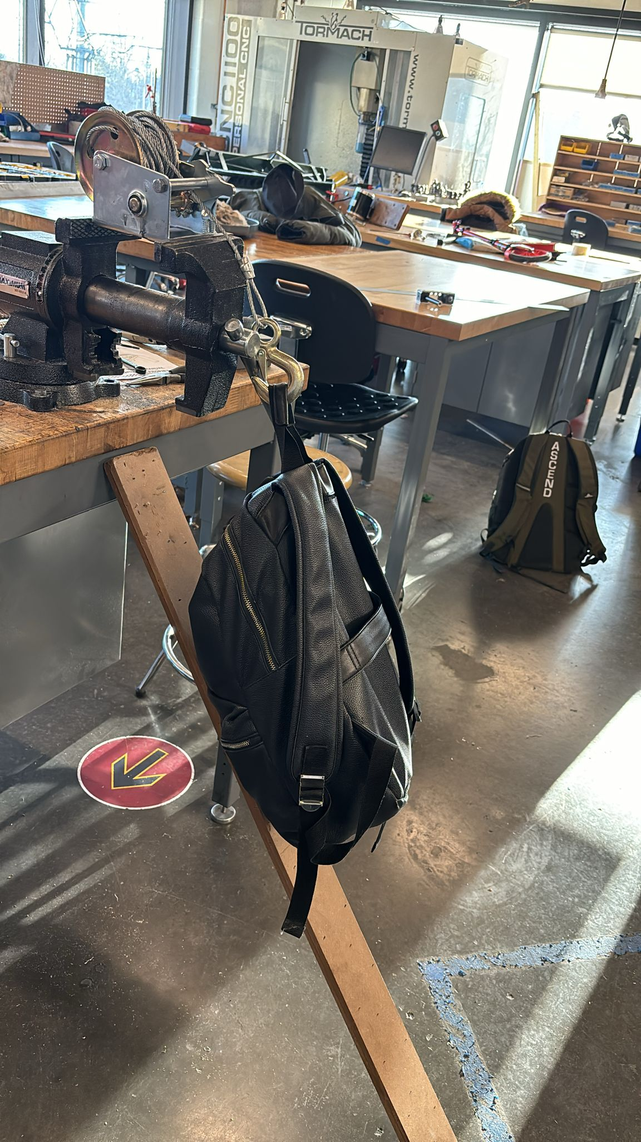
 | Movement control  = 0.25 m/s | How easy is it to use the manual winch?  Does it require a lot of physical effort?
 | Emergency safety feature  ≤ 1 second | Is there an easy locking mechanism to immediately stop the winch?
Headrest Attachment | Dimensions (width)  < 24” | A headrest attachment will be used to attach the winch to the wheelchair.  A pulley will be attached to the headrest on either side. | CAD model.  This prototype is a Focused analytical prototype.  The goal of this prototype is to achieve a general picture of the concept using real-world dimensions. We took from the wheelchair sent by the client and used the dimensions of the pulley we purchased.  Furthermore, the pulleys will be attached to the two flanges on the sides and bolted using screws and hex nuts. | 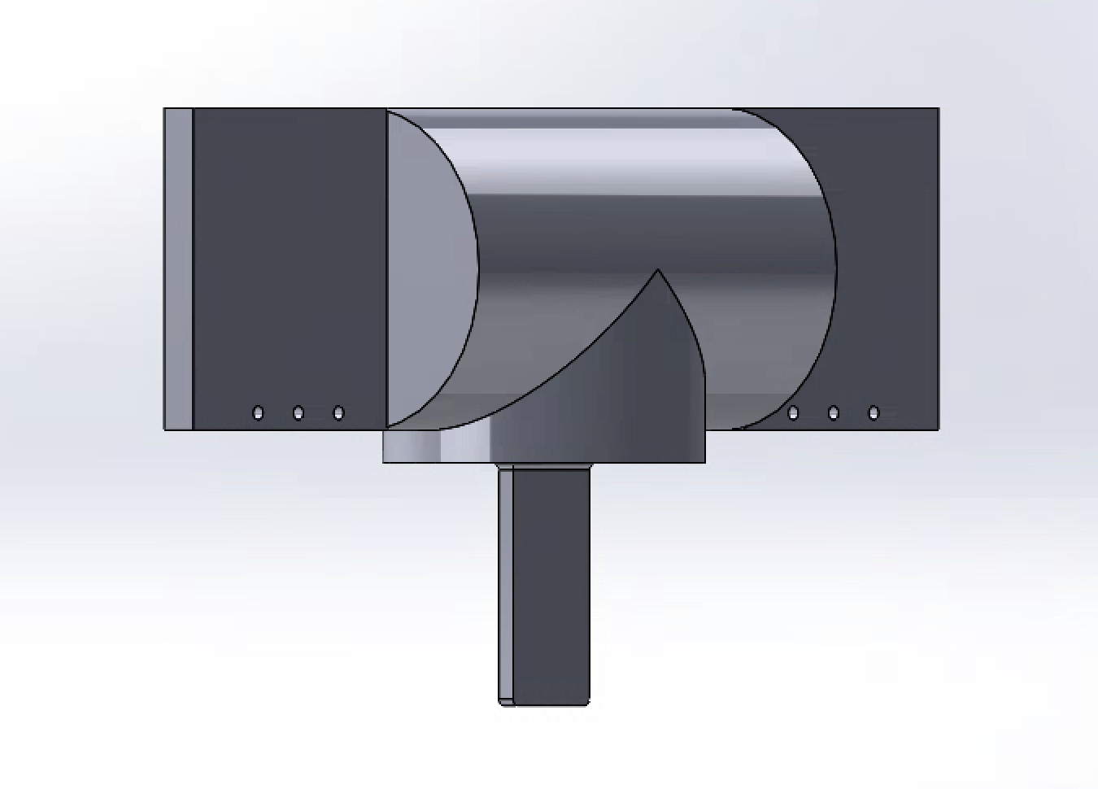  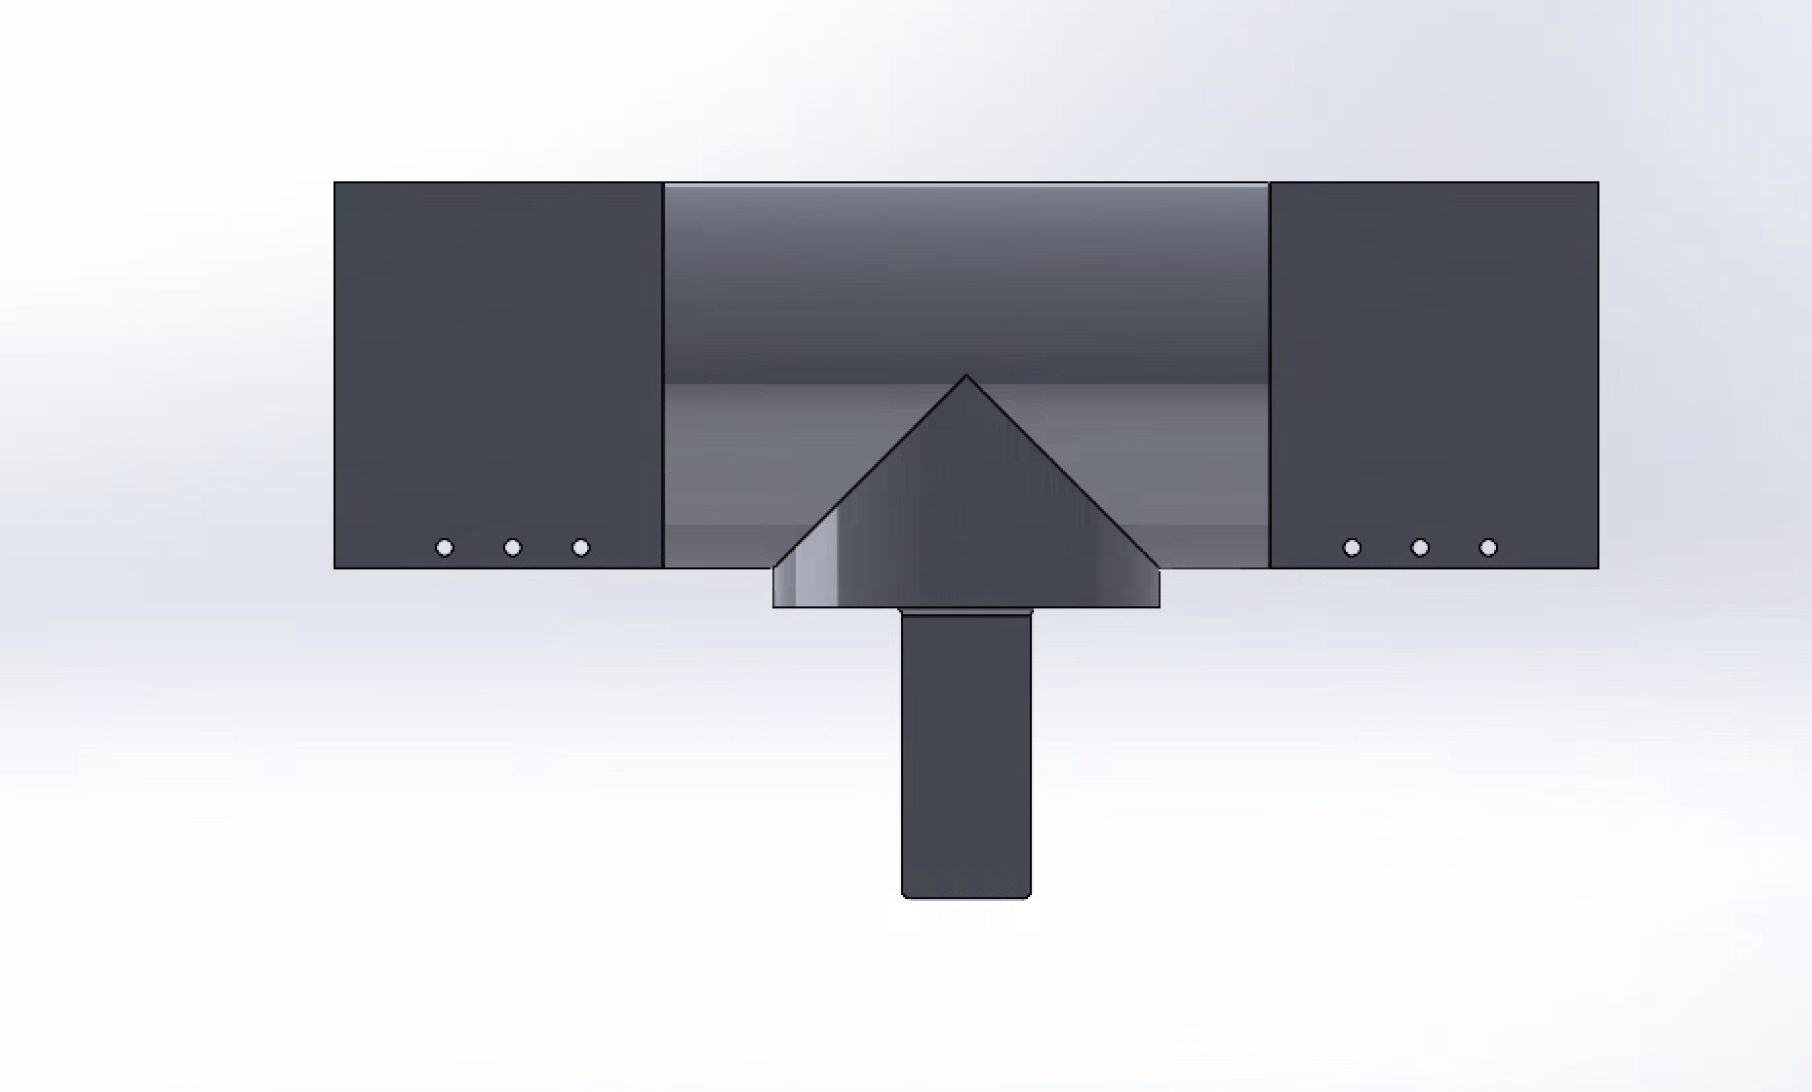  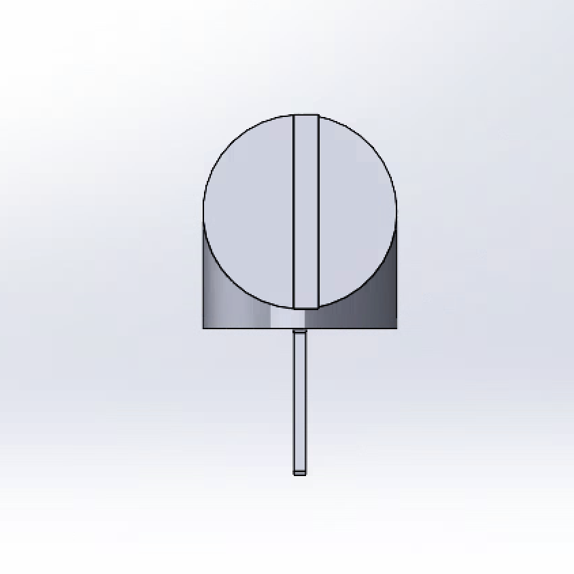  The CAD design is the blueprint for the real-life model we mean to construct.
Slide | Dimensions | A slide will be used to transport the person using the wheelchair back on it. | The dimensions used are based on the “standard” floor to wheelchair height which is 19 inches. The “standard” height of the wheelchair effects the angle and the length of the slide, so we have to calculate the angle and the rest of the dimensions the ensure efficiency | 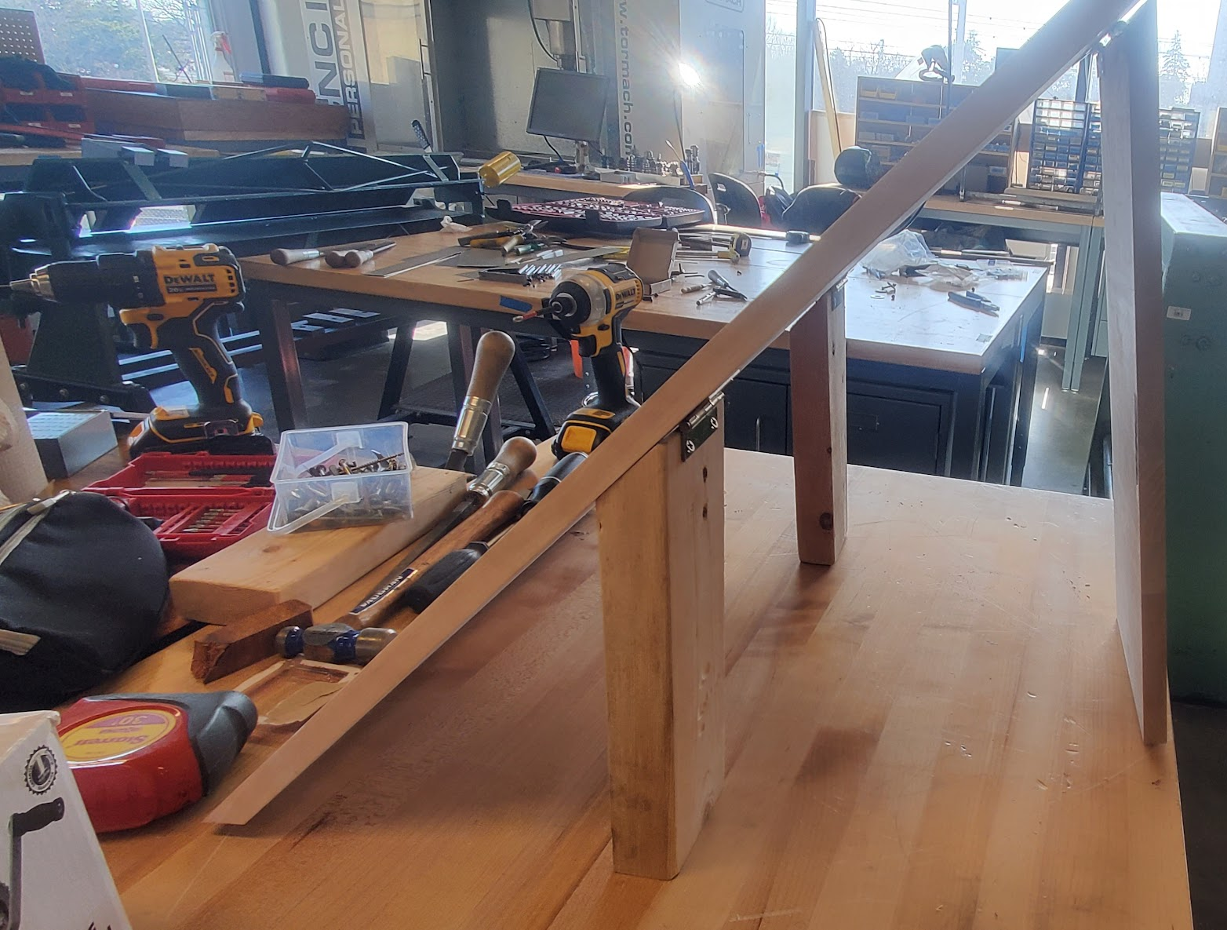  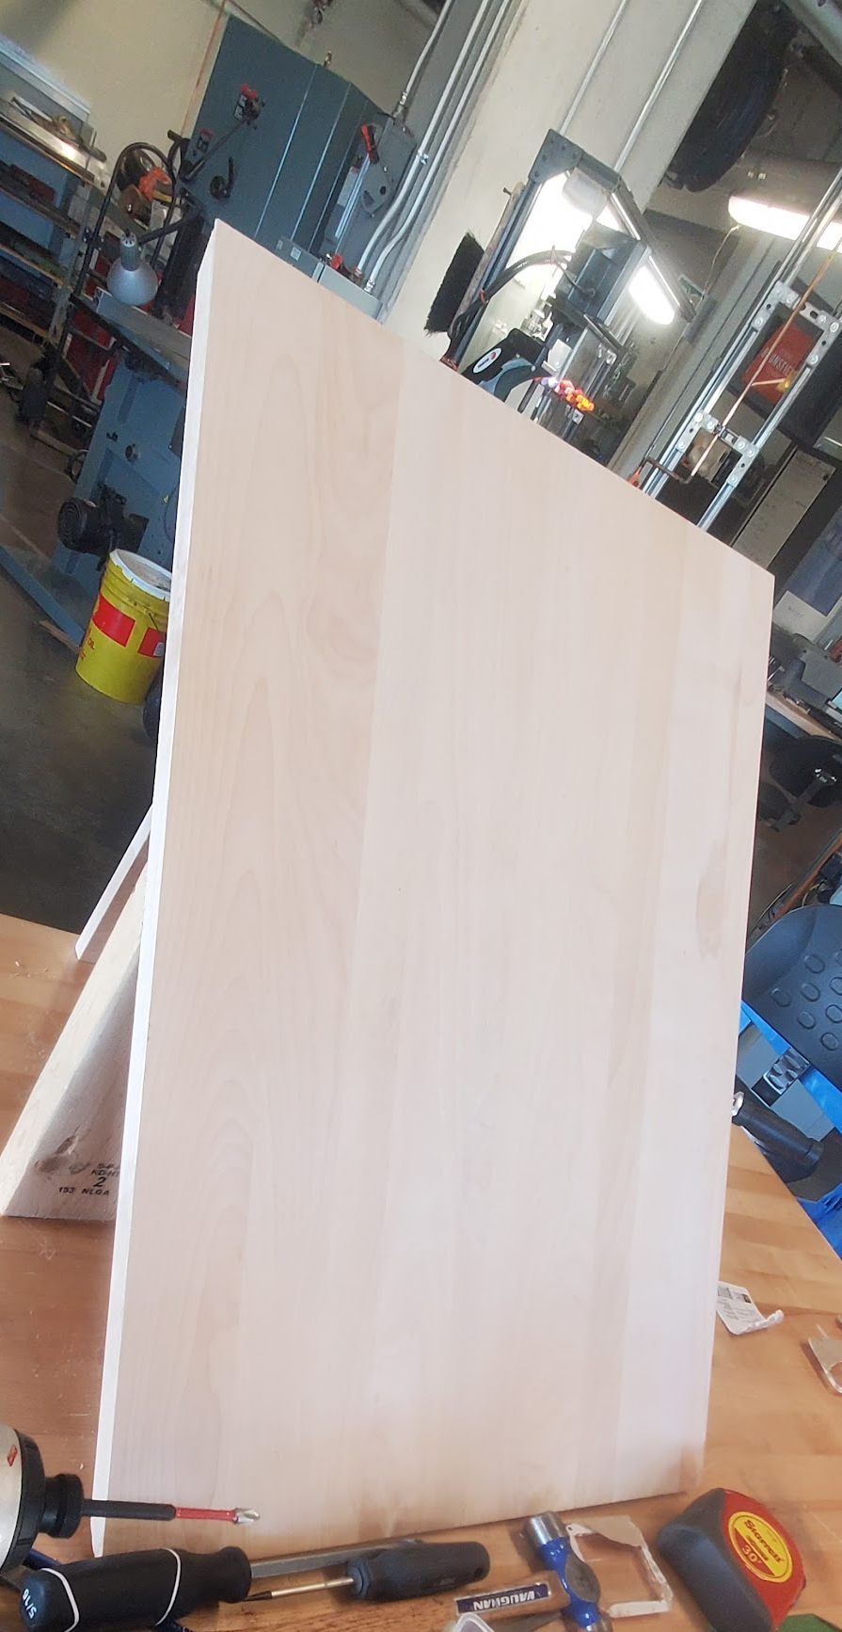

    - Next Client Meet Preparation
- Mention that the device needs a caregiver
- Talk about the headrest
- Address her feedback
- Prototypes tests and results
- Presentation link

Updated Prototype
The team consulted Alex during the testing and gained some feedback on the feasibility of the design:
-The headrest attachment would not be able to pull up 200 lb of weight in the current iteration. -The headrest attachment would most -likely snap during the pull because all the force will be directed to the piece and not benefit from the wheelchair weight we relied on.
What would be more feasible is to mount the winch lower on the wheelchair so that the weight distribution will be more balanced.
To improve our design, we came up with a new design; it begins with a three-bar base shaped as a triangle. Attached to this base are 3 metal flanges to which the wheels for movement are mounted. There is a fourth steel bar extruding from the tip part of the triangle to not cause any rotation or swaying. From this extruding bar, there is a hook-like shape at the top that’s purpose is to be placed into the headrest slot of the wheel chair for stability purposes. Finally, there is a steel flange placed at the bottom of the extruding steel bar to which the winch will be mounted. By keeping the weight of the winch at the bottom, we increase the chances of a more stable mechanism. The wire from the winch will be guided through the pipe that follows the profile of the structure up to the headrest area.

Updated CAD Model:
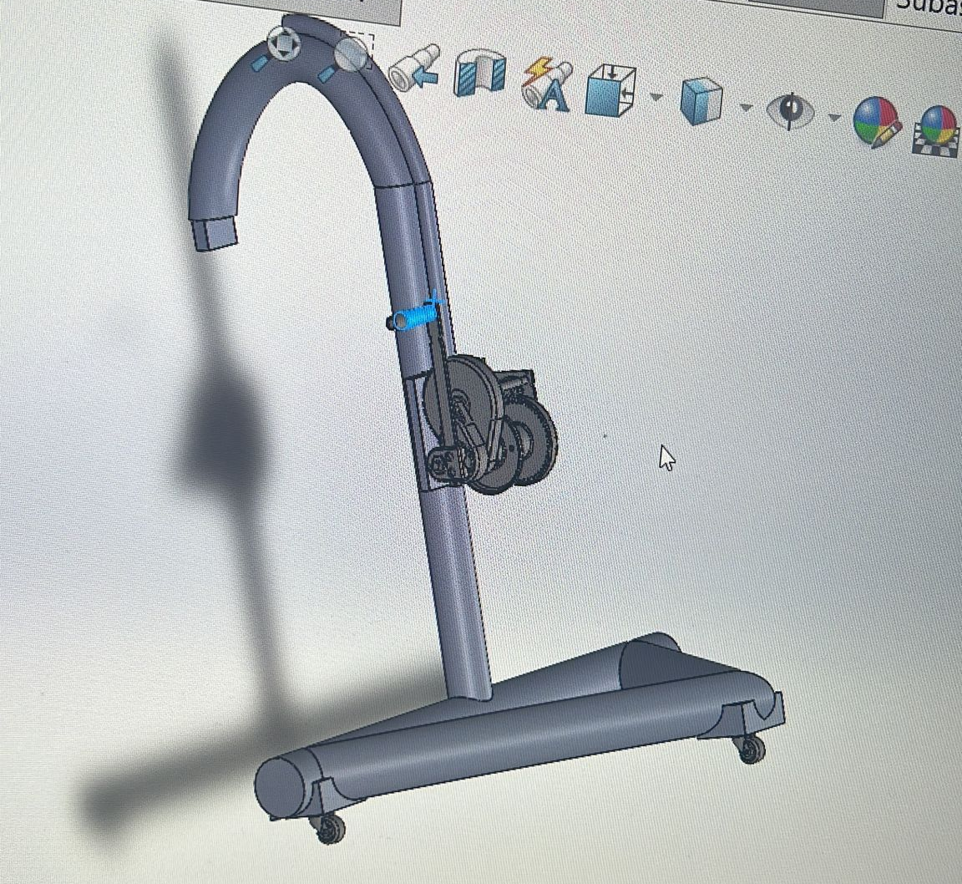

Gantt Chart Update (Deliverable F)
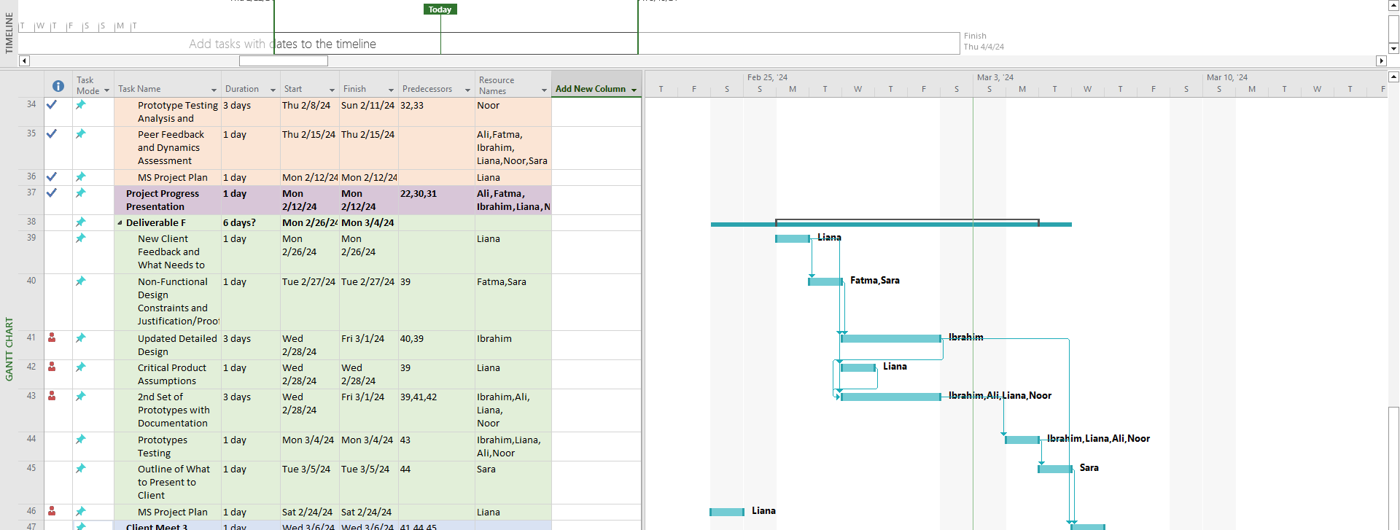

PDF Snapshot of Full Gantt Chart:
https://drive.google.com/file/d/1Qfas_crZuKQYTYA9iVOnQyihLc9eKmu0/view?usp=drive_link

Economics Report

Cost Classification
Materials | price per product | Variability of cost | indirect or direct | type of cost
Pull up bar |  | Fixed | direct | material
Straps |  | Fixed | Indirect | Material
Manual Winch |  | Fixed | Indirect | Material
Fabric |  | Fixed | Indirect | Material

3-Year Income Statement
Year 1 (2024):
Sales Revenue:
- price per device: $599
- number of device sold (estimated): 1,000
- total sales revenue: $599*1,000 = $599,000
Cost of goods sold:
- Cost per device (including manufacturing, materials and labour): $476.28
- number of device sold: 1000
- total “cost of goods sold”: $476.28*1000 = $476,280
Gross profit:
- gross profit = sales revenue - Cost of goods sold
- gross profit = $599,000 - $476,280 = $122,720
Operating expenses: this includes expenses like salaries, marketing rent, etc. Estimation at: $100,000 for the first year.

Operating income:
- Operating Income = Gross Profit - Operating Expenses
- Operating income = $122,720 - $100,000 = $22,720

Year 2 (2025):
Sales revenue:
- assuming 10% increase in sales. so, estimated devices sold = 1000*1.10
= 1100
- total sales revenue: $599* 1100 = $658,900
Cost of good sold:
- no change in the cost structure, fixed at $476.28 per device
- total “cost of good sold”: $476.28*1100 = $523,908
Gross profit:
- gross profit = sales revenue - Cost of goods sold
- gross profit = $658,900 - $523,908 = $134,992
Operating expenses: Assuming a minor increase in expenses to $101,000 due to potential expansion and inflation.

Operating Income:
- Operating Income = Gross Profit - Operating Expenses
- Operating Income = $134,992 - $101,000 = $33,992

Year 3 (2026):
Sales revenue:
- assuming another 10% increase in sales. so, estimated devices sold = 1100*1.10 = 1210
- total sales revenue: $599*1210 = $724,790

Cost of good sold:
- no change in the cost structure, fixed at $476.28 per device
- total “cost of good sold”: $476.28 *1210 = $576298.8

Gross profit:
- gross profit = sales revenue - Cost of goods sold
- gross profit = $724790 - $576298.8 = $148491.2

Operating expenses: Assuming a minor increase in expenses to $102,000 due to potential expansion and inflation.

Operating Income:
- Operating Income = Gross Profit - Operating Expenses
- Operating Income = $148491.2 - $102,000 = $46491.2

NPV Analysis
Assuming a Total “Cost of Good Sold” of $476,280 for the first year (see above) and $100,000 of operating expenses, we will break even at $576,280. With a cost of $599 per unit sold, we will break even at $576,280 / $599 = $962.07 units sold.Assuming that we sell 1,000 units, our operating income is positive and we break even in the first year, so an NPV analysis is unnecessary.

Cash flow diagrams

Year 1:

Cash inflows | $599,000, Sales Revenue
Total Inflows | $599,000
Cash Outflows | $476,280, “Cost of Good Sold”
 | $100,000, Operating Expense
Total Outflow | $576,280
Balance | $599,000 -$576,280 = $22,720

Year 2:
Cash inflows | $658,900, Sales Revenue
Total Inflows | $658,900
Cash Outflows | $523,908, “Cost of Good Sold”
 | $101,000, Operating Expense
Total Outflow | $624,908
Balance | $658,900 - $624,908 = $33,992

Year 3:
Cash inflows | $724,790, Sales Revenue
Total Inflows | $724,790
Cash Outflows | $576,298.8, “Cost of Good Sold”
 | $102,000, Operating Expense
Total Outflow | $678,298.8
Balance | $724,790 - $678,298.8 = 46,491.2

Assumptions Made
Assumption 1: We will sell 1,000 units per year.

By assuming that we have finished our product and entered the production phase, it is assumed that our company will adopt a concrete customer base in manufacturing our product efficiently. For this exercise, a realistic target has been set to selling 1,000 units annually. This translates to a daily output of 10 units (1,000 units/100 working days). It is reasonable to say that 1,000 units could be sold, annually by taking the following actions.

- Putting advertisement for our product
- offering shipping nationally or internationally
- contact care facilities for potential interest in buying the product etc.

Assumption 2: Sales increases by 10% annually
By assuming that our estimates above are reasonable and that it is possible to sell 1000 units annually, it is therefore we can confidently project a 10% increase annually. This increase is by taking new salaries, and our new income and investing in it to increase our sales and profit. For instance, we could invest in a method of new marketing where it would spike our sales, expand our new market and many more other methods. Overall, any combination of an advertising method could allow us for a 10% increase in sales over a year.

Assumption 3: Operating expenses increase by $1000 annually.

Rent and the salaries should stay constant assuming that no large changes are done to the company. However, we've outlined that if we assume that we are going to invest in better marketing and create new sales, we should consider that extra logistics and marketing would be needed. As a result, increasing the operating expenses by approximately $1000 per year is reasonable to state.

Intellectual Property Report

Sling bars, methods for attaching a subject sling to sling bars, and lift systems using sling bars (United States Patent 11767198)
Patent was avoided because the country it was issued from is the United States

Pull-Up Bar (United States Patent Application 20150024907)
Patent was avoided because it is only valid in the United States

Gantt Chart Update (Deliverable G)

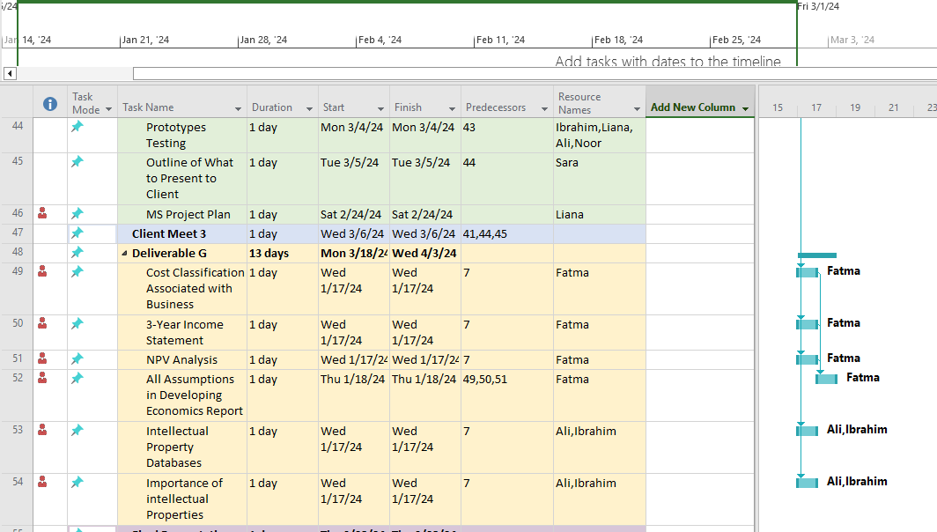

Design day preparation

Design day pitch

The problem we have related to mobility is the inability of individuals with disabilities to help themselves back into their wheelchairs once they have fallen out as a result of a transfer error. Why is this problem so important?

A PubMed study found that 46.3% of wheelchair users fell forward, and injuries occurred in over half of these occurrences, accounting for 57.4% of reported falls. This demonstrates the risk and importance of finding a safe solution to lift users. Our device makes a big step towards guaranteeing user freedom and well-being by reducing fall-related injuries, of which 15.8% were severe and included fractures. [1]

Our winch technology fills a major void in mobility and safety by helping wheelchair users recover with minimal help after a fall. By increasing user autonomy, this system lessens the need for a lot of physical outside assistance, which has a favorable impact on everyday functioning and mental wellness. It offers a safer method of getting back into wheelchairs, which could reduce medical expenses by reducing the likelihood of accidents and promoting more general accessibility objectives.

Our product provides safe transfer using an electric winch attached to a pull-up bar for minimal effort. The winch hook is then attached to a transfer chair that the user will be sitting on. The user is then lifted using the remote control of the winch. The caregiver can bring the chair under the client and lower them down safely.

Our mobility aid solution is a small, portable device designed to make life easier for individuals with mobility challenges. Our device is like a pull-up bar, offering convenience without sacrificing safety or reliability. It's small enough to fit between a door and easy to dismount, so you can move it to any indoor area with a door. In contrast to expensive and bulky alternatives that demand physical strength from users and caregivers, our solution is accessible, providing lifting support for indoor use.
Our design is user-centered and focuses on user experience, being accessible and aims to cater to a wide range of disabilities while being affordable and portable. Due to our main subsystem being a pull-up bar, it’s very accessible to most households and doesn’t require any additional custom or complex components to use, making it very simple and intuitive.

Show the video tutorial.

Presentation Link

Design Day Poster Board

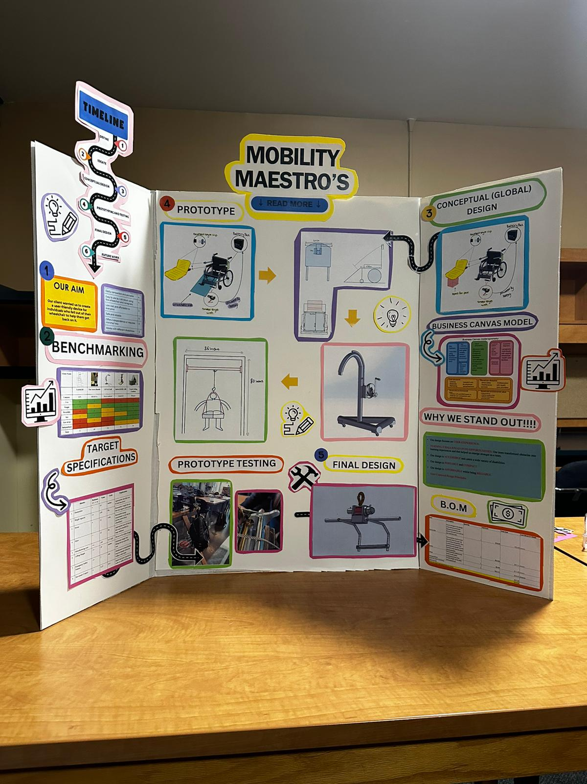

Video and User Manual

User Manual Link
Video Tutorial Link

Gantt Chart Update (H)

PDF of Full Gantt Chart:
https://drive.google.com/file/d/1_M7nRDoS3yU15od2EKRwikuGPnmh72q8/view?usp=sharing

Conclusion

In conclusion this document includes most of our process in designing the final product. From the very early stages like defining the problem, the client's needs, benchmarking, and the DfXs to the later stages including all the prototypes and the design changes we had to do to satisfy our client. The document also includes an economic statement showing cost classification, a 3-year income breakdown as well an NPV analysis including all assumptions we made making the report. This document showcases design day preparation, including our judges' pitch and the visuals we used. Finally, we added links to the user manual and video tutorial.

Bibliography

[1] https://pubmed.ncbi.nlm.nih.gov/7917161/#:~:text=Among%20the%20577%20appropriate%20respondents,%25%20backward%20and%2024.2%25%20sideways.

