GNG 1103C-16
Connor, Garret, Dylan, Leo
Project Deliverable D:
Conceptual Design

Introduction:
When designing a vertical hydropic system, it is important to create conceptual designs in which you can analyze to obtain feedback on your design process. Our group has come up with multiple sketches for these designs. Our designs prioritize on the focus of portability, cost efficient, and ease of use. Our concept will stay true to our problem statement and we will use our design criteria to remain focus on what is most important. Doing this will allow us to modify our concepts and enhance them to make sure that they become fully functional solutions.
Individual Designs:
Garret:
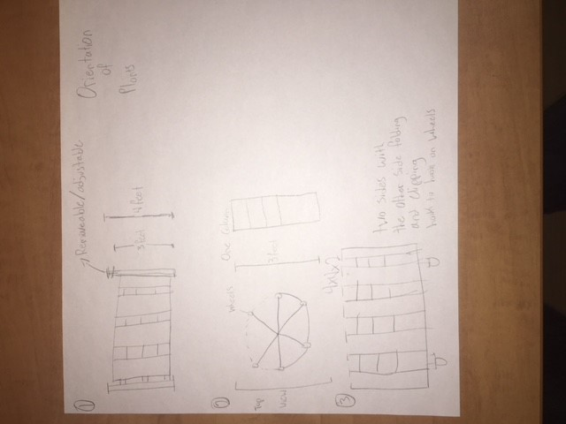
The first model being considered is for accessibility purposes. The problem with other solutions portability and traveling with the unit. The two bars slide up and off the hooks of the actual tank for easy portability. The tank can be then rolled on wheels. The hydroponics system can be adjusted to any height, this allows all students to reach the plants.

With this hydroponics system it can be used in a gallery type of viewing to showcase a lot of plants. The system is easily to push having 6 wheels for mobility purposes. Each one of the 6 sections can hold up to 4 plants allowing a total of 24 plants.

One of the larger systems that can be possibly considered for building is a grow wall that can be converted into a two sided hydroponic system. The top of the grow wall can be folded down to clip to the secure hooks on the wheels. The downside is, a parent might have to help with the folding. The system is really good for portability as it is not really big when folded.
Connor:
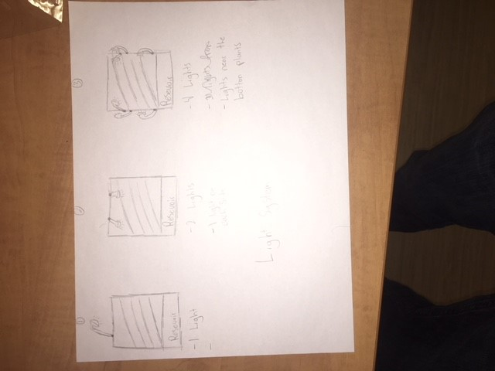
The first design has only one light source. This is the most cost efficient of the three designs, however this design allows the plants to have the least amount of lights. Often what happens is when the plants grow too big the plants at the top cover the light from the plants at the bottom. This is a huge downfall when considering this design.
This second design allows both sides of the plants to be covered with light. This is less cost efficient then the prior design but allows plants to have two sources of light. This design does not solve the main issue though, the lower plants still get blocked by the higher plants when they grow too large.
This third design is the least cost efficient but allows the plants to get the most light possible. This is the idea of having lights on the supporting rods lower down the system so when the plants grow too large, the lower plants still get light from a source. This design can be reduced in cost by only using 2 lights where maybe they can be adjustable.

Dylan:
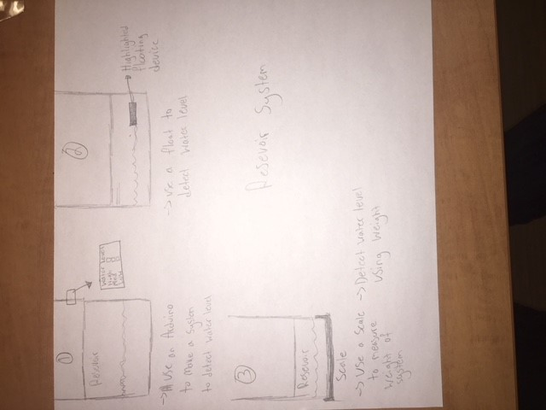
This design uses an Arduino to develop a software that can detect the water level and produce and output that tells the viewing what the water level is. For example, if the water is full it will be green, if the water needs to be filled It will be red. This is the most practical and efficient design.
This second design is a not very practical. The highlighted floating device would be able to be seen through the reservoir, or it is attached to something at the top, when the object at the top is no longer there, you need to fill the water. This system is very complicated and overall just not practical.
The third is not a very practical design. Using a scale to measure the whole system then when the weight falls below a certain point you need to fill up the reservoir. You would need to have the whole system be on top of a scale, this is not very practical.
Leo:
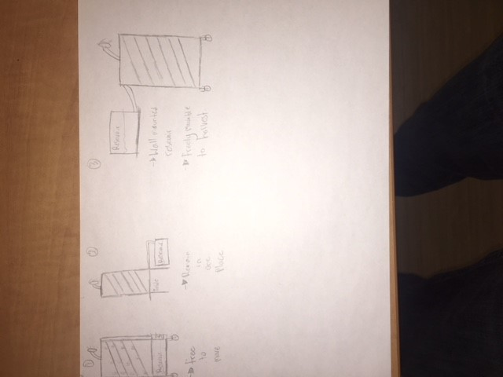
This first design is to have the system all attached together and to be on wheels. This means it is all very transportable and easy to move and fill up. The pump and hose will act as a support beam a long the side as well.
This second one’s design limits the mobility of the system. The only thing than can be removed is the reservoir so you can fill it up. This does make it easier to fill up, however it makes moving the whole system very difficult.
The second is the opposite idea to the one above. Wall mounting the reservoir keeps its one place so nobody has to touch it. If there is a problem with the reservoir you can just move the system to another reservoir. The plants and lights are on wheels, therefore they are portable however the reservoir is not.

Conclusion:
After creating conceptual designs for subsystems of the hydroponic system, we will continue to further develop these ideas. Using the best subsystems from all the designs will allow us to create the easiest and most portable hydroponic system. The design that we will be further enhancing is Connor’s third conceptual design. This design sums up our problem statement the best and we see as the most viable and most feasible option. Any of these other designs can be used as backups as they are all viable options.

