Project Deliverable C: Design Criteria and Target Specifications

GNG 1103 – Engineering Design

Faculty of Engineering – University of Ottawa

By: Zaineb Wadood, Rebecca Heller, Matthew Schroeder,
Benjamin Kelly, Cameron Caudle

February 21 2024

Introduction:

This deliverable focuses on the development of our project plan and a schedule for prototyping and testing the solution to our customer's needs. Furthermore, we will show our agenda by using tables, which will include the important dates, critical risks and contingency plan, cost of our materials and prototyping test plan. There will be three prototyping deliverables as listed below.

Final Idea:
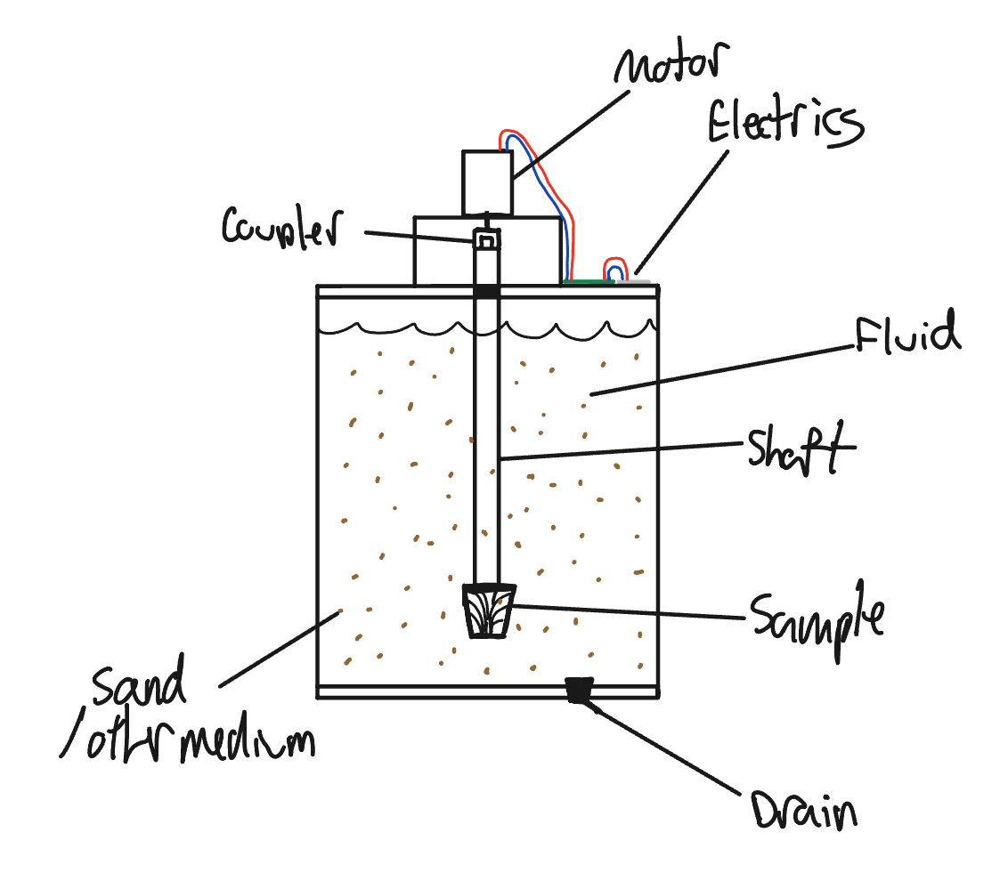

Figure 1 visual sketch of erosion tester

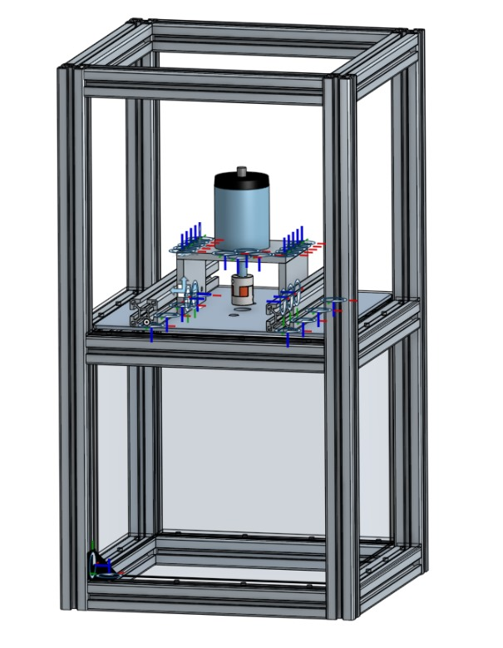
Figure 2 CAD design of erosion tester

Project Plan:

# | Task | Estimated Duration | Who is responsible
1 | Collect Materials | 1 day | Cameron  Zaineb  Matthew  Benjamin  Rebecca
2 | Assembling Prototype 1  (Deliverable F) | 2 days | Cameron  Zaineb  Matthew  Benjamin  Rebecca
3 | Analyzing Prototype 1 and Testing | 1 day | Cameron  Zaineb  Matthew  Benjamin  Rebecca
4 | Assembling Prototype 2  (Deliverable G) | 2 days | Cameron  Zaineb  Matthew  Benjamin  Rebecca
5 | Building Wood frame | 1 day | Cameron  Matthew  Benjamin
6 | Prototype 3  (Deliverable H) | 2 days | Cameron  Zaineb  Matthew  Benjamin  Rebecca
7 | Fixing Final Prototype Post Testing  (Final Touches) | 1 day | Cameron  Zaineb  Matthew  Benjamin  Rebecca
8 | Prototype Display | 1 day | Rebecca  Zaineb
9 | Design Day | 1 day | Cameron  Zaineb  Matthew  Benjamin  Rebecca
10 | Final Presentation  (Deliverable I) | 1 day | Cameron  Zaineb  Matthew  Benjamin  Rebecca
11 | Final Report  (Deliverable K) | 5 days | Cameron  Zaineb  Matthew  Benjamin  Rebecca

Cost Spreadsheet:

Item# | Material | Element | Quantity | Dimensions | Unit Cost | Total Cost | Getting from
1 | Sand | Abrasive | 1 cup | None | $0.00 | $0
2 | Acrylic | Tank | 1 | 350x350mm | $8 | $8 | Boreal Power System
4 | Motor | Rotates Shaft | 1 | 78x100mm  RPM at Nominal Voltage: 5600  Stall Torque:5Nm | $50.00 | $50.00 | Boreal Power System
5 | Stainless steel rod | Shaft | 1 |  | $8 | $8 | Boreal Power System
6 | aluminum/rubber | Coupler | 1 | 40x30mm | $3 | $3 | Boreal Power System
7 | Washers | Fasteners | 36 | M6 | $.02 | $0.7 | Boreal Power System
8 | Screws | Fasteners | 36 | M6x16 | $0.10 | $3.50 | Boreal Power System
9 | Water (in Liters) | Liquid | 5 | N/A | $0.00 | $0.00
10 |  | Power Supply | 1 | 24v DC  42A | $15 | $15 | Boreal Power System
11 | Arduino Board | Controls | 1 | ‎8x5.51x2.49 cm | $0.00 | $0.00
12 | Aluminum plate | motor support

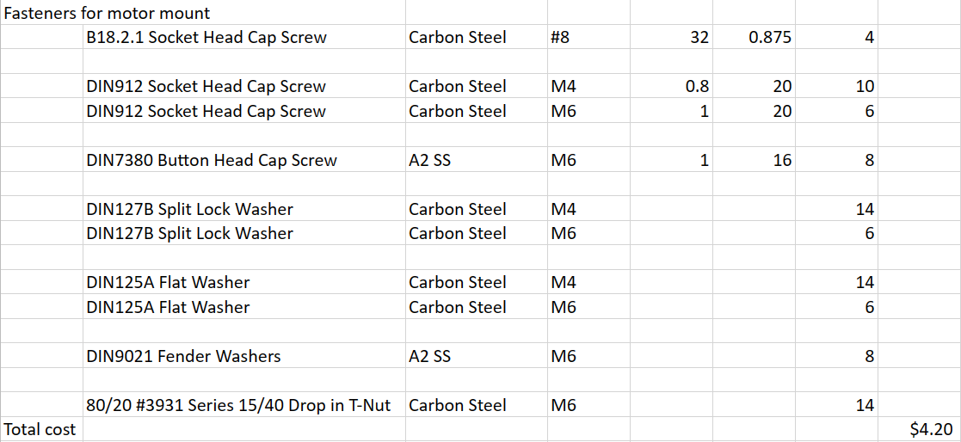
From Boreal Power System

Total Cost: $77.40

Critical Risks:

- Imbalance in shaft and sample components can lead to excessive vibrations
- Components breaking
- Not being able to source components
- Final design fails to erode sample
- Cost Overruns
- Functionality Issues (might not perform as expected)

Contingency Plan:

- Have spare components available
- Find a substitute that can supplement
- Use the backup idea, a styrofoam sample
- Look at the availability of components before using them
- Use a realistic material for the sample
- Re-evaluate the budget and see where we can cut costs
- To avoid functionality issues regular testing and user validation may be helpful

Prototyping Test Plan:

Test ID | Test Objective  (Why) | Description of  Prototype used and of  Basic Test Method  (What) | Description of  Results to be  Recorded and  how these results  will be used  (How) | Estimated Test  duration and  planned start  date  (When)
1.0  Test the water tightness of the acrylic tank system | Make sure tank is waterproof | Fill tank with water, and let it for an hour. | Qualitative | 1hour  24/02/24
2.0  Arduino control | PWM motor control functions | Test to insure that arduino is producing correct PWM signals for motor drive circuitry | Qualitative | 30min  29/02/24
2.1  Arduino control | Emergency stop | Test to make sure emergency stop functions, by cutting the power. | Qualitative | 10min  29/02/24
3.0  Motor lid assembly | Looking for excessive current draw and vibration | Initial operation of motor and stub shaft a low rpm (100rpm) | Qualitative | 15-20min  1/03/24
3.1  Motor lid assembly | Looking for excessive current draw and vibration | Operation of motor and stub shaft max rpm | Qualitative | 15-20min  1/03/24
3.2  Motor with sample shaft | Looking for excessive current draw and vibration | Operation of motor and shaft at low rpm (100rpm) without sample | Qualitative | 15-20min  1/03/24
3.3  Morot with sample shaft | Looking for excessive current draw and vibration | Operation of motor and shaft at max rpm without sample | Qualitative | 15-20min  1/03/24
3.4  Morot with sample shaft and sample | Looking for excessive current draw and vibration | Operation of motor, shaft, and sample at nominal rpm with sample | Qualitative | 15-20min  1/03/24
4.0  Erosion acceleration test | Looking for excessive current draw and vibration | Operation of motor and shaft at max rpm without sample | Qualitative | 1 week  10/03/24
5.0

Conclusion:

In conclusion, the project plan and schedule presented here aim to guide our team through the development of three prototypes to meet our client's needs. By breaking down the tasks, assigning responsibilities, outlining costs, and identifying potential risks with contingency plans, we aim to ensure a smooth progression towards our final goal.

