Project Deliverable C: Design Criteria and Target Specifications

GNG 1103 – Engineering Design

Faculty of Engineering – University of Ottawa

By: Zaineb Wadood, Rebecca Heller, Matthew Schroeder,
Benjamin Kelly, Cameron Caudle

February 3 2024

Description: This document describes the specific design criteria that are required for each and every aspect of our erosion testing machine. Below we have a table with priority of each need, description and design criteria to understand what is required for our design. This document also includes the functional and non-functional requirements as well as the constraints necessary to build this erosion testing prototype.

Priority # | Needs | Description | Design Criteria
1 | This device is reproducible | Develop a device that allows for repeatable tests with different materials and conditions | - On/Off button  - Keep the motor at the same speed always
2 | The device should be measurable | Provide a clear display of results for each test to showcase erosion effects | - Measure erosion by weighing the material  - Taking before/after pictures  - Measuring weight of sand before and after
2 | This device must be cost effective | Utilize easy and accessible materials for construction. Follow the principle “beg, borrow and steal” | - Plastic bucket (to hold liquid and material)  - Styrofoam (material used for erosion testing)  - Sand (free)  - Water  - Motor  - 3D print gears maybe
1 | This device must be safe | Operates at atmospheric conditions, no pressurized components. Limit RPM to 2000 or below for safety and to obtain erosion results within a week. Temperature must be below 40 C | - Room temp water  - Safety googles in case things blow out  - Lid to ensure water doesn’t splash around
3 | This device must be time efficient | Design a device that simulates erosion within 2 weeks to a month | - Prototype 1: test the device to see if its time efficient  - Put abrasives such as sand to ensure it erodes faster
4 | This device must be visually appealing | Design the system to have a presentable appearance, without requiring exquisite aesthetics. | - Must be quiter then a pressure washer  - Clean  - Cable managment

Constraints:

Design Sepcification | Value | Units | Verification method
Spinning shaft Speed | >= 2000 | rpm | Mesure
Erosion testing time | <= 1 week | Days | Keep track
Cost | < 100 | $ | Keep track
Operating temperature | < 40 | °C | Use thermometer if necessary or keep it room temperature
Operating conditions  (sand) | N/A | N/A | Testing
Reproducible  (On/Off button) | N/A | N/A | Testing
Drained and filtered | Must be less then original weight of the eroded material | mg | Measure weight before/after testing
Weight | <=10 without water | kg | Measure

Functional Requirements:
- Must simulate erosion/demonstrate how our device would conceptually simulate erosion on a rock core sample.
- Must be safe to use
- Must be cost effective

Non-Functional Requirements:
- Looks professional and well constructed
- Minimal environmental impact

Target Specifications:
- Shape such that it stirs the water and keeps the sand suspended
- Water volume: Enough to completely submerge the sample
- Frame must fit over a plastic Home Depot bucket and have enough area to support a motor and control systems
  - We will find dimensions once the bucket is purchased

Design Specifications:
- Target Size:
  - Max diameter of target: 150mm
  - Max thickness of target: 50mm
  - Max weight of target: 20kgs
    - Max density of target: 22.6g/cm^3 (Note: Iridium is 22.5g/cm^3)
- Tanks size:
  - Length and width should be a multiple of target diameter so that fluid flow over target is not affected by reflection of tank wall(i.e 3 or 4 times - 450-600mm
  - Height should be a multiple of the target height such that the target plus any mounting/clamping devices or shaft bearings are accommodated such that they are not affected by tank bottom or lid (i.e. 4-6 times 200-300mm)
  - Tank Lid should be selected to
    - Accommodate the weight of the Motor and all shaft bearing and attachment parts.
    - The weight of the target
    - The combined weight of lid, motor, shafts, target will be approximately 30- 40kgs.
    - Erosion Tester should have a lift system to allow for easy lid removal and support for changing of targets
- Speed of Rotation: Max 1500rpm
  - 1500 rpm is selected to reduce 1yr of erosion down to less than a week depending on temp.
  - Motor selection has to be able to spin 20Kg target plus the weight of any target holding devices at 1500 rpm.
- Operating Pressure: 100kPa (1 Atmosphere)
  - Simple design – no requirement for pressure vessel design 5)
- Liquid:
  - PH Range should allow for weak acids to weak alkyds.
    - 4 < PH< 10
      - Water, Heavy Water in Range of 6.5-7.5
      - Glycols or heat transfer in the range of 9-10.
  - Should be able to be easily drained from the tank.
  - Should be able to head to 40C without affecting the tank material.
- Operating Voltage:
  - 120 – 240 Vac 60Hz
  - System should handle ground fault conditions to prevent electrocution through the liquid.
- Operation Interface:
  - Graphical Touch Screen to set the following parameter.
    - RPM
    - Temp
    - Target Weight – for motor acceleration calculations
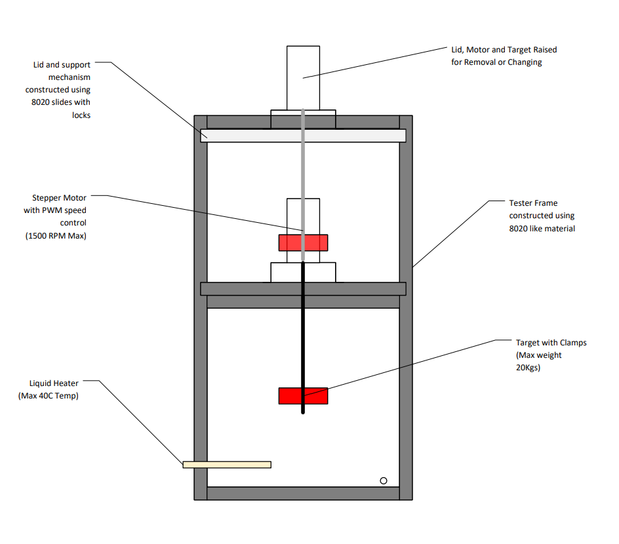
Figure 1. Prototype drawing of erosion tester

Technical Benchmarking:
- Other rotational erosion testers utilize a similar design with variable conditions such as:
  - Decreased rmp which prolongs the testing time
  - Various temperatures depending on the target material and the desired duration of the test
  - Some operate with different fluids to simulate erosion in real like fluid examples
  - Depending on the material, the max weight limit would be around 20kg in order to test exotic materials due to their increased density (more common in the nuclear industry)

Conclusion:

In conclusion, the development of the erosion testing system has been guided by a thorough analysis of both functional and non-functional requirements, aligning with the client's needs and priorities. These requirements outline the specific features and capabilities necessary for the system to perform erosion tests effectively, ensuring reproducibility, measurability, cost-effectiveness, safety, time efficiency, and visual appeal. These requirements provide a roadmap for the technical development of the system, ensuring it meets the core objectives set by the client.

