Project Deliverable H - Group 5

Prototype III and Customer Feedback

GNG1103-C01
November 26th, 2023

Noor Trigui 300350022
Ava Butts 300350306
Luca Chayer 300375838
Dev de Haan-Sharma 300339994

Table of Contents
Table of Contents 1
Introduction 2
Prototype Plan 2
Prototype Description 3
Links to Prototypes 5
Test Results & Observations 5
Specifics of the Tests 5
Test 1 Results and Observations 6
Comments From Users in Response to Questions 5 and 6 6
Test 2 Results and Observations 7
Summary of User Feedback 7
Updated Test Plan & Next Steps 8
Overview of Prototypes and Tests 8
Updated Bill Of Materials 10
Conclusion 10
Wrike Link 10

Introduction

Through the continuous development of our prototype for Mines Action Canada we have integrated assets and have programmed codes to help with the progression of our final prototype. All iterations to previous versions of our project work to address our problem statement as well as client and user feedback, ultimately exploring both the societal and personal impacts of autonomous killer robots with a focus on dehumanization and possibilities for racial prejudice and injustice, aligned with research suggested by the clients. This prototype goes beyond the technicalities that were important for the others (interactivity and movement) and instead delves into the adjustments that would arise in the presence of killer robots such as boarded windows, posters and reminders, fallen objects, and addition of masks. As this is the final prototype before Design Day, our tests include both quantitative and qualitative components to get more data for possible improvements.

Prototype Plan

This prototype is intended to be our highest fidelity prototype of the semester. Our goal for this prototype is to have our house assets include all of the adaptations to life with killer robots, to ensure that the transition between the inside and the outside of the house is seamless and to iron out the kinks of our previous deliverable. This prototype will be tested based off of the 6th and 7th Test ID’s from deliverable E. The stopping criteria for this prototype is to ensure that the house includes all of our modifications and fits our intended wartime vibe and to ensure that the transition from the inside of the house to the street is seamless. Future prototypes will work on our sound subsystem and will add more interactivity with the scene.

Test ID | Objective  WHY | Prototype & Test Description  WHAT | Results to be Collected  HOW | Estimated Time  WHEN
6 | Adjust the house asset to show the effects of autonomous killer robots (see project plan for these elements) | Examine the window and radio (scene 1) and the window, masks, and signs (scene 2) making sure that they are realistic and visible no matter how you move around the scene | Qualitative observations to check that the scenes are realistic and fit our intended message | Could easily take a couple hours to make adjustments to the surroundings and possibly even to the code of the VR
7 | Ensure that the transition from the indoor to the outdoor environment is seamless and doesn’t cause any lagging or discomfort | There must be a virtual door that users can interact with to exit the house as well as an animation of the door opening to reveal the outside environment (similar elements in every house - curtains over windows, locked doors, etc.). Some lighting changes would make the outdoor setting more realistic | Qualitative observations to check that the scenes are realistic and that the transition does not introduce any performance issues, such as lagging | May take about one hour to code and test the transition but some adjustments may need to be made to the outside world which would take a longer period of time (about an hour or two more)

Prototype Description

In order to address out goal of Realism, we added boarded windows, a toppled chair, two posters, and a smashed TV. We also integrated the door opening mechanism from the first prototype into this one.

Boarded Windows & Toppled Shelves

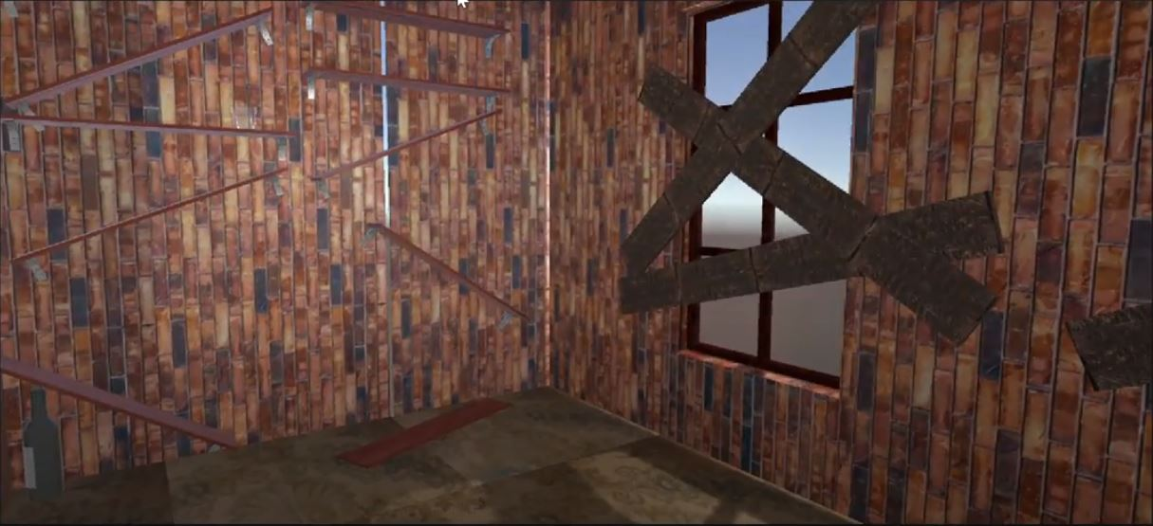

Toppled Chair

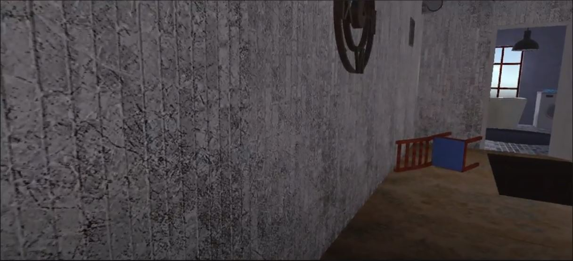

Posters

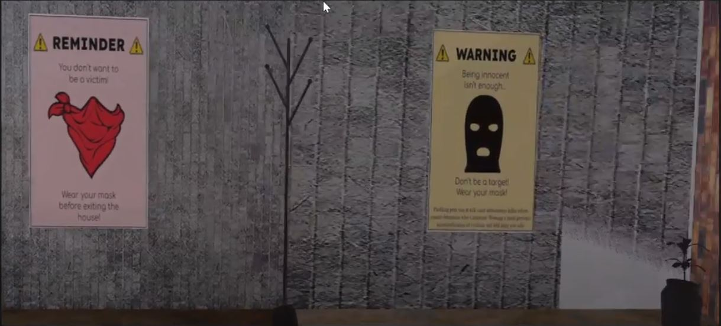

Smashed TV

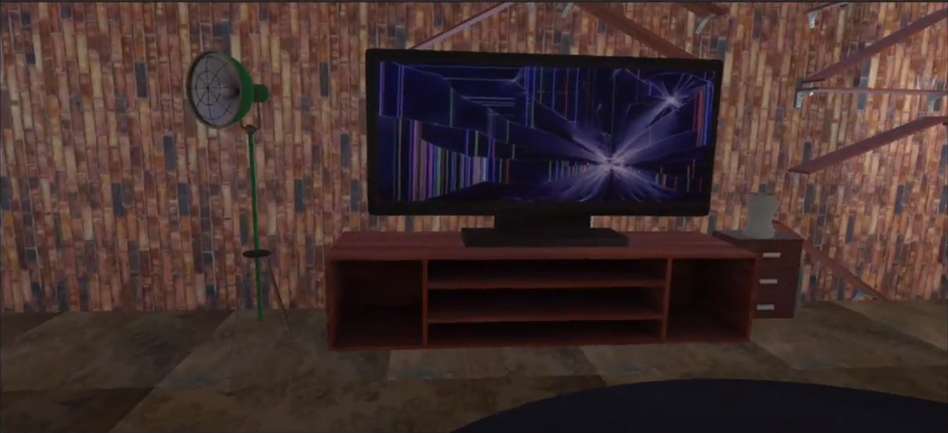

Door Opening

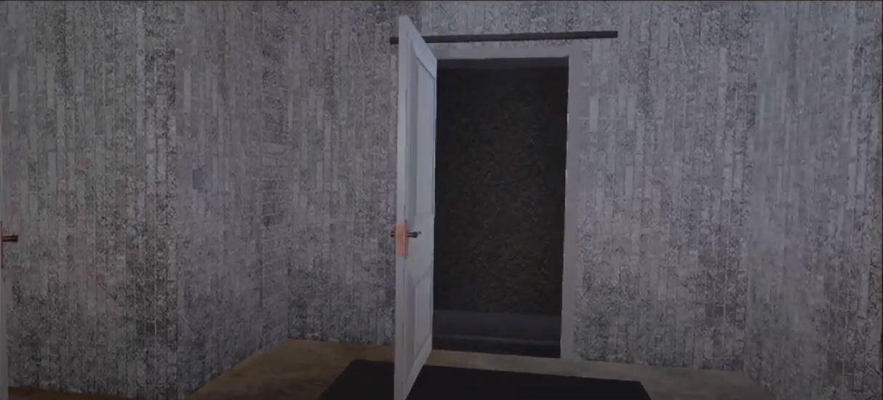

With these updates in the assets, we needed to add colliders to each one of the objects to ensure that the character would not run into them. This change also addresses some of the user feedback from the last prototype where they found that they could run into the wall or sofa, for example. Additionally, we added a roof made of the wooden planks to make the house more realistic. Various textures were created and imported into the design adding an element of creativity and showing how the person in the house may have adapted to life with autonomous killer robots. Currently, the outside area past the door is a black screen which gives an ominous feeling if we need to stick to that for Design Day. However, we plan on integrating an asset for the outside and making some slight alterations to it, corresponding to Scene 3 of our storyboard. Future goals will include adding the sound effects and the radio broadcast, wich will play throughout the video, as well as updating the code so that it can be used with the VR headset.

Links to Prototypes

Posters | Demo Video
Warning signs | Design Project - Demo

Test Results & Observations

We decided to run two tests on this prototype to see if our prototype was a success. These tests were based off of test ID 6 and 7 from our overview of prototypes and tests table.

Specifics of the Tests

1. Our first test will involve qualitative observations and poll data as to how much our adaptations send our intended message of humans adapting to life with killer robots. We showed 5 of our roommates and friends our scene and then asked them a series of questions to gauge their feelings about our scene. Four of the questions were asked on a scale of 1 to 5. We deemed that if the aggregate scores for the numerical questions were over a score of 17 then that portion of the test was deemed successful.

The questions were:

- On a scale of one to five how much does our scene resemble how you imagine life to be in a world with killer robots?
- On a scale of one to five how “grungy” is our scene?
- On a scale of one to five how much does our scene resemble a familiar environment?
- On a scale of one to five how unappealing does this house appear?
- How does this scene make you feel?
- Any other comments?

2. Our second test will be a mix of qualitative observations and data. This test will be run by five different users and they will each do three trials. In each trial the user will try to exit the house via the door. Their success or failure will be noted and they will be asked how to describe how seamless and easy the transition was. There will also be qualitative observations as to the ease with which they proceeded through the scene.

Test 1 Results and Observations

The successful aggregate test results are highlighted in green and the unsuccessful result is highlighted in red. These results show that we can make our scene more realistic to user expectations.

Question Number | Aggregate Score
1 | 15
2 | 20
3 | 23
4 | 18

Comments From Users in Response to Questions 5 and 6

Question 5
- “This scene makes me feel uncomfortable and gross”
- “This scene is very unappealing and does not seem like a good place to live”
- “Seems like a trap house”
- “If this is what life is like with killer robots it is not a world I want to live in.
- “Ick”

Question 6
- “I don’t really know what a world with killer robots would look like but this seems plausible.”
- “I want more context as to why the house looks like this”
- “I like how the message of the simulation is subtle”
- “I don’t really understand what the point is.”
- “No further comments”

Test 2 Results and Observations

Percent of trials where the door was successfully opened - 73%

 | User Descriptions of Ease to Open Door | Our Commentary & Observations on Tests
User 1 | “Was intuitive, the door opened as I would expect it to in real life. The outside world is undeveloped though” | 3/3 on door openings and never had any difficulty opening the door on every trial.
User 2 | “There were gaps between the door frame and the door but otherwise it worked well.” | 2/3 on opening the door but paused every time to look at the door gaps.
User 3 | “At first it didn’t click that you could click anywhere on the door to open it but once I understood that it was easy” | 1/3 on door openings. Kept running into the door expecting it to open via proximity but on the third trial realized that you had to click.
User 4 | “I got caught on an invisible asset and couldn’t leave the door for one of the trials but otherwise it was good.” | On trial 2 user 4 went to open the door and succeeded but was unable to exit the house as they were caught on an invisible asset. Otherwise they had no issue.
User 5 | “It’s a door and it opens, what more is there to say” | 3/3 on door openings, it was quick and easy for them.

Summary of User Feedback

Our two tests determined that our prototypes were mostly successful. Our first test was 75% successful as 3 out of the 4 questions we asked achieved our 17 aggregate point threshold. Our second test also had around a 75% success rate at 73%. From our numerical tests and written feedback from our users we determined 3 major takeaways from this prototype. Our first takeaway was that for the most part the users were receiving our intended message that the house is a sad and tense place and it would not be a great place to live. This is encouraging as these are the feelings we intended the house to elicit as life in a world with killer robots is not fun. Our next takeaway is that our current assets might portray a message that is too subtle. The one question in test one that did not achieve our aggregate score threshold was the question “On a scale of one to five how much does our scene resemble how you imagine life to be in a world with killer robots?”. We suspect that this is because our messaging was not clear enough that this sad and decrepit home is a result of killer robots. This is an area of improvement for the future. Our final takeaway is that our door interactivity code is good but needs a little improvement. 73% success is good but we are aiming for a 90+% success rate. We are planning to improve our numbers by fixing the bug that prevented one of our users from leaving the house and making it more intuitive to leave the house. Our three takeaways from this deliverable will shape our future prototypes.

Updated Test Plan & Next Steps

At this point in the project, we have completed all of our planned prototypes and tests specifically focussing on Test ID 6 & 7 for this deliverable. The changes between this version of our project and the previous one include adjusting the house asset to show the effects of autonomous killer robots (boarded windows, masks, posters, radio) and transitioning from indoors to outdoors (Test ID 6 & 7, shown in green). These prototypes align with Goal 3 of our product development, which was realism, and future iterations will continue to add more sound effects and interactivity, aligned with client and user feedback (Test ID 8, shown in blue).

Overview of Prototypes and Tests

Test ID | Objective  WHY | Prototype & Test Description  WHAT | Results to be Collected  HOW | Estimated Time  WHEN
2 | Ensure the player can move properly | Set a list of paths meant to correspond to certain inputs, and run these using a “movement” script in an undeveloped environment. | Mostly qualitative observations of how well the program produces the desired movements. | Given we already have an idea of such a program, I assume it would take one hour to develop the script and test it.
3 | Ensure that the scenery is realistic based on the assets used | Import the assets into the scene and make sure that the movement still works. Update the scene to make it more realistic and fit our original storyboard | Qualitative observations to check that the scene is realistic and assets are successfully imported | It will take 20 mins to import the needed assets but we may take an hour or more to play around with it and adjust the scene based on our research and user feedback
4 | Ensure objects can be interacted with | Design a simple code that produces a response when the user interacts with an object. Run this code through an undeveloped environment with a designated object to be interacted with. | Qualitative observations on if the object responds to interaction as intended. Designate one clear change in behavior, such as change in color. | Given the simplicity of the test, this should only take an hour to develop and test.
5 | Ensure that movement works in closed environments (the house where most of the VR will take place) | If the program from test 1 runs successfully, it can be tested in a closed environment, most likely whatever model for the house we end up using. The test would be similar using paths and inputs, not also causing collisions between the player and walls to see how they interact. | Same observations as the first movement test (Test ID = 2), with keen attention on how the player interacts with other objects. | Given the code would be written, this should take only 30 minutes.
6 | Adjust the house asset to show the effects of autonomous killer robots (see project plan for these elements) | Examine the window and radio (scene 1) and the window, masks, and signs (scene 2) making sure that they are realistic and visible no matter how you move around the scene | Qualitative observations to check that the scenes are realistic and fit our intended message | Could easily take a couple hours to make adjustments to the surroundings and possibly even to the code of the VR
7 | Ensure that the transition from the indoor to the outdoor environment is seamless and doesn’t cause any lagging or discomfort | There must be a virtual door that users can interact with to exit the house as well as an animation of the door opening to reveal the outside environment (similar elements in every house - curtains over windows, locked doors, etc.). Some lighting changes would make the outdoor setting more realistic | Qualitative observations to check that the scenes are realistic and that the transition does not introduce any performance issues, such as lagging | May take about one hour to code and test the transition but some adjustments may need to be made to the outside world which would take a longer period of time (about an hour or two more)
8 | Integrate sound effects into the VR based on certain interactions (ex. creaking noise when the door to outside opens and radio which would play throughout the VR) | Ensure that sound effects are in synch with VR interactions and that the sounds don’t produce any lagging or affect user experience | Qualitative observations to check that the scenes are realistic and that the sound effects do not introduce any performance issues, such as lagging | Given the majority of the code would be written and most of the VR should be designed, this should take only 30 minutes to an hour.

Updated Bill Of Materials

Updated Bill Of Materias

Conclusion

The third prototype has been the highest fidelity iteration so far and has brought us even closer to our final project goals. This time, we focused on our third project development goal, which was realism within the house asset through adding the boarded windows, posters, and masks. Continuing to incorporate feedback from users and clients will be paramount to our success in the completion of this project. However, some areas of improvement include creating the radio voiceover which will be incorporated into the VR and ensuring that all movement is smooth and that interactions are easy to figure out. The opportunity to test out the VR on the actual headsets will enable us to better understand how our project will appear to the judges and what we can do to create a better experience that communicates the emotions derived from client needs: concern, fear, and hope.

Wrike Link
https://www.wrike.com/frontend/ganttchart/index.html?snapshotId=LCTRYRyPLZb3hTsVLj9U7cKwlYOHuoHZ%7CIE2DSNZVHA2DELSTGIYA

