Guiding Cane

GNG 2101

Deliverable B

Team B32
Student number | Student
300189614 | Olivia Carnegie
300177467 | Murad Ismail
300128051 | Timilehin Tella
300193467 | Nathaniel Veluppillai
300184754 | Harry Xu

Date Submitted: September 23, 2021
Professor: Mana Azarm
Project Manager: Kyla Bondy
TA: David Londono

Faculty of Engineering
2021

TABLE OF CONTENTS
TABLE OF CONTENTS i
LIST OF TABLES ii
1. INTRODUCTION 1
PROBLEM STATEMENT 1
2. UNDERSTANDING THE PROBLEM 2
2.1 Client Statements and Customer Needs 2
2.2 List of Metrics 4
2.3 Benchmarking 4
2.4 Target Specifications 6
3. WRIKE UPDATE - DELIVERABLE B 7
4. REFLECTION 8
5. CONCLUSIONS AND RECOMMENDATIONS FOR FUTURE WORKS 8
6. BIBLIOGRAPHY 9

LIST OF TABLES

LIST OF TABLES 2
Introduction 1
PROBLEM STATEMENT 1
UNDERSTANDING THE PROBLEM 2
2.1 Client Statements and Customer Needs 2
2.2 List of Metrics 4
2.3 Benchmarking 5
2.4 Target Specifications 6
WRIKE UPDATE - DELIVERABLE B 7
REFLECTION 8
CONCLUSIONS AND RECOMMENDATIONS FOR FUTURE WORKS 8
BIBLIOGRAPHY 9

Introduction

The purpose of this document is to empathize with the client in order to better understand their daily issues. In addition, analyze the information and corresponding statements provided during the first client meeting which is then used to create a list of interpreted needs.These needs will then be used for benchmarking and to create metrics for which the final product will be based off of. The knowledge gained from this deliverable will be reviewed and reiterated throughout the design process to ensure the group is focused on solving the correct problem.

PROBLEM STATEMENT
The client requires an intuitive, compact, and portable guiding cane which allows visually impaired individuals to receive navigation aid from others. This ensures the user is able to oblige by social distancing restrictions implemented due to COVID-19.

UNDERSTANDING THE PROBLEM

In this section the group has listened to and empathized with the client in order to understand what it is they wish to see in the design. Similar design concepts were looked at and some of the key components were noted in order to get a stronger understanding of what else is out there on the market. Target specifications on metrics for this specific product were then created so that the group and the client would know what to expect from the final design of the guiding cane. This section is an introduction to what is needed from the design of the guiding cane.

2.1 Client Statements and Customer Needs
After meeting with the client, the group gained a better understanding of what was required in the design. From the client statements, the client's needs could be interpreted. Writing out these needs allowed the group to see what was of actual importance. These needs are then given a priority on a scale of 1-5, 5 being a higher priority and 1 being a lower priority.
Table 1. Client Statements and Interpreted Needs
Client statement | Interpreted Customer Needs | Priority (1-5)
“Being able to just pull it out of your bag when you need it would be very helpful.” | -Cane folds to portable size  -Kim mentioned she sometimes has to walk long distances | 4
“You don’t want to be carrying around something heavy.”n | -Cane is lightweight and easy to carry around | 5
Something that allows the user to feel more independent would be nice | -Cane is easy to assemble and requires minimal assembly time  -It is easier to navigate with guidance as users do not have to pay as much attention to their environment | 3
Walks (and sometimes buses) to work 10 blocks away (might be using for long periods of time) | -The cane is comfortable to hold for long periods of time  -The cane is able to contort to many orientations | 4
“When there is a blizzard and super windy, the landmarks are gone and it can be hard to find your way [when using a regular guiding cane].” And you could drop the cane due to the weather. | -Cane, more specifically the grip, should be durable for use in many environments  -Kim mentioned she has increased difficulty navigating in poor conditions | 3
Going shopping and strangers offer to help, but you have to stay socially distanced | -Allows the user to maintain social distancing | 5
Narrow spaces are harder to get through with someone guiding you from the side while also being 2 meters away from you | -Flexible orientation of the cane and handles  -Fits in narrow spaces | 3
Going shopping and strangers offer to help, but you have to stay socially distanced | -Extendable (2 meters) while allowing users to stay in contact with a guide  -Complies with Covid restrictions | 4
A safety mechanism might be nice | -Possibly include some sort of signal to notify those around | 1

2.2 List of Metrics
It is important to create an outline that features of our final product should be described by. After thorough reviewing and evaluation a list of metrics was created from the client’s statements and prioritized needs. Below is the list of metrics the guiding cane is expected to have:
Table 2. Metrics
Metric # | Metric | Priority | Units
1 | The size of the cane when collapsed | 4 | mm
2 | The cane’s full size | 4 | mm
3 | Unit manufacturing cost | 5 | $CAD
4 | Total mass | 4 | g
5 | Flexibility | 3 | m/N
6 | Functionality | 5 | scale
7 | Comfortable | 4 | scale
8 | Time to assemble | 3 | s
9 | Amount of people | 5 | unit

2.3 Benchmarking
(“Types of mobility canes for vision impairment,” n.d.)
Table 3. Benchmarking
Specifications | Symbol Cane | Guide Cane | Support Cane
Main Use | Used to show people around that the user is visually impaired. Also used for spatial awareness. | Used to detect obstructions in front of the user such as curbs and steps | Used to directly support the weight of the user mostly.
Size/Compactness | Small-sized canes that are sometimes collapsible. | Medium-sized cane that is usually straight. Length could be adjusted/customized according to the user's height. | Usually measured to the correct height based on the user’s height.
Durability and Weight | Average durability since it isn't used for weight support. Lightweight. | Sturdy material, great durability, and lightweight. | Relatively heavier and sturdier than other canes since it needs to support more weight.
Price Range | $15-$30 | $15-$40 | $20-$100
Usability | Since they’re usually foldable/collapsible they can be taken anywhere in a bag. | Compact enough to be taken anywhere needed. | It varies with the user’s height and cane length preference. Compact enough to use everywhere.
Safety | Adequate for spatial awareness and general balance possibly. Great for showing others that the user is impaired. | Good for weight support and guidance away from obstructions. | Excels in balance and weight support. It's also used to scan the surroundings of the user.

2.4 Target Specifications
The list of target specifications for the guiding cane was developed based on information gathered from both the requirements and needs identified during the client meeting as well as benchmarking similar products.

Table 4. Target Specifications
Metric | Constraint | Value | Units
Cost | ≤ | $50 | Canadian $
Time to Complete | ≤ | 47 | Days
Mass | ≤ | 750 | grams
Length | = | 6 | feet
Functionality | = | 1-10 | scale
Amount of people | = | 1-2 | # of people
Night Visibility Reflectors | >= | 1 | # of reflectors
Drop Resistant | >= | 10 | feet

WRIKE UPDATE - DELIVERABLE B

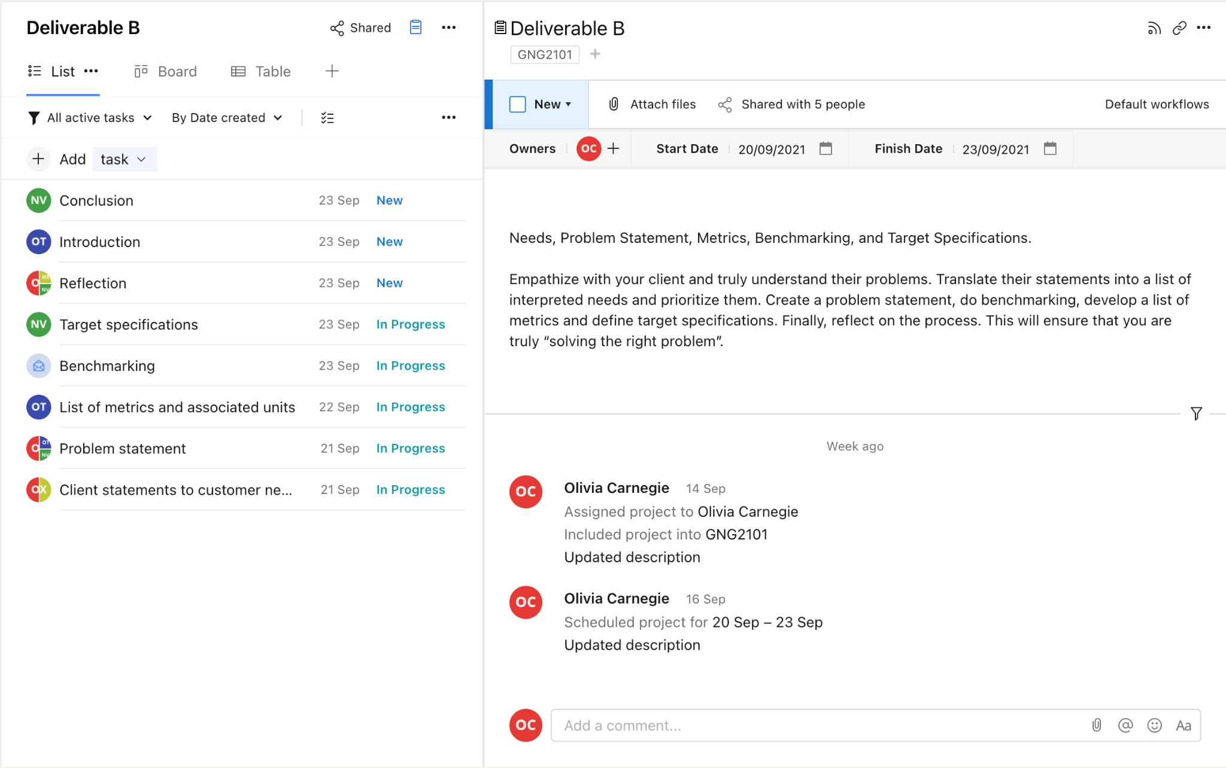
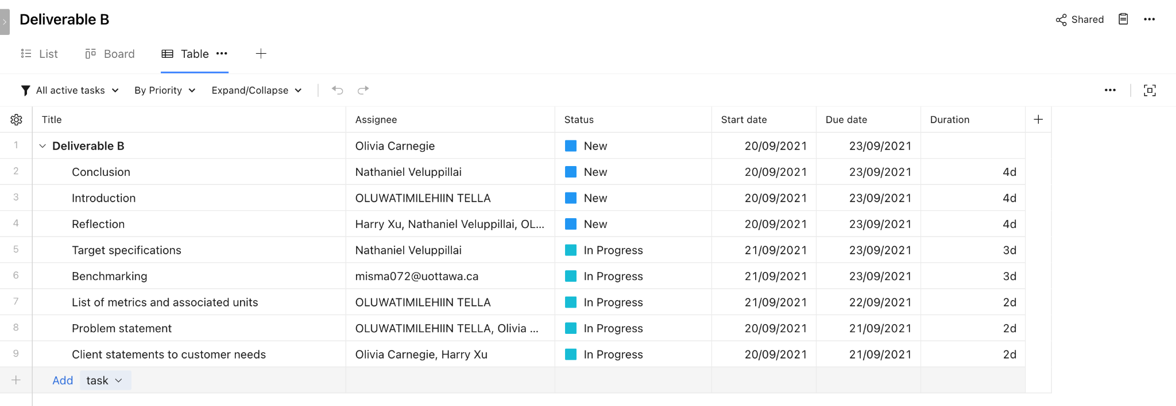

Link to Wrike

The Gantt chart option is only available to account owners that have paid for the account (which I have not) so I have included a link to the Wrike for easier access.

REFLECTION

The meeting we had with our client had a huge impact on the results above and the process we took to obtain these results. We had a first hand experience on what it is like being blind in a modern society especially during the pandemic. Insight was gathered from our client’s daily activities and how our client was able to carry out these activities. Seeing challenges our client faces while carrying out normal daily activities made our approach to gathering results more thoughtful. Our clients statements were studied carefully. The statements were eventually transformed to prioritized needs which created a basis on what our results should revolve around.

CONCLUSIONS AND RECOMMENDATIONS FOR FUTURE WORKS

The above information will be used to create a project plan which will, in turn, be used to create a product that will acknowledge the problem statement and the client’s needs. The information gathered from the client meeting was used to create the benchmarking, target specifications and metrics for the project and will help to create a design, prototype, and product that will meet the clients needs. To ensure that the client understands the development process; verbal descriptions will be provided to suit our client’s impaired vision.

BIBLIOGRAPHY

Types of mobility canes for vision impairment. (n.d.). Retrieved October 2, 2021, from Sight Scotland website: https://sightscotland.org.uk/articles/information-and-advice/types-mobility-canes-vision-impairment

