Project Deliverable E: Project Schedule and Cost

University of Ottawa

GNG1103: Engineering Design

October 29 2023

Group 6

Name: Student Number

Oreofe Oluwatayo (300240663)
Betselot Delnessahou Tadesse (300320450)
Tharshaon Thirukumaran (300297258)
Sohan Udayashankar (300323950)

Abstract

This project schedule and cost deliverable will be used to organize the project from the development of the first prototype to the final design day prototype. A final concept was chosen that involves an individual leaving their workplace onto a busy street where VR users can experience a day in the life of someone living with the threat of autonomous killer robots. To create this VR experience a list of equipment and tools such as Unity and asset packages were listed, along with a project schedule in Wrike. Furthermore, the total cost of the project is projected to be $43. A contingency plan was created to account for unexpected events and how to deal with them. Finally, a prototype test plan was created to test how well it meets design criteria and user needs. Ultimately, this project schedule and cost outline will be used as reference in future development of Rust in Peace’s VR experience.

1. Introduction 4
2. Concept Summary 4
3. Bill of Materials 5
4. List of Equipment 7
5. Project Risks and Contingencies 8
6. Prototyping Test Plan 8
7. Conclusion 10
8. References 11

Introduction
In the last delievrable‌, we generated a series of conceptual designs in response to our problem statement on which we got feedback on our client meeting. In this deliverable, we provided a refined version of our concepts and storyline with accurate sketches. We then proceed to create a task list with a timeline in mind to guarantee the successful completion of all three project prototypes by the end of the semester. Additionally, we provided a cost estimate and outlined the necessary components for your project. We’ve also outlined project risks and contingencies in the event of setbacks. Finally, we crafted a testing strategy for our prototypes to ensure that they meet user needs and the design criteria

Concept Summary

The story starts as the character walks out of his workplace and it is shown that they work at a shop that makes full cover face masks. They start heading down the street walking down the left sidewalk. The time is 8:33pm (past curfew) which is displayed on a large board. The streets are devoid of people and windows on buildings show no light coming through and buildings with lights on have their curtains drawn shut. There are ambient sounds of crickets and wind blowing as the character is walking down the street. Looking around they see the signs, stores, graffiti, cameras and nets and all stores are closed as well. A loud tornado warning siren goes off and the heart rate of our character quickens. They look up and see the loudspeakers alerting that there was an attack launched and the anti drone systems are working to shoot down all incoming threats and any citizens still outside should find shelter. Our main character starts to move quickly, frantically looking around with sounds of heavy breathing. They reach their house and as they enter there will be sounds of buzzing drones getting closer and closer. The main character enters the house, the door closes behind them and the call to action plays.
One caveat is that our character is never actually seen because this experience will be in the first person. There will be no other people in the scene because it makes no sense to be outside during this dangerous situation. It will be the setting and one character coming home late from work and the sheer act of coming home late from work is putting his life at risk.

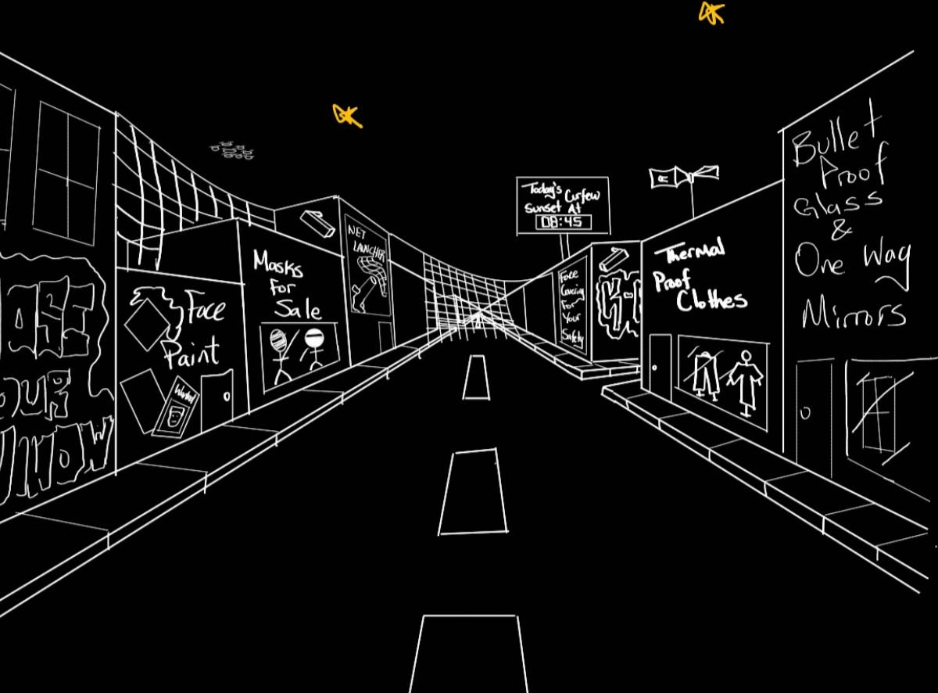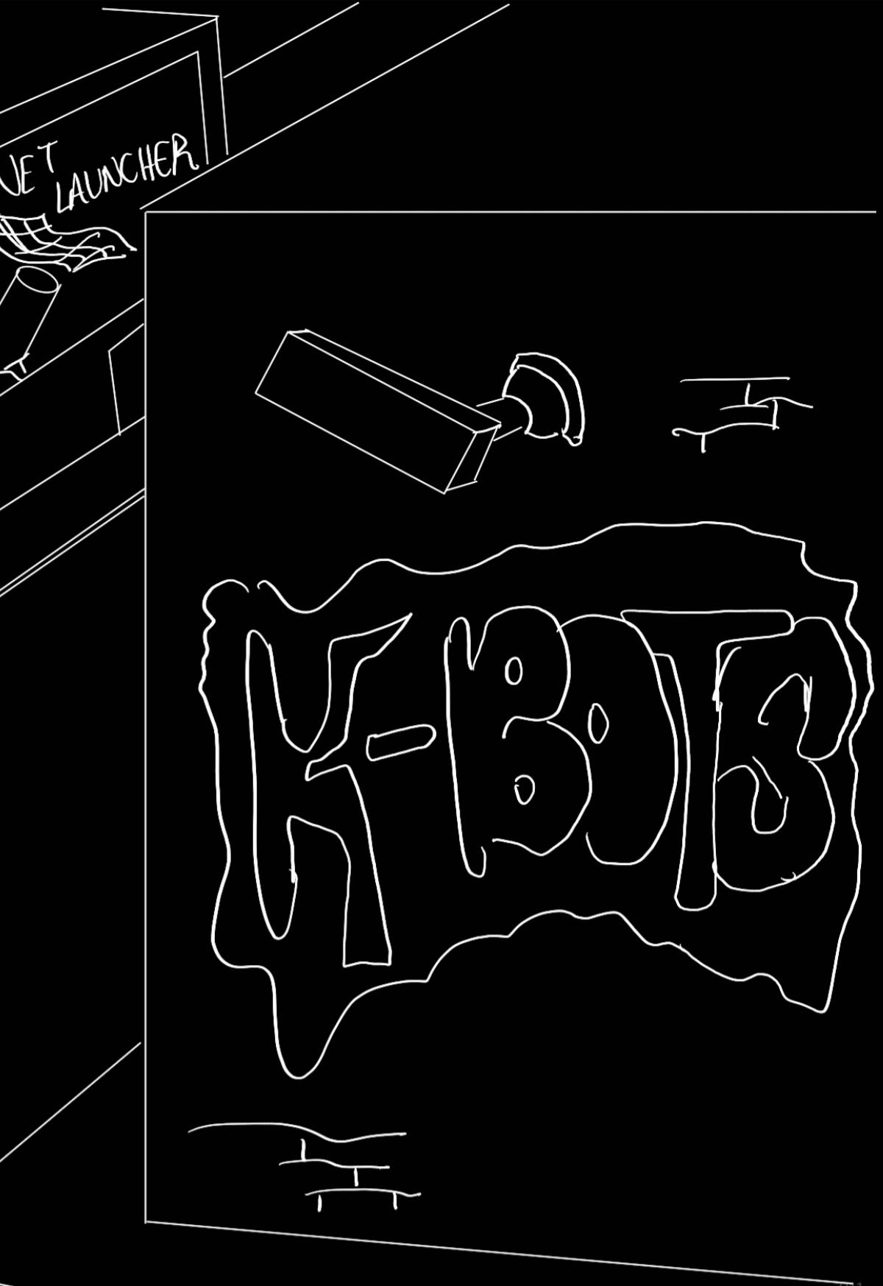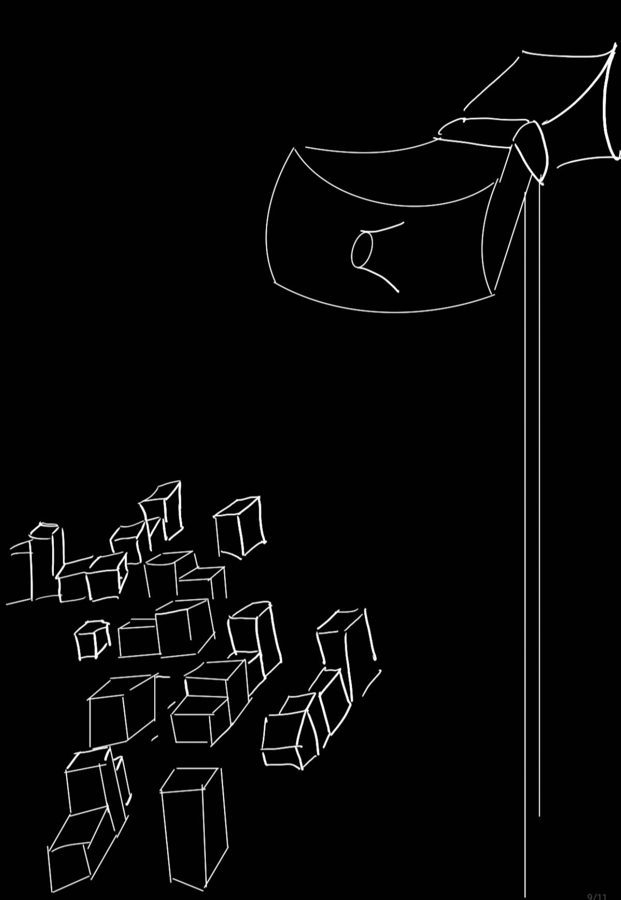

Bill of Materials
The bill of materials (BoM) covers all external elements we will have to buy or download for the project. As the project is based in virtual reality, the BoM does not include any physical elements and is made up of visual assets and sound effects. The sources used for assets and sounds include: Freesound.org [1], Unity asset store [2], TurboSquid [3] , CGTrader [4], Sketchfab [5] and Blender [6] .

Item no. | Description | Quantity | Store | Price (CAD)
#1 | Sound effects | 6 | Freesounds.org | FREE
#2 | Modular city Alley pack | 1 | Unity asset store | $19.80
#3 | 25 Realistic textures | 1 | Unity asset store | FREE
#4 | Street light Pack | 1 | Unity asset store | FREE
#5 | City Alley | 1 | TurboSquid | FREE
#6 | Spray Paint | 1 | TurboSquid | FREE
#7 | Cars | 4 | TurboSquid | FREE
#8 | Billboard_01 | 1 | TurboSquid | FREE
#9 | Fishing Net - Intact and Damaged Low-poly 3D model | 1 | CGTrader | $4.90
#10 | Fishing net | 1 | Sketchfab | FREE
#11 | Masks | 4 | TurboSquid | FREE
#12 | Security Set CCTV Low Poly | 1 | Sketchfab | FREE
#13 | Shop front with male mannequin 3D model | 1 | CGTrader | $13.30
#14 | Old Loudspeakers on the Pole | 1 | Sketchfab | FREE
#15 | Neon Alphabet 3D | 1 | TurboSquid | $5
#16 | 3D Glow - Neon Sign Asset Pack | 1 | TurboSquid | FREE
#17 | Unity | - | - | FREE
#18 | Computer | - | - | -
#19 | VR controllers | - | - | -
Total | - | - | - | $43

List of Equipment
Hardware:

Equipment | Quantity
Computers | 1
VR touch controllers | 2
Charging cables (USBC-USBC) | 1
VR headset | 1
Glasses Spacer | 1

Software:

Design software | Unity  - Main 3D software used to design environment  Blender  - Graphics tool for designing individual elements (store signs/art, graffiti, etc.)
Asset sources | - TurboSquid  - CGTrader  - Sketchfab  - Unity Asset Store  - Freesound

Project Risks and Contingencies
The complexity of this project may result in problems that may disrupt our workflow. Therefore, we have addressed some of the risks that may arise and contingency plans. Several different types of risks may be encountered from ideas not working, to rapidly approaching deadlines. We have a team contract that also addresses the event where a team member is unable to complete their task on time. They will receive a warning and a group meeting will be arranged to discuss what happened and how to avoid it from happening in the future. The TA/professor may be contacted if a team member repeatedly fails to deliver on their tasks. The risks and contingencies listed in the table below will help keep our project on task and avoid delays in an already tight schedule.

Risks | Chance | Impact | Contingency
Team member unable to complete task | Moderate | Moderate | Divide task amongst other group members
Unable to complete feature in time | Moderate | High | Schedule more time if permitted or simplify/omit parts or all of the feature
A project feature is not feasible | Moderate | High | Arrange group meeting to reevaluate design to be more functional
Team conflict arises | Moderate | High | Arrange a group meeting to discuss conflict and arrive upon resolution that everyone agrees upon. Otherwise, choose resolution through majority vote.
Unable to book time with VR headset | Moderate | High | Create video recording of the 3D environment to showcase the effects of autonomous killer robots

Prototyping Test Plan
We have developed a prototyping test plan to have a systematic method to check if the prototypes we develop are meeting user design needs effectively. A table of the different tests that will be conducted are listed below.

Test ID | Test Objective  (Why) | What is being figured out  (What) | Testing Method (How) | Attributes to Observe / Record | Duration (When/How Long)
1 | Test if environment is VR compatible | Can a user interact with the world with a VR headset | Connect VR headset to the Unity environment and test movement and hand operations. | Observe if movement is in sync with controller movements and hand positions. | Test in early prototype. Testing should take no more than 5 minutes to conduct.
2 | Test if environment is realistic | Do users find the environment immersive and believable | Observe users and receive feedback (survey) | Record user comments on environment | Test in every prototype and stop when users generally provide feedback that the graphics are realistic
3 | Test that the VR experience is easy to set up | Is the VR experience user friendly | Observe if users can set up the VR experience on their own and in under 30 seconds | Observe how the user sets up the system and how long it takes | Test in every prototype and continue until satisfied that most users can set up the experience in under 30 seconds
4 | Test the the VR controls are intuitive and comfortable | Is the VR experience ergonomical | Observe how users feel when using the VR experience | Observe if users need to remove the headset, make adjustments or if they become sick. Record any comments about how users felt in the game world | Test in every prototype and stop when users don’t feel the need to comment on comfort and the experience feels seamless.
5 | Test that the VR experience portrays a strong message | Is the VR experience effective at warning users about the dangers of autonomous killer robots | Observe and record user experiences | Ask users what they felt about the VR experience and their stance (before and after) on autonomous robots that can kill | Test in comprehensive prototype and stop when users felt an above average sentiment against autonomous killer robots (7/10 average)
6 | The VR experience is relatively simple and not too complicated | Is the VR experience is not resource intensive and loads efficiently | Measure software parameters and attributes | Measure time to load, size of the program, time to render graphics in-game | Test in comprehensive prototype and stop when load time is under 15 seconds, size of program is less than 1 gb and graphics render in-game in under 1 second
7 | Test that the VR experience is accessible | Is the VR experience compatible and accommodating to a broad audience | Survey and observe users | Ask users if they felt if there were any barriers to usability | Test in comprehensive prototype and stop when most users (90%) do not feel their experience was hindered due to a lack of accommodation.

Conclusion
Our story highlights the normal yet cautious living of a citizen in their own town as they leave work to get home. To establish a believable atmosphere, we will be using assets and sounds from various sources mentioned in the bill of materials. These assets will be added to the environment such as buildings, storefronts and cars to establish the user’s presence in the town. The assets will also be used to include adaptations civilians take to avoid detection and avoid drone encounters such as warning sirens and nets above buildings. When considering risks, feasibility related to complexity and time is a major barrier which we will solve with group meetings to restructure. Finally, we created a prototyping test plan which uses 7 test criteria to determine the successes and areas of improvement for each prototype.

References
[1]Freesound, “Freesound,” Freesound.org, 2012. https://freesound.org/
[2]Unity, “Unity Asset Store - The Best Assets for Game Making,” @UnityAssetStore, 2000. https://assetstore.unity.com/

[3]TurboSquid, “3D Models for Professionals :: TurboSquid,” Turbosquid.com, 2019. https://www.turbosquid.com/
[4]CGTrader, “CGTrader - 3D Models for VR / AR and CG projects”, https://www.cgtrader.com/
[5]Sketchfab, “Sketchfab - The best 3D viewer on the web,” https://sketchfab.com/
‌[6]Blender Foundation, “blender.org - Home of the Blender project - Free and Open 3D Creation Software,” blender.org, 2019. https://www.blender.org/

