Project Deliverable G: Prototype II

University of Ottawa

GNG1103: Engineering Design

November 12th 2023

Group 6

Name: Student Number

Oreofe Oluwatayo (300240663)
Betselot Delnessahou Tadesse (300320450)
Tharshaon Thirukumaran (300297258)
Sohan Udayashankar (300323950)

Abstract
This deliverable focuses on Prototype II which highlights the changes and updates made to the first prototype. Based on the client’s feedback during the third client meeting for Prototype I, we made changes to the environment, added new adaptations and improved the movement functions. The new prototype was then compared to the test plan which incorporated various user feedback. Using this feedback, we implemented a subsequent test plan for the following prototype. The bill of materials and target specifications were also updated. Prototype III will focus on custom assets used to create a greater immersion of an artificial intelligent-controlled city. Overall, the project is on schedule and we continue to meet deadlines. Progress will continue to be monitored for any potential conflicts.

1. Introduction 4
2. Prototype I Client Feedback 4
3. Prototype II - VR Implementation 4
4. Prototype II Testing and User Feedback 7
5. Prototype III Test Plan 8
6. Bill of Materials 8
7. Target Specifications 9
8. Conclusion 9

Introduction
The first prototype for this project focused on developing a city environment that users could traverse through. The prototype successfully demonstrated realism, had colliders on objects to prevent users from walking through and featured immersive sound effects. Client and user feedback was used from the prototype to develop the testing phase for the next prototype which focused on the VR implementation. In the following deliverable, we highlight the VR prototype, the testing that took place and the results. Overall, the VR experience was successfully implemented but some changes will need to improve the user experience. The next prototype will focus on another critical aspect of the project which is implementing custom assets for the environmental adaptations. The project is proceeding on schedule and the progress suggests the VR experience will be completed in time for design day.

Prototype I Client Feedback
In a pitch presentation to the client, our team received feedback on our environmental prototype I. Overall, the client seemed to find the environment realistic but their first impressions also highlighted some issues. They said that the environment, “...looks like ChinaTown ... .but that’s okay”. However, the tone of their voice suggested that they did not like this aspect of the prototype despite the content of their words suggesting otherwise. Therefore, we will use this feedback to remove possible unintended racial undertones by removing the Chinese-style lanterns in the main foyer of the environment. We will continue to inspect the environment again and remove any elements that might be insensitive.

Prototype II - VR Implementation
In this prototype, VR capabilities were tested in the game environment. The XR interactive and XR toolkit packages were added to Unity and were implemented to be compatible with the Oculus Meta Quest 2 headset. The prototype was developed that enabled the user to move around using the joystick controllers, have the player view track the user’s head movements, visualize the user’s controllers in game and interact with simple elements in the game environment.

The VR headset and controllers were tested on users to receive feedback as demonstrated in figure 1. Specifically, the ability to move around in the environment was analyzed and user feedback was generated. A video and screenshot of the implementation is highlighted in figure 2. Thirdly, a test was set up for users to use their controllers to interact with the environment to trigger actions. In the test, a sound effect was triggered when the user pointed their controller at a poster. Furthermore, the interactive elements were optimized so that if the user selected another interactive element, the second one’s sound would play instead of the first. A screenshot and video of this being tested is shown in figure 3.

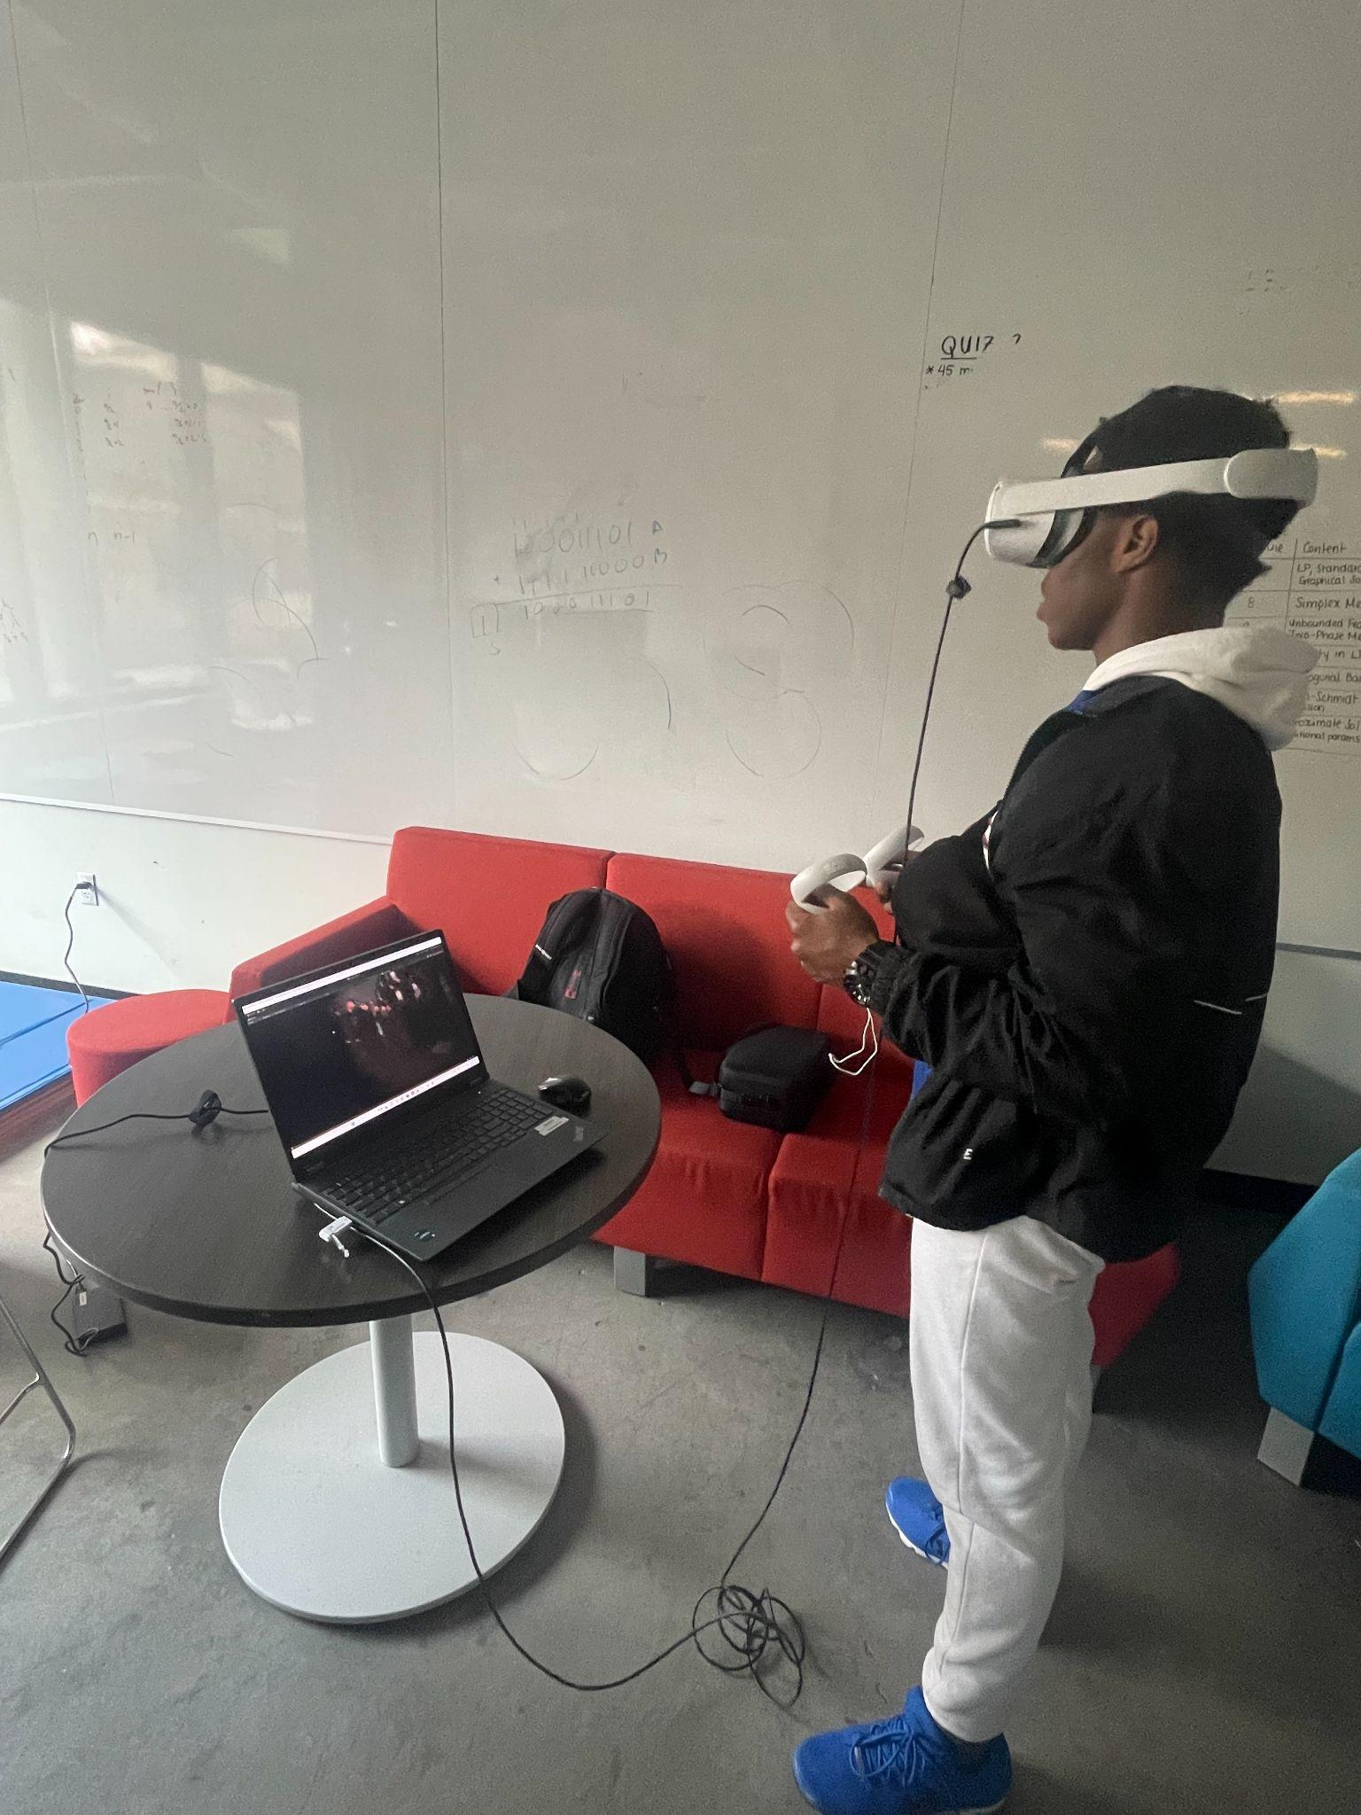

Figure 1: User testing VR experience with the Oculus Meta Quest 2 headset.

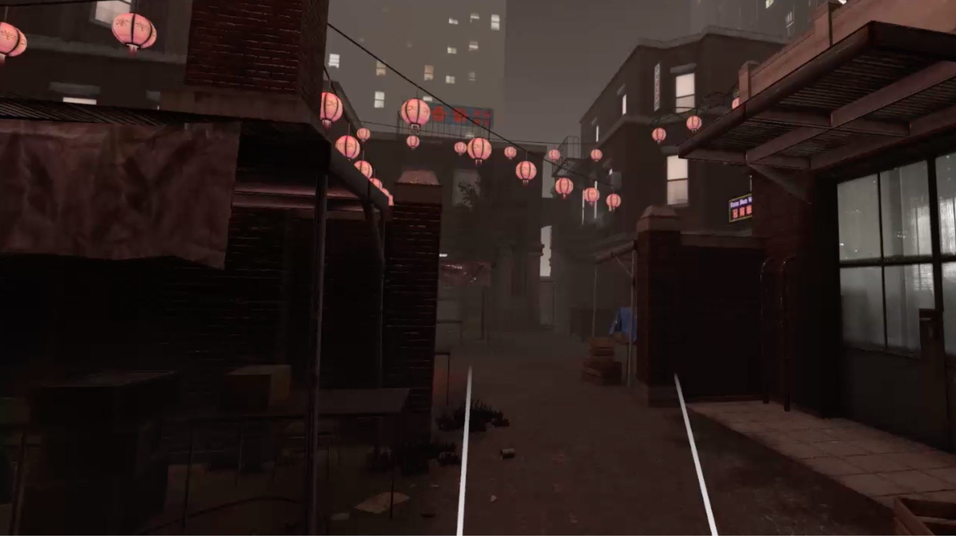
Figure 2: Screenshot of a VR user walking through the environment. The two white lines at the bottom of the image are pointers from the VR hand controllers. A video of the walkthrough can be found at the following link: https://drive.google.com/file/d/1fgDM7kEPU5RO_bro7C88uTQzUPKSyTpJ/view?usp=sharing

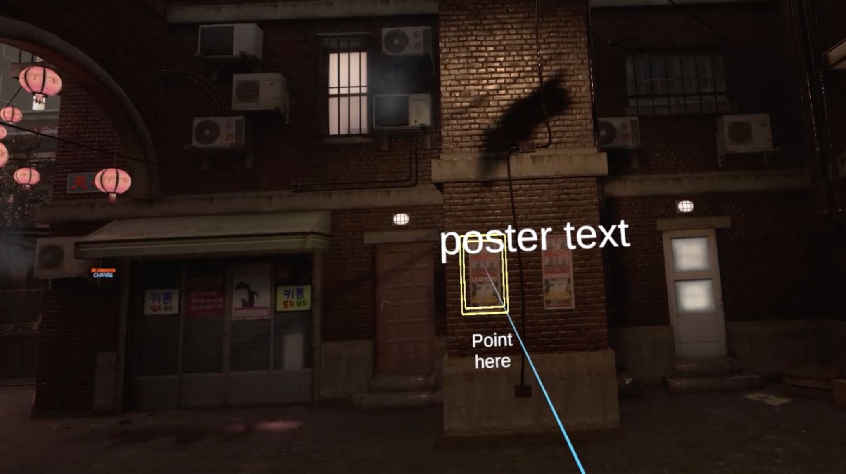
Figure 3: Screenshot of a user pointing their controller at a poster and having text and sound trigger. The elements were also optimized so that the element pointed to most recently would have priority and its sound and text would occur without the previous. This is highlighted in the following video: https://drive.google.com/file/d/1FqMQcZOonRVVut9dzG3L2cxR_KjUIKY1/view?usp=sharing

Prototype II Testing and User Feedback

To test the VR capabilities of the prototype, the major features were implemented and users were allowed to freely interact with the game world. The tests primarily focused on player movement and the user experience. The results of the testing can be found in table 1. Ultimately, The results of the testing found that the VR experience was successfully implemented.

Most of the users chosen for testing were students that were also in the GNG1103 class. They mostly gave positive feedback for the VR experience. Users were able to freely move around and look around the environment. Furthermore, most users found that the experience was comfortable but occasionally they felt motion sick. The interactive elements were also effectively implemented since they executed upon pointer click and switched when a new element was pointed to. Users suggested that they would prefer that they could use the left joystick to be able to look around instead of their headset. Therefore, we will need to consider how to map the camera scheme so that it is interactable with the controller. Users were also impressed by the level of detail in the world environment. However, they also didn’t understand the connection with killer robots. Therefore, moving forward, in future prototypes, custom adaptation will need to be implemented to demonstrate the existence of VR robots and how humans adapt. Furthermore, additional UI elements will need to be added to aid orient users since some users found it overwhelming and not sure which direction to go in. Overall, the VR prototype was most successful and small adjustments will need to be made as finishing touches.

Table 1: Results of the prototype testing plan for prototype II which focused on implementing VR to the game world and introducing interactive elements.
Test ID | Test | Testing Method | Results | Pass/Fail
1 | Test if environment is VR compatible and users can move around | Observations | - Users can traverse the environment and move around  - “Whoa, this is cool, I’m actually moving around.” | Pass
2 | Test that the VR experience is easy to set up | Measurement | - The VR experience was set up in under 2 minutes and ready to run | Pass
3 | Test that the VR controls are intuitive and comfortable | User Feedback | - Users found the VR experience comfortable but on occasion felt dizzy. They also found it would be easier if they could control their vision with the right joystick and move with the left | Conditional Pass
4 | The VR experience is relatively simple and not too complicated | Observation / User Feedback | - The interactive elements in the VR experience were limited and only include painting at objects and having text / audio play  - Users found the particle effects next to interactable elements | Pass
5 | Test that the VR experience is accessible | Observations /User Feedback | - The VR experience includes text for the hearing impaired  - Users found the text to be nice addition since they acknowledged hearing-impaired individuals | Pass
6 | VR users can interact with external element | Observations / User Feedback | - Users are able to interact with highlighted elements and have sound and text appear immediately when pointed to  - “Oh so when I point my controller at it, it starts making sounds and text appear? How’d you do that?” | Pass

Prototype III Test Plan

Table 2: Prototype II test plan used to measure the quality of the VR interface implemented into the environment.
Test ID | Test Objective  (Why) | What is being figured out  (What) | Testing Method (How) | Attributes to Observe / Record | Duration (When/How Long)
1 | Test if the objects we downloaded from different sites are customizable on Blender | The compatibility of the downloaded files. We need to also test if these files are editable. | We will download some of our assets as different forms of files (.obj, .blend,...) and open them on Blender. | We have to observe the size, quality, and compatibility of each asset. | This process can take 15 minutes per asset. We have 10 to 12 assets. In total, it will take up to 3 hours.
2 | Test if these customized assets are compatible with Unity. | After we customize our assets we need to be able to add them and resize them, | We will export these assets from Blender and import them on Unity to open them on our main scene. | We will have to observe the fit of each asset to determine whether we will keep them or remove them. | On the other hand, this test only takes 15 in total as each asset exported from Blender has the form.
3 | Test if the sounds added (and their respective codes) work properly. | We need to associate each sound with their code and check if they are easy to use for the user | We will download our sounds from the internet. We will code a script on Unity to activate these sounds (at the time and place we want). | We will have to  Check the clarity, the volume, and, the accuracy of our sounds. | Unfortunately, we cannot determine the time because it will vary depending on the number of sounds we will be adding, and the quality of our codes.
4 | Test if the different added codes work (camera, interaction,...) | We need to fix any coding errors that we will detect. | Run the different code added to the VR correctly. | We will have to run the VR multiple times to catch any glitches. | This also depends on the quality of our codes and our coding skills.
5 | Test if our environment, custom assets, and sounds convey the main message | We need to check if our assets and the environment correlate with each other. | We will have to show our final VR experience to people and gather their feedback. | We will have to take notes on their reactions to modify our VR accordingly. | This test will approximately take 1 hour as we can ask 4 people for their feedback (15 min each).

Bill of Materials

Item no. | Description | Quantity | Store | Price (CAD)
#1 | Sound effects | 6 | Freesounds.org | FREE
#2 | Modular city Alley pack | 1 | Unity asset store | $19.80
#3 | 25 Realistic textures | 1 | Unity asset store | FREE
#4 | Street light Pack | 1 | Unity asset store | FREE
#5 | City Alley | 1 | TurboSquid | FREE
#6 | Spray Paint | 1 | TurboSquid | FREE
#7 | Cars | 4 | TurboSquid | FREE
#8 | Billboard_01 | 1 | TurboSquid | FREE
#9 | Fishing Net - Intact and Damaged Low-poly 3D model | 1 | CGTrader | $4.90
#10 | Fishing net | 1 | Sketchfab | FREE
#11 | Masks | 4 | TurboSquid | FREE
#12 | Security Set CCTV Low Poly | 1 | Sketchfab | FREE
#13 | Shop front with male mannequin 3D model | 1 | CGTrader | $13.30
#14 | Old Loudspeakers on the Pole | 1 | Sketchfab | FREE
#15 | Neon Alphabet 3D | 1 | TurboSquid | $5
#16 | 3D Glow - Neon Sign Asset Pack | 1 | TurboSquid | FREE
#17 | Unity | - | - | FREE
#18 | Computer | - | - | -
#19 | VR controllers | - | - | -
Total | - | - | - | $43

Target Specifications

With the completion of prototype II, target specifications were updated to reflect progress. In Table 4, design criteria that have been met (neon green), are in progress (green) and need to still be addressed (white) are shown. This update will be used to track progress and highlight what still needs to be worked on.

Design specification | Relation  (<, >, =) | Value | Units | Verification
Functional
Environmental Adaptations | = | Yes | N/A | Testing/Review
Emotion evoking | = | Yes | N/A | Testing/Review
Realism | = | Yes | N/A | Testing/Review
Engaging | = | Yes | N/A | Testing/Review
Story Driven | = | Yes | N/A | Testing/Review
Call to Action | = | Yes | N/A | Testing/Review
Informative | = | Yes | N/A | Testing/Review
Dissuade use of autonomous robots | = | Yes | N/A | Testing/Review
Non-Functional
Reliability | = | Yes | N/A | Testing/Review
Storage Space | <= | 2 | Gigabytes | Measure
Safety | = | Yes
Ease of Use | = | Yes | N/A | Testing/Review
Loading Time | <= | 30 | seconds | Measure
Response Time | < | 200 | milliseconds | Measure
Frame Rate | >= | 30 | Frames per second | Measure
Set-up Time | <= | 15 | minutes | Measure
Constraints
Cost | <= | 50 | $ (CDN) | Measure
Hardware Requirements | <= | Mid-Range Smartphone | N/A | Test/Review
Disturbing Content | = | No | N/A | Test/Review
No Deadnaming | = | Yes | N/A | Inspection
Duration | <= | 30 | seconds | Measure
Deadline | <= | 1 and 1/2 | months | Measure

Conclusion
Significant progress was made for the second prototype which saw various new adaptations, posters with an interactive element and functional movement mechanisms. User feedback was generally positive with feedback mainly centred around the interactivity of the simulation. An area of concern some users felt was motion sickness which is an issue that needs to be covered for the next deliverable. The next deliverable/prototype will cover custom assets for the environment and will be structured based on the Prototype III test plan made in this deliverable. Overall, we are progressing well and have made significant progress to a complete VR simulation project.

