GNG2101
Design Project Progress Update

<GROUP NAME AND GROUP NUMBER>

Submitted by:
Noor Al-lafta 300301892
Sara Elmalky, 300333601
Fatma Abdo, 300278634
Ibrahim Ghamlouche, 300331686
Ali Sherry, 300239471
Liana Chu, 300287510

<Date>
University of Ottawa

Table of Contents
1. Introduction 7
2. Sustainability report and DFX 7
2.1. sustainability report 7
2.2. Design for X 7
3. Problem definition, Client needs, problem statement 8
3.1. Problem definition 8
3.2. Client needs 9
3.3. Problem statement 9
4. Detailed design and BOM 10
4.1. detailed design 10
4.2. BOM 10
5. Prototype 1, Project Progress Presentation, Peer Feedback and Team Dynamics 10
6. Design Constrains and prototype 2 10
7. Other consideration 10
8. Design day pitch 10
9. Video and user manual 10
10. Conclution 10
11. Biblography 10

List of Figures
Insert your list of figures here (right-click to update this field).

List of Tables
Table 1. Acronyms vi
Table 2. Glossary vi

List of Acronyms and Glossary
Provide a list of acronyms and associated literal translations used within the document. List the acronyms in alphabetical order using a tabular format as depicted below.

Table 1. Acronyms
Acronym | Definition

Provide clear and concise definitions for terms used in this document that may be unfamiliar to readers of the document. Terms are to be listed in alphabetical order.

Table 2. Glossary
Term | Acronym | Definition

Introduction

Sustainability report and DFX

sustainability report
 | Positive Impact | Negative Impact
Social | - More independence for users to lift themselves up when fallen  - Improved quality of life by reducing barriers users may face in mobility | - The possibility of reducing the need for caregivers and social work  - Possible unethical sourcing and manufacturing of material
Environmental | - Reduced need to buy new wheelchairs to accommodate worsening disability  - The usage recycled parts (when possible) minimizes environmental impact | - Manufacturing process of device could increase waste and increase environmental footprint
Economic | - Cost reductions from less injuries and less need for a constant caregiver  - Due to growing need and demand for accessibility devices, jobs can be generated in manufacturing, design, and transportation | - Depending on cost of device, there cost be economic and cost accessibility barriers for the target demographic

Design for X

 | DFX | Explanation
1 | Design for safety | - Lift is used to help fallen individuals on their own  - Needs to be reliable enough to prevent any injuries and accidental falls
2 | Design for portability | - Device needs to be brought to any room, environment and space  - Device needs to be moved by anyone
3 | Design for accessibility | - Device can be used by a wide range of individuals, can adapt with the disability (because they can change), cost should be accessible, anyone can use design for worst case scenario
4 | Design for maintainability | - Device need to last for a long time  - Device need to handle going outside, other levels in the house  - Adapt to different environment  - Easily maintained by user/ caregiver
5 | Design for ease of use | - Users can lift themselves up with limited help/alone  - Helpers should also easily use device to lift user

Problem definition, Client needs, problem statement

Problem definition
The client would like us to create a user-friendly and adaptable device to assist individuals lift themselves when fallen. The mechanism should be designed to accommodate individuals with varying mobility/disabilities, ensuring a safe lift process with as few transfers as possible. Consideration should be given to the ease of use for the person transferring and any caregivers involved (preferably the person should be able to use it on their own). The solution should consider different settings where individuals may have fallen and as a result be portable, of appropriate size, and should be adjustable to accommodate individuals with different physical abilities and needs. Additionally, the device should prioritize safety, stability, and minimal physical strain on both the user and the caregiver during the lift.
Our team will also need to define the main target audience and scope of the design the device is for. At the moment, the scope of the design is small and focused on our client specifically.

Client needs
 | Client statement | Interpreted need | Ranking
1 | Lift someone who has a disability up alone (if possible with one arm/hand) or with limited help | Device provides independent help or minimal help. | 5
2 | Small in size | Minimal space occupied by the device and as compact as possible. | 3
3 | Device should be able to go up and down the stairs and possibly outside. | Easily compatible and portable with the user's lifestyle. | 4
4 | Low cost and available for everyone. | Inexpensive, and affordable | 2
5 | Usable for support workers no matter the strength. | The device is usable by any support worker despite their physical limitations. | 5
6 | Could be accessible and usable for different people with different disabilities. | The product is suitable for different types of disabilities and adapts to changes in disability | 3
7 | Safe and reliable. | A robust quality and safety control measures throughout the manufacturing process. | 5
8 | The individual in care varies in size and the product needs to be able to securely withstand the user. | Lift someone of, at least 250 lbs. | 2

Problem statement
KPC Capability Inc. seeks a solution for individuals with limited mobility or one functional hand/arm, addressing the absence of a device for minimal work lifting. The challenge is to create a tool that ensures safety and portability which aligns with the client's mission.

Detailed design and BOM

detailed design
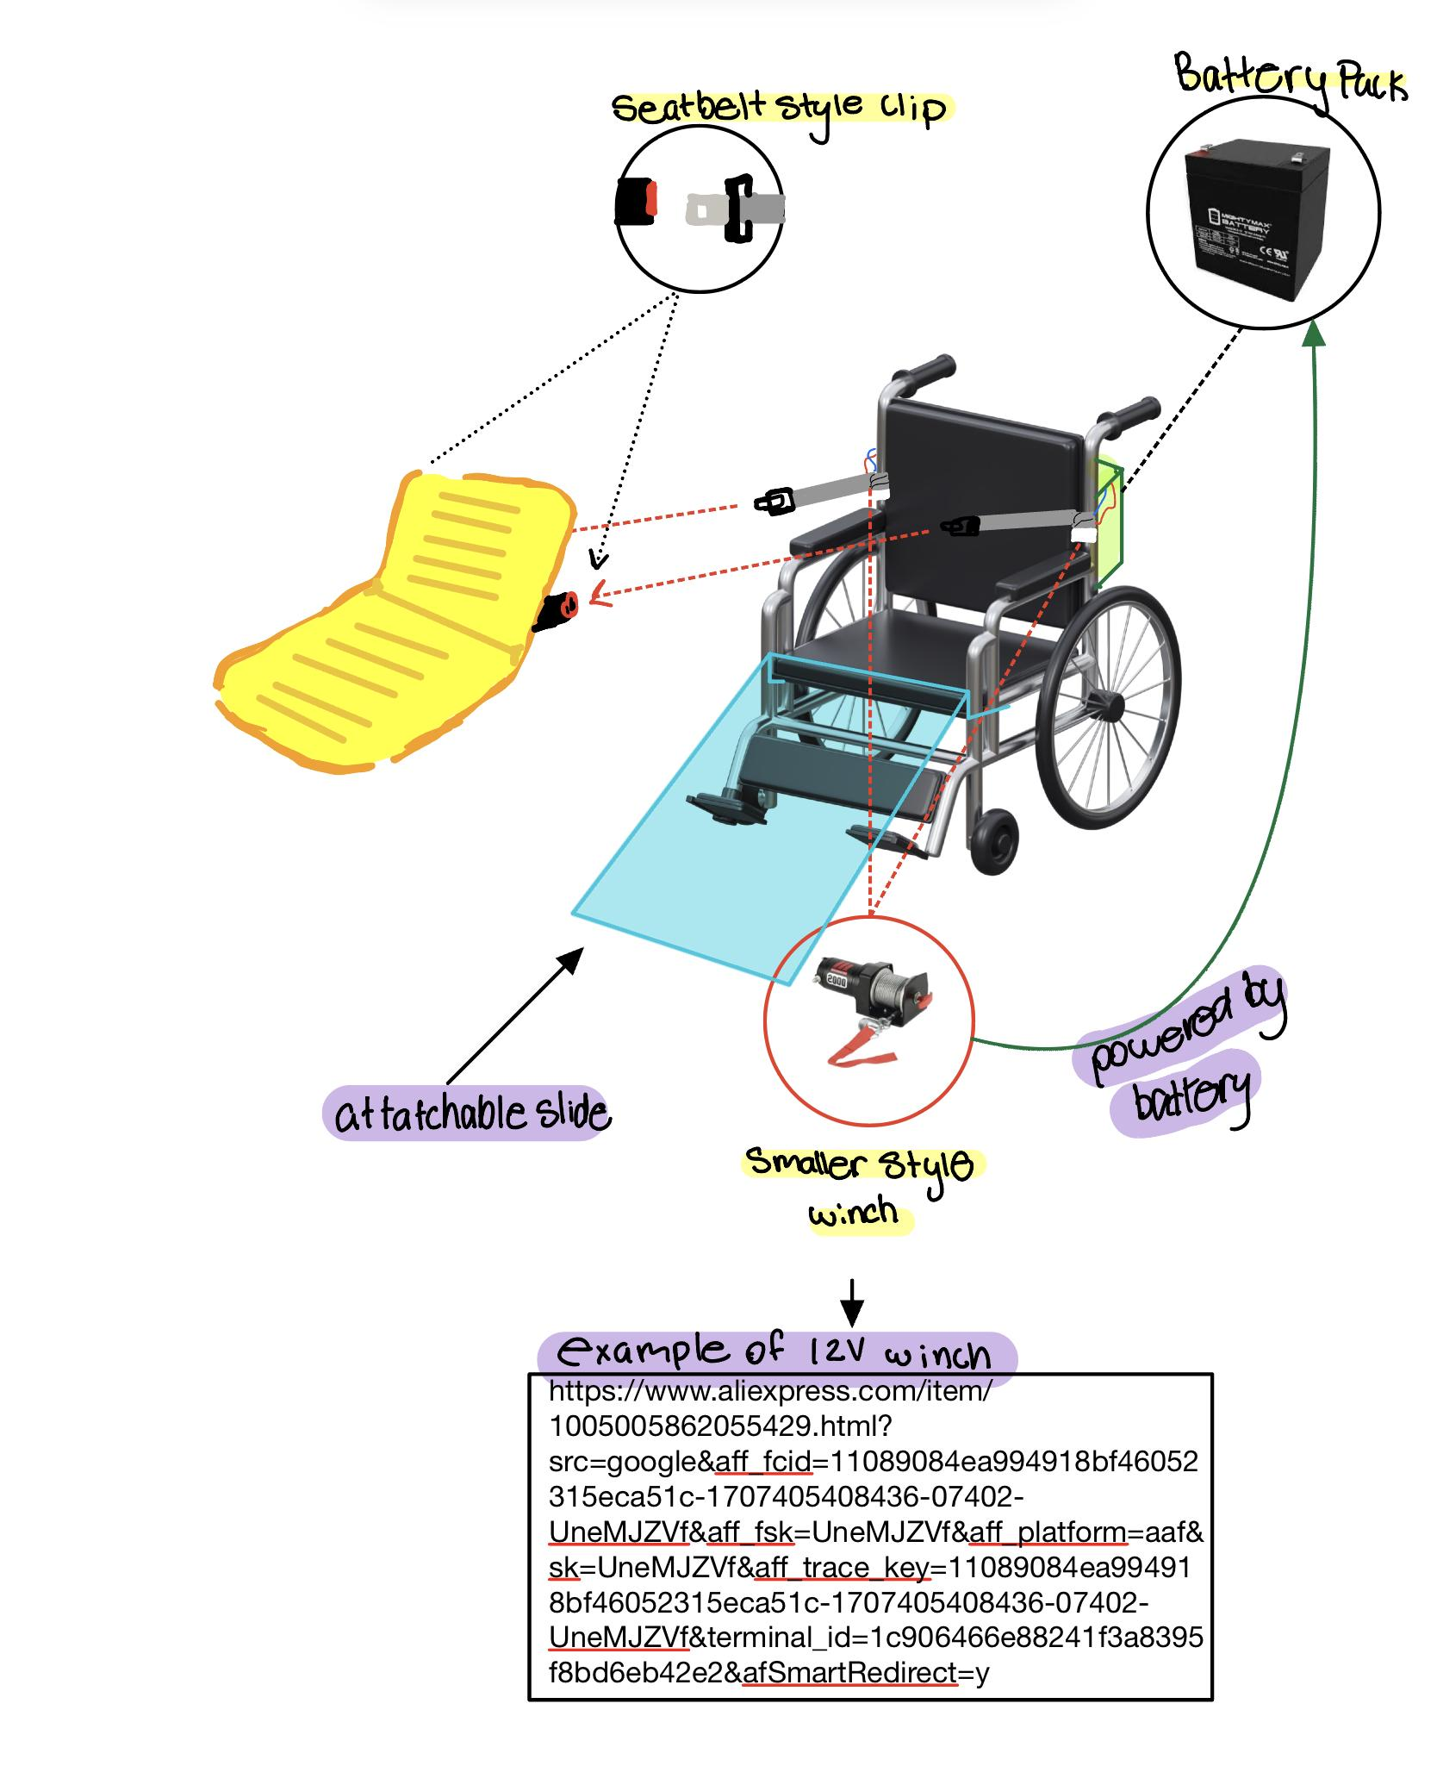

Inflatable chair example:
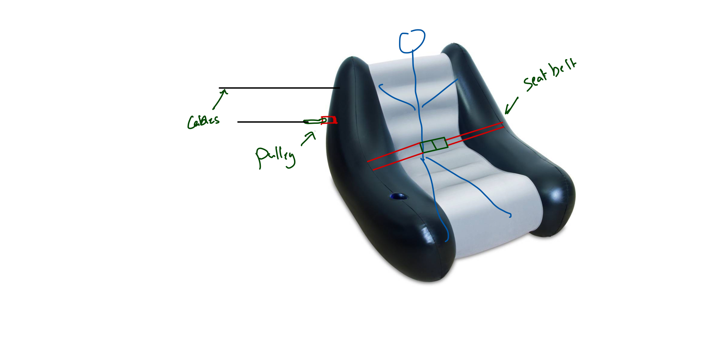
How the concept works:

BOM

Item name | Description | Unit of measure | Quantity | Unit item | Extended cost | Link
Slide | Wood parts | Meters | TBD | TBD | TBD | Homedepot
Winch | Manual winch to test the mechanism | Kg | 2 | 28 | 56 | Amazon
Vinyl roll | To put on the wood to reduce friction | Meters | 1 | 15.89 | 15.89 | Wallmart
Total without taxes and shipping |  |  |  |  | 71.89
Total including taxes and shipping |  |  |  |  | 81.24

Prototype 1, Project Progress Presentation, Peer Feedback and Team Dynamics

Prototype 1
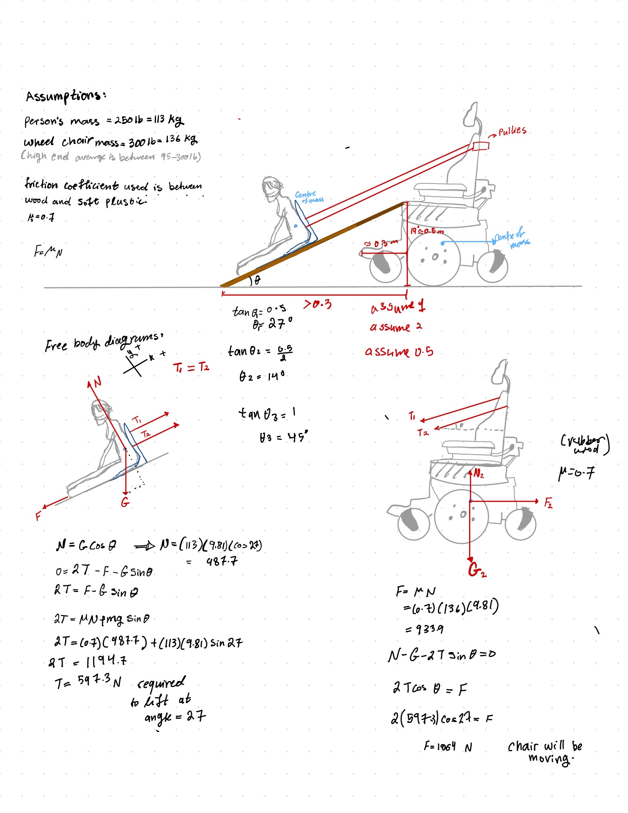
Physics Analysis

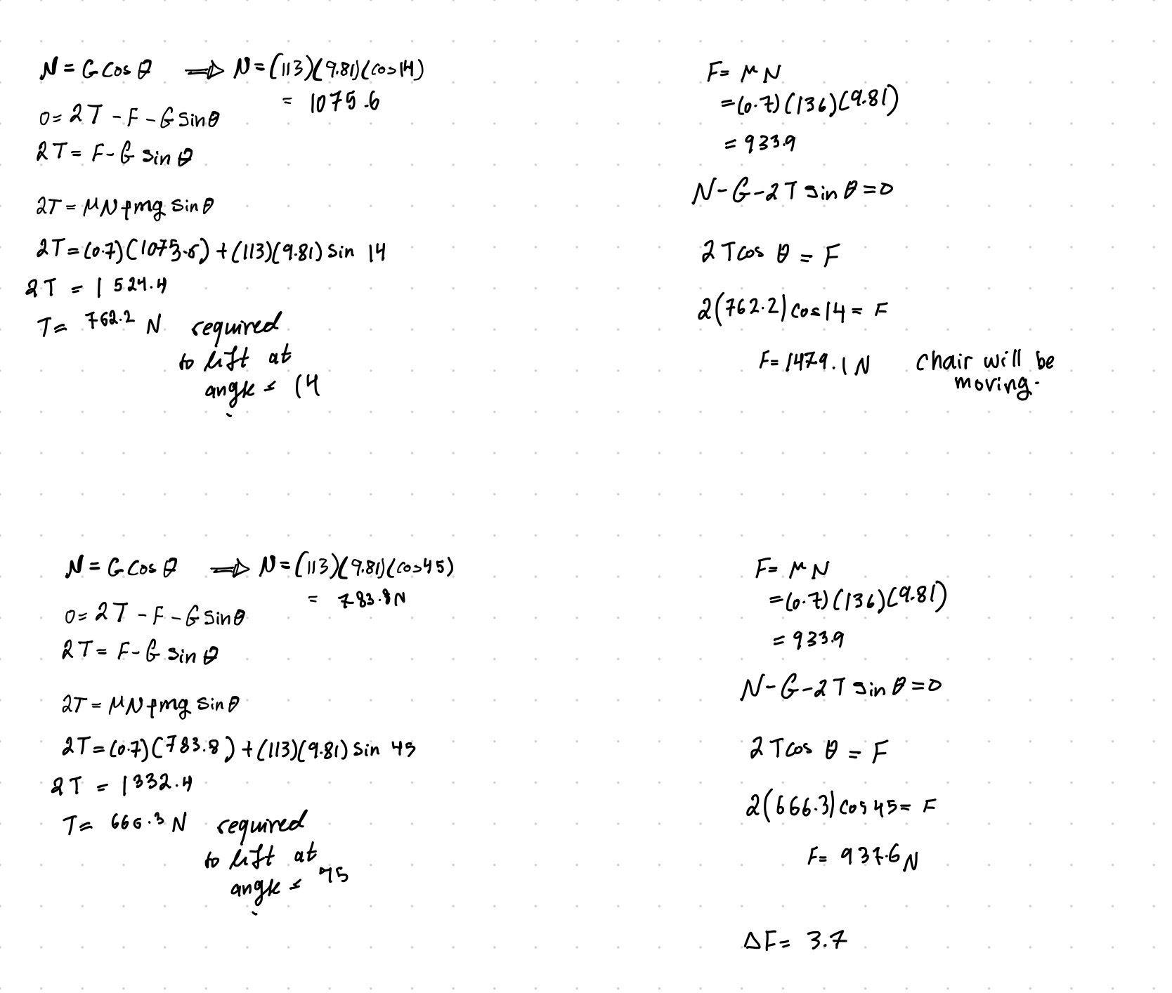
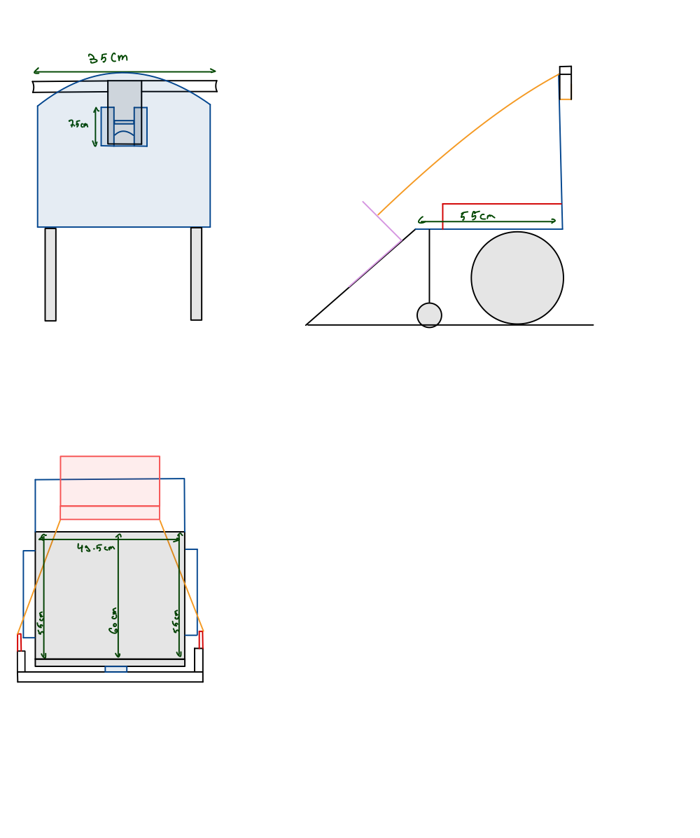

Progress presentation

Presentation Link

Gantt chart update

Design Constraints and prototype 2

Other consideration

Design day pitch

Video and user manual

Conclusion

Bibliography

