GNG2101 Report

Project Deliverable G: Business Model and Economic Report
Submitted by
Team 4.2 - Immersive VR Experience

Student Number |  | Name
300231269 |  | Brevin Baskaran
300228908 |  | Henry Radar
300126254 |  | Jiachen Wang
300231222 |  | Nicholas Yeung
300231531 |  | Reyaan Trimizi
8737165 |  | Uzair Mohiuddin

Faculty of Engineering

Introduction

In this deliverable, we will discuss our business model after our product launch and also an economics summary of our fictitious business. We will also provide our most critical business assumption and will research the current market for our product to make reasonable assumptions. We will also develop a 3-year income statement, cost associated with the business and a cash flow statement.

Business Model

Our team will use freemium and premium business models to commercialize our team’s product.
Our team is aiming to build VR immersive experience applications to help the user deal with discriminations like language barrier, race, gender, sexual orientation, religion, visible or invisible disability. Our productions are VR immersive experience applications, this business mode can make users easily achieve our products. By using a freemium business model, users can have some basic training. It would be helpful for individual users. By using the Individual premium business model, users can have an up-to-date training experience but that is for governments, schools, companies and organizations.
The freemium model entails offering free basic features in terms of the VR immersive experience and expanding the depth of features once a subscription is attained. A well-developed immersive VR experience that helps users feel empathy towards discrimination offers a high-degree of utility to users. Given this, it serves the purpose of VR development to allow easy access to basic VR functionality to as many users as possible. However, given institutions want to adopt the VR experience into learning and training curricula, offering a subscription through the freemium business model would allow them to acquire a more expansive functionality of the software. Furthermore, given smaller businesses or individuals want to use the VR experience, they can also sign up for a subscription with added functionality. This will support and strengthen the institutions through proper education and training that isn’t accessible without a subscription.

How? |  | What? | Who?
Key Partners  Government, Educaters，  Psychologists,  Doctors,  People with discrimination experiences, VR Developers | Key Activities  Build VR immersive experience applications. Deliver the application to customers. | Value Proposition  Help the user deal with discriminations like language barrier, race, gender, sexual orientation, religion, visible or invisible disability. Provide a deep, immersive, education experience to users. | Customer Relationships  Same-side Network Effects  Cross-side Network Effects | Customer Segments  Universities,  Governments,  Post-high school students,  People with discrimination experiences
 | Key Resources  Servers/cloud,  VR immersive experience applications built by Unity platform |  | Channels  Cloud library,  VR immersive experience applications
Cost Structure  Product Development,  Web Hosting costs,  General and Administrative |  | Revenue Stream  Free offerings and premium subscription.  Marketing Solutions.  Advertisements within the VR.  However, our team is not aiming to make money since we are doing this for public welfare. We try to get financial support from the government and public donations.

Core Assumptions in developing our Business Model Canvas
The VR experience is intended for educational institutions. The core assumption is that this product will attract users in educational institutions, which can potentially be extended to users in different industries as part of their training program for Employees. The core assumption can be validated by examining if educational institutions will adopt our VR experience.
Another core assumption is that we will be able to host our VR experience on the cloud to allow users to access. We can test this by examining various options of hosting our VR experience that will allow users to utilize within their training experiences.

The table below is the outcome of user and technical benchmarking on three companies who are offering similar services and products aiming at public welfare and educational training.
 | Equal Reality | VOISS | Scott Howie
User Benchmarking | Youtube account registered on 2017-04-12, 352337 views, 586 followers, 43+ videos, few comments, and hundreds of thumb ups.  Facebook business account, 999 likes, 1056 fans, few but all good comments. | Youtube account registered on 2021-04-01, 4034 views, 75+ videos, no comments, few thumb ups.  Facebook account, 184 users like it, 188 users followed, no comments. However, from the recent update, VOISS is concerned by the Egyptian educational system and is going to have international collaborations. | Issue Date:13 Jun, 2018  50% of the 10 user reviews for this game are positive.
Technical Benchmarking | Viveport (Personal computer) | Google play(Android),  Test Light(ios) | Steam (Windows)

The outcome of this table is telling that there is a high possibility that our products will not gather social attention. However, governments and educators might care about our products as they are often dealing with youth problems, discrimination problems and problems from societies.

Economics Report

Costs
Marketing | $5,000 | Indirect (variable)
Electricity | $6,000 | Fixed
Salaries | $160,000 | Fixed Direct (labor)
Staff Training | $3,000 | Direct (labor)
VR Development | $100,000 | Semi-variable
Software Licensing Fees | $1,000 | Fixed (variable)
Rent | $20,000 | Fixed
Tax | 9% | Special Costs (Tax)
Bank Loan (7% per annum) | $300,000 | Indirect

Income Statement
Description | 2022 | 2023 | 2024
Revenue

Gross Profit on Sales (Cost of VR Simulation $4,000) | $284,000 | $400,000 | $450,000
Operating Expenses
VR Development | 100,000 | 150,000 | 180,000
Marketing | 5,000 | 7,000 | 6,000
Staff Training | 3,000 | 2,500 | 4,000
Salaries | 160,000 | 205,000 | 210,000
Electricity | 6,000 | 6,500 | 6,600
Software Licensing Fees | 1,000 | 1,400 | 1,400
Rent | 20,000 | 22,000 | 24,000
Total Operating Expense | $289,000 | $394,000 | $432,000
Operating Income | ($5,000) | $6,000 | $18,000
Net Income | ($5,000) | $6,000 | $18,000

Cash Flow Statements

Description | 2022 | 2023 | 2024
Cash In

Gross Sales | $284,000 | $400,000 | $450,000
Sales Tax, VAT, HST/GST Received | $1,000 | $1,200 | $1,300
New Current Borrowing | $5000 | $4000 | $3200
Total Cash In | $290,000 | $405,000 | $454,500
Cash Out
Sales Tax, VAT, HST/GST Paid Out | $3000 | $3700 | $5000
Bill Payments | $100,000 | $140,000 | $190,000
Subtotal Spent on Operations | $170,000 | $180,000 | $170,000
Total Cash Out | $273,000 | $323,700 | $365,000
Net Cash Flow = (total cash in – total cash out) | $17,000 | $81,300 | $89,500

Cash Flow Diagrams
​​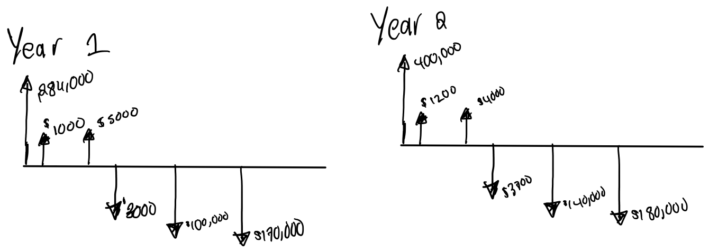

NPV Analysis
Rate of Return: 3%
NPV = NPV _{Year 2020} + NPV _{Year 2021} + NPV _{Year 2022}
NPV = $\frac{\$17,000}{(1+0.03)^{1}}+\frac{\$81,300}{(1+0.03)^{2}}+\frac{\$89,500}{(1+0.03)^{3}}$
NPV = $175,043.08

Break even point is when the NPV = 0,

Annuity Factor: 0.03
Initial Investment: 10,000

Cash Flows = Initial Investment

0.03 * (4000 X - 290,000) = 0
X = 155.8 units

Thus, 156 untis must be sold in order to reach break even.

Market Research and Assumptions

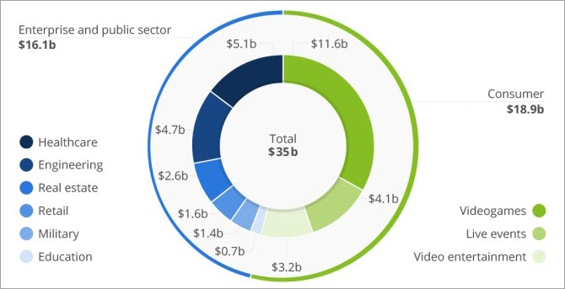
When conducting similar products, we realized that our product would be tailored to experience for educational institutions. The core assumption is that this product will attract users in educational institutions, which can potentially be extended to users in different industries as part of their training program for employees. Moreover, when researching VR training pilot programs, we learned that most pilot costs cost somewhere in between costs between $20,000 and $30,000 (Barto 2022). However, this is a cost for advanced training simulations, however we are developing a low fidelity model and does not contain many advanced features. Thus we choose the unit price of our VR training simulation to be $4000. Moreover, VR training is becoming increasingly popular as it gives users a more immersive experience helping them in real world solutions. Moreover, during economic standstill and social barriers VR bridges this gap which makes the VR business an increasingly demanding field. Moreover the figure above, depicts the VR marketing trends and the market size of VR technology of each sector of industry. Moreover, we expect to own around 5 percent of the education sector in the VR industry, as a small business just starting out we hope to further expand our operations and be able to develop more modules for educational training.

Wrike Link: https://www.wrike.com/workspace.htm?acc=4975842&wr=20#/folder/965918825/tableview?vie
wId=108819336

Conclusion

In this deliverable, we learned a lot about developing financial statements for a business and the market research and financial statements one needs to prepare when developing a business. It also helped us with making our product more feasible in the future when continuing to develop.

Citations

Libretexts. (2022, September 14). Titration of a weak base with a strong acid. Chemistry LibreTexts. Retrieved November 15, 2022, from https://chem.libretexts.org/Ancillary_Materials/Demos_Techniques_and_Experiments/General_Lab_Techniques/Titration/Titration_of_a_Weak_Base_with_a_Strong_Acid
McClintock, S. (2022, February 17). Top 7 questions to determine if virtual reality training is right for you. eLearning Industry. Retrieved November 20, 2022, from https://elearningindustry.com/top-questions-to-determine-if-virtual-reality-training-is-right-for-you

