GNG2101 Report

Project Deliverable D
Submitted by
Team 4.2 - Immersive VR Experience

Student Number |  | Name
300231269 |  | Brevin Baskaran
300228908 |  | Henry Radar
300126254 |  | Jiachen Wang
300231222 |  | Nicholas Yeung
300231531 |  | Reyaan Trimizi
8737165 |  | Uziar Mohiuddin

Faculty of Engineering

Introduction
In this deliverable we will provide a lot of new information about our product. These things include: a detailed design (software flowchart), bill of materials, feedback we received from our client, materials and equipment needed, prototype testing, and sketches of our product. Our product is an interactive experience where the user feels left out due to the language barrier. Specifically, we will provide the experience of a professor dividing students into groups for a project and a student who suffers from a language barrier feels discriminated against due to a language barrier.
Software Flowchart 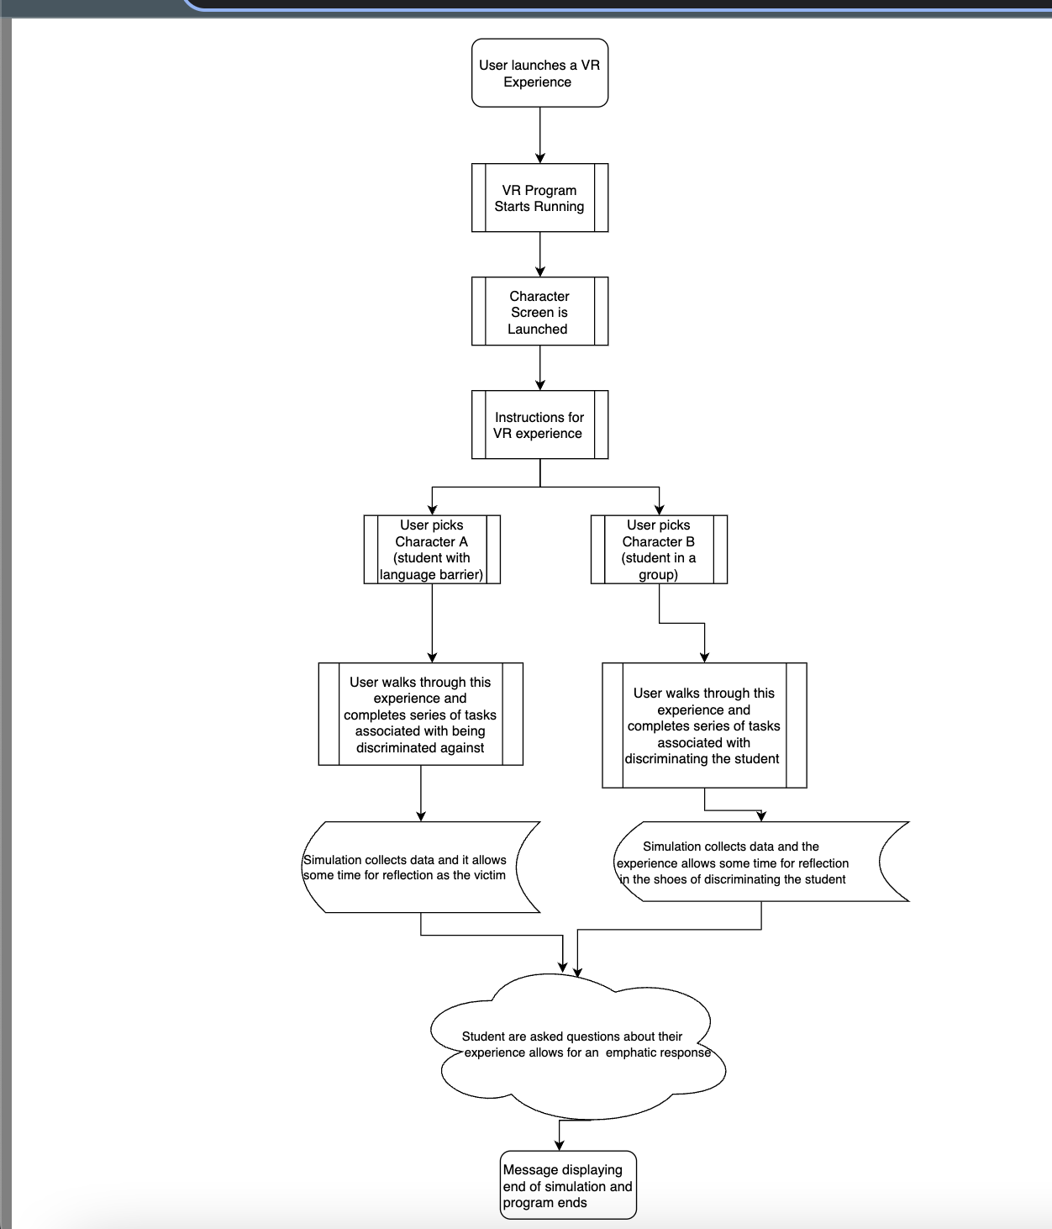

Feedback from Client
On October 3rd, our group met with the Client to gather feedback regarding our concepts. The three concepts we presented to her include: (1) Facing racial discrimination on campus, (2) Navigating through campus in a wheelchair, and (3) Experiencing exclusion from group work due to a language barrier. Our group chose to proceed with Concept 3 where a User feels left out due to a language barrier.
The feedback the Client provided is listed below:
- The goal is to create empathy and not to feel sorry for someone.
- Make the VR experience interactive and address different perspectives.
  - For example: Capturing the VR experience of 3 perspective being: (1) the person with the language barrier, (2) the students not acting nicely towards the person with a language barrier, and (3) the students who accept the person with a language barrier into their group and work as a team to give them tasks that manifest their strengths. Display how inclusivity can support their experience.
- Ask someone with a language barrier how they feel and what would make them feel better?
- Storyboard in "gory details" and gather storyboard feedback from an international student experiencing this. Gather feedback from as many people as possible whose primary language is not English.

Materials/ Equipment List
 | Item | Cost | Description | Link for Item
Assets | University Classroom | $20 | Detailed university classroom interior that includes multiple objects such as desks, chairs, blackboard. | https://assetstore.unity.com/packages/3d/props/interior/university-classroom-86107
 | Menus - Add on for VR Builder | $9.99 | Provides interactive guidance to the user in the form of text. | https://assetstore.unity.com/packages/tools/visual-scripting/menus-add-on-for-vr-builder-227449
 | Ultimate Cartoon People Pack (38 Bodies) | $14.99 | 3-D Cartoon characters to depict students | https://assetstore.unity.com/packages/3d/characters/humanoids/hyper-casual-cartoon-people-casual-203113
Audio Assets | Sad Hope - Music | Free | High quality music perfect for portraying the mood for darker scenes.  Time: 1 min 44 sec | https://assetstore.unity.com/packages/audio/music/music-sad-hope-157746
Software | Unity | Free | Cross-platform game engine used to develop video games and simulations | https://unity.com/
 | Blender | Free | Free and open-source 3D computer graphics software tool | https://www.blender.org/
Hardware | VR Headset | Free - Maker Space | Head-mounted device that enables the user to experience an immersive and interactive 3D experience | https://www.vive.com/ca/
Throughout this VR experience, we would need to purchase virtual assets needed for the 3D experience. We will be using the Unity 3D asset store, which is a studio made for VR developers that already have a variety of development tools for VR. We will be purchasing assets to create the environment, characters, and the audio aspects of the virtual reality experience. We will be breaking down the costs of not only the cost of software but also of the assets being used in the software such as 3D assets, audio assets, and accessibility assets. We will be trying to purchase most of the assets in order to focus more on the storyboard aspect of the VR experience. Thus, we can create a more enriching experience for the end user as it would give our team more time to spend on the educational and empathetic experience of the VR simulation. No equipment will need to be purchased as the VR headset and the software used for VR development is also free.

Prototyping Test
Each prototype will be evaluated based on the subsystems existing with the VR. The subsystems we designed based on functional decomposition are listed below.
Emotional Response
- User is given the opportunity to experience the same situation through multiple perspectives
- Must be implemented using VR or AR
- Experience simulates most human senses (touch, sight, hearing)
- User is aware of the wrongdoings of the aggressor
- Provides users with virtual objects or characters to interact with
- Allow the user to reflect on what they have learned throughout the module
- Experience allows the user to find a more inclusive outcome/solution to the situation

Fosters Diversity/Inclusion
- Experience has a story that informs about a societal issue
- VR experience has a story that has a defined plot that opens their mind to the issue
- User is able to come out of the experience with a new appreciation for the specification marginalized group

Accessibility/Ease of User
- VR experience should start with tutorial module on how to use the software
- Contains captions, and audio options for users
- Features for easy navigation through the module
- Show hint buttons to help user in VR experience
- Experience does not cause physical pains such as migraines/headaches

UI Design
- Bright and colorful visual images
- User has a full VR experience (360° view), and also allows user to zoom in or out
- User of different colors to depict emotions or errors that occur
- Images are mostly presented in a 3-Dimensional view
- There is spatial awareness around the different objects in VR

Software Capabilities
- VR experience has no or limited cost (usually requires software purchase)
- Software is reliable (does not crash unexpectedly) and can handle multiple users
- Software can be used by different operating systems
- The software is easy to navigate and use
- The frame rate is high to provide an enriching experience
Prototype 1 Test Plan
Prototype Test Plan 1 is intended to test a low fidelity prototype in which we have a detailed storyboard that aims to address inclusivity related to language barriers. This prototype captures the storyboard of the VR experience.
The storyboard encapsulates feedback from the Client to capture different perspectives related to the experience. This includes perspectives of the individual experiencing exclusion due to their language barrier, the students who don’t include the individual, and other students who choose to include the individual in their group. This prototype is crucial because it sets the stage for the future prototypes. The client indicated to test this storyboard as much as possible with anyone who has a language barrier. This will inform future iterations of our storyboard to maximize the effectiveness of the final product. Furthermore, it will allow us to assign baseline metrics related to subjective measures such as empathy towards the storyboard.

Test Objective and Subsystem Being Tested | Description of Prototype | Testing Method | Description of Results | Estimated Test Duration
Category: Emotional Response  Objective: Users should have an empathetic response to viewing the different perspectives in relation to a language barrier. | Low fidelity prototype that captures the storyboard of the VR experience. | Showing the User different perspectives in the storyboard based on language barriers.  For example, experiencing the situation through the shoes of the person with a language barrier, students excluding them, and other students including them. | We will have a survey with a series of questions to capture the User empathetic response. The survey will be used to gather feedback regarding the storyboard and the user's empathetic response. | Approximately 10 minutes which includes the duration to view the storyboard and complete the surveys.
Category: Fosters Diversity/Inclusion  Objective: Users should be informed of the issue of language barriers through an engaging story. | Low fidelity prototype that captures the storyboard of the VR experience. | Users will go through a storyboard that will be used to inform the building of the VR experience. | We will ask questions to analyze the level of information the user gained.  Results will be used to fill in any gaps in the storyboard. | Approximately 5 minutes to ask questions.
Prototype 2 Test Plan
Prototype Test Plan 2 is intended to test a medium fidelity prototype that includes a VR experience with basic navigation through the storyboard. This prototype captures a minimal VR experience that allows Users to navigate through the simulation. The objective of this Test Plan is to have a base layout of locations and characters that will be included in the simulation. We will test if a User is able to navigate a minimal storyboard within the VR experience, which will be refined in the high-fidelity prototype. This will include simple navigation with user prompts, entering into the VR simulation, and interacting with other assets.
Test Objective and Subsystem Being Tested | Description of Prototype | Testing Method | Description of Results | Estimated Test Duration
Category: Emotional Response  Objective: Users should have an empathetic response to viewing the different perspectives in relation to a language barrier. | Medium fidelity prototype that includes a baseline VR experience | Showing the User different perspectives in the VR experience based on language barriers.  For example, experiencing the situation through the shoes of the person with a language barrier, students excluding them, and other students including them. | We will have a survey with a series of questions to capture the User empathetic response. The survey will be used to gather feedback regarding the VR experience and the users empathetic response. | Approximately 10 minutes which includes the duration to view the storyboard and complete the surveys.
Category: Fosters Diversity/Inclusion  Objective: Users should be informed of the issue of language barriers through an engaging story. | Medium fidelity prototype that includes a baseline VR experience | Users will go through a VR experience that implements the storyboard. | We will ask questions to analyze the level of information the user gained.  Results will be used to fill in any gaps in the storyboard. | Approximately 5 minutes to ask questions.
Category: Accessibility/Ease of User  Objective: Users should be able to easily navigate through the VR experience. | Medium fidelity prototype that includes a baseline VR experience | Users will go through the VR experience on their own and seek assistance where they need. | We will record the pathway that User’s travel through and the amount of assistance they require. | 5-10 minutes to navigate through the VR experience.
Category: Accessibility/Ease of User  Objective: Users can start the simulation with little guidance. | Medium fidelity prototype that includes a baseline VR experience | Users will try to start the VR experience. | We will record if Users are able to begin going through the VR experience on their own. | 2 minutes.
Prototype 3 Test Plan
Prototype Test Plan 3 is intended to test a high-fidelity prototype that includes a VR experience with implementation of a detailed storyboard that navigates Users through an experience of language barriers. This prototype has an in-depth implementation of the storyboard including user prompts, user navigation, a tutorial module, and details related to the setting and characters used in the simulation.

Test Objective and Subsystem Being Tested | Description of Prototype | Testing Method | Description of Results | Estimated Test Duration
Category: Emotional Response  Objective: Users should have an empathetic response to viewing the different perspectives in relation to a language barrier. | High fidelity prototype that includes a detailed VR experience | Showing the User different perspectives in the VR experience based on language barriers. | We will have a survey with a series of questions to capture the User empathetic response. The survey will be used to gather feedback regarding the VR experience and the user’s empathetic response. | Approximately 10 minutes which includes the duration to view the storyboard and complete the surveys.
Category: Fosters Diversity/Inclusion  Objective: Users should be informed of the issue of language barriers through an engaging story. | High fidelity prototype that includes a detailed VR experience | Users will go through a detailed VR experience. | We will ask questions to analyze the level of information the user gained.  Results will be used to refine the high-fidelity prototype. | Approximately 5 minutes to ask questions.
Category: Accessibility/Ease of User  Objective: User’s should be able to easily navigate through the VR experience. | High fidelity prototype that includes a detailed VR experience | Users will go through the VR experience on their own and seek assistance where they need. | We will record the pathway that User’s travel through and the amount of assistance they require. | 5-10 minutes to navigate through the VR experience.
Category: Accessibility/Ease of User  Objective: User’s can start the simulation with little guidance. | High fidelity prototype that includes a detailed VR experience | Users will try to start the VR experience. | We will record if Users are able to begin going through the VR experience on their own. | 2 minutes.
Category: User Interface  Objective: The VR experience provides a good UI to the User | High fidelity prototype that includes a detailed VR experience | Users will go through the detailed VR simulation. | User will fill out a questionnaire that asks for rating of the images used, colors, and images. This will be used to inform future iterations of the prototype. | 5 minutes.
Category: Software Capabilities  Objective: The VR simulation provides Software Capabilities meeting the minimal benchmark metrics. | High fidelity prototype that includes a detailed VR experience | Team will measure the capabilities of the VR simulation based on the benchmark metrics. | Team will record the data and use it to inform future iterations. | 1-2 days to analyze and record the data.

Prototype 1 Test and Results
For this Deliverable, we executed the Prototype 1 Test Plan to test the low fidelity prototype. The table below presents the results.
For the Empathy Questionnaire, we modified the Toronto Empathy Questionnaire to fulfill the needs of testing. Empathy refers to the ability to accurately perceive the feelings of another (Spreng et al., 2009). The Toronto Empathy Questionnaire is a self-report measure of empathy that has been able to be easily-administered, while being correlated with high convergent validity (Spreng et al., 2009). All Questions in the Questionnaire are referring to the person with a language barrier in the simulation. Each question was scored between 1 and 5 based on 5 responses: (1) Never, (2) Sometimes, (3) Neutral, (4) Agree, (5) Strongly Agree. For negatively framed questions, the scale was reversed. The modified Empathy Questionnaire included the following questions:
- When viewing the simulation, seeing the person with a language barrier excited, resulted in me being excited.
- Seeing their misfortune did not disturb me a great deal.
- It upset me to see someone being treated disrespectfully.
- I wanted to make them feel better.
- I had tender, concerned feelings for the person with a language barrier.
- When watching the Simulation, my thoughts steered in other directions.
- I felt “in tune” with the person’s emotions.
- I was not too interested in how they felt.
- I got a strong urge to help when seeing the person upset.
- When I saw them being treated unfairly, I did not feel very much pity for them.
- When I saw the Simulation, I felt kind of protective towards the person.
Article Citation:
Spreng, R. N., McKinnon, M. C., Mar, R. A., & Levine, B. (2009). The Toronto Empathy Questionnaire: scale development and initial validation of a factor-analytic solution to multiple empathy measures. Journal of personality assessment, 91(1), 62–71. https://doi.org/10.1080/00223890802484381

Toronto Empathy Questionnaire: https://psychology-tools.com/test/toronto-empathy-questionnaire
Test Objective and Subsystem Being Tested | Testing Method | Results
Category: Emotional Response  Objective: Users should have an empathetic response to viewing the different perspectives in relation to a language barrier. | Showing the User different perspectives in the storyboard based on language barriers.  Test: We will have a survey with a series of questions to capture the User empathetic response. The survey will be used to gather feedback regarding the storyboard and the user's empathetic response. | The Questionnaire was tested on 3 people with language barriers.  Questionnaire Results Summary  Question Score  Person 1 Person 2 Person 3  1 2 2 1  2 4 3 4  3 4 4 4  4 3 4 4  5 3 4 4  6 2 3 2  7 3 3 3  8 3 4 4  9 3 3 3  10 3 4 3  11 3 3 3  Total 33 37 35  The average score was 35 out of a potential 55.  Discussion  These results gave an understanding of room for improvement. In specific, the following deductions are made from the results:  - Future iterations of the storyboard should go into further detail of the positive outcome of a person with a language barrier being included into a group. This will allow a person to feel excited for the person with a language barrier.  - Our storyboard did a good job in expressing the difficulty a person with a language barrier faces and inducing empathy into the viewer of the storyboard.  - Due to the nature of the low fidelity prototype, we expected a lower level of connectivity towards the images. This resulted in the thoughts of viewers steering in other directions.  Future Direction: Improving the detail of the storyboard and capturing more perspectives.
Category: Fosters Diversity/Inclusion  Objective: Users should be informed of the issue of language barriers through an engaging story. | Users will go through a storyboard that will be used to inform the building of the VR experience.  Test: We will ask questions to analyze the level of information the user gained.  Results will be used to fill in any gaps in the storyboard. | Feedback from Users:  - They were able to gain an understanding of what someone with a language barrier is experiencing when trying to work in a group project on campus.  - Users do not have a complete understanding of the personal perspective of the person experiencing the language barrier. Need to better capture their thoughts and decision making when being placed in these uncomfortable situations.  - Require more information on how others could assist the student and potentially have a positive scenario for the person with the language barrier.
Prototype Specifications - Testing
Target Specifications | Device | Testing Value | Marginally Acceptable Values | Reason
FPS | Device #1 | 40 FPS | 30 FPS | The FPS is not completely accurate for this prototype as we produced a low fidelity prototype. This low fidelity prototype was a storyboard intended to validate our prototype.  Our Team decided to use Unity to produce the VR. Given this, expected FPS is minimum 30 FPS. This meets the marginally acceptable value for the target specifications of our prototype.
 | Device #2 | 47 FPS
 | Device #3 | 60 FPS
Load time | Device #1 | 39 seconds | 120 Seconds | The Load Time is not completely accurate prototype as we produced a low fidelity prototype. This low fidelity prototype was a storyboard intended to validate our prototype.  The Unity Software is expected to take 1 min on the low end for the Load Time. Depending on the VR and RAM, the Load Time can increase to 3-5 min. We will do further testing once a medium fidelity Unity Prototype is created.
 | Device #2 | 45 seconds
 | Device #3 | 60 seconds
Usage Data | Device #1 | 800 MB | 2 GB | Usage time is essential for the game to load on a device and it gives how much user data is used.
 | Device #2 | 1 GB
 | Device #3 | 1.5 GB
Memory size | ALL DEVICES | 1.2 GB | 3 GB | The Memory Size is not completely accurate as it was the memory size for the environment for the VR simulation applicable for this prototype as we produced a low fidelity prototype. This low fidelity prototype was a storyboard intended to validate our prototype.  The Expected Memory Size for the Unity Software is between 1-2 GB of Hard Drive Space. Further testing will be done to update the Prototype Specifications once a medium fidelity prototype is produced.  If the memory size of the medium fidelity prototype is between 1.5 and 3 GB, it will meet the target specifications.
Complete time | All devices | 8 min | 15 min /  10 min (Min) 25 min (Max) | The completion time for the Storyboard was 8 min. Given the Storyboard is easier to go through and untimed, it is not an accurate representation of the completion time of the VR.  Once the medium fidelity prototype is generated, a more accurate Prototype Specification will be gained. If the completion time is between 10 and 25 min, it will meet the target specifications.
Progress | ALL DEVICES | 100% | 80% / 50% | All Users who navigated the Storyboard completed 100% of this. This exceeds the Target Specifications.  Nonetheless, this is not an accurate representation of the final prototype. We will gain a better understanding of the Prototype Specifications once a VR is produced and this will be used to update the Prototype Specifications. If the User completed 50%-80% of the VR, it will meet the Target Specifications.

Prototype of the Design
Figure 1 - Group joining sequence
​​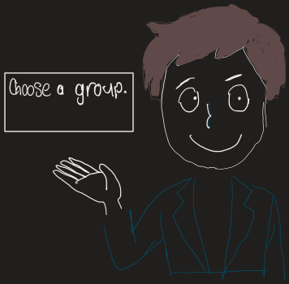
Give the user the choice of joining a group or already being in a group and being the aggressor.
Figure 2 - Character joining sequence
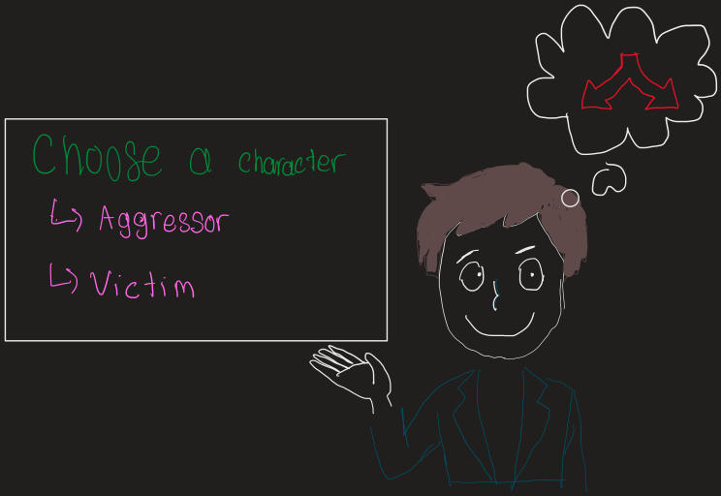

The user is given the option to pick a group to join. When they choose a group they will be rejected because the members either ignore or do not want to work with them.
Figure 3 - Group isolation sequence
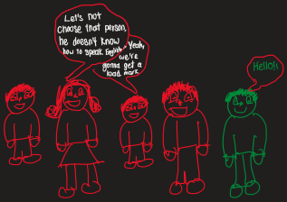
The user can decide whether they want to ask another group or go to the Professor to be assigned a group.
Figure 4 - Group work sequence
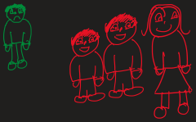
The user starts to work with the group. However, he/she feels isolated as the group rarely talks to them and is constantly isolated from group meetings.
Figure 4 - Reflection on Simulation
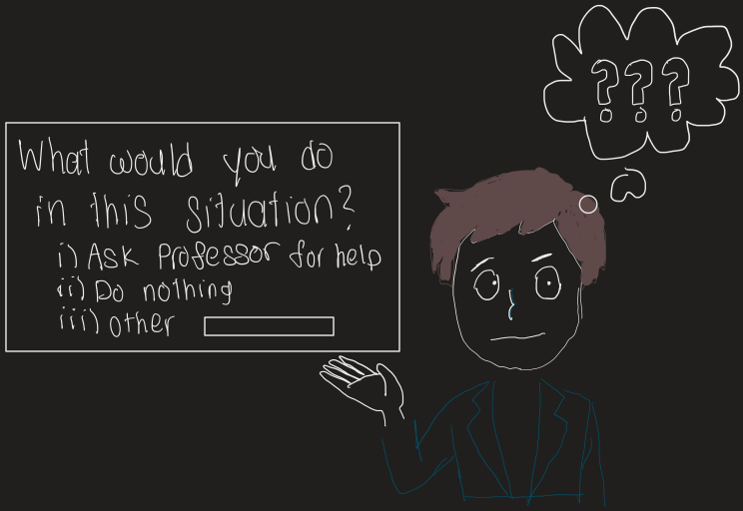
  - The user can pick from options to say what they want to do about the situation.
    - Ask professor for help in situation
    - Let group members do the work and sit back
    - etc.
  - The experience will give different feedback based on the option chosen
Optional: Have the user join a different group where better solutions are provided and it works out better.
Conclusion
In this deliverable, we provided a lot of information about our product and what we plan to do with it. As a group, we understand that we are working in an agile environment so we will need to adjust and alter our product as we go, but we will try to stick to the information we provided in this deliverable as much as possible.
Wrike link: https://www.wrike.com/workspace.htm?acc=4975842&wr=20#/folder/965918825/tableview?viewId=108819336

