Group 8: (Kristen Wells, Jacob Roberge, Ramtin, Victoria Guo, Semilore Busari ).
Deliverable D: Conceptual Design

Objective:
Develop a set of conceptual designs for the accelerated erosion testing prototype based on the client's needs, safety considerations, and technical benchmarks. Analyse and evaluate these concepts to choose the most suitable design for further development.

Instructions:

1. Individual Concept Generation:
- Each team member generated at least one concept for each required subsystem based on the problem statement, benchmarking, and prioritised design criteria.

2. Team Discussion and Refinement:
- The team convened to categorise, combine, and refine individual concepts for each subsystem, aiming to produce innovative and comprehensive designs.

3. Subsystem Documentation:
- Each subsystem was thoroughly documented with clear sketches and descriptions, highlighting benefits, drawbacks, and considerations for interchangeability. Individual team members were attributed to each concept.

4. Combination into Functional Solutions:
- Subsystems were combined to create three fully functional solutions, ensuring versatility and adaptability to different testing conditions.

5. Analysis and Evaluation:
- Global concepts were analysed against design criteria using a selection matrix approach similar to the one used in technical benchmarking. Benefits, drawbacks, and justifications were provided for each concept.

6. Final Concept Selection:
- Based on analysis and evaluation, the best global concept was chosen for further development, with justification provided. Top three ideas were recorded for future reference.

Conceptual Designs:
This are just the various concepts and consideration made when making the designs and sketches;

1. Safety Features Integration:
- This concept prioritises safety by integrating various safety features such as emergency stop mechanisms, protective enclosures, and fail-safe systems to mitigate risks associated with hazardous materials and high-speed components.

2. Controlled Parameters Design:
- Focuses on precision control of erosion acceleration parameters including rotation speed, fluid viscosity, and temperature. Offers flexibility in adjusting testing conditions to replicate real-world scenarios accurately.

3. Versatile Testing Setup:
- Designed to accommodate a wide range of materials and operating conditions, this concept emphasises modularity and adaptability. Allows testing under varying pressures, temperatures, and rotational speeds for comprehensive analysis.

Analysis and Evaluation:

- Safety Features Integration:
- Benefits: Ensures compliance with safety regulations, and reduces the risk of accidents or equipment damage.
- Drawbacks: This may increase the complexity and cost of the prototype.
- Justification: Safety is paramount in erosion testing, and integrating robust safety features aligns with client expectations and industry standards.

- Controlled Parameters Design:
- Benefits: Offers precise control over erosion testing conditions, enhances repeatability and accuracy of results.
- Drawbacks: Requires sophisticated control systems and monitoring equipment.
- Justification: Accurate control of parameters is crucial for reliable erosion testing, justifying the investment in advanced control mechanisms.

- Versatile Testing Setup:
- Benefits: Enables testing of various materials and scenarios, and enhances the prototype's flexibility and applicability.
- Drawbacks: Complexity may increase setup and operation time.
- Justification: Versatility is essential to cater to diverse testing requirements, allowing for comprehensive analysis of erosion resistance across different materials and conditions.

Based on the analysis and evaluation, the team has concluded that each concept is necessary in coming up with a design and contribute for further development. Combination of the concepts balances safety, precision, and versatility, aligning closely with client needs and project constraints. The integration of advanced control mechanisms ensures accurate replication of erosion conditions while maintaining operational safety and efficiency.

Conclusion:

The conceptual design phase has provided valuable insights into the development of the accelerated erosion testing prototype. By incorporating safety considerations, technical benchmarks, and client feedback, the team has identified a promising design direction.
After clients feedback, the selected concept will undergo detailed refinement and prototyping to meet project objectives effectively.

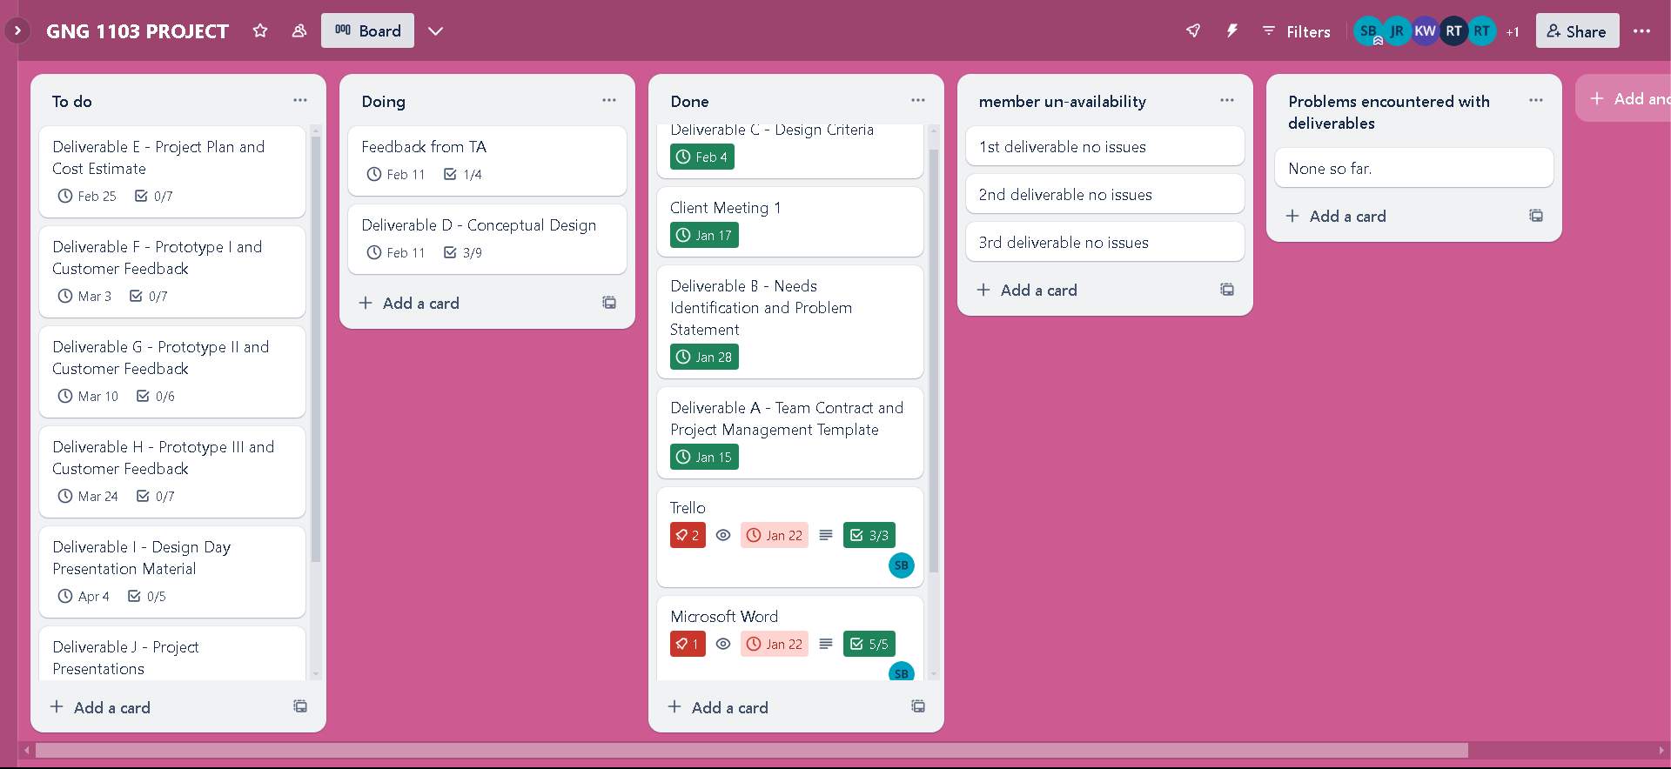
Update on Trello

Trello link: https://trello.com/invite/b/CRQGbBp6/ATTI1da075bb32a439ed37b061fe809aaa8a86593A1A/gng-1103-project

Task Plan Update:

1. Trello Task Board Update:
- Tasks have been updated to reflect the current understanding of the project and any identified roadblocks.

2. Detailed Sub-Tasks:
- Sub-tasks have been added to tasks to facilitate better planning and execution over the next few weeks.

3. Task Start and End Dates:
- Task timelines have been adjusted based on project progress and team availability.

4. Accounting for Team Member Availability:
- Task assignments consider each team member's availability and any significant events that may affect project work progress.

5. Issue Resolution:
- Group issues have been discussed and addressed, ensuring constructive conflict resolution and effective collaboration.

Recommendation:
It is recommended to proceed with the chosen concept while remaining within budget constraints and adhering to safety standards.

Sketches
Ramtin’s Sketch 1
- see-through tank( Silicone, Glass)
Product Dimensions: 16.5 in L x 8.75 in D x 10.75 in H
Capacity: 5.5 Gallons
Product Weight: 6 lb
https://www.petsmart.ca/fish/tanks-aquariums-and-nets/aquariums/aqueon-standard-glass-rectangle-aquarium-5345486.html?gad_source=1&gclid=Cj0KCQiAwvKtBhDrARIsAJj-kThvTF2epMNpGa26hHXjb9NcjNBXNcXyxYLxbT1azCTetYdSzmc7mrEaAuqKEALw_wcB&gclsrc=aw.ds
-(6’’) 3 blade propeller https://cad.onshape.com/documents/bdc4690ea852c3f631a1828d/w/451bac945ec12a1830017c82/e/279f7b0648cb6c98c802d43f?renderMode=0&uiState=65bd4ba9fc66723b907e03c9
-A small electric motor that can propel the fan up to 10 rpm
https://www.adafruit.com/product/1177
(5mm to 10mm)
Outer Diameter: 20mm / 0.8" Inner Diameter (wide side): 10mm / 0.4" Inner Diameter (small side): 5mm / 0.2" 15 grams
3-D printed plastic rod to hold motor and blade
TBD
https://www.amazon.ca/Neptonion-Thermometer-LCD-Digital-Temperature-Reptiles-Like/dp/B07RBPV8Q4/ref=sr_1_1_sspa?crid=3F9RBWSQQ50J8&keywords=fish+tank+thermometer&qid=1706904418&sprefix=fish+tank+the%2Caps%2C221&sr=8-1-spons&sp_csd=d2lkZ2V0TmFtZT1zcF9hdGY&psc=1
Thermometer
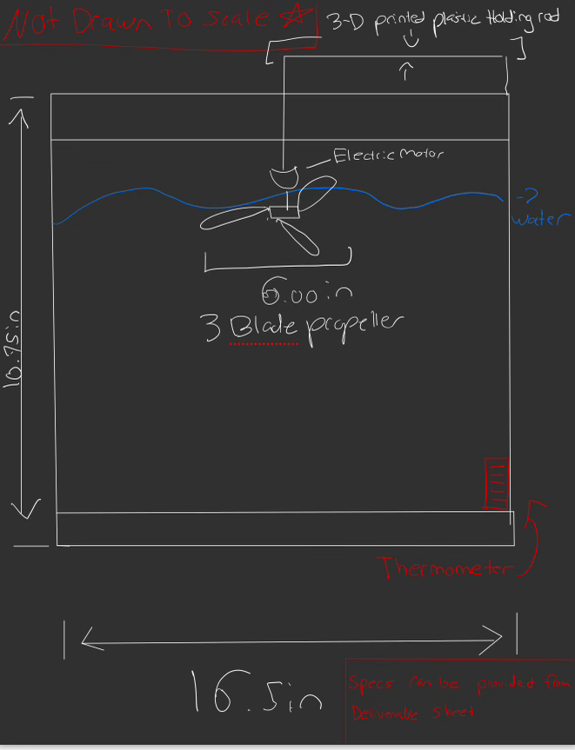
Total estimated cost(with shipping and tax): CAD 49.13

Jacob’s Sketch 2,
https://www.petsmart.ca/fish/tanks-aquariums-and-nets/aquariums/top-fin-open-glass-aquarium-5318197.html?gad_source=1&gclid=CjwKCAiA2pyuBhBKEiwApLaIOw7S7ItZk9jQCMQAao1a8jqfJDyJ1RDtf_FNflOMyIN90I4vU3a2iBoCjkIQAvD_BwE&gclsrc=aw.ds
The tank seen above is slightly smaller than was featured in our design, coming in at 2.5 gallons instead of the 5.5-gallon tank we originally decided on. This will allow for a more concentrated area for the propeller to spin, as well as making a slightly more compact design. Picking up and moving a 2.5-gallon tank would be a lot easier for the team than a 5.5-gallon design.

https://cults3d.com/en/3d-model/tool/impeller-hair-dryer-redmond-rf-cb526-rf-531-3ddrukby
This is what is known as an impeller, a propeller designed specifically for spinning containers of water. This is something that the group would 3D print, and resize for the appropriate load of water. The downside of this design would only be the complexity of the impeller design, if something in the design were to malfunction, it would be the impeller.

https://learn.adafruit.com/assets/16734
These are standard Arduino stepper motors, codable and highly controllable speeds. This would be placed outside of the water of the tank, likely on a board connected to the system. The good thing about these motors is how customizable they are, with the ability to change the rotation speed of the motor, this will be the ideal motor type for this design.

https://www.amazon.ca/Finnex-PF-7-Aquarium-Power-Filter/dp/B082JJJL75/ref=asc_df_B082JJJL75/?tag=googleshopc0c-20&linkCode=df0&hvadid=459389502145&hvpos=&hvnetw=g&hvrand=13125373597523261688&hvpone=&hvptwo=&hvqmt=&hvdev=c&hvdvcmdl=&hvlocint=&hvlocphy=9000668&hvtargid=pla-1012268577294&psc=1&mcid=3f700aefdc7f382e9df3764f4da84173
This is a simple fish tank filtration system, a system designed to remove sediment from fish tanks. This design could save the team a lot of hassle, as we are using a fish tank, we may as well stick with the design. This will help remove sediment that will naturally come from the erosion process and will help further analysis by capturing the sediment in the filtration system.

https://www.canadiantire.ca/en/pdp/starfrit-digital-kitchen-scale-5-kg-0424076p.0424076.html?gclid=Cj0KCQiAwvKtBhDrARIsAJj-kTixyVT72BDXJzLUSdQ8Tv-sdHnMYjb6FjFhqd01NxRGVQWNVkKd0NUaAuMpEALw_wcB&gclsrc=aw.ds#store=174
This is a common kitchen scale, this was picked due to cost and accessibility. The scale measures within 0.1g of accuracy and can be used to track material weight throughout the experiment.

https://www.amazon.ca/Neptonion-Thermometer-LCD-Digital-Temperature-Reptiles-Like/dp/B07RBPV8Q4/ref=sr_1_1_sspa?crid=3F9RBWSQQ50J8&keywords=fish+tank+thermometer&qid=1706904418&sprefix=fish+tank+the%2Caps%2C221&sr=8-1-spons&sp_csd=d2lkZ2V0TmFtZT1zcF9hdGY&psc=1
This is a thermometer commonly used for fish tanks, being a reliable and easy-to-use way to keep track of the temperature of the water.

Completed Sketch,
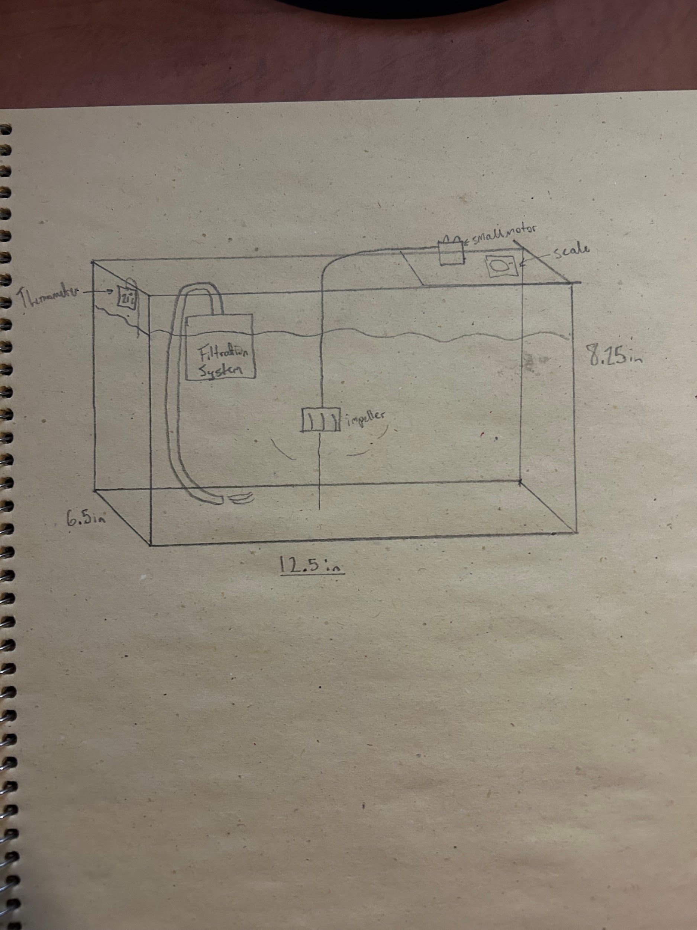
Total estimated cost(with shipping and tax): CAD 89.68

Semilore’s Sketch 3 ,
A multi-blade propeller design would be most suitable for this experiment. Multi-blade propellers are known for providing better efficiency and uniform flow compared to single-blade designs. A 3-blade propeller is a common choice for such applications but might as well try a 6-blade propeller to check how it affects the system.
https://www.amazon.ca/accessories-Propeller-Multirotor-Cinelifter-Replaceable/dp/B0C59DZGNG/ref=sr_1_33?crid=23GESXS1550M0&keywords=6%2Bblade%2Bpropeller&qid=1707696784&sprefix=6%2Bblade%2Bpropeller%2Caps%2C137&sr=8-33&th=1

The Cylindrical water Tank contains 3 threaded Holes, the tank is heat Resistance,Withstand high Heat.
https://www.amazon.ca/Cylindrical-Computer-Reservoir-Resistance-Withstand/dp/B0886G7W83/ref=sr_1_2_sspa?crid=1PHUCOAF0T3E7&keywords=cylindrical+water+tank&qid=1707697166&sprefix=cylindrical+tank%2Caps%2C161&sr=8-2-spons&sp_csd=d2lkZ2V0TmFtZT1zcF9hdGY&psc=1

These are standard Arduino stepper motors, codable and highly controllable speeds. The good thing about these motors is how customizable they are, with the ability to change the rotation speed of the motor, this will be the ideal motor type for this design.
https://learn.adafruit.com/assets/16734

Zacro LCD Digital Aquarium Thermometer Fish Tank Water Terrarium Temperature
https://www.amazon.ca/Zacro-Aquarium-Thermometer-Terrarium-Temperature/dp/B01N80F1D1/ref=sr_1_5?crid=F95CAWPSVPWY&keywords=water%2Bthermometer&qid=1707699178&sprefix=water%2Bthermometer%2Caps%2C207&sr=8-5&th=1

MAXUS Precision Pocket Scale 200g x 0.01g, Digital Gram Scale Small Food/Jewelry Scale Ounces/Grains Scale with Backlit LCD, Great for Travel. It is suitable for weighing the residue of the eroded material.
https://www.amazon.ca/Precision-MAXUS-Digital-Jewelry-Stainless/dp/B07DJBDL6L/ref=sr_1_1_sspa?crid=631J649N0B5X&keywords=small%2Bscale&qid=1707699390&sprefix=small%2Bscale%2Caps%2C226&sr=8-1-spons&sp_csd=d2lkZ2V0TmFtZT1zcF9hdGY&th=1

NICREW Slim Aquarium Filter, Quiet Fish Tank HOB Filters for up to 5 Gallon Aquariums, Adjustable Flow, 42 GPH, 3W for filtering out the eroded pieces of the material.
https://www.amazon.ca/NICREW-Aquarium-Filters-Aquariums-Adjustable/dp/B0CGN1TV1G/ref=sr_1_8?crid=1BWO4J0CV2RV3&keywords=water%2Btank%2Bfilter&qid=1707700008&sprefix=water%2Btank%2Bfilter%2Caps%2C157&sr=8-8&th=1

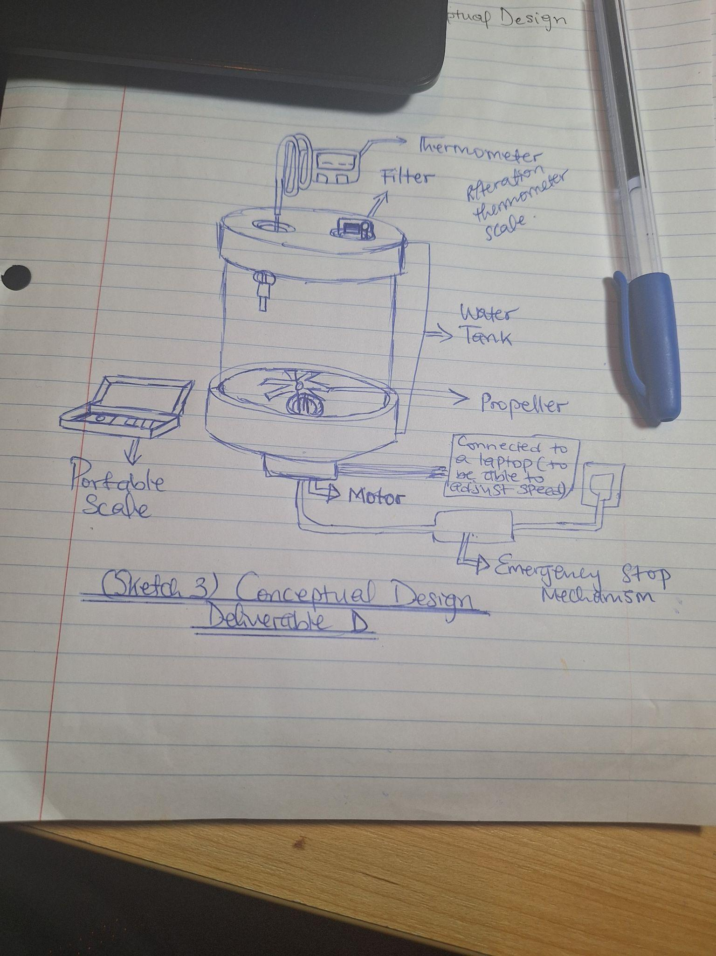
Total Estimated Cost(with shipping and tax): CAD 94.60

Victoria’s Sketch

A large acrylic clear terrarium tank with a locking hatch to allow the sediment to be transported or removed .
https://www.amazon.ca/Zilla-Micro-Habitats-Arboreal-Large/dp/B08M4DFWJW/ref=mp_s_a_1_3?crid=QOEJPZHB00J6&keywords=clear+tank+with+opening&qid=1707709389&sprefix=clear+tank+with+opening%2Caps%2C101&sr=8-3

A 3 blade aluminum propellor
https://www.amazon.ca/Novelbee-Propeller-Evinrude-2-2-3-3Hp-Outboard/dp/B083J3XNQB/ref=asc_df_B083J3XNQB/?tag=googlemobshop-20&linkCode=df0&hvadid=341612205093&hvpos=&hvnetw=g&hvrand=10030172360253321474&hvpone=&hvptwo=&hvqmt=&hvdev=m&hvdvcmdl=&hvlocint=&hvlocphy=9000668&hvtargid=pla-914933153027&psc=1&mcid=81a7a3828fa93b0488963f34fd2c05ec

Dc electric motor , can go up towards 20 rpm
https://www.amazon.ca/Gear-Motor-High-Torque-Intelligent/dp/B072FNYTQB/ref=asc_df_B072FNYTQB/?tag=googlemobshop-20&linkCode=df0&hvadid=341832968344&hvpos=&hvnetw=g&hvrand=3337834450745090215&hvpone=&hvptwo=&hvqmt=&hvdev=m&hvdvcmdl=&hvlocint=&hvlocphy=9000668&hvtargid=pla-354745118858&psc=1&mcid=364061dcac8c3566b095d610bd33d034

Thermometer strip adhesive digital
https://www.amazon.ca/Adhesive-Temperature-Thermometer-Fahrenheit-Readings/dp/B06ZZDJCFX/ref=mp_s_a_1_6?keywords=thermometer+strip&qid=1707710534&sr=8-6
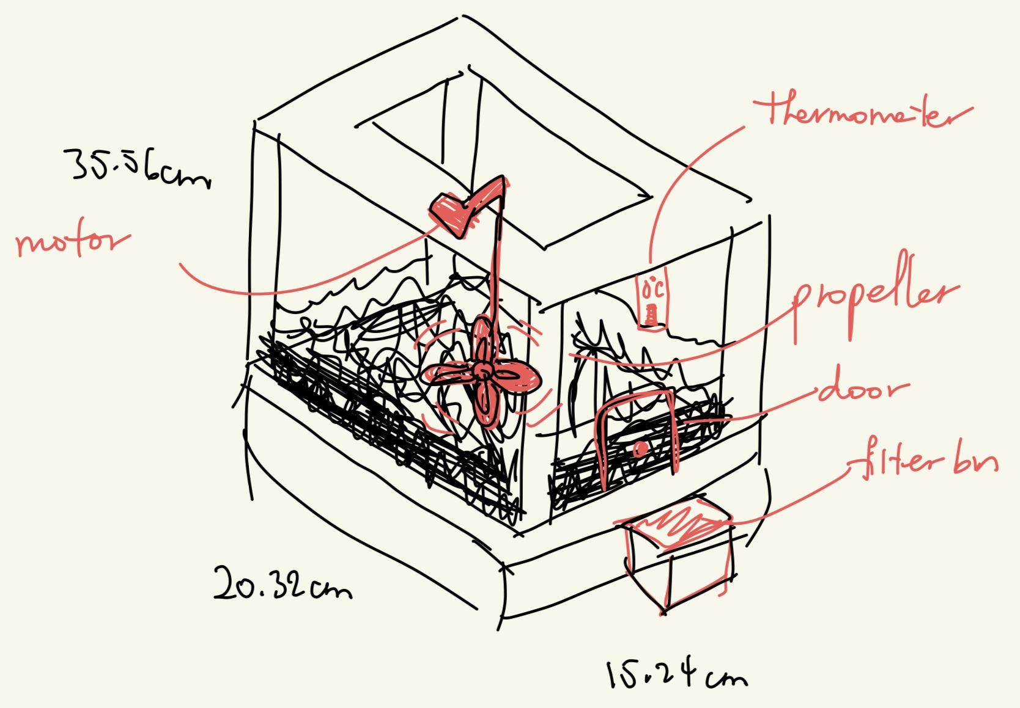
Total estimated cost: $97.03

Kristen’s Sketch
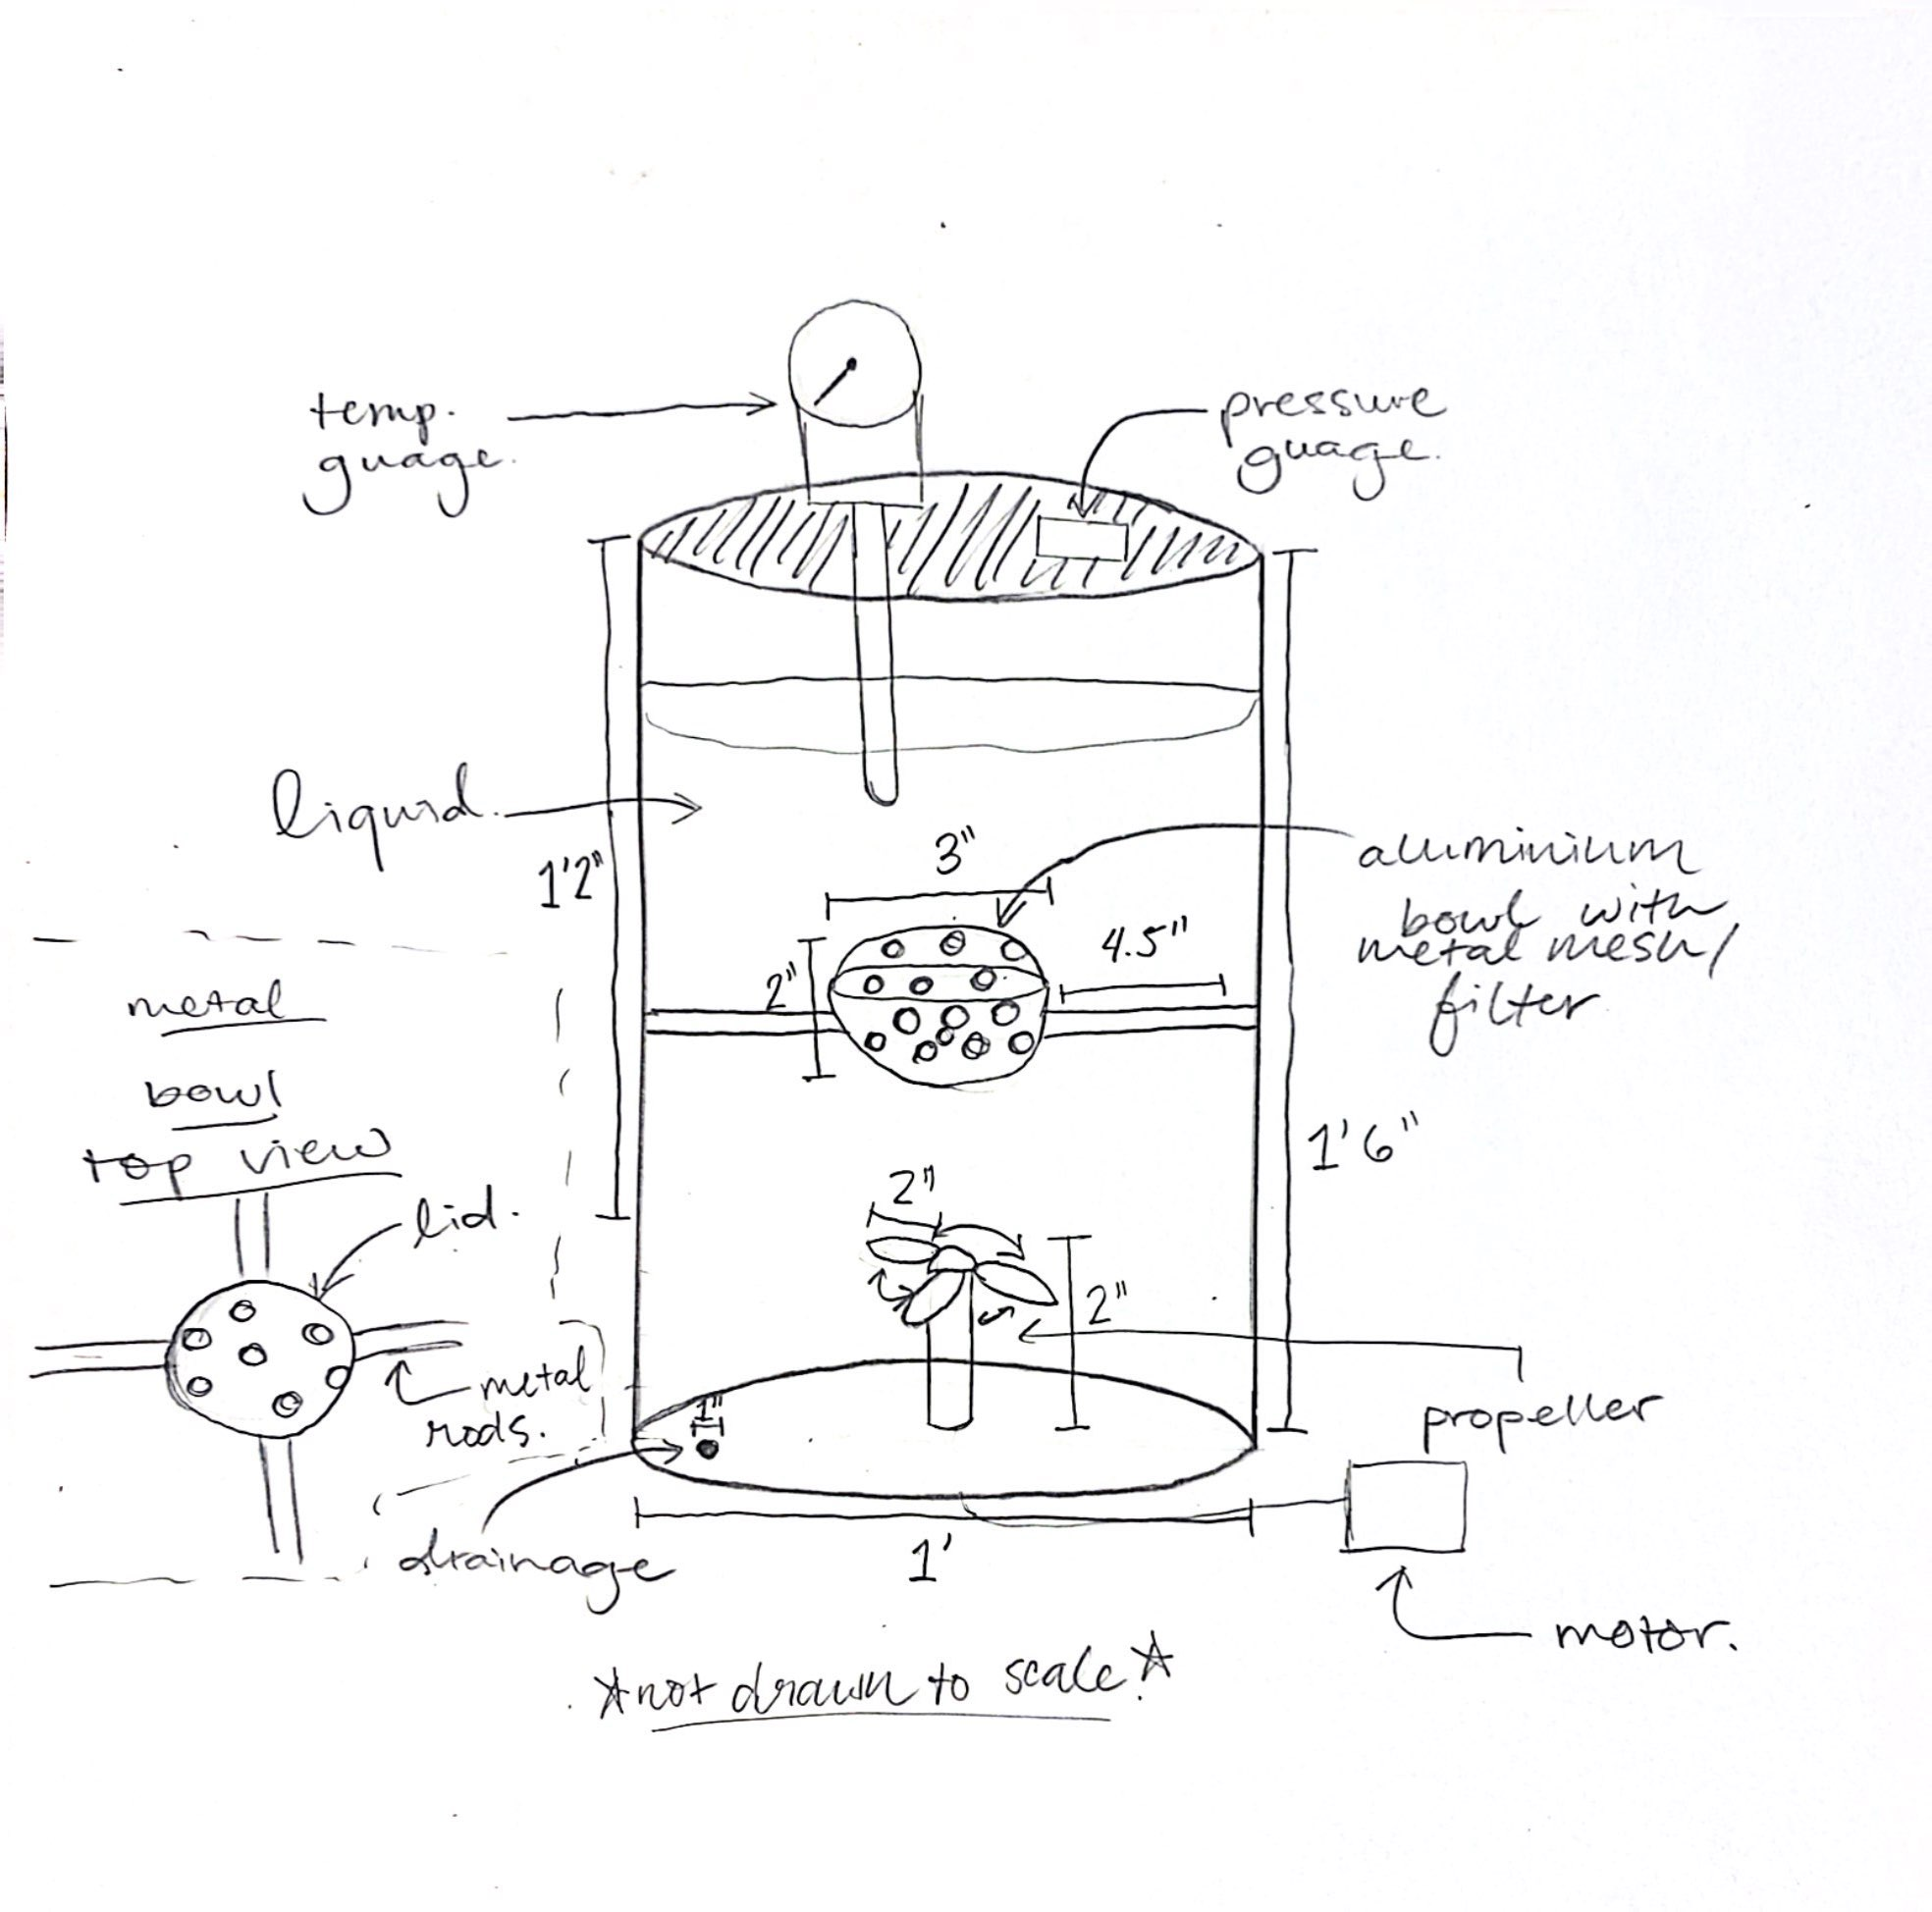
- A metal bowl that has holes throughout, that is lined with a metal mesh, that acts and serves as a filter in the case of any breakage from the sediment. This bowl is then connected to metal rods that permit it to rotate in a circular up-and-down motion to create “climate factors” artificially. Additionally, the bowl can come out of the water allowing for easy access.
  - tank
  - bowl
- A propeller is found at the bottom of the cylindrical tank ensuring that the erosion’s acceleration remains at a constant speed.
  - propeller

- A pressure gauge and a temperature gauge are found attached to the lid of the closed system to maintain and ensure that these values remain constant and that other variables cannot enter the system.
  - pressure gauge
  - temperature gauge
- There is a drainage hole found at the bottom of the tank allowing for easy cleaning.
  - rubber stopper for drainage hole

Estimated total cost (without shipping/tax): $78.70 CAD

