Deliverable K – User and Product Manual

Group Members:
Kevin Lavigne
Andrew Hill
Jonathan Charette
Chadi Hasbani
Roman Rovishen

Date: Dec 8^{th,} 2021

Table of Contents
List of Figures iv
List of Tables v
List of Acronyms and Glossary vi
1 Introduction 7
2 Overview 7
2.1 Conventions 9
2.2 Cautions & Warnings 9
3 Getting started 9
3.1 User Access Considerations 11
3.2 Accessing the System 11
3.3 System Organization & Navigation 11
3.4 Exiting the System 12
4 Using the System 12
4.1 Conversion of Points 12
4.2 Addition of Other Points 13
4.3 Addition of Zafin Points 14
4.4 Withdrawal of Points 15
5 Troubleshooting & Support 16
5.1 Error Messages or Behaviors 16
5.2 Maintenance 16
5.3 Support 16
6 Product Documentation 17
6.1 Subsystem 1 of Product 18
6.1.1 BOM (Bill of Materials) 18
6.1.2 Equipment list 19
6.1.3 Instructions 19
6.2 Testing & Validation 20
7 Conclusions and Recommendations for Future Work 20
8 Bibliography 22

List of Figures
Figure 1. U.P.S. Home Page 8
Figure 1. U.P.S. Home Page 9
Figure 2. U.P.S. Menu Page 10
Figure 3. U.P.S. Deals Page 10
Figure 4. Conversion of Points 12
Figure 5. Addition of Other Points 13
Figure 6. User Reviews 14
Figure 7. Withdrawal of Points 14
Figure 8. Excel Table of Data 17
Figure 9. SharePoint File of Functions 17

List of Tables
Table 1. Acronyms vi
Table 2. Glossary vi
Table 3. Bill of Materials 18
Table 4. User Reviews 20

List of Acronyms and Glossary

Table 1. Acronyms
Acronym | Definition
U.P.S. | United Points System

Table 2. Glossary
Term | Acronym | Definition
Excel |  | A Microsoft business application that creates spreadsheets and can compute data
Power Apps |  | A Microsoft business application to create simple and low-code apps
SharePoint |  | A cloud-based service, hosted by Microsoft, for businesses of all sizes. Users can create sites to share documents and information with colleagues, partners, and customers.

Introduction
This User Manual is structured to guide the users and any other developers willing to take this product even further, through the app step by step. It explains everything that goes on behind the system and how it functions. We have organized this manual with sections and subsections corresponding to each part of the app. There are also screenshots that provide visuals to the user and shows how to access each of the functions embedded into the software. There are not any security or privacy considerations associated with the use of the User and Product Manual.

Overview
This year’s group project was to democratize loyalty points and create a unified rewards points system to be shown and used by Zafin. Zafin is an international software enterprise platform company that sells its software to be used in banks and other financial institutions.
Fundamental Needs:
- Should be a B2B (business to business) platform.
- A frictionless consumer experience to how customers use their loyalty points.
- Easily accessible to small businesses as much as larger businesses.
The idea, the product is different. Since all loyalty rewards program points are assigned a value proportional to the Canadian dollar, all businesses would have an equal opportunity to get on board. Larger companies would be incentivised to join because the users must already be subscribed to the rewards programs. This application would allow users to convert points they already know to a unified value to spend points. This allows users to use points from other systems too.

Figure 1. U.P.S. Home Page
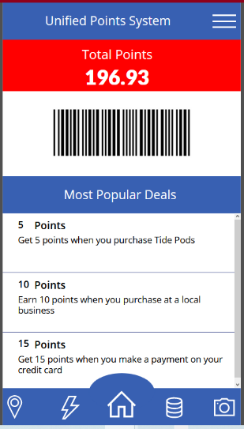
Key Features:
- Addition of Points. This Simulates the addition of points to an account after a transaction
- Conversion of Points. This simulates the conversion of points
- Withdrawal of points. This simulates the spending of points
- Addition of other points into our system. This simulates the addition of points from other rewards systems
The system is designed to be as simple as possible. All features are accessible from a drop-down menu that looks like three horizontal bars. The entire system and all features are accessible from there. The X button always brings the user back.

Conventions
The software is designed to be remarkably like an application. You must click on the pictures to take you to where you want to go. Do not click on the text or it will not take you to the link.

Cautions & Warnings
Once a certain number of transactions have been done, the software lag increasingly. We recommend clearing the cache or deleting data from the SharePoint to speed up the running time of the software.

Getting started

Figure 1. U.P.S. Home Page
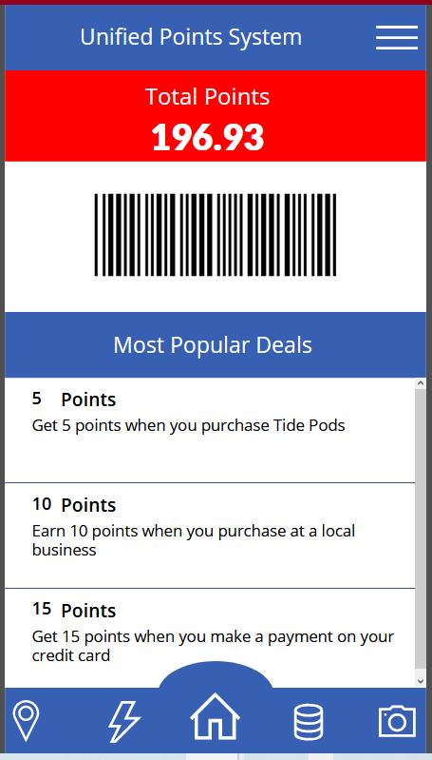
This is the menu screen which is the home screen of the app. It displays your total points and is what you see when you start up the app. It is where you access the features of the app.

Figure 2 U.P.S. Menu Page
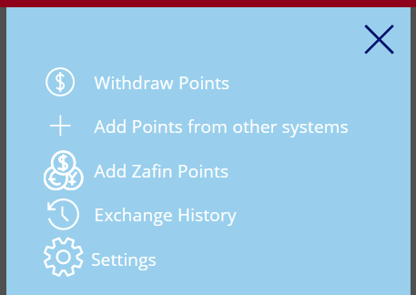
This is the menu screen that can take you to withdraw and add functions of the app as well as your transaction histories and user settings. It can be accessed by clicking the three lines at the top right of the home screen shown in Figure 1.

Figure 3 U.P.S. Deals Page
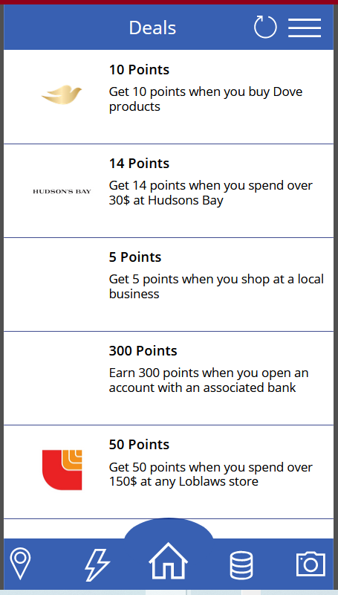

This is the deals page of the app. This page shows all the current deals that a user can partake in to earn more points. To access this page the user can click the 3 white coins on the bottom right of the home page on the functions bar.

User Access Considerations
People who have certain disabilities such as being blind or not being able to read or use their hands may have difficulty using our app. Our app relies on the user having basic human capabilities such as working eyes and functional limbs and hands. If a person can use a cellphone, then they can use our app.

Accessing the System
To access the app a user must go onto Microsoft Power apps and download the app. Then the user must request access to use the apps share points. The process usually takes around 24hours for everything to be set up. Once the request has been accepted the user then has full control to use the apps features.

System Organization & Navigation
In our app the blue bar at the bottom is the Functions Bar. It holds the refresh button camera button and deals buttons. The top right corner is the Menu Page, it holds all the features dealing with point deposits and withdraws, and settings for the app. When looking at different pages in our app the solid blue bars with white text are title of the page or feature in the app.

Exiting the System
To exit the app a user can just close the app however he/she closes an app on their phone or computer normally. Everything is saved online so nothing will be lost by just abruptly closing the app.

Using the System
When using our system, you will come across several features from the drop-down menu bar. These features are Addition of points, conversion of points, Withdrawal of points, and Addition of other points into our system.

Conversion of Points

Figure 4: Conversion of Points
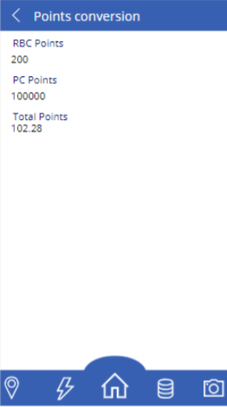
This page displays a single conversion that the user has made. It shows the value between the point values entered and our points.

Addition of Other Points

Figure 5: Addition of Other Points
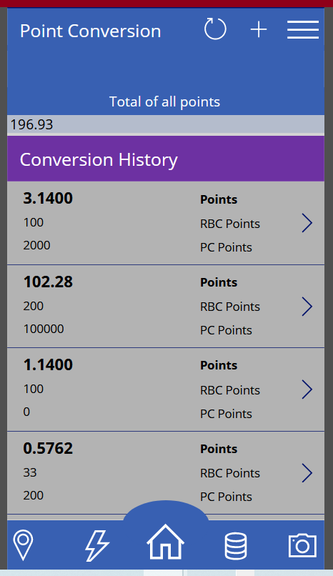

Since you need to enter the number of points you have, this page allows you to do so with your specific loyalty point. After this the points are converted and added to the total. History is stored in history.

Addition of Zafin Points

Figure 6: Addition of Zafin Points
If any vendor uses our system’s points, you can input the amount here.

Withdrawal of Points

Figure 7: Withdrawal of Points
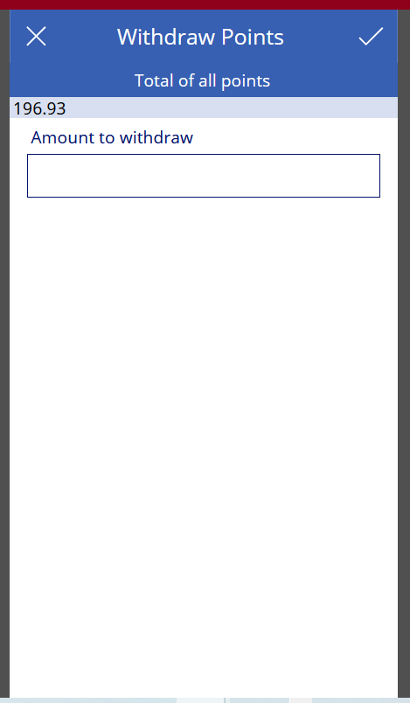
Here is where you withdraw your points to spend on an item. Since we were not able to make a scanning feature, this is a simulation to replace that feature. This simulates spending points in real life.

Troubleshooting & Support
To correct any errors that could appear software, technical support specialist must modify the Excel files on the SharePoint on Microsoft Power apps. The Excel files hold all the user’s point data and are the only way to edit or change the data if there is an error. To edit the data - just find the table with the incorrect value and manually change it.

Error Messages or Behaviors
The current system on Power Apps has no way of displaying error messages to the user. The only way to cause behaviors that break the app is to withdraw more points than you currently have on deposit and/or accumulate more than 9999 points. When withdrawing more points than you have, the app will give you a negative value which should not be possible in the first place. When depositing or accumulating more than 9999 points, the UI of your total number of points breaks and splits the total amount on a text line below it. The app is still fully functional in a bugged state, but it is unappealing and inconvenient for users to see.

Maintenance
To maintain the app there is not much that needs to be done other than having a server running the software. Nothing can break without the user doing an action to break the app.

Support
For support a user can contact Microsoft support by calling 1 (877) 568-2495. A user can also reach Microsoft support at https://support.microsoft.com/. When support is need with the account points in the app a user can contact unviversalpointssystemsupport.com.

Product Documentation
The final product was built in Microsoft power apps and utilizes Microsoft SharePoint, Excel, and Power BI. Microsoft SharePoint holds all the information uploaded in the cloud and is the middle point between PowerApps and Excel. Excel is the brain of the app and does math for all the totals and values. PowerApps is the interface and is the main app for communicating with SharePoint and Excel. The reason to use only Microsoft apps was our familiarity with said line of programs and their interface, allowing us to start working on design implementation right away.
Microsoft programs were used to make this product, other options could have been Wix.com but it was not used because of the lack of knowledge the team had working with software. Microsoft programs were the final choice as they are simple to use and understand, they are also constantly being improved to perform better. Any user could modify the product if they were knowledgeable in Microsoft apps.
Originally, we planned to add special so-called “Ranking system” but, unfortunately, we decided not to add it due to the complexity of the task and the time constraints. We also found that a loyalty ranking system may not be as profitable as it seemed.

Figure 8: Excel Table of Data
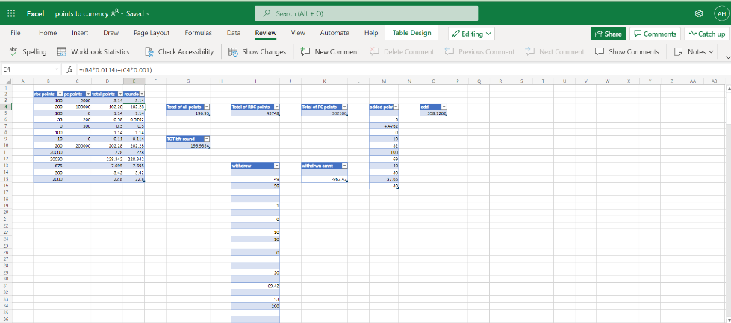

Figure 9: SharePoint File of Functions
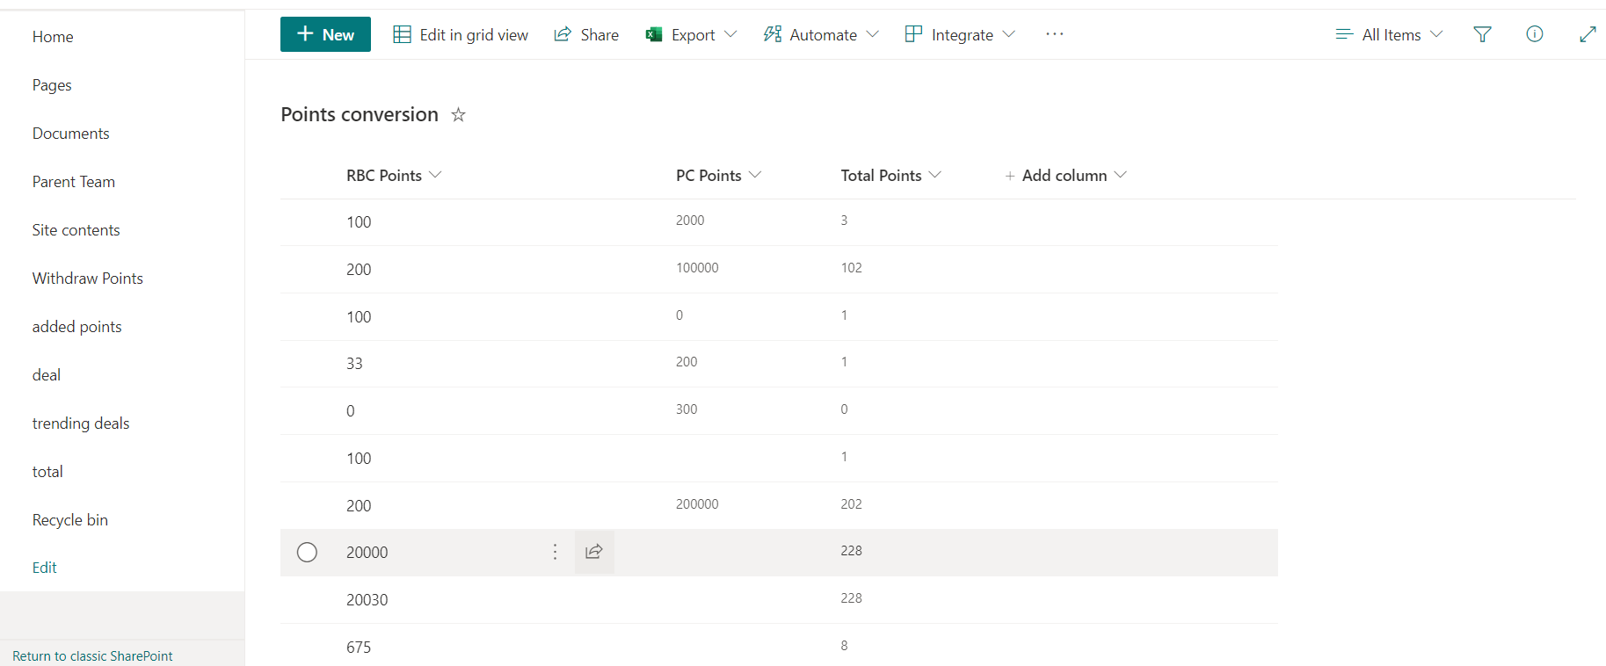

Subsystem 1 of Product

Bill of Materials
Since the whole project is software-based, we did not end up spending any money on anything. Therefore, our bill of material would be 0$.

Table 3. Bill of Materials
Item | Cost ($)
Excel | 0
Power Apps | 0
Hardware | 0
SharePoint | 0

Equipment list
Since the whole project is software-based, the only required equipment is laptops/PCs/desktops.

Instructions
The first step is to create a SharePoint list with columns for each rewards system and a column for the total. The total column will be calculated in the SharePoint list. Once the SharePoint list is created it will be linked to an excel spreadsheet and it will create a table. In the spreadsheet. Within the spreadsheet you will create multiple tables.
Added points
Add
Withdraw
Withdrawn Amount
Total before rounding
Total of all points
And tables for the total of your other systems
For the tables Withdraw, added points you will need to create a SharePoint list for each.
Next you will create a power app from the original SharePoint list. You will then link the lists to the PowerApps and all data tables. Within the power apps you will add screens for the points conversions and a homepage. From there you will add your basic pages such as the pages seen in the final product pictures above.

Testing & Validation
This product was tested with various users, and they rated it on a scale of 1 to 3, 3 being the best rating.
Table 4. User Reviews
 | Ease of use | Design | Functionality | Is the user interested
User 1 (49) | 2 | 2 | 3 | yes
User 2 (47) | 3 | 2 | 3 | yes
User 3 (81) | 1 | 3 | 2 | yes
User 4 (19) | 3 | 3 | 2 | yes
User 5 (16) | 3 | 2 | 3 | yes

Conclusions and Recommendations for Future Work
The most important lesson to take away from this project is to manage your time and to communicate changes with other team members. PowerApps and SharePoint can be frustrating and unintuitive so users must be patient and familiarize themselves with the software.
In conclusion, prototype III is a satisfying accumulation of all our previous prototypes
and bug fixes. We were able to expand on our first and second prototypes based on what we
learned while participating in lectures and working on the previous deliverables. Prototype III was more oriented towards bug fixing and testing all functions. We can convert points from other programs into our reward programs and able to withdraw points from the total amount of points. The software can work and convert points without any hassle from the Power Apps UI to the Excel tables. This is the final prototype that is an accumulation of all other prototypes and all their systems. Our prototype simulates the deposit and withdrawal of points as well as converts point values. There are also quality-of-life additions like trending deals and advertisements to earn points on the app. We also implemented a menu page. All this is to simulate an app experience a user would have with an actual app once more development is done in the future.
For future work it is recommended to translate this product over to another software. PowerApps and SharePoint are amazingly simple code apps to make apps. Thus, to take this product to the next step a user may wish to move the software over to a more complex system where more details and designs may be added. It is also recommended that the exchange points from other rewards programs feature be completed with research into what other systems points values are to expand the list of rewards programs in the database. As well, the conversion function would need to be updated with these added rewards programs.
Given more time, the above recommendations would have been done. As well, we would have used different software that would do the same things but would be more aesthetically pleasing to users. We would make the UI simpler as well for older users who have a challenging time navigating.
We abandoned the idea of adding a ranking system to our loyalty rewards program. We also were not able to implement a way for a camera to be used to scan bar codes to “pay” for items. This project has much potential to be even greater given more time and resources.

Bibliography
RBC point value worth: https://www.simplerate.ca/credit-cards/rbc/points-value/
PC point value worth: https://www.pcfinancial.ca/en/learning-hub/faqs/pc-optimum/what-are-my-pc-optimum-points-worth/

