Project Deliverable C
Detailed Design and Bill of Materials

GNG2101–INTRODUCTION TO PRODUCT DEVELOPMENT & MANAGEMENT FOR ENGINEERS & COMPUTER SCIENTISTS

Presented to:
Professor: Dr. Emmanuel Bouendeu
TA: Mohamed Bougader
PM: Cecilia Lou

Group #Z15:
Tristan Rodgers - 8680457
Usman Khan - 300185666
Ismail Mostafa - 300127711
Yahya Mostafa - 300127715

University of Ottawa
Submitted: June 6, 2023

Table of Contents

Introduction 3
Summary of Client Feedback 5
Updated Detailed Design 6
List of Skills and Resources 7
Assessment of Time 8
Critical Product Assumptions 9
Bill of Materials 10
Conclusion 11
Project Plan Update 11

Introduction
The goal of this deliverable is to provide complete design details and develop a preliminary BoM for the final prototype. This introduction will provide an overview of the goals and guidelines provided, guiding our approach to effectively meeting requirements.
- Customer feedback: During our second meeting with the client, we engaged in productive discussions and received valuable feedback on our original design. The client has emphasized certain needs that will be discussed later in the report. Based on this feedback, we have identified several areas for improvement.
- Detailed design improvements: Based on the feedback received from our client, we developed an updated and detailed design for our concept. This design combines improvements as we reviewed the information obtained during the meeting with the client and incorporated it into our design to ensure that it met their expectations and requirements.
- Skills and resources: We are fortunate to have many skills and resources that will allow us to successfully create our designs. Our team members have expertise in both programming and mechanical engineering. In addition, we have access to prototyping tools, such as 3D printers and production equipment, that will help us bring our designs to life. If we identify skills or resources that are missing during the implementation phase, we will seek outside support or gain the necessary skills through initiatives.
- Time assessment: To give a realistic estimate of the time it took to execute our design, we carefully assessed the complexity of the project, time spent with our team members, and other factors. Potential external factors may affect the schedule. By efficiently managing our time and resources, we aim to meet project schedule and ensure timely completion of the final prototype.
- Important product assumptions: In addition to the feedback, we received from our customers, we identified several important product assumptions that could affect our design implementation. These assumptions include availability of specific materials or components, adherence to accepted values ​​for specifications, and functionality of key features. We will conduct extensive research and testing to validate these assumptions and ensure a successful implementation of our design.
- Bill of Materials (BoM): To facilitate our final prototype purchase and approval process, we have prepared a detailed bill of materials. This BoM includes all the components and parts needed to assemble our design. Each BoM entry is accompanied by web links, including $0 entries, to provide easy access to required documents. We considered an allocated budget of $50 or $100 (depending on the project) and made sure that our BOM matched the available resources.

By addressing the goals and following the guidelines outlined in this introduction, we are confident in our ability to deliver a well-defined design and evaluate its feasibility. We look forward to the next steps of the project and the realization of our final prototype.

Summary of Client Feedback
Below is a list of key points and take-away's from our Client Meeting 2:
- The use of Alexa or other home assistants is not advantageous to the client, since they are looking at the big picture and the ability to use this product in different scenarios where home assistants are not available. Ex: Hospital beds
- The client’s voice is not clear, we may need to use recordings of his voice and use these as prompts for the remote instead of a typed phrase in the code which the microphone is constantly listening for.
- The client uses Smart Switch, a product that we compared with our prototype with benchmarking. He likes the Smart Switch but agrees that it has limited functionality and is not customized enough to accomplish the necessary functions and fill the client needs.
- Of all concepts, the client agreed that concept 1, using a fixed casing and mechanical button pushers with no need to alter the remote, is the most advantageous and fit for this task.
- Concept 2 is good, but the disassembly of the remote makes the concept too complicated and not replicable. The client prefers something more versatile which does not alter the original remote.
- Concept 3 is not elaborate enough, and the client had trouble understanding the functionality of the design. However, the Velcro strap attachment was interesting for the client and can be implemented in the final design.
- The use of solenoid is interesting for the client. He mentioned that getting the device as compact as possible is important.

Updated Detailed Design
Updated design drawing according to the client’s feedback:
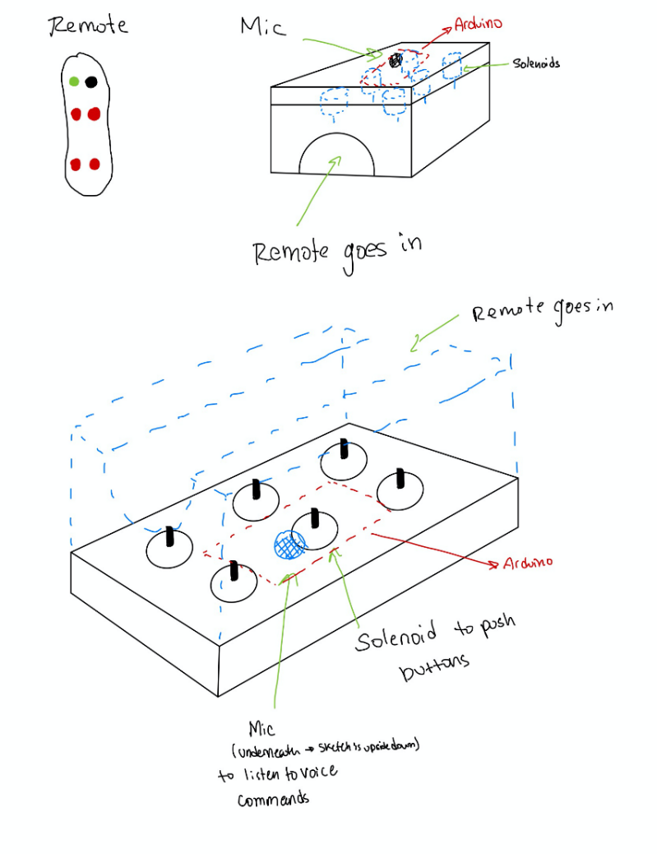

List of Skills and Resources
Skills and Resources for building our prototype:
- Programming and development skills: We have expertise in programming languages ​​like Arduino, Python and Java commonly used in the industry. These skills will be critical in the design and implementation of voice recognition.
- Speech recognition technology: We have access to existing speech recognition APIs and libraries that can be incorporated into our designs. These resources will allow us to convert voice commands into actionable instructions for the remote.
- Hardware knowledge: We have a good understanding of electronic components and hardware integration, especially Arduino. This knowledge will help us design the physical aspects of the remote, such as buttons, connectivity options, and power management.
- Prototyping tools: We have access to prototyping tools such as 3D printers, soldering equipment, Arduinos, circuit boards, and many more. This will be helpful in creating and testing the physical prototypes of the remote.
- Collaboration and communication skills: Our team members have strong communication and collaboration skills, allowing us to work together effectively and exchange ideas, feedback, and updates on progress throughout the design and development process.
If the skills or resources needed to complete the design are missing, we'll take the following steps to get them:
- Skills acquisition: We will allocate time for team members to improve their skills or acquire new skills needed for the project. This could involve online tutorials or collaborating with friends/TAs who have the necessary expertise.
- Purchase resources: If we are short of specific hardware components or devices, we will explore options such as purchasing or borrowing from external sources or asking the Makerspace for any alternative solutions.

Assessment of Time
To provide a realistic assessment of the time required to execute the design, we will divide the project into major phases and estimate the time required for each phase. This will include tasks such as implementing speech recognition, developing mechanical features, and performing tests and improvements. Actual time spent with the group and its individual members will depend on several factors such as:
- Team member availability: We'll look at each team member's work commitments and availability to determine how much time they can allocate to the project. This will help us estimate the collective time available for development.
- Project schedule: Depending on the requirements and constraints of the project, we will establish a schedule (using Wrike) that considers the available time and sets realistic deadlines for each phase.
- External factors: We will consider any potential constraints or external dependencies that may affect project progress, such as the availability of external experts, access to resources needed or unforeseen challenges.
By taking these factors into account, we can make a more accurate assessment of the time it takes to deploy and tailor it to the time spent on the team and individual team members. Wrike.com will be very useful in managing this assessment.

Critical Product Assumptions
Product assumptions that could affect the ability to implement our design:
- Accuracy of speech recognition: A key assumption is that the speech recognition technology we will be using has a high degree of accuracy in understanding and interpreting voice commands. If the voice recognition accuracy is lower than expected, it could affect the overall usability and effectiveness of the voice-activated remote. To mitigate this, we will thoroughly test and refine speech recognition algorithms and APIs during development.
- User accessibility: We assume that voice-activated remote will be accessible to many users, including those with physical limitations. To ensure comprehensiveness, we will aim to incorporate powerful speech recognition algorithms and APIs that can adapt to different user voices.
- Connectivity and compatibility: One of our designs assumes that the voice-activated remote will be compatible with devices, such as mobile phones and home automation systems (Alexa). We will have to consider the availability of the necessary protocols and APIs to establish communication and ensure compatibility with different devices.
By meeting these important assumptions, we can ensure that our design is workable, user-friendly, and able to meet the expected functionality of a remote control activated by voice.

Bill of Materials
Part | Quantity | Product | Cost per part ($) | URL
Microcontroller & Microphone | 1 | Voice Recognition Module V3 Speed Recognition Compatible with Ard for Arduino | $49 | https://www.amazon.ca/LuxtechPro-Speech-Recognition-ELECHOUSE-Interface/dp/B07Q6WPSD8
Remote | 1 | Lift Chair Hand Control, Ancable 6 Button Home Recliner Replacement Power Hand Chair Switch Remote Hand Control | $28 | https://www.amazon.ca/Control-Replacement-Recliner-Controller-Electric/dp/B092DSQHG6
Servo motors | 3 | SG90 9G Micro Servo | $2.80 or cheaper | https://www.amazon.ca/Miuzei-Helicopter-Airplane-Remote-Control/dp/B07H85M78M/ref=sr_1_5?keywords=servo+motors&qid=1688064075&sr=8-5 or Makerspace
ABS polymer plastic | 1 | Plastic for 3D printing | ~15$ | Makerspace
Arduino UNO | 1 | Microcontroller | $39 or cheaper | https://www.amazon.ca/ARDUINO-A000066-Uno-DIP-1-5/dp/B008GRTSV6/ref=sr_1_1?crid=1RV6JOZU02C7L&keywords=arduino+armor&qid=1688064367&sprefix=arduino+armor%2Caps%2C66&sr=8-1 or Makerspace
M2 screws and M2 nuts | 6 screws and 6 nuts | Screws and nuts for servo motors | $7 or cheaper | https://www.amazon.ca/SGTKJSJS-M-2-Screw-NVMe-Mounting/dp/B07Q3DLCJ4/ref=asc_df_B07Q3DLCJ4/?tag=googleshopc0c-20&linkCode=df0&hvadid=342811070093&hvpos=&hvnetw=g&hvrand=6759457113416027483&hvpone=&hvptwo=&hvqmt=&hvdev=c&hvdvcmdl=&hvlocint=&hvlocphy=9000684&hvtargid=pla-817792029339&psc=1 or Makerspace
Total | $146.40
Total* | $79.40
Total**
*This total does not include items that are already owned: Arduino UNO and Remote.
**This total does not include items that are obtainable without a price: Arduino UNO, Remote, Servo motors, M2 screws

Conclusion
In conclusion, this deliverable allowed us to provide detailed design specifications for our concept and assess its feasibility. By summarizing client feedback and incorporating necessary improvements, we have developed an updated and detailed design that addresses the required needs. The diversity of our team's skills and access to resources will allow us to efficiently create designs. A realistic assessment of the time required to deploy was reviewed and important product assumptions were identified and carefully validated. A BoM showing the required components and a web link has been provided for easy access. With the completion of this product, we are now well equipped to proceed with the final prototype development, to meet the expectations and requirements of our client.

Project Plan Update
https://www.wrike.com/frontend/ganttchart/index.html?snapshotId=eSEs3jZk86oQbSzRiNLSDjwDa0bKGJnv%7CIE2DSNZVHA2DELSTGIYA

