Deliverable H. Prototype III and Customer Feedback

Group 1

GNG 1103 – Engineering Design

Faculty of Engineering – University of Ottawa

March 17, 2022.

Table of contents
Prototype 3 Testing
Figure 1. Prototype 3
Table 1. Prototype 3 Tests
Observation/Results of Tests

Prototype 3 Testing – Comprehensive prototype
Prototype 3 testing will be the final set of tests to determine if all parts of the end-effector, code and user interface are functioning as needed. This will consist of testing the inverse kinematics solution and code on the arm, testing the functionality of the LED lights, depth sensor and camera, as well as testing improvements to the user interface.
Table 1. Prototype 3 tests
Test ID | Test Objective | Description of Prototype used and of Basic test method | Description of Results to be Recorded and how these results will be used | Estimated Test duration and planned start date
1 | Test code for movement of alternate arm | In the meantime, with the original arm not functioning, we will connect to the alternate arm and run the code to see if the arm moves at all. | We will take a video of the arm at the time the code is run to record if the arm moves due to the code. | Thursday March 17th during the lab time.
2 | Test code for ability to move the original arm. | Once the arm is functioning, we will connect to it and run the code to determine if the code successfully moves the arm in 3 degrees of freedom. | Results will be recorded by a video of the arm while the code is running to show if the arm moves in 1, 2 or 3 degrees of freedom. | Saturday, March 19th.
3 | Test for ability of depth sensor to identify distance to an object (box) | We will wire the depth sensor to the Arduino and run it to determine if the depth sensor returns the correct distance from the object which will be measured prior to the test. | The result will be the distance that the depth sensor returns. This will be recorded by noting what it returns for each trial. The test will be successful when the sensor returns the correct distance to the box which is 20 cm. | Saturday March 19th
4 | Test functionality of LED lights. | The LED lights will be wired and activated to determine if they are connected and wired correctly by weather or not the lights will illuminate. | The result will be weather the LED lights turn on or not. This will be recorded by a photo. | Saturday March 19th
5 | Test functionality of camera, its ability to take a photo. | The camera will be wired and connected. We will determine if the connectivity is correct by weather or not the camera can capture a photo. | The result will be if the camera successfully captures a photo. The photo will be included if the test is a success. | Estimated start date between March 21th and 23rd. Test will be completed on March 24th in the lab session.
6 | Test dimensions of holes on the face of the end- effector for fit of the depth sensor and camera. | We will attempt to insert the camera and depth sensor into their respective slots on the face of the end-effector. | This test will be successful if the camera and depth sensor fit into the holes of the end-effector without having to make modifications. | March 24th during the lab session.
7 | Testing depth sensors interaction with the warning lights | The 5 lED should light up after reaching a specific set depth corresponding to each lED (each LED is activated by a different depth) | Had one problem, the pins were not in the right place, once we fixed that, it worked successfully with the first LED being activated at a depth of 15cm, followed by the next at 10cm, then 8cm, 5cm, then at 3cm all 5 were activated and flashing on and off to grab the attention of anyone in close proximity to the arm. | March 26th
8 | Test accuracy of inverse-kinematic solution on original arm | The method used to test this will be to input values in our code and test the ability of the code to move the end effector to the desired location. | For this we will record the results of expected location vs actual location of end effector. We can calculate a percentage of accuracy of the IK solution based on deviation from expected end-effector location. | We had intentions of carrying out this test during the lab on Thursday, March 17th however the provided arm was still not functioning. This test will happen when the arm is functioning (planned for March 19th)
10 | Test speed of inverse-kinematic solution | To test this, we will record the amount of time required for our code to operate from the time it is started to the time the end-effector reaches the desired location in space. | The results recorded will be the speed of execution for each individual test trial. From this we can deduce an average time that our IK solver takes. | Again, these tests will begin when the arm is functioning.
11 | End-effector: UI-interaction | We can test the ability of information from the pictures taken and depth recorded to be transferred to the user interface. | Ability of User interface to import images from the Arduino cam. | The ability of UI to import images from the Arduino cam will be tested after the completion of Test 3 and when the camera is received.
12 | UI search bar addition | Small test codes created for individual functions | Users’ ability to search for the wanted picture by typing into the UI interface | March 21st
13 | UI search bar deletion | Small test codes created for individual functions | Users’ ability to backspace and edit the keyboard inputs into the search bar | March 21st
14 | UI to Arduino connection code | Small test codes created for individual functions | Functionality of Stop command being sent from UI to the Arduino | March 24th
15 | Inverse kinematics reset button | Small test codes created for individual functions | Find the pins which send the Arduino a signal when the robot has been zeroed so that the inverse kinematics are as accurate as possible | March 24th

Notable Observations/Results of Testing From:
Test 1: Test code for movement of alternate arm.
When running our code while connected to the alternate arm, the arm successfully moved in 2 degrees of freedom. The 3rd degree of freedom, which comes from the rotation of the base did not work.
Test 2: Test code for ability to move the original arm.
When running the code while connected to the original robot arm, the arm successfully moved in all 3 degrees of freedom after many trials. During the first trial, the arm moved in the x direction which is the forearm (1 degree of freedom). The code was modified and during the second trial, the arm moved in two degrees of freedom (x and y direction) which is the forearm and the bicep. The code was modified to implement the motor that controls the z axis so that motion in the 3rd degree of freedom could be achieved. Trials 3, 4 and 5 were unsuccessful at moving the arm in 3 degrees of freedom but finally during trial 6, the arm also moved in the z direction, which is the rotation of the base, making a successful arm movement in 3 degrees of freedom. During the 7th trial, the delay in the code was changed from 500 milliseconds to 100 milliseconds so that the arm moves through the degrees quicker, which makes the movement of the arm look slightly smoother.
Test 3: Test for ability of depth sensor to identify distance to the box.
For this test, a box was placed 20 cm away from the depth sensor. The first 3 trials of testing the depth sensor’s ability to determine the distance to the box returned a value of 0, meaning the connection or the sensor was not functioning properly. We determined that it was the sensor itself that was not working, therefore we swapped the original sensor for another one to run another trial (number 4). During trial 4, the sensor successfully determined that the box was 20 cm away as that is the value it returned. Below is a photo of the depth sensor connection.
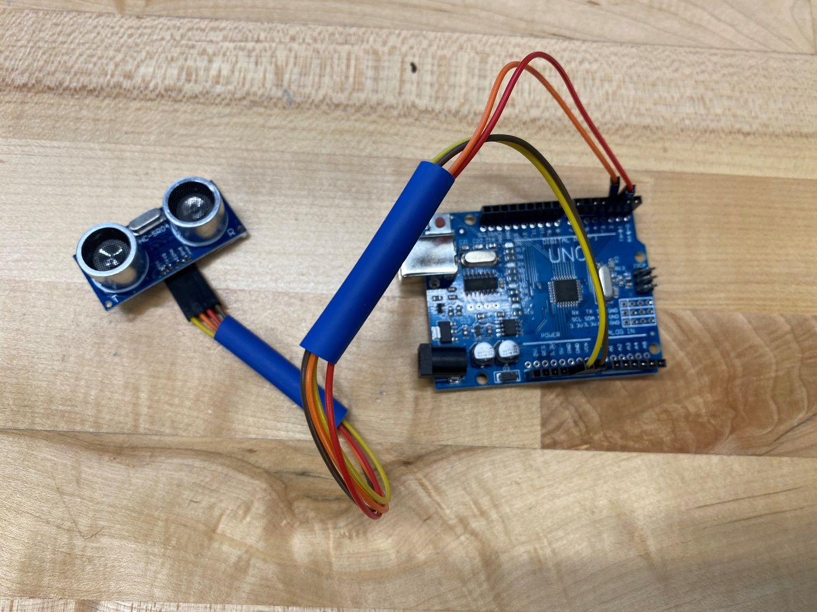
Figure 1. Depth sensor connection
Test 4: Test functionality of LED lights.
The wiring of the LED lights was first set up in Tinkercad to create working connections which could then be replicated in the lab with the actual LED lights and Arduino. The connection in Tinkercad was successfully set up on Thursday, March 17th. The real connection was then successfully set up and tested on Saturday March 19th, resulting in the LED lights illuminating.
Test 6: Test dimensions of holes on the face of the end- effector for fit of the depth sensor and camera.
The camera and depth sensor fit in the holes that were originally created for them. No further modifications were needed to fit these two items. Below is a photo of them in the end-effector.
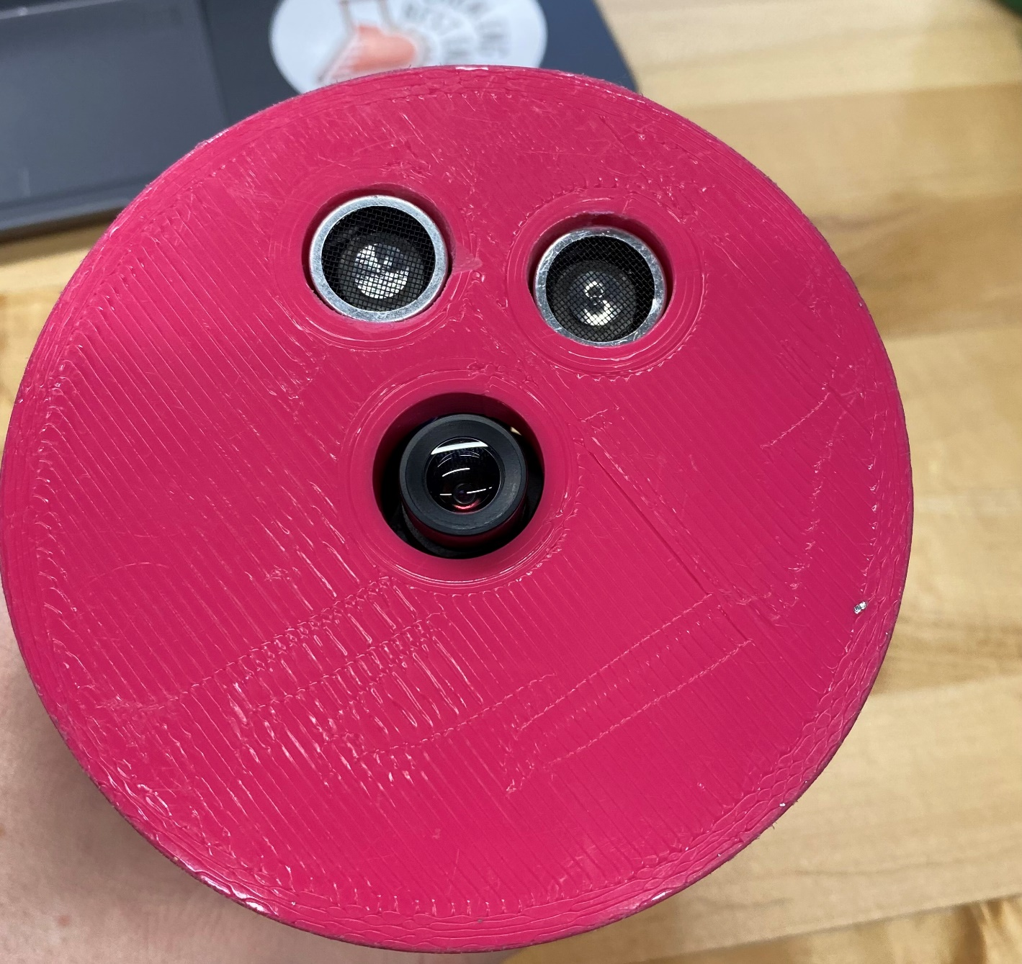
Figure 2. Camera and depth sensor inserted into the face of the end-effector

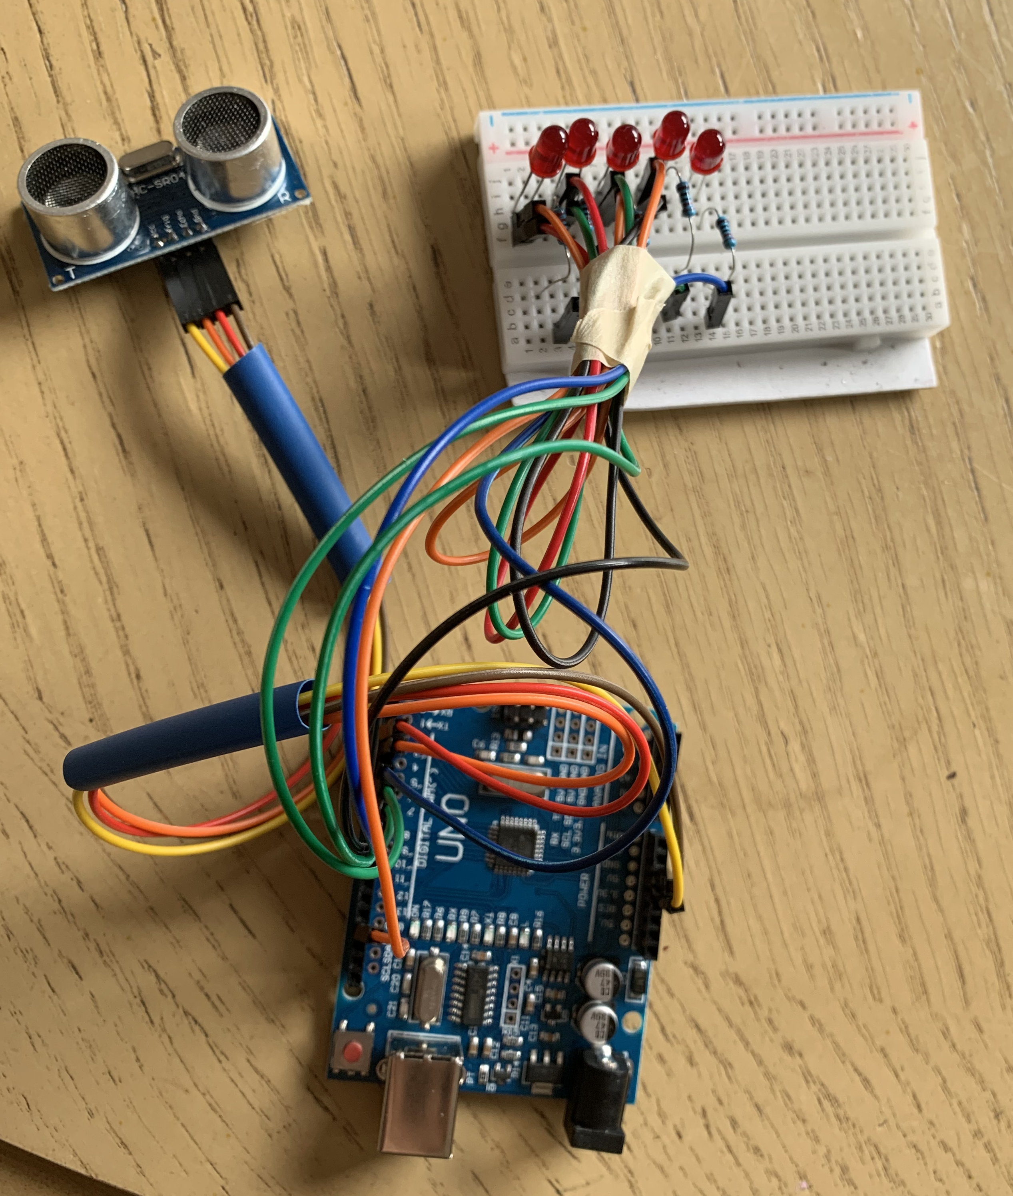
Figure 3. Circuit Layout from Test 7

Code For Test 1:
#include <Wire.h>
#include <Adafruit_PWMServoDriver.h>

// Creat object to represent PCA9685 at default I2C address
Adafruit_PWMServoDriver pca9685 = Adafruit_PWMServoDriver(0x40);

//Define Minimum and Maximum ticks
#define SERVOMIN 80
#define SERVOMAX 600

//Servo motor positions
int pwm0;
int pwm1;
int pwm2;

//Create the 3 servo variables
#define Shoulder 2 //motor 1
#define Bicep 1 //motor 2
#define Elbow 0 //motor 3

//Create the joint length variables
float forearm = 20; //length from third motor to tool
float bicep = 14.29; //length from second to third motor
float shoulder = 6; //length from first to second motorS

float a, a1, a2, b, c; //angle variables
float d, e, f, g; //variables for calculations

void setup(){
Serial.begin(9600); //create monitor to output angles to
pca9685.begin();
pca9685.setPWMFreq(50);
Coordinates(25,25,10);
pwm0 = map(c, 0, 180, SERVOMIN, SERVOMAX);
pwm1 = map(b, 0, 180, SERVOMIN, SERVOMAX);
pwm2 = map(a, 0, 180, SERVOMIN, SERVOMAX);
if(isnan(a)||isnan(b)||isnan(c)){
Serial.println("Coordinates cannot be reached");
}
else{
delay(500);
Serial.print("Bicep Angle: ");
Serial.println(b);
pca9685.setPWM(Bicep, 0, pwm1);
delay(500);
Serial.print("Elbow Angle: ");
Serial.println(a);
pca9685.setPWM(Elbow, 0, pwm2);
delay(500);
Serial.print("Shoulder Angle: ");
Serial.println(c);
pca9685.setPWM(Shoulder, 0, pwm0);
}
}

void loop(){}

void Coordinates(int x, int y, int z){
c = atan2(x,y)*(180/PI); //angle needed to be moved by base
d = (sq(x)+sq(y)+sq(z)-(sq(shoulder)+sq(bicep)+sq(forearm))-2*shoulder*(z-shoulder))/(2*bicep*forearm);
e = sqrt(1-d);
a = atan2(d,e)*(180/PI); // angle needed to be moved by third motor
f = d*forearm + bicep;
g = e*forearm;
b = asin((-2*f*(shoulder-z)+sqrt(sq(2*f*(shoulder-z))-4*(sq(f)+sq(g))*(sq(z)+sq(shoulder)-sq(g)-2*z*shoulder)))/(2*(sq(f)+sq(g))))*(180/PI); //angle needed to be moved by second motor
}

Code for Test 2:
int XSTEP = 2;
int YSTEP = 3;
int ZSTEP = 4;
int XDir = 5;
int YDir = 6;
int ZDir = 7;

//Create the joint length variables
float forearm = 30; //length from third motor to tool
float bicep = 30; //length from second to third motor
float shoulder = 9; //length from first to second motor

float a, a1, a2, b, c; //angle variables
float d, e, f, g; //variables for calculations

int count = 0;
char Stop;
void setup() {
Serial.begin(115200);
pinMode(XSTEP,OUTPUT);
pinMode(YSTEP,OUTPUT);
pinMode(ZSTEP,OUTPUT);
pinMode(XDir,OUTPUT);
pinMode(YDir,OUTPUT);
pinMode(ZDir,OUTPUT);
digitalWrite(XDir, HIGH);
digitalWrite(YDir, HIGH);
digitalWrite(ZDir, HIGH);
Coordinates(50,20,35);
if(a<0){
digitalWrite(XDir,LOW);
a = 0 - a;
}
if(b<0){
digitalWrite(YDir,LOW);
b = 0 - b;
}
if(c<0){
digitalWrite(ZDir,LOW);
c = 0 - c;
}
for(int i=0;i<b/1.8;i++){
digitalWrite(XSTEP,HIGH);
delay(100);
digitalWrite(XSTEP,LOW);
}
for(int i=0;i<c/1.8;i++){
digitalWrite(YSTEP,HIGH);
delay(100);
digitalWrite(YSTEP,LOW);
}
for(int i=0;i<a/1.8;i++){
digitalWrite(ZSTEP,HIGH);
delay(100);
digitalWrite(ZSTEP,LOW);
}
}

void loop() {}

void Coordinates(int x, int y, int z){
c = atan2(x,y)*(180/PI); //angle needed to be moved by base
d = (sq(x)+sq(y)+sq(z)-(sq(shoulder)+sq(bicep)+sq(forearm))-2*shoulder*(z-shoulder))/(2*bicep*forearm);
e = sqrt(1-d);
a = atan2(d,e)*(180/PI); // angle needed to be moved by third motor
f = d*forearm + bicep;
g = e*forearm;
b = asin((-2*f*(shoulder-z)+sqrt(sq(2*f*(shoulder-z))-4*(sq(f)+sq(g))*(sq(z)+sq(shoulder)-sq(g)-2*z*shoulder)))/(2*(sq(f)+sq(g))))*(180/PI); //angle needed to be moved by second motor
}

Code for operating UI:
char holder;
float x = 615;
int count = 0;
String input = "";
ArrayList search = new ArrayList();
PImage img;
PFont f;
PFont temp;
String screen = "Default";
int a,b,c,d;

void setup() {
size(1500, 1001);
background(0);
f= createFont("ProcessingSansPro-Regular.ttf", 20);
textFont(f);
fill(#FFFFFF);
rect(550,400,350,100);
fill(0);
text("Enter Name of Photo File",625,425);
}

void draw() {
switch(screen){
case "Default":
background(0);
f= createFont("ProcessingSansPro-Regular.ttf", 20);
textFont(f);
fill(#FFFFFF);
rect(550,400,350,100);
fill(0);
text("Enter Name of Photo File",625,425);
String hold = "";
for(int i = 0; i< count; i++){
hold += search.get(i);
fill(0);
text(hold,615,450);
}
if(img != null){
background(img);
fill(color(0,0,0));
rect(0,0,200,100);
fill(255,255,255);
text("Menu",50,60);
fill(color(0,0,0));
rect(1300,0,200,100);
fill(255,255,255);
text("Clear",1350,60);
}
break;
case "Image":
background(0);
f= createFont("ProcessingSansPro-Regular.ttf", 20);
textFont(f);
fill(#FFFFFF);
rect(550,400,350,100);
fill(0);
text("Enter Name of Photo File",625,425);
String hold2 = "";
for(int i = 0; i< count; i++){
hold2 += search.get(i);
fill(0);
text(hold2,615,450);
}
if(img != null){
screen = "Default";
}
break;
case "Menu":
background(img);
fill(color(0,0,0));
rect(0,0,200,100);
fill(255,255,255);
text("Back",50,60);
fill(0);
rect(0,110,200,100);
fill(255);
text("Change Image", 50, 170);
fill(0);
rect(0,220,200,100);
fill(255);
text("Stop", 50, 280);
fill(color(0,0,0));
rect(1300,0,200,100);
fill(255,255,255);
text("Clear",1350,60);
break;
case "Stop":
background(img);
fill(color(0,0,0));
rect(0,0,200,100);
fill(255,255,255);
text("Back",50,60);
fill(#ED1111);
rect(600,400,300,200);
fill(0);
temp = createFont("ProcessingSansPro-Regular.ttf", 50);
textFont(temp);
text("STOP",690,500);
textFont(f);
break;
}
if(!OverMenu(0,0,200,100)){
if(screen == "Default" && img!=null && !OverClear(1300,0,200,100)){
stroke(255);
noFill();
rect(a,b,c,d);
}
if((screen == "Menu") && !OverButton(0,110,200,100) && !OverClear(1300,0,200,100)){
stroke(255);
noFill();
rect(a,b,c,d);
}
}
}

void keyTyped() {
if (key == ENTER) {
//Search
for(int i = 0; i < count; i++){
input = input + search.get(i);
}
input += ".jpg";
img = loadImage(input);
img.resize(1500,1001);
background(img);
input = "";
for(int i = count-1; i >= 0; i--){
search.remove(i);
}
count = 0;
} else {
// If it's a backspace remove the last letter typed
if(key == BACKSPACE){
background(0);
fill(#FFFFFF);
rect(550,400,350,100);
fill(0);
text("Enter Name of Photo File",625,425);
count -= 1;
for(int i = 0; i < count; i++){
input = input + search.get(i);
}
float y = x;
x = 615;
text(input,x,450);
x = y - textWidth(holder);
input = "";
search.remove(count);
}
else{
holder = key;
x = x + textWidth(key);
search.add(key);
count += 1;
}
}
}

boolean OverMenu(int x, int y, int width, int height){
if(mouseX >= x && mouseX<= width && mouseY>= y && mouseY<= height){
return true;
}
else{
return false;
}
}
boolean OverButton(int x, int y, int width, int height){
if(mouseX >= x && mouseX<= x+width && mouseY>= y && mouseY<= y+height && screen == "Menu"){
return true;
}
else{
return false;
}
}
boolean OverClear(int x, int y, int width, int height){
if(mouseX >= x && mouseX<= x+width && mouseY>= y && mouseY<= y+height && (screen == "Menu" || screen == "Default")){
return true;
}
else{
return false;
}
}
void mousePressed(){
if(mousePressed){
a = mouseX;
b = mouseY;
if (OverMenu(0,0,200,100)){
if(screen.equals("Menu")){
screen = "Default";
}
else{
screen = "Menu";
}
}
if (OverButton(0,110,200,100)){
screen = "Image";
img = null;
a = -1;
b = -1;
c = -1;
d = -1;
}
}
if(OverButton(0,220,200,100)){
if(screen.equals("Menu")){
screen = "Stop";
}
}
if(OverClear(1300,0,200,100)){
a = -1;
b = -1;
c = -1;
d = -1;
}
else{
if(a == -1 || b == -1){
a = mouseX;
b = mouseY;
}
}
}

void mouseDragged(){
c = mouseX-a;
d = mouseY-b;

}

CODE FOR TEST 7
//Group 1 Safety System
//Tell the damn arduino what everything is
int LED1 =8;
int LED2 =7;
int LED3 =6;
int LED4 =5;
int LED5 =4;
int TRIG =3;
int ECHO =2;
float duration;
float distance;
void setup() {
//set all the lights to outputs
pinMode(8,OUTPUT);
pinMode(7,OUTPUT);
pinMode(6,OUTPUT);
pinMode(5,OUTPUT);
pinMode(4,OUTPUT);
//Make the sound part an output and the echo part an input
pinMode(TRIG,OUTPUT);
pinMode(ECHO,INPUT);
//write some shit in the serial moniter
Serial.begin(9600);
Serial.println("Ultrasonic Sensor HC-SR04 With Arduino Uno");
}
void loop() {
//make some noise
digitalWrite(TRIG, LOW);
delayMicroseconds(200);
digitalWrite(TRIG, HIGH);
delayMicroseconds(1000);
digitalWrite(TRIG, LOW);
//figure out how long it takes the bitch to hear the echo
duration = pulseIn(ECHO, HIGH);
//time --> distance
distance = duration*0.034/2;
if(distance < 10)
{
//print sum more shit in the serial moniter
Serial.println("Distance: ");
Serial.print(distance);
Serial.println("cm");
}
{
digitalWrite(TRIG, LOW);
delayMicroseconds(2);
digitalWrite(TRIG, HIGH);
delayMicroseconds(10);
digitalWrite(TRIG, LOW);
duration = pulseIn(ECHO, HIGH);
distance = duration*0.034/2;
if(distance < 10)
{
Serial.println("Distance: ");
Serial.print(distance);
Serial.println("cm");
}
{if (distance <15&& distance >10) // gettin close
digitalWrite(LED1, HIGH);
if (distance <10&& distance >8) //ah shit a bit closer
digitalWrite(LED1, HIGH);
digitalWrite(LED2,HIGH);
if (distance <8&& distance >5)
digitalWrite(LED1,HIGH);
digitalWrite(LED2,HIGH);
digitalWrite(LED3,HIGH);
if (distance <5&& distance >3)
digitalWrite(LED1,HIGH);
digitalWrite(LED2,HIGH);
digitalWrite(LED3,HIGH);
digitalWrite(LED4,HIGH);
if (distance <3)
Serial.println("RESTRICT FORWARD MOTION");
//Send Signal to IK to stop moving forward HERE if
//Pankaj would buy us a damn bluetooth module
digitalWrite(LED1,HIGH);
digitalWrite(LED2,LOW);
digitalWrite(LED3,HIGH);
digitalWrite(LED4,LOW);
digitalWrite(LED5,HIGH);
delayMicroseconds(250);
digitalWrite(LED1,LOW);
digitalWrite(LED2,HIGH);
digitalWrite(LED3,LOW);
digitalWrite(LED4,HIGH);
digitalWrite(LED5,LOW);
}
}
}
https://howtomechatronics.com/tutorials/arduino/ultrasonic-sensor-hc-sr04/
Pankaj give us an A+ brotha

