Hot Car Emergency: Project Schedule and Cost

Briana Archdeacon (8222069)
Alexander Gayowsky (300075283)
Ronan Mackrell (300231301)
Jasmine Wang (300006737)

October 26, 2021

Abstract
Upon iterating and revising various designs, we have determined a global concept that best satisfies the client’s needs. However, to thoroughly analyse the chosen design, we will need to divide the overall system into components and determine suitable materials for these constituents. This document will therefore present a detailed drawing of the system, a plan of the upcoming tasks for the overall project, a bill of materials, a list of equipment, and a test plan for the first prototype.

Table of Contents

Introduction 2
Detailed Drawing 2
Project Task Plan 4
Bill of Materials (BOM) 6
List of Equipment and Tools 6
Prototype 1 Test Plan 7
Conclusion 7

Introduction
Before creating the final product, we require adequate product testing and client feedback. To do these, however, we require many physical prototypes and design iterations. Thus, this document features a detailed drawing of our initial prototype, which will serve as a proof-of-concept. It also features a project plan that details what tasks must be done and by whom, alongside contingency plans for potential problems that can arise along the prototyping phase. The bill of materials is also included, which will need to be approved by the project managers before any purchases may be made. A list of equipment, consisting of the tools that will be used throughout the prototyping stage, is added to ensure that this project can be replicated. Finally, a test plan for the initial prototype is included and outlines the objectives of the initial testing phase.

Detailed Drawing
The following sketches are not to scale. They outline an idealized design for the device, which includes all desired modules regardless of cost considerations; features may be removed to accommodate price restrictions. In the current (tentative) final design, the outer shell (layer 1, layer 3, and sides) will be cut or folded from sheet metal, and layer 2 will be a thin polycarbonate plastic sheet. For our first proof-of-concept prototype, we will substitute cardboard, and components will be fastened with hot-glue if necessary.
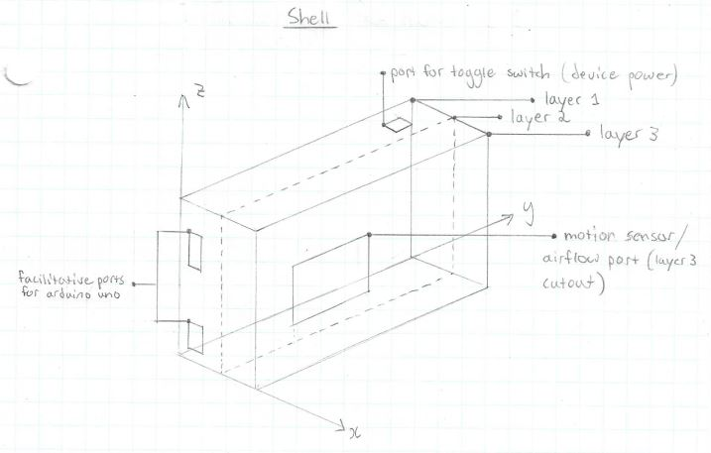
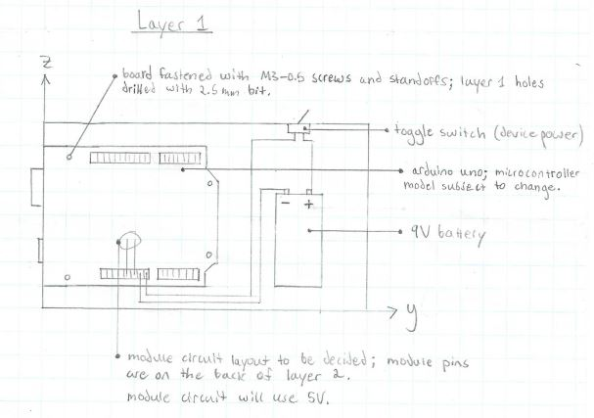
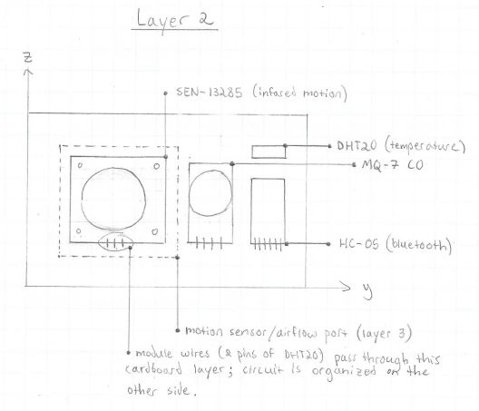
The associated app will be designed using MIT app inventor, and for practical reasons, it will be limited to Android-based operating systems.

Project Task Plan
This project will require various tasks to be completed. These tasks have been subdivided and assigned to individual group members to ensure an even distribution of work. The upcoming task and its related subtasks have been delegated as follows:
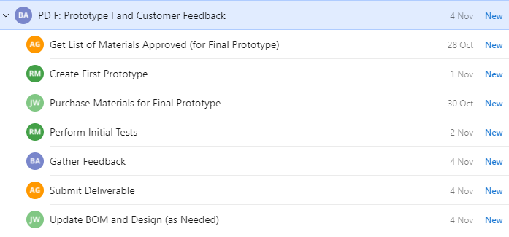

A Gantt chart outlining a more detailed timeline of the tasks is shown below:
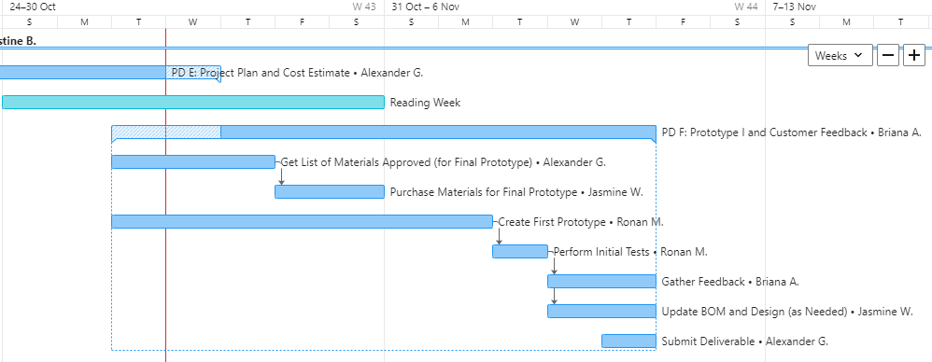

It can be seen that the tasks regarding approval and purchasing of materials have great overlap with the creation of the first prototype. Thus, one significant risk is that it may be difficult to acquire the materials in time for the first and possibly second prototyping phases. To circumvent this potential risk, it is expected that we create our first prototypes from materials that are immediately available to us, such as borrowed Arduino microcontrollers and breadboards. This, however, ensures that we cannot fully test all of our sensors if they are not already at our disposal or test our soldering as we cannot solder any connections on borrowed equipment.

Another significant risk that can be noted is the large amount of dependencies. The creation of the prototype has been given precedence over all of the other subtasks, hence the large timeline. Therefore, if any issues arise during that stage or in the subsequent testing phase, the rest of the project tasks will be heavily burdened. The only contingency plan in case this were to happen, is the high division of labour by all of the group members. This ensures that the deliverable is completed on time and without burdening any one individual member.

Bill of Materials (BOM)
Given a maximum budget of $50, we have chosen the following products to include in our preliminary prototype.It must be noted that these materials are subject to change in later prototypes, following client feedback and prototype testing. Items that have been crossed out and marked in red denote parts that surpassed the budgetary constraints.

A screenshot of the BOM is appended below:
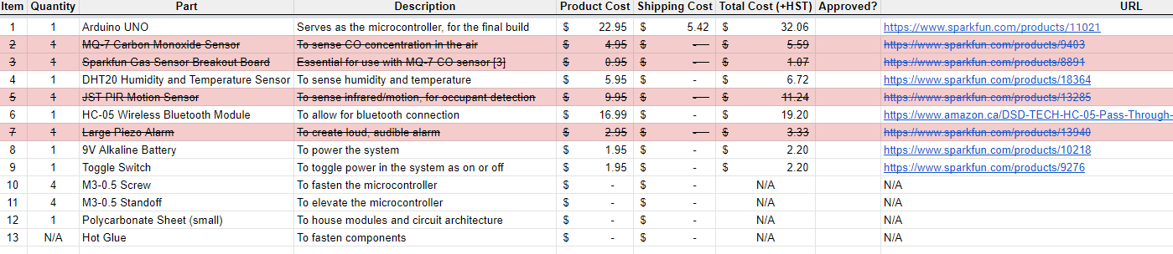

For a better view, a hyperlink to the spreadsheet is also included: https://docs.google.com/spreadsheets/d/1YGeyD9HVv8dC1QptiGBWQKlCk3IyMU83bSXr2-4EoEA/edit?usp=sharing

List of Equipment and Tools
To create the prototypes and eventual final product, we expect to use a(n):
- Arduino UNO, which will serve as the controller for prototyping purposes
- Arduino IDE software, for writing and uploading code into the Arduino.
- Breadboard, for testing the Arduino’s code and circuit design.
- Jumper cables, for connecting sensors and power supplies to the Arduino.
- Battery, to power the Arduino, the sensors, and the alert system.
- Laptop/desktop computer, to upload the code into the Arduino.
- Arduino UNO, for the final product controller
- Soldering iron, to solder circuit connections to the Arduino Nano

Prototype 1 Test Plan
For the first prototype, we will primarily test for feasibility of the design. The main objectives are thus to gather information and feedback regarding the installation process, the reliability of the individual sensors, the effectiveness of the chosen alarm as well as its durability as a product. To do so, we won’t be testing the subsystems themselves but the system as a whole (CO sensor being an exception) and troubleshoot from there.

Product Under Test | Test Objectives | Participants | Test Tasks | Responsibilities
Hot Car Emergency Device | -Analyze consistency and effectiveness of device  -Assess ease of installation  -Assess durability  -Assess ease of use  -Assess if alarm is reliable and suitable for moderate ranges (including SMS) | -1 participants required | -Setup device in a variety of applicable locations  -Test 1: Have device present in car and increase temperature  -Test 2: Turn on device and keep track of temp and CO levels for 10 minutes (testing for false alarm)  -Test 3: CO sensor to be tested in a controlled environment at a suitable facility | Person performing test:  -Managing their own safety  -Take notes on feedback from system while assessing from laptop
Business Case |  | Equipment
-Test is being performed to ensure feasibility of both sensory and signaling components  -Testing will lower rates of failure in the final product |  | -Laptop  -Car  -Prototype Assembly  -Heater  -Cellphone (in case of SMS)

Conclusion
In summary, this document thoroughly describes the ideology behind the first prototyping phase. It begins with a detailed drawing to depict what the prototype is intended to look like and how it may function. Then, the project plan is shown to demonstrate the division of tasks among group members. It also notes some risks that may arise along the course of the prototyping stage and how we may attempt to circumvent them. A tentative BOM and list of equipment have been appended as well. These will allow others to see the cost breakdown and replicate the project as desired. Finally, the document includes a test plan for prototype I which describes the procedure and the objectives for the first test.

