Project Deliverable F:
Prototype 1 and Customer Feedback

University of Ottawa
GNG1103: Engineering Design
Group 10

February 27, 2024

Catherine Satoh (300351169)
Fahad Husain (300361090)
Jennifer Campbell (300359940)
Manning Whitby (300118220)
Reese Jenkins (300393859)

Table of Contents
1.0 Introduction 1
2.0 Client Meeting Results & Feedback 1
3.0 Analysis of Critical Components 1
5.0 Prototype I 1
5.1 Mapping Ethical to Object/Room Significance 1
6.0 Prototype II 5
6.2 Results 5
6.1 Test Plan 5
Test Objectives (Why) 6
Description of Prototype used and of Basic Test Method (What) 6
Description of Results to be Recorded and how these results will be used (How) 6
Estimated Test duration and planned start date (When) 6
7.0 Bill of Materials 6
8.0 Storyline & its Elements 8
8.1 Bedroom 9
8.2 Walk Around House 9
8.3 Bathroom 9
8.4 Panic 9
8.5 User Controls 9
9.0 Target Specifications 9
10.0 Conclusion 10
10.1 Getting Customer Feedback 10
11.0 References 10
Appendix? 10

1.0 Introduction
Mines Action Canada tasked us to develop an accessible VR experience and a short video that demonstrated the dangers and ethical concerns of autonomous weapons and how civilians may adapt their environment to survive. The initial design criteria were synthesized in our first client meeting and included communicating ethical and moral consequences of failed autonomous weapons, human adaptations, generating an emotional response in users and ultimately inspiring preemptive banning of autonomous killer weapons. The second client meeting, which evaluated the prototype plan generated from the first meeting, further guided this 1st prototype. A test plan was devised for the 2nd prototype and the results will be presented to our client in the next meeting.

2.0 Client Meeting Results & Feedback
- Good ethical concerns
- Need to be simplified.
- Just building out the safe space, showing adaption
- Everyone’s own home relates to everyone, might be easier.
- Talking to civilization might be hard.
- Have narration and posters instead of civilians (do you have your mask, etc.)

- They felt that our original storyline had too many complicated elements and therefore needed more time and skills to be completed.
  - To accommodate their request to simplify our storyline

3.0 Analysis of Critical Components
The physical product of our project goal, to create an immersive VR experience that effectively communicates the ethical and moral consequences of failing autonomous weapons, can be divided into systems that engage the user’s senses (i.e., audio-visual; see Figure 1) - the sense of touch is relevant to control the VR agent but is not directly relevant for achieving the project goal.

Figure 1: Analysis of Critical Components
An immersive VR experience communicating ethical consequences
Visuals
Audio
Ethical scenarios
Storyline
user

Within Unity, a variety of 2D and 3D assets will be used to communicate the visual component. Images (e.g., ads, labels) and sketches (e.g., drawing on fridge) will be uploaded to create 2D assets. 3D assets were sourced online (see References) and...

- Assets and an environment are bought from the untiy store.
- Said components will be incorporated into the build, to display the desired atmosphere.
- Visuals will include posters, designed to inform the viewer context to the scenario
- Posters will inform user about the ethical concerns of killer robots.
Moreover, sound effects will be incorporated by...
- A background audio on loop in the background
- An NPC looped into an aduio action using scripts

5.0 Prototype I
The first prototype we developed focused on building the preliminary visual environment (see photos below). To focus on creating a basic proof of concept an abandoned-looking house was chosen; and following the sample floorplans, that were conceptualized in Deliverable E - Project Plan and Cost Estimate, the house was divided into separate spaces, to highlight separate groups of ethical scenarios. Unique 2D & 3D objects will be added to our preliminary visual environment to communicate these ethical scenarios (see 5.1 Mapping Ethical to Object/Room Significance). Overall, the first prototype successfully passed initial testing and further testing in a second prototype will be used to develop VR capabilities.

Figure 2: Screenshot of Environment in Unity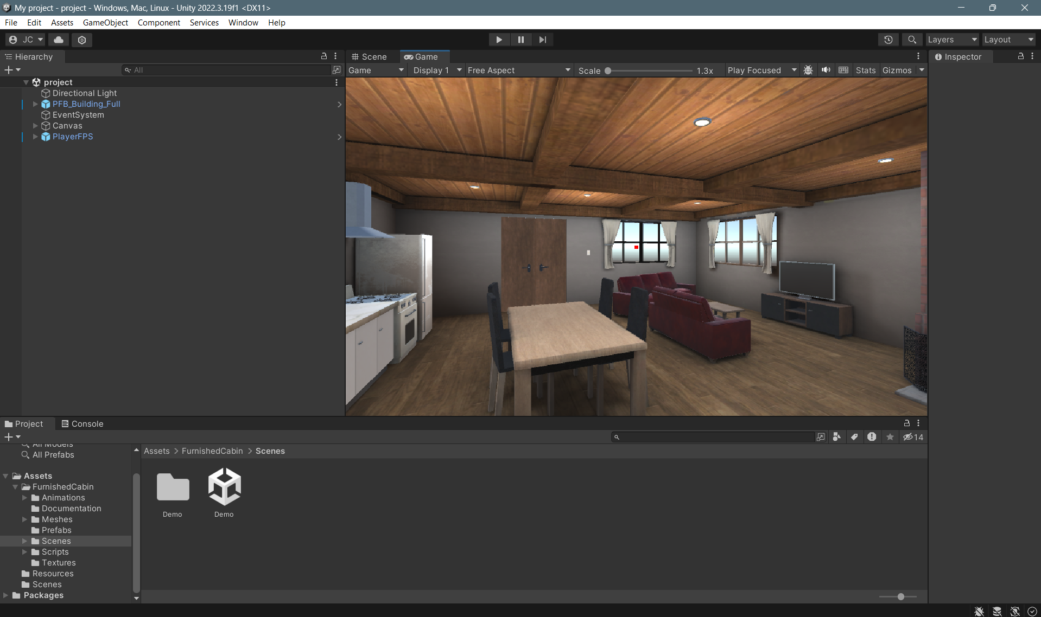

Figure 3: Screenshot of Bedroom from entrance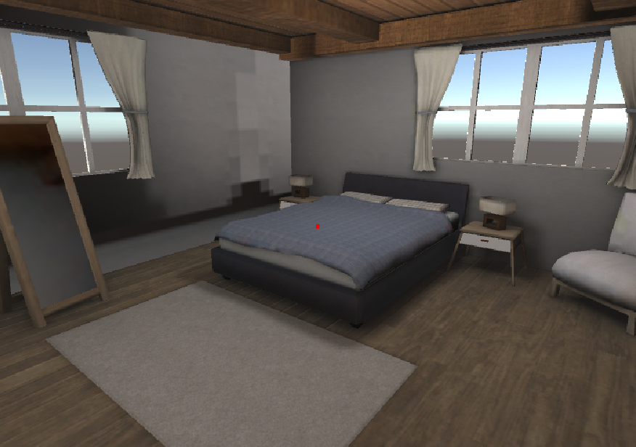
Figure 4: Screenshot of Bedroom from starting position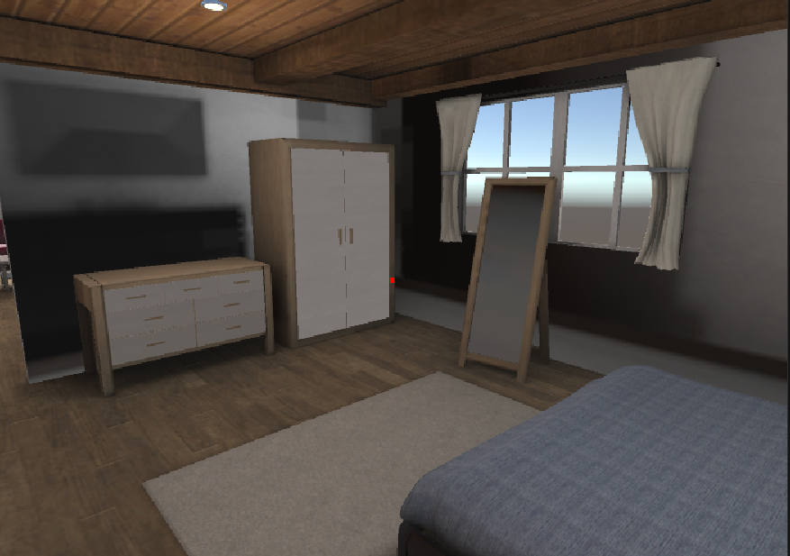

Figure 5: Screenshot of Kitchen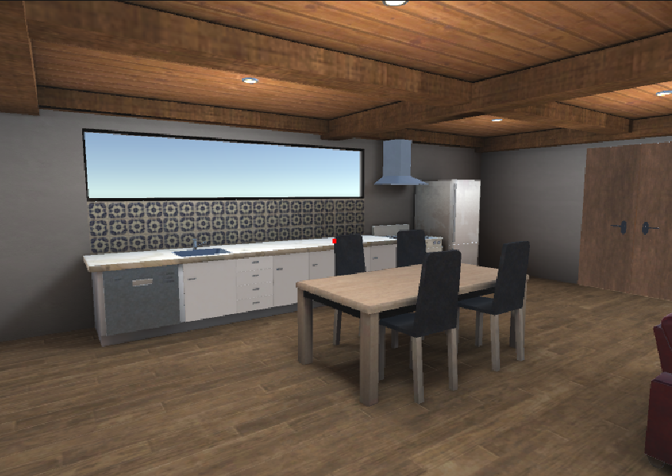
Figure 6: Screenshot of Living Room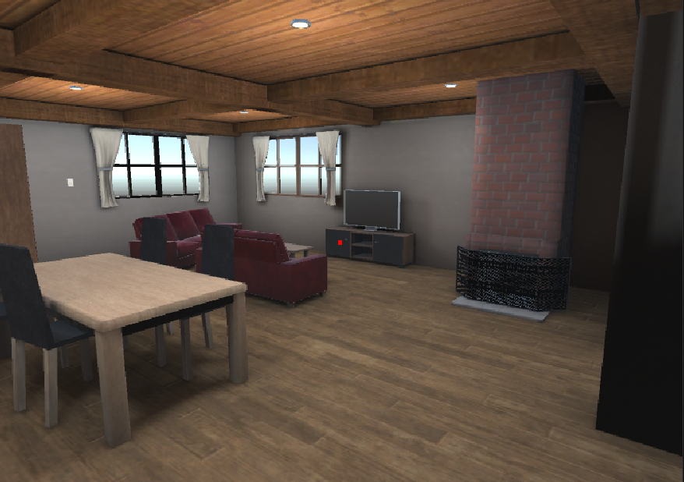
Figure 7: Screenshot of Restroom
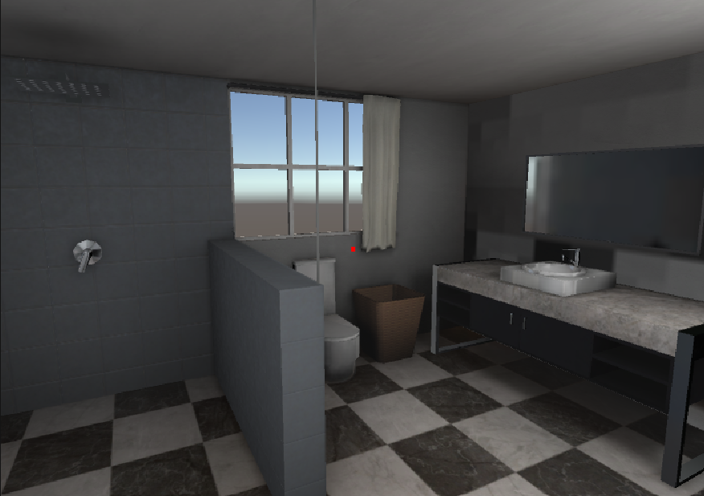
Figure 8: Screenshot of Interior
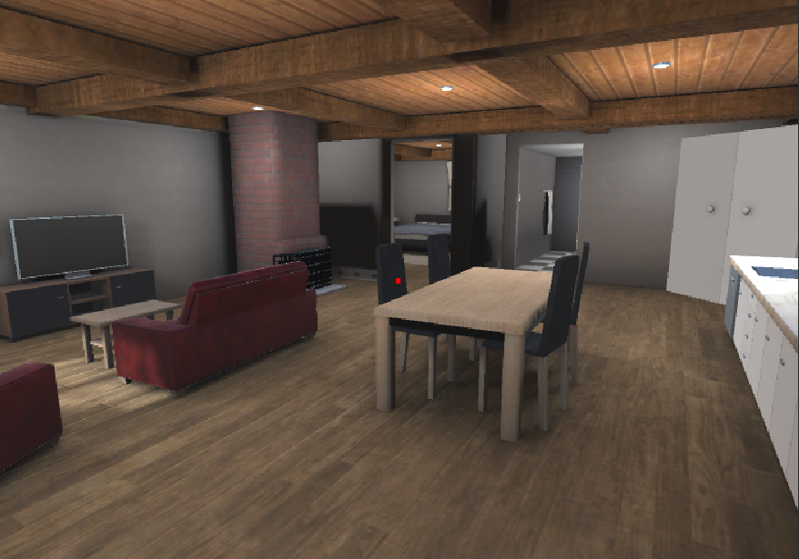

6.0 Prototype II

5.1 Mapping Ethical to Object/Room Significance
An environment that models a reality where autonomous weapons have failed must consider integrating elements that subtly reflect the ethical and humanitarian concerns associated with these technologies. The house was divided by its separate spaces; ethical scenarios were considered, and 2D & 3D objects were proposed to map these ideas into the VR environment.

Table 1: Kitchen Object Significance (Manning and Fahad)
The kitchen is a familiar and domestic setting, that can be a powerful space to depict some of the potential realities of a world affected by autonomous weapons.

Score | Visual | Ethical Scenario
 | Empty and abandon dog bowls | Signifies a lost pet due to the AI weapons to provoke emotion in the user.
 | Emergency Water purification Tablets | Highlights the need to ensure a clean water supply amidst disruptions caused by AI attacks
 | Empty cabinets and cans | Shows a lack of food. Displays how a killer robot attack can destroy means of acquiring essential items.
 | Indoors mini garden (inefficient/dead? | Displays the lengths the individuals must go to gain access to minimal amounts of food. (adaptation)
 | Childs drawing of people being killed (alternative to next point) | Displays the human lives lost due to the AI weapons, pulls on viewers heartstrings.
 | Photo frame of deceased loved one (parent etc.) with flowers | Displays the human lives lost due to the AI weapons, pulls on viewers heartstrings.
 | Newspaper clippings (on small corkboard) | Highlight the major events that lead to the current environment
Overlap | Light & Siren | To alert for incoming waves
 | Mold | Displays how unsanitary the location has become due to being locked down.

Table 2: Bathroom Object Significance (Catherine)
Score | Visual | Ethical Scenario
 | Empty bottle of Medication | Shows the lack of resources that arise from being confined to your own home.  Grandpa might have medical problem? Desperate need of new medication  Potassium iodine*** (robot version)
 | Faucet/ Leaky pipes | Difficult to call for plumbing help in these circumstances, house can’t be properly maintained
 | Boarded windows all around | The bathroom is definitely not different from the other rooms; everything must be boarded and soundproof for robots not to come chasing
 | Bugs? | Shows the disgusting state the house has come to during the long period of confinement, child doesn’t know how to clean well since parent deaths

Table 3: Object Significance Living Room (Reese)
Score | Visual | Ethical Scenario
 | Newspaper posters | Shows what is happening around the person and what the robots have done to their environment and any major events that has happened
 | Family photos | Shows photos of their loved ones that are not around anymore, pulls heart strings
 | Boarded window/ broken/ covered | Shows that they are trying to hide from the robots and do not want to be seen from the outside world to protect themselves
 | TV broadcast (kind of like a amber alert) | Allows the person living in the house to know what the robots have done to impact the environment or a static screen
 | Dead plants | Allows the viewer to see how they are unable to keep anything alive during the conditions
 | Person in the living room | Shows that the person in the living room is unable to function on their own (younger sibling, older person)
 | Coffee table | Has a bunch of garbage on it and around it, showing that they are not living in a good environment

Table 4: Object Significance Bedroom (Jennifer)
Score | Visual | Ethical Scenario
 | Calendar | Displays how long the viewer has been stuck inside.
 | Wardrobe/Clothes | Displays the required protection equipment.
 | Radio | Share recent news about the AI autonomous weapons (for video).
 | boarded window | Blocks the weapon sensors from detecting movement inside the house.
 | Family photos on nightstand | It shows the people who have passed due to weapons. This will provoke emotion in the user.
Don't know how to implement | Geiger Counter on nightstand | Used to measure radiation levels to highlight the AI autonomous weapons with nuclear capabilities.
 | A bookshelf with self-help and phycological books | The titles of the book can show the psychological effects of autonomous weapons. Ex. Book titles could be “How to Overcome Survivors' Guilt,” “Learning to be Okay with Being Alone.”, “Grieving in 5 Steps!”.

6.1 Test Plan
The different ‘W’ questions (i.e., “why”, “what” and “when”) answered (below) represent different objectives in prototyping; this way we are clear on exactly what each test is trying to accomplish (measurable results). All the tests that we plan to execute are captured in Table 5. These tests are unique and independent of each other; being modular divisions of the design criteria previously defined in Deliverable D: Conceptual Design, that are specific about what functionality they test. These will serve as the basis as we continue towards developing a ‘comprehensive prototype’.

Table 5: Test objectives for Prototype Plan
Test Objectives (Why) | Description of Prototype used and of Basic Test Method (What) | Description of Results to be Recorded and how these results will be used (How) | Estimated Test duration and planned start date (When)
Emotional Response | Find general public’s opinion by using people to view our environment | Comments, (High, Medium, Low)  How do you feel? Make a survey | From first prototype until final design (2 weeks)
Ethical Concerns | Find general public’s opinion by using people to view our environment | Gather comments from survey  Make a checklist | Week – 2 weeks
Environment Set-up Time | Measure how long it takes to set up the VR, video, and environment. | Use a stopwatch to time the average setup time. | Once final design is finished
Length of Video | Check as a team and cut down if needed | Check video length on editor | 1 minute approx. per test
Effectiveness of Objects (convey a message?) | Find general public’s view on what it conveys | Get them to try the VR and describe what they understood from each object | When prototype has been completed all the way to final prototype
Video Quality | Test on different people to see if issue is reoccurring | Get people to watch video and note any apparent issues | When VR prototype has been tested already and video needs to be checked

7.0 Bill of Materials
An estimate of the cost for all components and materials was developed in Deliverable E - Project Plan and Cost Estimate. Following tests and analysis the BOM was updated and outlined in Table 6. The goal for this first prototype was to use generic materials and components that cost very little; we wanted to be creative in how we mapped our ethical scenarios into an immersive VR environment.

Table 6: Updated Equipment and Pricing
Equipment | Purpose | Where to source | Price
Environment (House) | User will be in this environment for the entirety of the video | Furnished Cabin | 3D Urban | Unity Asset Store | FREE
VR headset | To walk through the environment | MakerLab | Provided (Free)
Unity | The software to build the environment | Online | Free
Posters | To inform the user what will happen after autonomous weapons has been used | Digitally Designed | Free
Monitoring Watch | A protective device used to monitor heart rate and alert people of emergencies and dangers | VR watch modern and classic | 3D Characters | Unity Asset Store | $4.99
Radio | To inform user of the dangers in their environment | Radio | 3D Props | Unity Asset Store | Free
Video recording/editing | To show what has happened to a person's life and environment after autonomous weapons | CapCut | Free
NPC’s | To add realism to the environment and interaction with the user | Mixamo | Free
Microphone | To record voiceovers for the environment and video | Owned | Free
Wheelchair | To show how the weapons are biased against people with disabilities | Folded wheelchair, Unfolded wheelchair PBR | 3D Props | Unity Asset Store | $4.99

Total Price | $9.98

8.0 Storyline & its Elements
For the most part, a lot of focus has been committed to ensuring that our project satisfies the design criteria of communicating the ethical consequences and life scenarios of failing autonomous weapons systems. A big part of this communication involves an emotional storytelling element (also defined in our design criteria). Below we have described the story we hope to tell with these ethical scenarios and their objects (or spaces). Dynamic elements & audio were considered given the additional complexity of coding & integrating these elements.

Table 7: Storyline & Critical Components
Segment | Scene | Dynamic Elements | Audio
8.1 Bedroom | - Wake-up  - Look @ wardrobe  - Radio | - Nothing | - Calm heartbeat  - Radio
8.2 Walk Around House | - Check kitchen for food  - Out of food  - Go to grandparent in living room  - Grandparent needs meds | - Bugs | - Heartbeat increases  - Grandparent?
8.3 Bathroom | - Find meds  - Med bottle is empty | - Bathroom cabinet | - Heartbeat speeds-up  - Leaky faucet
8.4 Panic | - Run out of house in panic (heart rate monitor beeps like crazy)  - Scene ends | - Front door | - Loud heartbeat

8.5 User Controls
Within the VR environment, the user will be able to move and look around (perspective) by controlling the arrow buttons on a computer and mouse. A preset script was used to program these controls.

9.0 Target Specifications
This report has considered all of the critical components guiding this project. Following a prototyping test plan, analysis and our results, we can now evaluate how close we are to our target specifications (see Table 8, defined in Deliverable C: Design Criteria). The criteria we have yet to satisfy will be discussed and planned for the next deliverable.

Table 8: Target Specifications
 | Design specification | Relation  (<, >, =) | Value | Units | Verification
 | Functional
1 | Concern (Fear and anger) | = | Yes | N/A | Testing/Review
2 | Motivation/inspiration | = | Yes | N/A | Testing/Review
3 | Visuals (objects and settings) | = | Grim lighting | N/A | Testing/Review
4 | Audio (sound effects and music) | > | One song + 5 sound effects | # | Analysis
5 | Non-Interactive (static) | = | yes | N/A | analyze
6 | One location | = | yes | N/A | Review/ analyze
7 | Easy to follow story | = | yes | N/A | Review/ analyse
8 | Focused on Environment | = | yes | N/A | Review/ analyze
9 | Clear Message | = | yes | N/A | Review/ analyze
10 | Unknown/unrecognizable place | = | yes | N/A | Review/ analyze
11 | Number & diversity of ethical dilemmas present | > | 5 | scenarios | Measure
12 | Complexity of ethical scenarios depicted | = | yes | N/A | Review/ analyze
13 | User engagement time with ethical scenarios | > | 10 | seconds | Review/ analyze
Non-functional
1 | Fluidity of video | = | Yes | N/A | Testing/Review
Constraints
1 | No Flashing Lights | = | Yes | N/A | Testing/Review
2 | No Loud Noises | = | Yes | N/A | Testing/Review
3 | Duration | = | 1 | Minute | Measure

10.0 Conclusion
This deliverable focused on planning how to show the ethical concerns of AI autonomous weapons. The next delivery will focus on implementing the objects and NPCs and summarizing our next client meetings feedback.

10.1 Getting Customer Feedback
On March 5th, 2024, we will be gathering feedback during our client meeting. This feedback will be implemented into our next prototype.

11.0 References

Folded wheelchair, Unfolded wheelchair PBR | 3D Props | Unity Asset Store. (2023, January 9). Unity Asset Store. https://assetstore.unity.com/packages/3d/props/folded-wheelchair-unfolded-wheelchair-pbr-212036
Furnished Cabin | 3D Urban | Unity Asset Store. (2022, May 21). Unity Asset Store. https://assetstore.unity.com/packages/3d/environments/urban/furnished-cabin-71426
Radio | 3D Props | Unity Asset Store. (n.d.). Unity Asset Store. https://assetstore.unity.com/packages/3d/props/radio-230712
VR watch modern and classic | 3D Characters | Unity Asset Store. (n.d.). Unity Asset Store. https://assetstore.unity.com/packages/3d/characters/vr-watch-modern-and-classic-126406

Appendix?
When preparing to write our script we considered constants for presentation variables such as words spoken per minute:
- 120 words < slow speaker
- 150 words = our goal
- 160 > fast speaker

