Project Deliverable E:
Project Plan and Cost Estimate

University of Ottawa
GNG1103: Engineering Design
Group 10

February 11, 2024

Catherine Satoh (300351169)
Fahad Husain (300361090)
Jennifer Campbell (300359940)
Manning Whitby (300118220)
Reese Jenkins (300393859)

Introduction

For this deliverable, the goal is to predict possible risks that may arise from working on our intended project and to outline the prices of assets we plan on buying to build our environment.

Problem Statement

Mines Action Canada needs an accessible VR experience and a short video (1 min) demonstrating the dangers and ethical concerns of autonomous weapons and how civilians adapt their environment to survive.

Risk Managment
Possible Risk | Likelihood | Impact | Prevention
Losing a member/ gaining a new member | Low | High | - Communicating continuously to notice quickly when a member ghosts the chat  - Set in meetings every week
Late submissions | Moderate | High | - Setting the ‘due date’ 24 hours before necessary submission.  - Effective communication
Not having enough of a budget for our plan | Low | High | - Be sure to double check on what the budget is, ask a team member or log into Brightspace
Compiling Errors | High | High | - Allow enough time to correct errors
Our clients disapproving of our prototype | Moderate | High | - Check for input by reaching out to clients and or TAs  - Understand what we should fix and rework the environment with new feedback
Lack of motivation | High | Moderate | - Find aspects of the project that excite us instead of sulking
Decision making conflicts | Moderate | Low | - Use the appropriate conflict management strategies (Dominating, collaborating, avoiding, accommodating, and compromising)

Drawings/Diagrams
Sample floor plan:
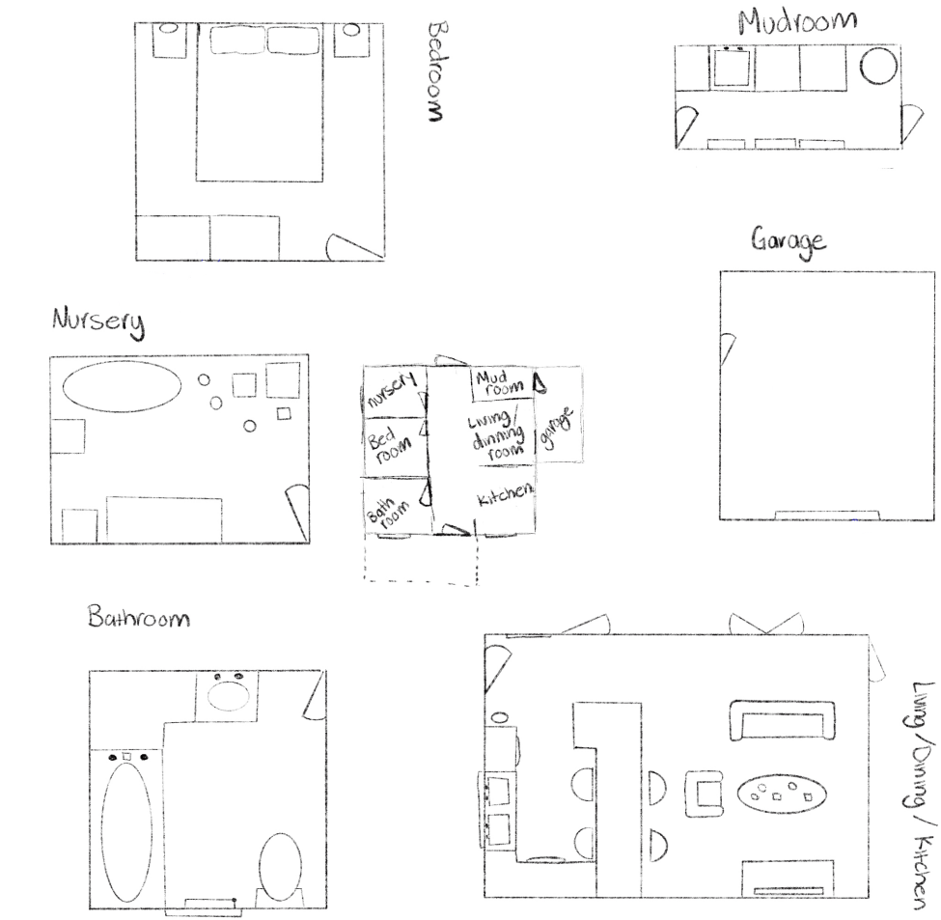
Sample floor plan with notes:
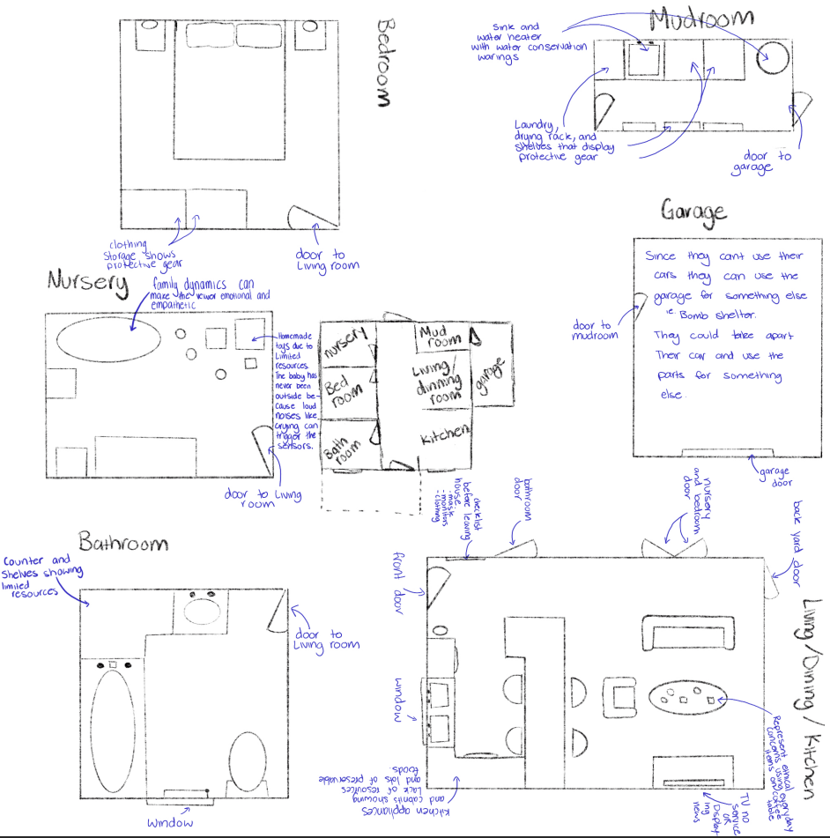

Equipment and Pricing

Equipment | Purpose | Where to source | Price
Environment (House) | User will be in this environment for the entirety of the video | Country houses with interiors | 3D Urban | Unity Asset Store | $24.99
VR headset | To walk through the environment | MakerLab | Provided (Free)
Unity | The software to build the environment | Online | Free
Posters | To inform the user what will happen after autonomous weapons has been used | Digitally Designed | Free
Monitoring Watch | A protective device used to monitor heart rate and alert people of emergencies and dangers | VR watch modern and classic | 3D Characters | Unity Asset Store | $4.99
Radio | To inform user of the dangers in their environment | Retro Metal Radio | 3D Electronics | Unity Asset Store | $4.99
Video recording/editing | To show what has happened to a person's life and environment after autonomous weapons | CapCut | Free
NPC’s | To add realism to the environment and interaction with the user | Mixamo | Free

Total Price | $34.97

References

Country houses with interiors | 3D Urban | Unity Asset Store. (2023, August 31). Unity Asset Store. https://assetstore.unity.com/packages/3d/environments/urban/country-houses-with-interiors-155343
Retro Metal Radio | 3D Electronics | Unity Asset Store. (2017, October 6). Unity Asset Store. https://assetstore.unity.com/packages/3d/props/electronics/retro-metal-radio-85919
VR watch modern and classic | 3D Characters | Unity Asset Store. (n.d.). Unity Asset Store. https://assetstore.unity.com/packages/3d/characters/vr-watch-modern-and-classic-126406

