GNG1103
Design Project User and Product Manual

PANDORA’S BOX

Submitted by:
TEAM 8
EUNHYO JUNG, 300374867
RONAN THOMAS, 300377301
INES SENHADJI, 300133538
GEORGE LAI, 300298485
ANUAR MAGAUYA, 300367226

April 10th, 2024
University of Ottawa

Table of Contents
______________________________________________________________________________

Table of Contents Error! Bookmark not defined.
List of Tables iv
List of Acronyms and Glossary v
1 Introduction 1
2 Overview 2
2.1 Cautions & Warnings 5
3 Getting started 6
3.1 Configuration Considerations 6
3.2 Exiting the System 7
4 Using the System 8
4.1 Movement 8
4.2 Waypoints 8
5 Troubleshooting & Support 9
5.1 Error Messages or Behaviors 9
5.2 Support 9
6 Product Documentation 10
6.1 Environment 10
6.1.1 BOM (Bill of Materials) 10
6.1.2 Equipment list 10
6.1.3 Instructions 10
6.2 Movement 12
6.2.1 BOM (Bill of Materials) 12
6.2.2 Equipment list 12
6.2.3 Instructions 12
6.3 Animations 13
6.3.1 BOM (Bill of Materials) 13
6.3.2 Equipment List 14
6.3.3 Instructions 14
6.4 Testing & Validation 15
7 Conclusions and Recommendations for Future Work 16
8 Bibliography Error! Bookmark not defined.
APPENDICES 17
9 APPENDIX I: Design Files 17

List of Tables
Table 1. Acronyms v
Table 2. Glossary v
Table 3. Referenced Documents 17

List of Acronyms and Glossary
Table 1. Acronyms
Acronym | Definition
AWS | Autonomous weapon system
VR | Virtual Reality

Table 2. Glossary
Term | Acronym | Definition
Unity | (None) | Program used to create games.
Unity Asset Store | (None) | Online store for assets to be imported into Unity projects.

Introduction
Autonomous weapon systems (AWS) are weapons that can independently search and initiate combat without any human intervention. With the rise of AI in recent times, the development of these weapons is getting faster.
Mines Action Canada wants a video in a VR environment that will convince politicians to ban autonomous weapons, by showing how non-combatants will be affected by these weapons. The video should be 1 minute long and ideally be showing the ethical standpoints of the conflict.
Pandora’s Box was made by Team 8 to convince these politicians to ban AWSs.

This User and Product Manual (UPM) provides the information necessary for users to effectively use Pandora’s Box and for prototype documentation.

Overview
Mines Action Canada wants a video in a VR environment that will convince politicians to ban autonomous weapons, by showing how non-combatants will be affected by these weapons. The video should be 1 minute long and ideally be showing the ethical standpoints of the conflict.
Our product, Pandora’s Box, is a VR experience that is driven by a unique story. Our focus was to primarily show how not only civilians, but a person with disability could be affected by AWSs. Additionally, we added elements of moral accountability, including a character who once worked for the development of these AWSs and is now facing the consequences.
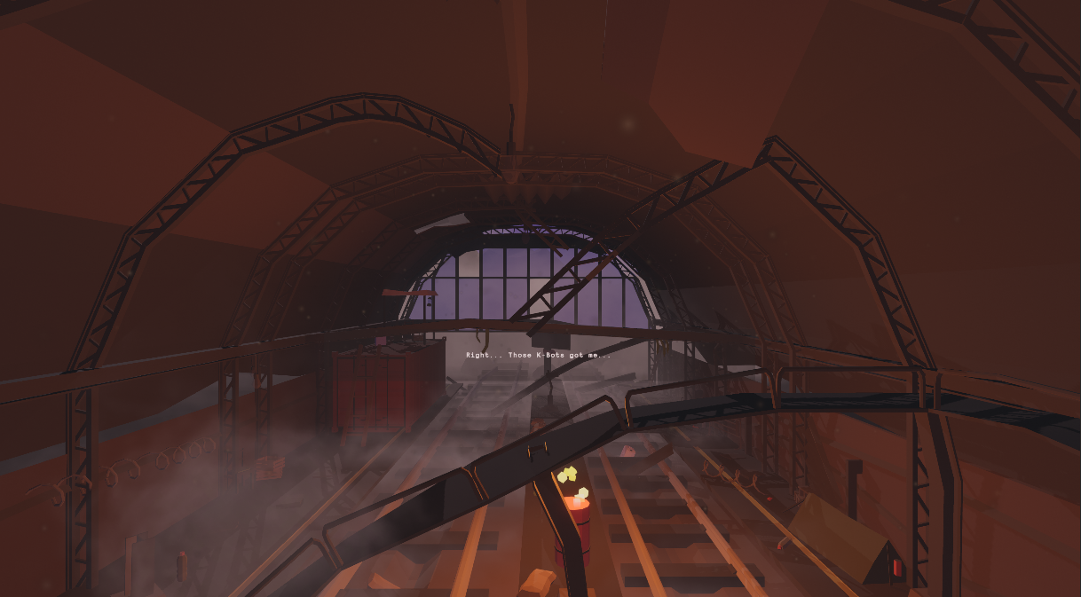
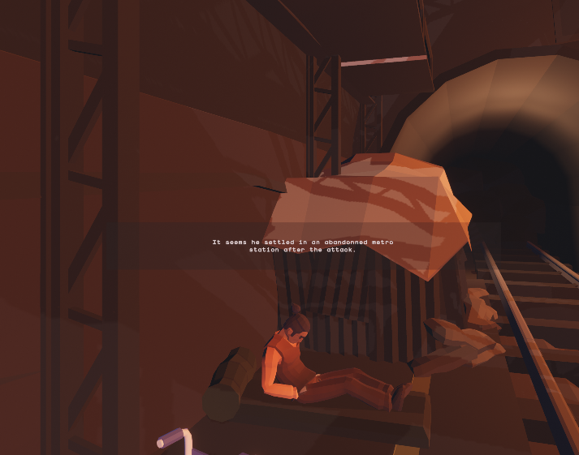

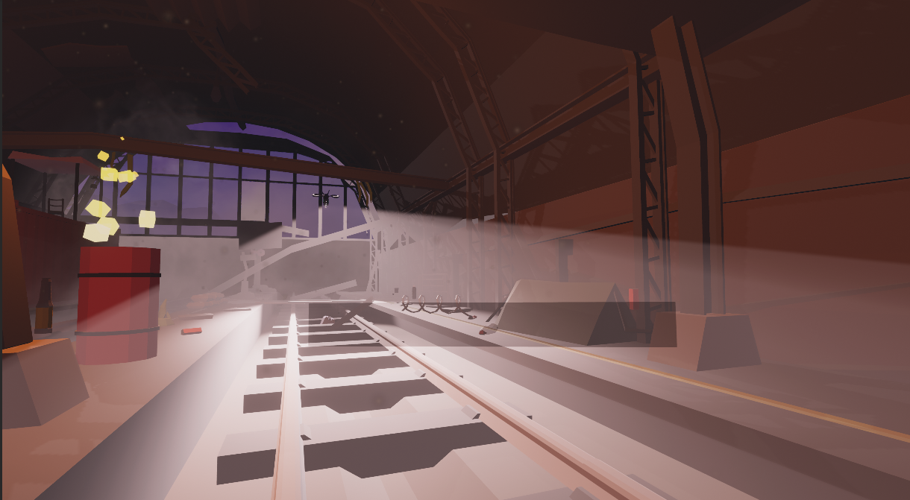

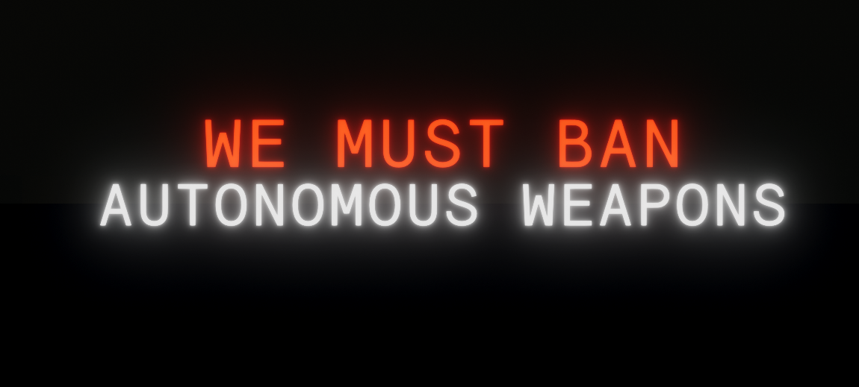

Key features:
- Story driven experience.
- Exploration of conflict from perspective of person with disabilities.
- Themes of moral accountability and ethical standpoints of AWSs.
- Character animations.
- Minimal input required.

Cautions & Warnings
Do not use a VR headset when you are suffering from lack of sufficient sleep or under the influence of alcohol or drugs.
A VR headset should be safely used away from any animals, sharp objects, tripping hazards, stairs, open doors, wet surfaces, other items you may bump into or trip over during use.
If you experience motion sickness related symptoms, stop use and do not use the VR headset.
People sensitive to vertigo or motion sickness are discouraged from using the VR headset.

Getting started
- Download the zip folder “Pandora” from MakerRepo.
- Extract the folder.
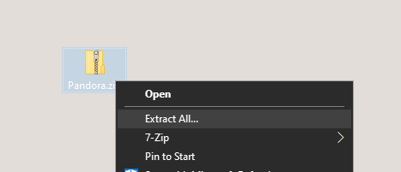
- Open the folder and run the .exe application.
- Once the game is loaded, use the VR controllers to trigger the start button to start the VR experience.
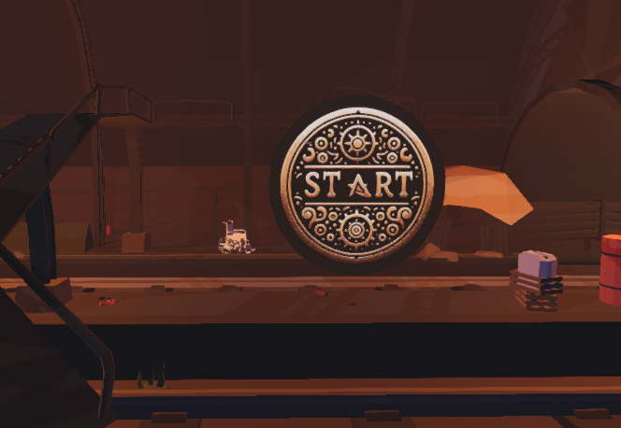

Configuration Considerations
Connect the VR headset to the computer before running the .exe application. When connecting, make sure the headset is setup, and run any external software that is needed, so that the headset is ready to be used.
Make sure the devices have enough battery.

Exiting the System
To exit the VR environment, press Alt+F4 to quit the game. To run the game again, start from step 3 of section 3.1.

Using the System

Movement
To move around in the VR environment, use the left controller joystick to walk. To pan the view side to side, use the right controller joystick to turn.

Waypoints
To activate events during the VR environment, the player will be prompted to walk towards a waypoint.
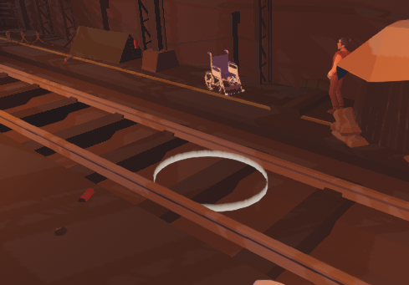
Use the movement function to walk inside of the white ring to continue the VR experience.

Troubleshooting & Support

Error Messages or Behaviors
If the VR experience is frozen, wait for it to load. If it is taking too long, the computer hardware may not be suitable for running a VR game.
If the VR experience is choppy, the computer hardware may not be suitable for running a VR game.

Support
For support, email ejung072@uottawa.ca for help regarding the use of the VR environment.

Product Documentation

Environment

BOM (Bill of Materials)
Asset | Link | Price
Low Poly - Apocalypse Metro Station | https://assetstore.unity.com/packages/3d/environments/low-poly-apocalypse-metro-station-123203 | $8.99
Low Poly Fire | https://assetstore.unity.com/packages/vfx/particles/fire-explosions/low-poly-fire-244190 | Free
Free Stylized Skybox | https://assetstore.unity.com/packages/2d/textures-materials/sky/free-stylized-skybox-212257 | Free

Equipment list
- Unity Asset Store

Instructions
- Buy the asset “Low Poly – Apocalypse Metro Station” from Unity Asset Store.
- Buy the asset “Low Poly Fire” from Unity Asset Store.
- Buy the asset “Free Stylized Skybox” from Unity Asset Store.
- On Unity, click Window -> Package mangager.
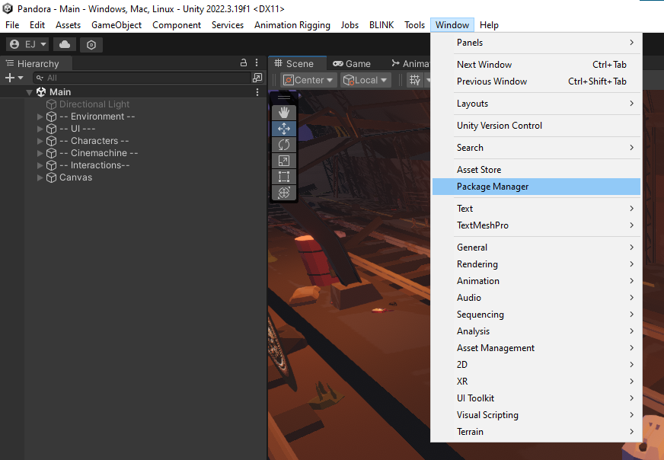
- For each asset, download the asset from the package manager and import into the project.
- Place all assets into scene.

Movement

BOM (Bill of Materials)
Asset | Link | Price
XR Interaction Toolkit | (Inside Package Manager) | Free

Equipment list
Unity Package Manager

Instructions
- Open Package Manager.
- Download “XR Interaction Toolkit” and import it.
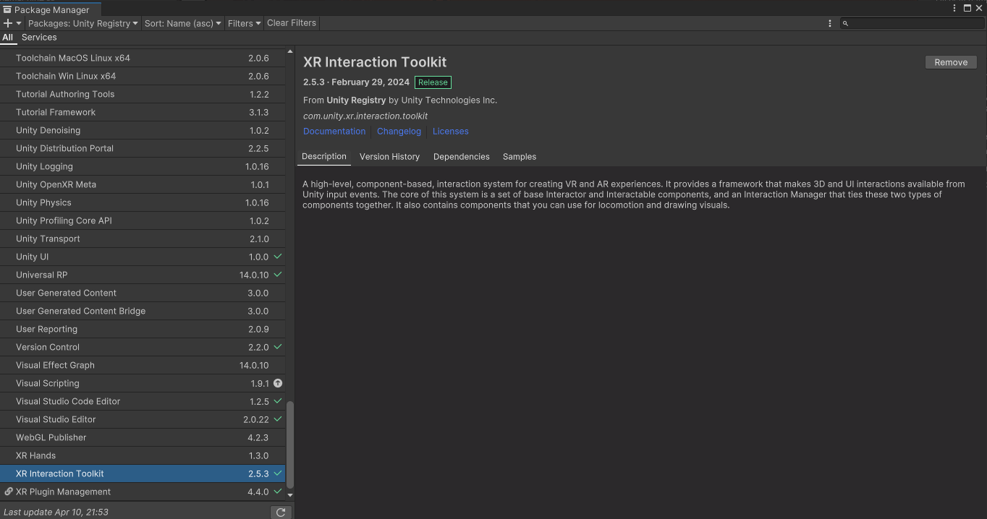
- Search for “XR Interaction Setup” in project assets.
- Drag and put it into the scene.

Animations

BOM (Bill of Materials)
Asset | Link | Price
FREE Low Poly Human – RPG Character | https://assetstore.unity.com/packages/3d/characters/humanoids/fantasy/free-low-poly-human-rpg-character-219979 | Free
Mixamo - Waking | https://www.mixamo.com/#/?page=1&query=waking | Free
Mixamo – Sad Idle | https://www.mixamo.com/#/?page=1&query=sad+idle | Free
Mixamo – Nervous | https://www.mixamo.com/#/?page=1&query=nervous | Free
Mixamo – Right turn | https://www.mixamo.com/#/?page=1&query=right+turn | Free
Mixamo – Start walk | https://www.mixamo.com/#/?page=1&query=start+walk | Free
Mixamo – Walking | https://www.mixamo.com/#/?page=1&query=walking | Free
Mixamo – Stop walk | https://www.mixamo.com/#/?page=1&query=stop+walking | Free
Mixamo - Crouch | https://www.mixamo.com/#/?page=1&query=crouch | Free
Mixamo – Crouch to stand | https://www.mixamo.com/#/?page=1&query=crouch+to+stand | Free
Mixamo - Running | https://www.mixamo.com/#/?page=1&query=running | Free

Equipment List
Unity Asset Store, Unity Package Manager

Instructions
- Download animations as .fbx files and import into Unity project assets.
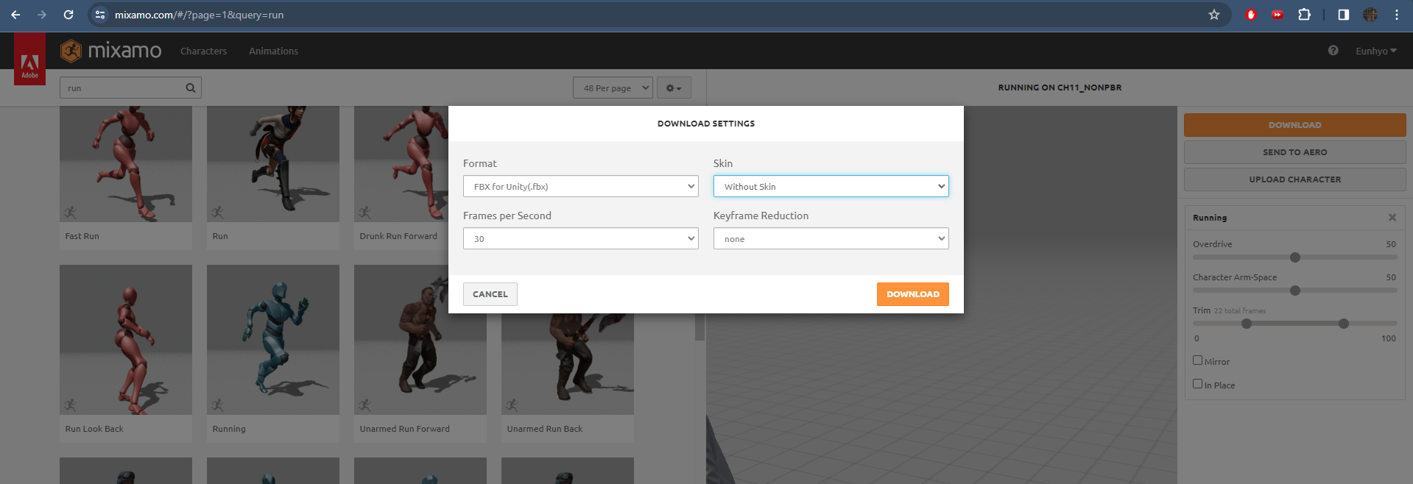
- Create a Timeline in unity.
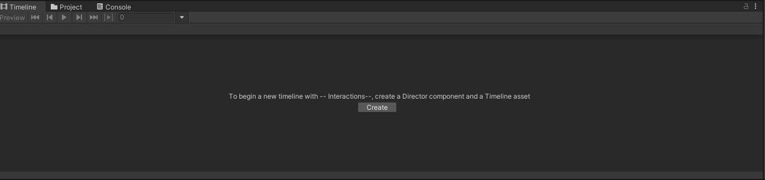
- Import the animation files into timeline and organize to create an animated character.
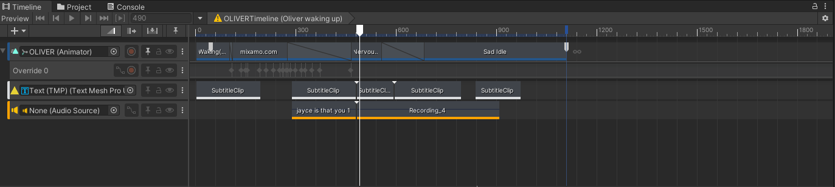

Testing & Validation
- Testing was done to ensure stability of the animated character (offset position + smooth transitions between animations).
- Testing was done to confirm that the subtitles and animations followed the overall story line of storyboard (separate file – deliverable e (Final).pdf).

Conclusions and Recommendations for Future Work
To summarize, we, as Team 8, learned a lot about teamwork and designing thanks to this project. Firstly, it is important to organize everything within your team, so everyone knows what to do. Achieving this by assigning a leader is a good choice. Second, its okay to give up on some ideas. We weren’t too attached to one specific plan, so we were very flexible with our ideas, which allowed us to explore the side of persons with disabilities more freely.
If we had more time, we would ultimately polish up our work by cleaning up the animations and the timelines. Also, with more time, we could’ve had more time to find more realistic assets instead of low poly style assets. What held us back was improper team management. A lot of us were not doing work simply because the work was not properly distributed among the team. Due to this, we had to give up work on our final scene, where we wanted to implement another cinematic cutscene, but we had to settle for a simple animation.

APPENDICES

APPENDIX I: Design Files

Table 3. Referenced Documents
Document Name | Document Location and/or URL | Issuance Date
Pandora.zip | https://makerepo.com/RonanThomas/2005.gng1103-group-8-pandoras-box- | 4/10/2024
deliverable e (Final).pdf | https://makerepo.com/RonanThomas/2005.gng1103-group-8-pandoras-box- | 4/10/2024

