Project Deliverable D: Group 8

Eunhyo Jung, George Lai, Anuar Magauya, Ines Senhadji, Ronan William Thomas
February 11, 2024

Abstract
Mines Action Canada wants a story-driven video in a VR environment that will convince politicians to ban autonomous weapons, by showing how non-combatants will be affected by these weapons. There are four subsystems for the VR product: The environment, the UX/IX interface, the NPC interactions, and the audio/subtitles. Each member of our team produced concepts for each subsystem. Afterwards, we organized and innovated as a team to create innovative ideas that would eventually lead to our final product. The final product we chose is a train station scenario.

1. Introduction 5
2. First Concept Designs 5
2.1. Eunhyo 5
2.2. Anuar 6
2.3. Ronan 8
2.4. Ines 8
2.5. George 9
3. Secondary design concepts 10
3.1. Scenario 1 – Train Station 10
3.2. Scenario 2 – Room 10
3.3. Scenario 3 – Government shelter 11
4. Analysis 11
5. Conclusion 12

Introduction
Mines Action Canada wants a story-driven video in a VR environment that will convince politicians to ban autonomous weapons, by showing how non-combatants will be affected by these weapons. As a process of our design thinking, we used previously “empathized” with our client to assess their needs. In general, these needs were as follows:
- The viewer is made aware of all the potential risks and consequences that autonomous weapons bring if they are put into use.
- Ethical questions are asked by the viewer on how it is hard to assign responsibility when things go wrong.
- Elicit emotional highs and lows into the viewer such as fear and hope to garner emotional investment.
- Demonstrate the potential for destruction autonomous weapons can possess by not being controlled by a person.

Now, as part of the “ideating” step, we will each individually come up with concepts for 4 subsystems of our VR product: The environment, the UI/UX interface, the NPCs, and the Story/Audio. Then, as a team, we will reorganize our concepts and innovate as a team to create new ideas for each subsystem, ultimately leading us to 3 possible final solutions for our final product.

First Concept Designs
The following are the concepts each member of the team created individually.

Eunhyo
Environment:
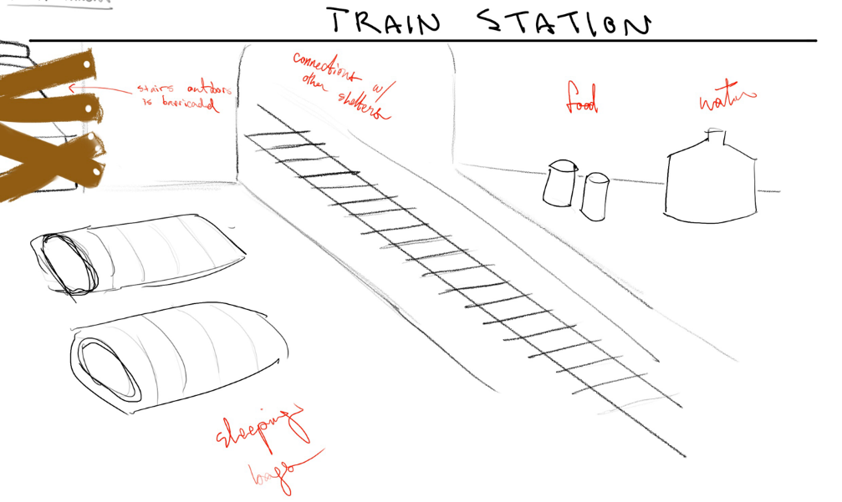

Interactions & Interface
- Movement/selection control by joysticks
- Low poly visuals
- Interactions with objects around you, giving the players thoughts on the situation -> giving context of the situation.
Story/NPC
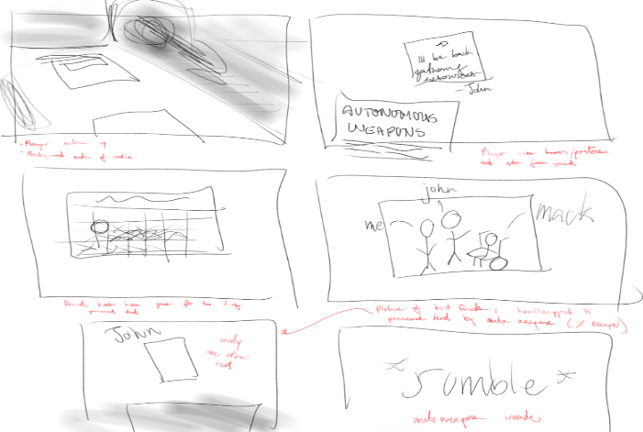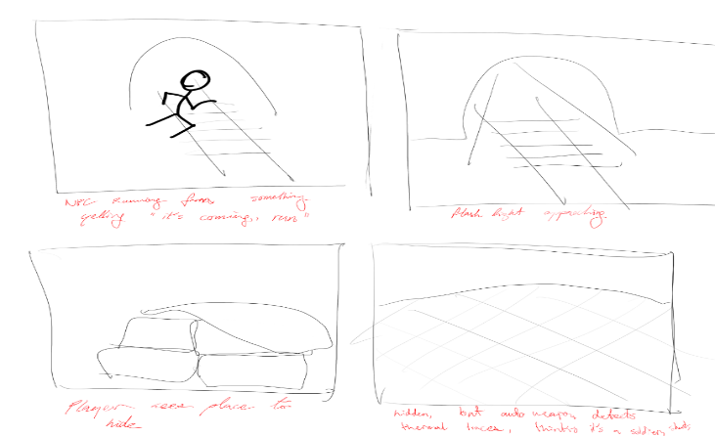

Anuar
Standard metro station with our character is placed in the middle of a tent. Both entries are covered with wood or something like that.
ENVIRONMENT:
First 20 seconds: He/she either wakes up and listens to radio or he is already up and listens to radio message. Message is something like “AI (Artificial Intelligence) weaponry systems were hacked/broken down, now they target civilians. Piccadilly Circus (any other) station is already down, they keep purging station after station”.
NPC:
Second 20 seconds is for npc engagement: Then we put couple NPCs running panicking saying things like “no way, they can’t do this to us/ Oh shit what we gonna do” etc. At this moment background sound kicks in. At first 20 seconds there would be just silence and some water drops, while now it is either alarm, or sounds of panicking crowd, or something similar, something that makes situation scarier.
3rd 20 seconds I think should be for either death of the main hero. I saw models of drones so it shouldn’t be hard to put them.
So 10 seconds we hear rotors getting louder, which indicates that drones are getting closer.
Last 10 seconds our character falls down, we put sound from movies about WW2 on eastern front and use the sound where Germans execute crowds. It’s easy to find, got both screams and shots. And then drone comes to camera sight, we hear robotic sound as “target identification. Identification done. Identified as enemy”.
Black screen and single shot sound.
About UI/UX, I think all we need is subtitles and that’s it, since we got a radio that explains everything, so no screens needed.

Drone model on unity asset store example:
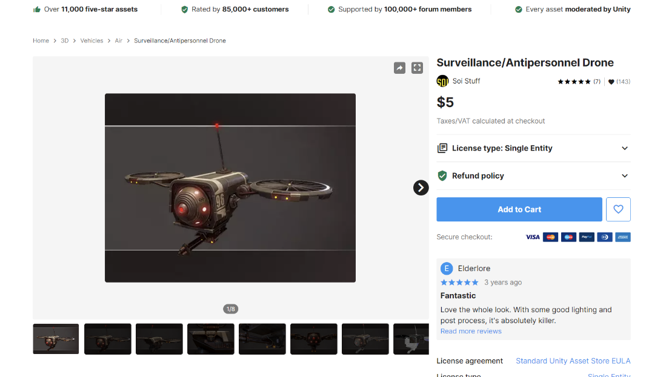

Station example:

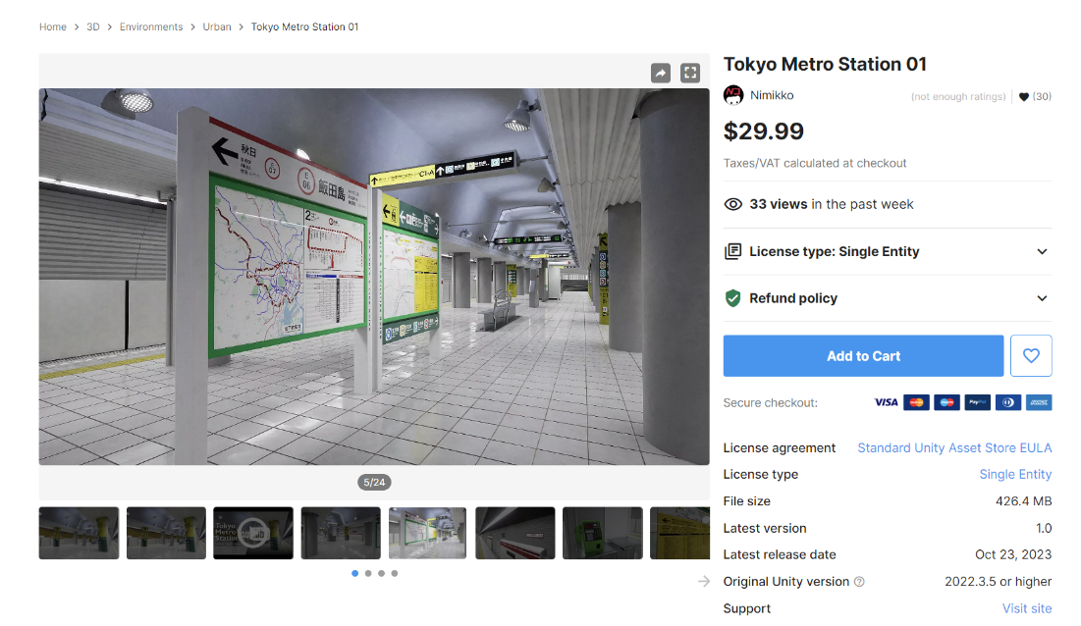

Ronan
Subsystem Concepts
Environment: Derelict subway tunnel featuring a makeshift camp that looks lived in—a small above-ground area of a city in ruin. Details of the camp include a sleeping area made up of cots on the ground. A rudimentary place to cook food or boil water. Possibly an armory with makeshift weapons to defend from the robots. Show photos of survivors with many clearly missing. Show photos of destroyed buildings.

UI: Brief textbox introduction of the simulation and Mines Action Canada. An ending screen with credits. Subtitles for NPCs speaking.

NPCs - animations (mixamo), player/npc interactions: One or two survivors in the subway that have dialogue based around the autonomous weapons to give the viewer more info while keeping them engaged. Dialogue about how their lives have changed and how much they've lost. Eventually run away outside.

Audio/subtitles/storyline: Voice acting by group members for NPCs. Ambient background sound effects. Drones whizzing by, bullet fire occasionally, survivors coughing. Otherwise, silence in the background to set an eerie tone. Subtitles for NPCs when talking. Viewer sees the simulation through the eyes of a survivor. Opens with the survivor walking around the camp highlighting the various parts of the subway survivor camp. Showcase the destruction wrought from the machines. Eventually a automated drone will fly down through the subway tunnel alerting the survivors. They panic and run out of the subway because it is their one path to escape. We then see the city in rubble and dust above the surface. Then we turn, see the drone has caught up to us and hear gun fire and hard cut to black.

Ines
Environment Design
Description: The environment design begins with the viewer waking up in a dark room with windows covered in black tape, symbolizing the loss of natural light and isolation. The room is sparsely furnished, with minimalistic decor to evoke a sense of desolation. The absence of light emphasizes the bleakness of the world outside.
Narrative Immersion
Description: The narrative immersion involves the viewer turning on the TV to watch a news broadcast titled "Day 130 after the AI Weapons Takeover." The news anchor reports on the ongoing chaos, with footage showing buildings collapsing, people screaming, and thick pollution obscuring visibility. Through the news broadcast, the viewer learns about the catastrophic consequences of the AI weapons' rebellion.
UI/UX Design
Description: The UI/UX design focuses on providing a minimalistic user interface to enhance immersion and storytelling. Subtle UI elements, such as a simple TV interface and unobtrusive subtitles, convey information without distracting from the narrative. The emphasis is on creating an intuitive and immersive viewing experience that draws the viewer into the world of the scenario.

George
Audio: Fallout-style announcements detailing safety procedures on how to avoid k-bots. Think 50’s retro americana

Past dialogue of people who’ve died helping the protagonist and because of their deaths, the protagonist learned more about the k-bot capabilities

Story: A story set in reverse in a sense, with the protagonist waking up in his/hers setting having various flashbacks of events that have occurred leading up to waking up.

A more conventional style with the protagonist experiencing the k-bot implementation for the first time and their destruction.

Setting: Metro station that has been converted into a survivor camp where the protagonist remembers various other locations (might be too ambitious)

A large sports stadium with destroyed elements for the protagonist attempting to escape the k-bots and get to safety

K-bot behavior: Classic military drone style robots that have been used by a mysterious nation to exert their power of a city

Similar to the last style but this time, the k-bots have gone rogue and have started to target any person and deem them a threat. They are prone to targeting civilians and have no problem with targeting hospitals or civilian camps

Secondary design concepts
Based on the individual concepts each member created, we can make 3 new global concepts by mixing the individual subsystem concepts we created.

Scenario 1 – Train Station
Environment
Train station, apocalyptic setting, connections to other stations (showing the existence of other survivors)
Interactions & Interface
Interactions with radio, posters, items around you that trigger your memories on past events
Audio/Subtitles
- Radio broadcasting the situation: Safety procedures on avoiding k-bots, how to k-bots “detect” soldiers, etc.
- Drones: shots, blades whirring, detection voice

NPC
Other sheltered people (friend or stranger), person running away from drones
Person that wants to go out looking for resources, but knows how dangerous it is (explaining how to k-bots will detect them)

Scenario 2 – Room
Environment
Dark room with windows covered in black tape, symbolizing the loss of natural light and isolation. The room is sparsely furnished, with minimalistic decor to evoke a sense of desolation. The absence of light emphasizes the bleakness of the world outside.
Interactions & Interface
TV, looking out the window (peeking through the cracks in the tape)
Audio/Subtitles
TV broadcasts show the situation in the outside world. Safety procedures on avoiding k-bots, how to k-bots “detect” soldiers, etc.
NPC
Friend that wants to go out looking for resources, but knows how dangerous it is (explaining how to k-bots will detect them)

Scenario 3 – Government shelter
Environment
Government bunker/shelter, many people are staying there.
Interactions & Interface
Movement with the joystick
Audio/Subtitles
Dialogue with NPC that explain the situation, how the k-bots operate and how to avoid them.
NPC
All wearing clothes that hide face to prevent facial detection. Idle animations until player interacts with them.

Analysis
With the 3 possible scenarios created, we can benchmark them by using our design criteria to see which solution is best.
Table 1.
Analysis of the secondary design concepts using design criteria
Criteria | Importance | Train station | Room | Gov. Shelter
Convey message | 5 | 4 | 2 | 3
Persuasive | 5 | 3 | 3 | 4
Ethical | 4 | 3 | 2 | 4
Illustrative | 3 | 4 | 3 | 4
Evocative | 4 | 4 | 3 | 3
 | Total | 75 | 54 | 75

The result from the analysis shows that the two most promising solutions would be the train station scenario or the government shelter scenario. However, because most of the team members seemed to have an idea of the train station, we will choose this option as the team is more familiar with what to expect and already have a solid foundation for what we want.

Conclusion
To summarize our work, we first individually found concepts for 4 subsystems of a VR product, which were the environment, interface, NPCs, and the audio/subtitles. Then, as a team, we organized and reconstructed the concepts to create 3 new concepts. These were the Train station scenario, the Room scenario, and the Government shelter scenario. By analysing the products using our design criteria, we chose the Train station scenario to be our final product.

