GNG2101

Introduction for Product Development and Management for Engineers

Project Deliverable M: Final Report

Project A3: Self Braking Wheelchair

Connor Davies
Haozhou Huang
Martin Shiu
Matan Zelikovitz
Nilaanthy Balachandran

Abstract
The purpose of this project was to design and develop a self-braking system for conventional wheelchairs capable of stopping a wheelchair automatically as a patient attempts to get off the chair or lean forward. This system is not created with the intent to replace the current manual brakes installed on the wheelchairs but are to be used as a backup to prevent falls. The start of the project was based on creating ideas on how to make a wheelchair stop automatically. After these ideas were created, we looked at other existing designs regarding similar issues. Once research was completed, we created and ranked the design criteria to determine the most important parts of the project. Using the knowledge from benchmarking, we then decided on the best ideas and combined components from each to make our first design. After a successful analytical prototype we created a second prototype to finalize any assumptions made for installing the braking mount and general system. The final prototype provides a functional stopping design within a reasonable amount of time. It is also able to withstand all the forces caused by constant everyday use but is also safe enough for anyone to use.

Table of Contents
Abstract 1
Introduction 4
Existing Solutions 5
Client Meetings 6
Design Solutions 7
Design Criteria 8
Metrics 8
Final Design Selection 9
Applicable Safety Standards and Constraints 9
Prototype 1: Brake-Force Testing 9
Prototype 2: Low Fidelity Model 10
Final Prototype 11
Conclusion
References

List of Tables
Table A - Benchmarking 4
Table B - Design Criteria 7
Table C - Metrics 7

List of Figures
Figure 1 - Peg and Slotted Disk 7
Figure 2 - Disk Brake 7
Figure 3 - Brake Force Test 9
Figure 4 - Minimum Force 10
Figure 5 - Second Prototype 10
Figure 6 - Original Frame 10
Figure 7 - Steel Spacer 11
Figure 8 - Bracket 11
Figure 9 - Motor and Block 11
Figure 10 - Brake Mounting Bracket 12
Figure 11 - Mechanical and Electronic Mount & Housing 12
Figure 12 - Hub Cap 12

Introduction
In 2003, more than 100 000 wheelchair related injuries were treated in emergency departments in the US. Tips and falls accounted for 65–80%, Many of which occur when a patient neglects to engage the integrated manual brakes on their chair before they attempt to get up or leans over too far and gets caught off balance.

Evidently, a system that automatically stops a patient’s chair would vastly improve the level of safety afforded to these patients, while simultaneously reducing the necessity for constant nurse supervision.

The system we have developed to meet this need not only automatically engages brakes on a patient's wheelchair as the attempt to stand up, but also alerts nearby nurses that a fall prone patient is out of their chair with the use of a buzzer.

Existing Solutions
Before starting the design process for our final product, we searched for existing solutions to the problem and compared the relevant specifications to see how each system aligned with the problem we are seeking to address. The existing solutions helped us build on our design, as we figured out difference improvements we could add to the previous designs and how we can implement our design criterias into the designs. The following table describes the different solutions we found:
Parameters | Conventional brake | “Safer automatic wheelchair locks” | Electric brake system for manual wheelchairs | Automatic Wheelchair Rollback Lock
 | 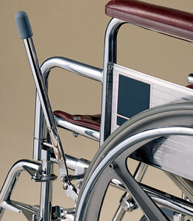 | 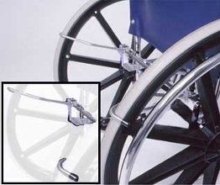 | 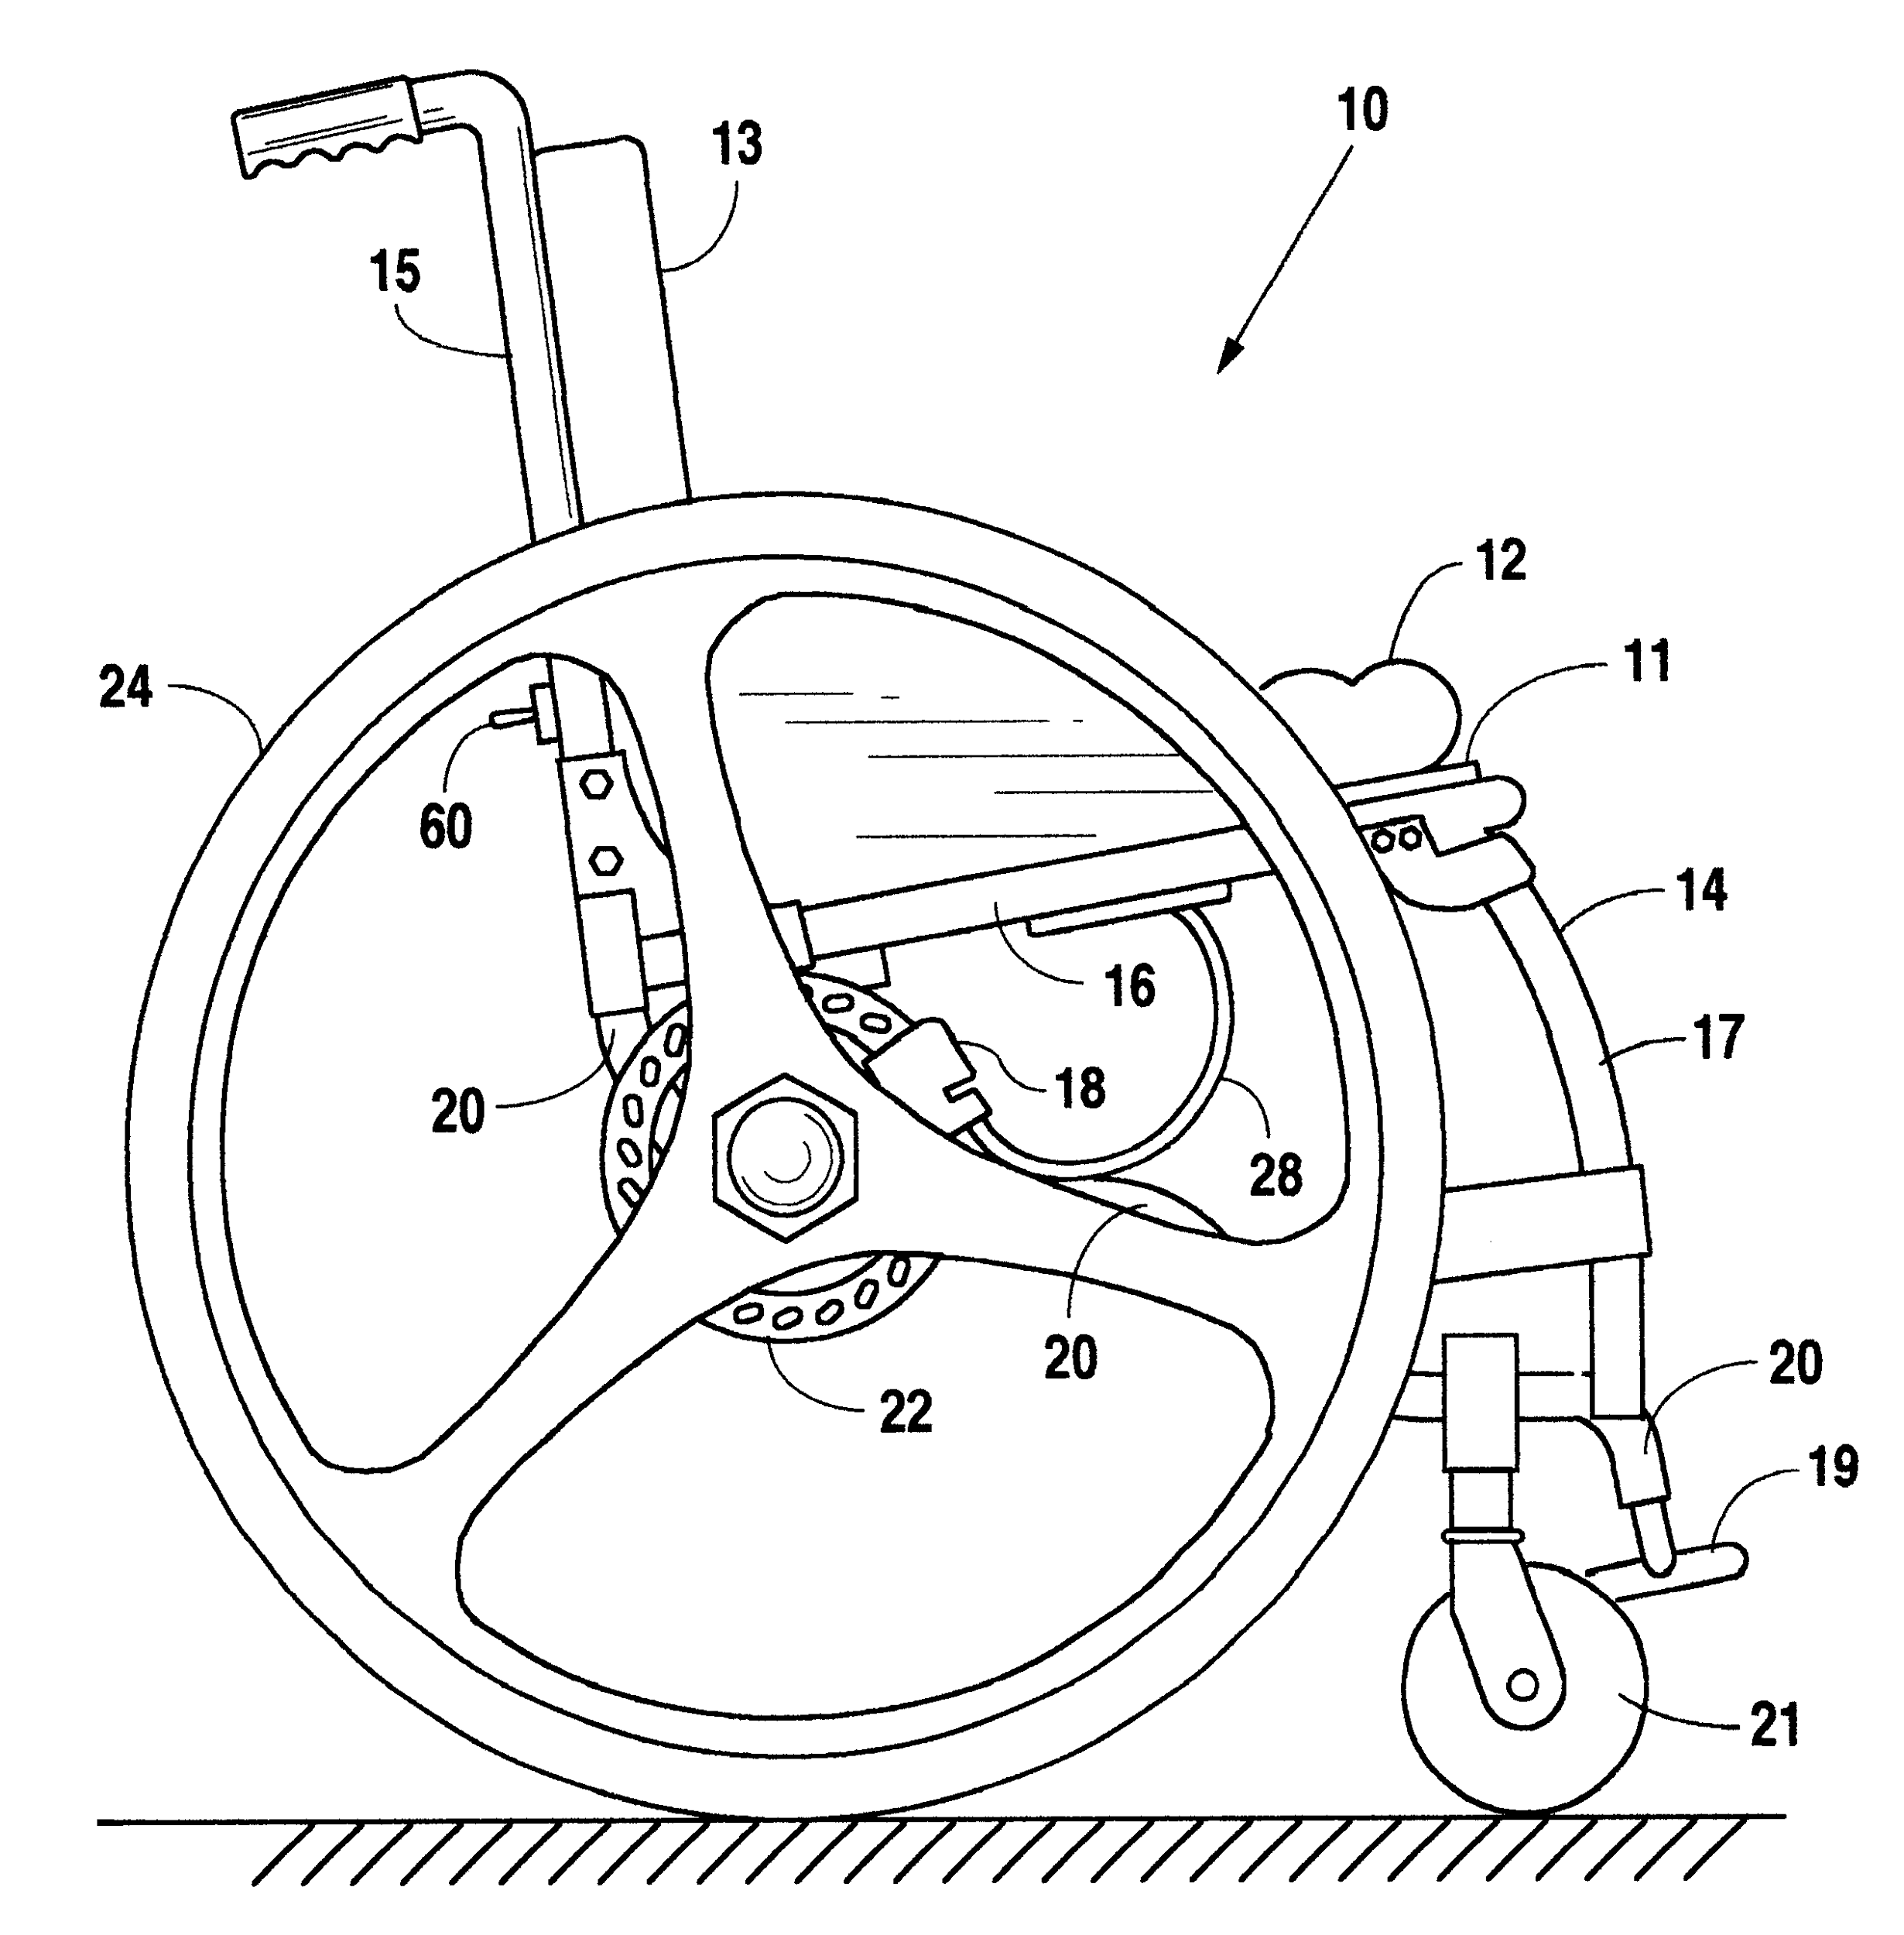 | 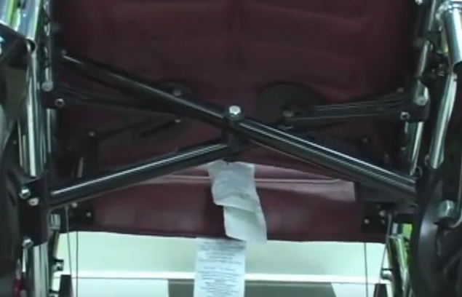
Additional cost | Included in original chair | Varies based on wheelchair | System not in production | $180
Method of operation | Mechanical | Mechanical | Electrical | Mechanical
Braking solution | Pressure on wheel | Pressure on wheel | Disk brake | Pressure on wheel
Trigger | None | Weight of person | Pressure pad | Weight of person
Flexibility of use on different wheelchairs | All | Most models by Invacare, Medline and Drive | None mentioned in specs | Can only be used on 2 different frame sizes
Manual override system | None | Lever-cable on handles | None | Lever
Rank (1-4) | 4 | 2 | 3 | 1
Reference | Wheelchair Tech | http://www.saferwheelchairs.com/ | https://www.google.com/patents/US6471231 | https://www.alzstore.com/automatic-wheelchair-antirollback-device-p/0101.htm
Table A - Benchmarking

Client Meetings
In order to determine the requirements that our system would have to meet, we met with various employees and patients at Saint Vincent’s Hospital (SVH). We first met with Bocar Ndiaye, the technologist at SVH, to get general information on the problem from a first hand perspective which was as follows:
- Usually, falls occur when patients exit from the wheelchair
- Patients often forget to put the manual brakes on before exiting the chair
- Needs to be overridable if when not in use

After being debriefed on the problem Bocar introduced us to Phil, the wheelchair technician at SVH, who showed us previous years designs and told us of the constraints that our product would have to stay within:
- Cannot modify the structural integrity of the wheelchair (welding, drilling, etc.)
- Last years attempts were too fragile and couldn’t stop the chair consistently
- Showed us the different types of wheelchairs our device would need to work with

Next we spoke to a pair of physiotherapists working at SVH to learn what they would like from the system in terms of features and requirements:
- Most falls occur when getting in and out of wheelchairs
- Must be overridable, and alert a nurse when a patient is getting out of their chair

Bocar then introduced us to a wheelchair bound patient that was known to be fall prone:
- Needs to get out of wheelchair around 10-12 times a day
- Requires the nurse for assistance to get in and out of chair .

To more clearly define the problem, the information we gathered from our clients was condensed into the following problem statement:

“There​ ​is​ ​a​ ​need​ ​for​ ​an​ ​automatic​ ​braking​ ​system​ that​ ​can​ ​bring​ ​a​ ​patient's wheelchair​ ​to​ ​a​ ​complete​ ​stop​ ​and​ ​alert​ ​a​ ​nurse​ ​if​ ​a​ ​patient​ ​attempts​ ​to​ ​get​ ​up​ ​alone, reducing​ ​the​ ​chance​ ​of​ ​patient​ ​injuries.”

Design solutions
In order to meet this need, we started the ideation process. What follows is a few select interesting concepts we created to meet this need:
Figure 1 - Peg and Slotted Disk

Peg and Slotted Disk
This braking system would use a peg which actuates linearly to slot into a disk mounted to the hub of the wheel, thus stopping the wheel.
Pros:
Figure 2 - DIsk Brake

- Simple construction
- Hard stop instead of a friction brake
Cons:
- Same as previous groups design
- Potentially inconsistent braking, relies on peg being aligned

Bike disc brakes

A mechanical disc brake engaged by an electronic sensing system will brake the chair. The sensors will be placed on the armrest or under/behind the seat. When the user tries to get up, the disc brake will be activated by bicycle style metal wire forced by a spring.
Pros:
- Reliable brake mechanism
- Can purchase a disc brake
Cons:
- May be hard to manufacture
Design Criteria
Our customer statements were categorized and prioritized into design criteria and metrics as seen in the following tables. The design criteria was referred to multiple times during the design process, as our design had to follow the prioritized criterias. The design criteria was derived from the client statements made at the client meetings. Metrics were created to satisfy the needs of the clients and to supply us with all the measured requirements that the product has to follow.

Priority (1 being highest) | Customer Needs | Design Criteria
1 | Users forget to put the brakes on before exiting the chair. | The system will stop the wheelchair automatically
2 | Gets in and out 10-12 times a day.  Previous designs broke easily. | The system will be reliable and durable device to withstand repeated use
3 | Needs to disable brakes when transporting wheelchair. | A nurse can disable the brakes
4 | Cannot modify the structural integrity of the wheelchair (welding, drilling, etc.). | The system will be non- intrusive to the wheelchair
5 | Should alert a nurse if patients stand up. | Wireless, or audible alert system
Table B - Design Criteria
Metrics
Name | Unit | Target Specs
Price | Dollars ($) | <100
Stopping Time | Seconds (s) | <2-3
Braking force | Newtons (N) | 30 at cable
System Weight | Kilograms (kg) | <7
Product Life | Years (yrs) | >1
Size | Centimeters (cm) | Depends on wheelchair
Ease of use | Difficulty | Easier than a regular wheelchair brake
Table C - Metrics

Final Design Selection
The final design utilized a standard bicycle disk brake triggered by an ultrasonic distance sensor pointing at the patient's back that detects forward motion.
After triggering, an Arduino will activate the Li-po battery powered motor. The motor will then spin a bolt attached to threaded block, thus pulling or releasing the brake cable, actuating the brakes and stopping the movement of the wheelchair.

Applicable Safety Standards and Constraints
During the design process we had to consider the applicable safety standards and constraints for our design. The worldwide standards for wheelchairs are managed by the International Standards Organization (ISO). They also work in collaboration with the Rehabilitation Engineering and Assistive Technology Society of North America (RESNA) to provide the standards for North American countries. These standards include the required dimensions for the wheelchair, static stability, testing methods and multiple other standards. The applicable standards are mentioned in the ISO catalogue ISO/TC 173/SC 1. Mentioned in this catalogue were descriptions on the batteries we were allowed to use, which was a limited amount of 250 V AC, and a nominal output no larger than 36 V. also mentioned were the regulations behind the brakes, we had to create a product with functional brakes that were effective for the wheelchair. Keeping these regulations in mind, we created a design that followed all the appropriate standards therefore pushing the design to market is possible.

Prototype 1: Brake-Force Testing
Our first prototype consisted of analytical formulas and data to test the feasibility of the motor we selected and keep the wheel stationary. We will be using a bike with a similar braking solution to the one we will be using in our design. Before conducting the test, we must first determine the worst case scenario for the force. This is when the force is being applied tangentially at the edge of the wheel when a patient stands up. This will be estimated with an analytical solution.
Figure 3 - Brake Force Test

Testing for braking force:
a) Analytical Solution
Assumptions:
- Worst-case weight: 136 Kg (300 lbs)
- Wheel diameter: 61 cm (24”)
- Wheel is stationary when brake is engaged
- Patients takes 2 seconds to stand up
- Patient's center of mass shifts 0.75m horizontally
The resulting tangential force, F_{t} , is given by:
F_{t} = (136kg) a_{x}
d_{x} =½ a_{x} t² = 0.75 m = ½ a_{x} (2s)² => a = 0.375 m/s²
F_{t} = (136 kg)0.375 m/s² = 51N = 5.204 kg ≃ 12 lbs
Therefore, to continue with the physical testing to determine the required force, we can apply a weight of 5.204 kg (roughly 12 lbs) at a distance of 12” from the hub of a bike wheel, and measure the required force to keep the system stationary
Figure 4 - Minimum Force
b) Physical testing
With our theoretical upper bound on the force that would be exerted at the rim of the wheel, we tested (using a bike with disk breaks) the minimum force required for the brake lever to keep the system stationary.

Using a newton meter at the edge of the brake lever, a force of 8.5 ± 0.5 newtons was recorded, as shown in the diagram below.

Where, F_{a} ,is the force recorded by the newton meter
F_{t} , is the required force to keep the system stationary, and the force our motor will have to apply.
F_{NET} = 0, (F_{a}) (10cm)= (F_{t}) (4 cm) = (8.5 N) (10 cm) ; F_{t} = 21.5 N

Prototype 2: Low Fidelity Model
Our second prototype consisted of a low fidelity model made from cardboard, paper and tape (Figure 5). We structured the paper so that it reflects the composition of the wheelchair. This allowed us to determine the position of where to attach our disk brake and mount it in the right position to the frame of the chair. This prototype was costless and provided us with a good idea of how our final prototype might be constructed. Photos of the chair were obtained before any construction commenced to help us get a better understanding of sizing and placement of the braking system (Figure 6).
Figure 6 - Original Frame
Figure 5 - Second Prototype
Final Prototype
Figure 7 - Steel Spacer
The final design utilized a standard bicycle disk brake triggered by an ultrasonic distance sensor pointing at the patient's back that detects forward motion. Mechanical machining was required to construct a steel spacer between the wheel and the axle, allowing the brake mechanism to fit without obstructing the wheel spokes. Attaching the disk to the spacer required tapping the cylindrical spacer, enabling the disk to be removed easily (Figure 7).

Following the design criteria, the wheelchair must not be modified structurally. Meaning we were not able to directly drill into or weld onto the frame of the chair. At first, zip-ties were used to secure the disk to the wheel. This was causing major problems as the zip-ties were applying too much force onto the disk, making it uneven and not lining up correctly to the brake mechanism. To overcome this problem, we created a sheet metal bracket wrapping around the outside of the wheel to attach securely to the steel spacer instead of the actual disk (Figure 8).
Figure 8 - Bracket
Figure 9 - Motor & Block
After triggering, an Arduino will activate the Li-po battery powered motor. The motor will then spin a bolt attached to threaded block, thus pulling or releasing the brake cable, actuating the brakes and stopping the movement of the wheelchair. By using the bolt and block arrangement, we don’t need any power to hold the brakes closed, only to pull or release the cable, thus saving power in the 1300 mAh battery we selected.

Attaching the brake mechanism to the chair frame required a custom bracket that would support such mechanism without applying too much tension when the brake is engaged. In Figure 10, it is shown how the brake mechanism is securely attached to the frame. By simply unscrewing the axle mount from the chair, the bracket rests tightly against the frame, in addition it is secured to the same mount the axle is installed on.
The system we have created possesses multiple components of mechanical or electronic nature. These components, including the 12V DC gearhead motor, the Li-po battery and the Arduino are placed on a custom shaped sheet metal rack placed beneath the seat out of plain sight (Figure 11). They are then housed in a similar material to increase durability, protect against weather or damage and provides a cleaner aesthetic appeal to the system. In addition to an appealing feature, we added a 3D printed hub cap to cover the sharp edges of the sheet metal bracket as seen in Figure 8. This Hub cap provides protection from the bracket and an aesthetic improvement to that wheel (Figure 12).
Figure 12 - Hub Cap
Figure 10 - Brake Mounting Bracket
Figure 11 - Mechanical and Electronic Mount & Housing

Maybe throw cost after final prototype??

Conclusion
In conclusion, we successfully created a durable braking system that could stop a wheelchair and alert the nurses as a patient attempts to get up. This solution solved all of the issues described in our problem statement and met all the customer needs from our design criteria. We started the project by creating an attainable set of goals from our experience at the client meeting. With information we gathered from Bocar, Phil, and the physiotherapists, we created a prioritized set of design criteria for us to follow during the project. With the design criteria determined and our problem statement made, we determined a set of metrics that could be made to test the success of the device. Our team then all individually created a set of primary designs that all fell within the boundaries set by the design criteria. Using all these designs, we took the best aspects from the groups and combined them to create the best design possible. After the first design was developed we made sure it followed all possible safety standards and that we were not infringing on any patents. The next step was to test our riskiest assumption. This was done through an analytical prototype involving a simple test with a bike disk brake. With the information gathered on that test we made a few changes to the design and proceeded onto testing the next set of issues. The next prototype tested the placement of the brakes and how they would fit into the small gap of the wheelchair. Once the placement was determined we felt confident in the ability of the design to function. For the final prototype we determined that the best method to make a durable product was to make the entire system out of metal. During the build of the physical system the process of writing a program for the detection of a patient needed to be created. The next step to the build was the combination and debugging of both systems. After the fine tuning and debugging of both systems were complete, aesthetic and safety features were added to the prototype to keep the product safe and neat. Although we got the system to work, we were only able to complete one side of the prototype due to cost and time restrictions. Ultimately, the prototype functioned correctly, safely, and solved the problem statement

We learned a few lessons about design projects during this build. For the future we could have planned better for the mounting systems used on the wheelchair in the final prototype there were times where we ran into issues where the original plan failed and we were left to create a new plan during the build. Another issue we encountered was that some components such as the motor shield could have been better researched to prevent issues such as not having enough current. In terms of problems with software, we encountered many bugs when it came to coding in Arduino. This could have been solved by debugging the code ahead of the final installation and double checking all work that is done to ensure setbacks do not happen.

References

Cooper, R. (2006). Wheelchair Standards: It's All About Quality Assurance and Evidence-based Practice. The Journal Of Spinal Cord Medicine, 29(2), 93-94. http://dx.doi.org/10.1080/10790268.2006.11753862
ISO/TC 173/SC 1 - Wheelchairs. (2017). Iso.org. Retrieved 10 November 2017, from https://www.iso.org/committee/53792/x/catalogue/
Wheelchairs and Transportation | Rehabilitation Engineering & Assistive Technology Society of North America. (2017). Resna.org. Retrieved 10 November 2017, from http://www.resna.org/standards/wheelchairs-and-transportation/wheelchairs-and-transportation
Xiang, H., Chany, A., & Smith, G. (2006). Wheelchair related injuries treated in US emergency departments. Injury Prevention, 12(1), 8-11. http://dx.doi.org/10.1136/ip.2005.010033

Main Body: Structure this well (e.g. using the design steps or process used, like we did in the course). Most of your project deliverables could appear in your final report. Make sure that you include:
  - Related work, research and benchmarking information
  - A detailed description of your user and his/her/their requirements, explaining the relative priorities. It should be clear that you have empathized with the user and also performed a significant amount of research and critical analysis here.
  - A problem statement and all or any required justification for that problem statement ✓
  - A list of some of the interesting design solutions that you generated ✓
  - The design criteria that you used (and an explanation of the metrics and design specifications that you used) to select your chosen approach ✓
  - A clear and detailed description of your design solution and its features
  - Knowledge of applicable regulations and standards or other constraints on your design solution ✓
  - Your prototyping strategy and testing objectives and results

Make sure that you show the progression from your initial problem, to your final solution. Spend most of your time in your report on the main ‘success’ path, rather than providing too much detail on the things that didn’t work. However, critical analysis is required, so make sure that you understand why things did or didn’t work or what you would do differently at differentstages in the design process (i.e., if you are aware that certain decisions were suboptimal). Figures and tables are important and these should be labelled and indexed in a List of Figures and a List of Tables, respectively. Microsoft Word has features to generate tables of contents, figures and tables, automatically. Citations should be provided where necessary and be properly linked to a bibliography (again Microsoft Word has a feature for this, but standalone systems such as Zotero or Mendeley work well too). Meeting minutes and any additional technical drawings or calculations should be included in the appendix.

Content (70%)
- Design Process summarized adequately (sufficient detail and adequate coverage) and justifications provided, as required
- Correct and concise summary and prioritization of all issues and constraints • Project plan and execution as well as demonstrated effective handling of allissues.
- General level of comprehensiveness and adequate level of detail of the description of the resulting design. This is the most significant documentation of your term’s project work that you will leave behind.

Organization (20%)
- Overall message or summary presented at the start (clearintroduction)
- Conclusions extracted and presented at the end (clear conclusions)
- Report has adequate structure (middle bit!)
- Report is clear, engaging and interesting
- Priorities in the design (based on user feedback) are presented clearly Professionalism (10%) • Appearance and structure of the document
- General impression of care and adequate attention to detail

