Detailed Design
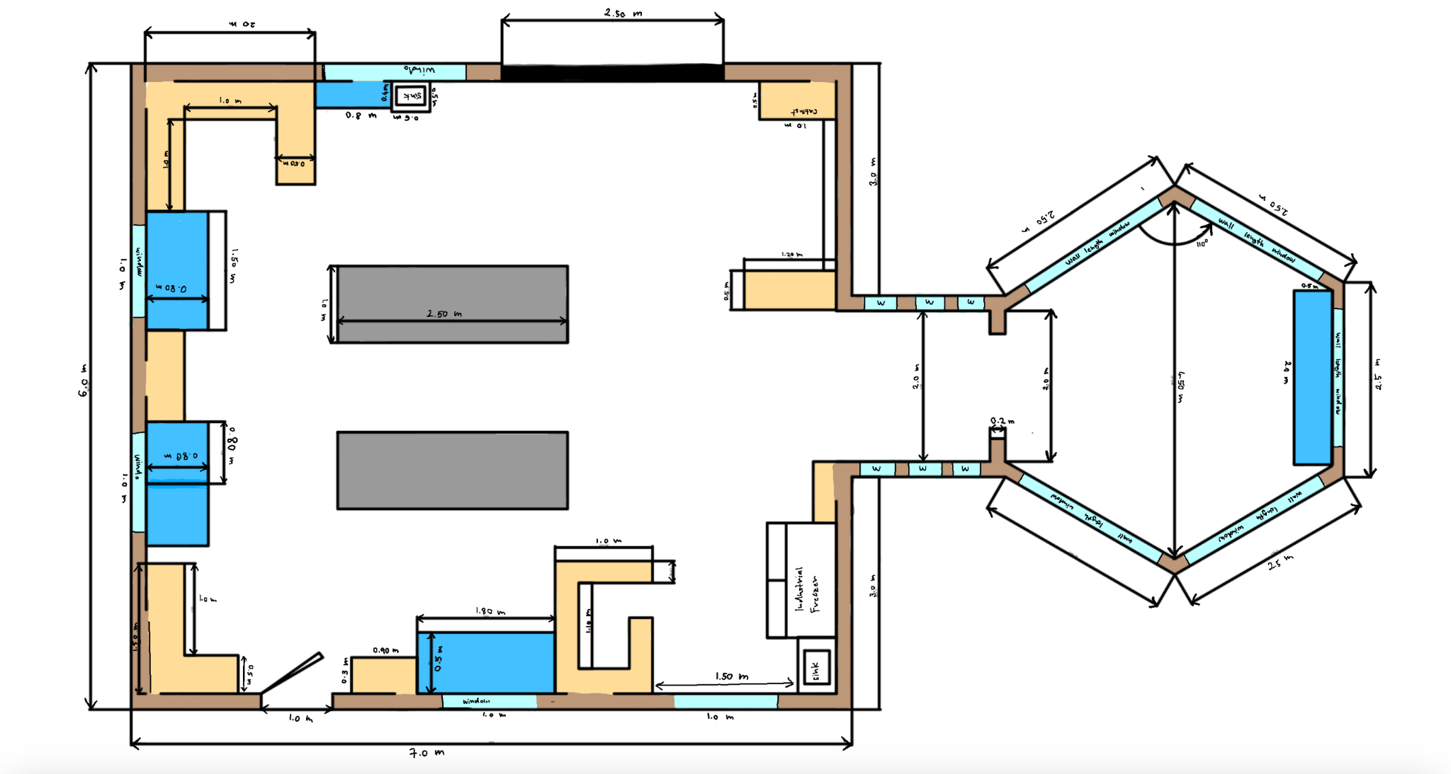

List of equipment for prototype:
- Cardboard
- Glue
- Tape
- MDF wood
- Popsicle sticks
- Markers
- Plastic
- Metal wire
- Paint
- Autocad
- Onshape
- Inkscape

Project Risks and Contingency Plans:

Hazards for the building:
Slipping Hazard
Chosen or desired materials may be slippery, especially during wet seasons. Slipping hazards may cause harm to users, and could result in serious injury. To prevent this, the group has chosen a suitable material for the flooring in a lab setting that is a non-slip surface (i.e. has a COF rating of over 0.5). In addition to this, users should be aware that slipping hazards are not completely eliminated, and should try to wear non-slip shoes whenever possible.

Heat Loss in Greenhouse during Cold Winters
During colder seasons, the attached greenhouse runs the risk of large fluctuations in temperature. This may cause harm to the plants/substances stored in the greenhouse. To prevent this, the group has considered a few solutions:
- Bundles of bubble wrap to insulate the walls of the greenhouse is an inexpensive
solution.
- Curtains to cover the screens of the greenhouse will ensure heat retained throughout the day and is saved for colder nights.
- If this is not sufficient and conditions seem dire, then the last resort is to rely on an adjustable electric heater.
The client may choose any one of these solutions, or a combination of these solutions to prevent heat loss during cold seasons, and potential damage to plants stored in the greenhouse.

Health hazards:
As requested by the client, the plant processing station was designed in such a way that it can be cleaned easily in a short amount of time. Although this is the case, users should be aware that the cleaning method does not guarantee a 100% clean environment for work. The group has been made aware that the station may be used for the processing of animals in addition to plants, in which case the station will require specific cleaning methods in order to keep health risks at a low.

Hazards for the prototype:
Material constraints
The main constraints in terms of materials for this project are as follows:
- desired materials for the prototypes may be unavailable
- desired materials may be difficult to obtain
- materials chosen may not be sufficient/effective later in the prototyping
To avoid these constraints, the group has carefully chosen materials which are easy to obtain, have a low cost, and are fairly durable. Additionally, the materials chosen are flexible and allow easy changes in the event a change of material is necessary.
Time constraints
Time constraints for this project add the risk of deadlines. The main risk is that the project (final prototype) will not be finished by the deadline. To avoid this, the group has planned the progress of the project, and created a schedule for when tasks need to be completed for each main project milestone. In the event this initial plan fails, the project has been planned in such a way that if the final prototype is not finished completely by the deadline, the group will still have a fully functioning 3D prototype online, and a partially functioning physical prototype.

Client restraints
These restraints involve the client’s evaluation of the project as it moves along. This can involve client feedback, limited information, client wants, etc. which have an influence on the desired final prototype of the project. For example, the group has very limited information about the plant processing station and how the client would like it to be. To avoid these situations, the group has, and will continue, to actively seek the client’s feedback on the project throughout the given timeline to make wants/needs more clear. The group will also continue to use our individual and combined assumptions based on empathising with the client to fill any ‘holes’ in our information.

Design specifications and target values:
ID | Design specification | Value | Verification method
1 | Room capacity | >10 people | Online simulation, benchmarking
2 | Storage capacity | As much as possible | Client feedback
3 | Natural light exposure | As much as possible | Client feedback

Prototyping test plan

Testing purpose:
The purpose of this test plan is to validate the functionality and performance of the laboratory prototype to ensure it meets the specified requirements and standards, as a guideline for follow-up work after completing the prototype.

Testing approach:
The test will be separated into multiple different aspects.
1 Individual equipment function test
2 Temperature measurement test
3 Workflow test
4 Safety measurement test

Test tools:
Auto CAD floor plan graph, a physical prototype, real lab equipment, computer simulation tool,
Thermometer, calculator, Ontario’s Laboratory Safety Regulation.

Test procedures:
For the individual equipment function test:
Verify and detect the facilities in the laboratory to ensure that its functions can be used normally and meet the needs of Clients.

For the temperature measurement test:
Measure the temperature of the room, greenhouse, freezer and outdoor temperature separately. Adjust the temperature control panels of the greenhouse and freezer respectively to ensure normal function. Conduct three sets of tests in the morning, midday, and evening to ensure that the temperature changes do not affect the temperature in the laboratory.

T/K | ROOM TEMPERATURE | GREENHOUSE TEMPERATURE | FREEZER TEMPERATURE | OUTDOOR TEMPERATURE
MORNING
MIDDAY
EVENING

For Workflow test:
We will simulate the placement of equipment according to the Auto CAD floor plan, and our team members will simulate real experimenters to conduct tests to ensure the continuity of the workflow. If some equipment arrangement hinders the work efficiency, we will rearrange the placement of that equipment to ensure the continuity of the work chain.

For Safety measurement test:
Testing all safety equipment (emergency showers, eye wash stations, fire extinguishers) for proper functionality. And make sure all arrangements in the laboratory meet the requirements of Ontario’s Laboratory Safety Regulation.

Additional tests:
The above tests are all important, however are somewhat impractical for the group as we do not have the time, nor resources to carry out all tests. As such, project factors and design specifications will also be tested based on client feedback. The detailed design and future prototypes will be evaluated by the client, and the feedback received will be used to determine whether or not the design specifications were met, or if the project needs to be modified to better meet the target specifications.

Some factors of the project (ex. room capacity) may be tested using online resources such as benchmarking, online simulations, and also personal experience and knowledge.

