Project Deliverable E
Design Constraints and Prototype 2

GNG2101–INTRODUCTION TO PRODUCT DEVELOPMENT & MANAGEMENT FOR ENGINEERS & COMPUTER SCIENTISTS

Presented to:
Professor: Dr. Emmanuel Bouendeu
TA: Mohamed Bougader
PM: Cecilia Lou

Group #Z15:
Tristan Rodgers - 8680457
Usman Khan - 300185666
Ismail Mostafa - 300127711
Yahya Mostafa - 300127715

University of Ottawa
Submitted: June 25, 2023

Table of Contents
Introduction 3
E.1 Design Constraints 3
E.1.A Two Design Constraints: 3
E.1.B Design Changes 4
E.1.C Effectiveness of Changes 4
E.1.D Design Update 5
E.2 Prototype 2 5
E.2.A New Client Feedback Summary 5
E.2.B Critical Assumptions 6
E.2.C Second Set of Prototypes 6
E.2.D Sketches, Diagrams and Pictures 7
E.3 Wrike Snapshot 9
Conclusion 10

Introduction
In this deliverable, we define two non-functional design constraints which are important in the development of our prototype. For each design constraint, we elaborate on which design changes must be made to satisfy the constraints. A modified design will be presented, as well as sketches, diagrams and pictures. A summary of our third client meeting will also be presented, as well as the client's feedback on our current design. Assumptions about the product will be stated and a second set of prototypes will be created in order to test the critical product assumptions.
- Design Constraints: A design constraint is a range of restrictions in the design process which can be imposed by internal or external factors. Constraints can be environmental, legal, ethical, or related to factors such as health and safety, time, resources, materials etc. In the case of our product, the two constraints we identified are sustainability and resources.
- Client Feedback: During our third client meeting, we received feedback on our latest prototype. The client...
- Assumptions: Testing risky and critical assumptions is an imperative step in the design process. It allows us to ensure that our product will be well received by the target market. If assumptions are not listed and tested, then there is no way of ensuring that the product will succeed on the market. In this deliverable, we will list the assumptions, determine the success criterion, and find the cheapest and easiest way to test these assumptions.
- Prototype and testing: In this deliverable, we will elaborate on the second set of prototypes that we created, following our client meeting and the feedback we received, as well as the constraints and assumptions that we have explored and tested.

E.1 Design Constraints

E.1.A Two Design Constraints:
Constraint 1: Sustainability
Sustainability refers to a product's capacity to function for a long period of time. Measuring and implementing sustainability can be challenging, since standards vary, and it is hard to measure the exact sustainability of a product. In our case, we have listed sustainability as a constraint since our product relies on many components with varying lifespans, over which we have no control. For example, we require the use of solenoids, and a voice activated micro-computer, which we will obtain from companies that we do not have much information about, putting our product at risk of malfunctioning.
Constraint 2: Resources
Resources are a critical component to a successful product. In project management, the three most important constraints comprise what is known as the iron triangle: time, cost and scope. In the case of this project, we are mostly constrained by time and cost, as we were able to define the scope of the project in the previous deliverables. We are restricted to a period of a little more than two months, which limits our ability to create our own parts. This forces us to rely on components created by other companies which can have a negative impact on sustainability, as mentioned above. Also, the cost of our materials must not exceed our budget, which restricts on certain factors such as size and weight for our final product. If, for example, the budget was unlimited, we would have access to more materials and components to optimize our product and make it as seamless as possible in the environment.

E.1.B Design Changes
Design changes for constraint 1:
Our design heavily relies on materials from third parties. Although developing an alternative to the use of a third-party solenoid, or voice activated micro-controller, would increase the lifespan of our remote, it is not realistic during the span of the semester. For this reason, instead of replacing these parts, we will modify the design for our remote to ensure that each component is easily removable and replaceable, so that upon failure the component can rapidly be replaced instead of having to replace the entire remote casing.
Design changes for constraint 2:
In product development, companies have strived to make their products smaller and lighter to accommodate consumers. Phones, computers, and many other devices have been downsized, however, this does come at an increase cost in materials, time and resources. In the case of our project, the design has been conceived to satisfy many conditions and based on set metrics. Although initially, the weight and size of the remote casing was listed as a metric with a target specification, we have decided to lower the priority index of these two metrics to save money and time on trying to make the remote casing smaller and lighter. The design is therefore modified to sit on the floor next to the chair.

E.1.C Effectiveness of Changes
Design change 1: By modifying the design to have easily replaceable parts, we are increasing the sustainability of the product since instead of replacing the entire casing upon failure of a single part, we can easily replace the part itself. This way, we avoid having to dispose of the entire assembly when a single part fails. By doing so, less material will be wasted, therefore increasing the environmental sustainability of the product.
Design change 2: By modifying the design to have the casing rest on the ground, we are avoiding the need to create a compact, lightweight product. Since it will sit on the floor, it doesn’t require lightweight or small materials, which would increase the financial and time cost of the project. This will also allow us to use recycled materials to create the polymer box for the casing, which will not only reduce cost and satisfy our second constraint, but also improve the environmental footprint of our product by re-using materials.

E.1.D Design Update
Rough Detailed Design:
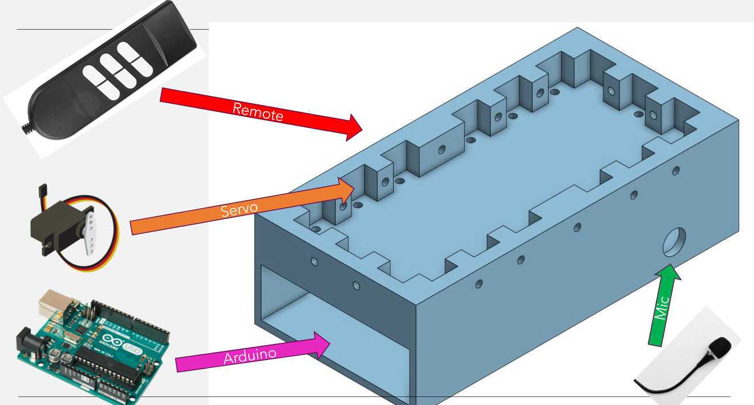
Sources: https://tinyurl.com/ChairRemote ; https://tinyurl.com/ServoMotorAmazon ; https://tinyurl.com/ArduinoUnoAmazon

E.2 Prototype 2
E.2.A New Client Feedback Summary
- Having adjustable slots in the remote casing to place the servos could diversify the use for the remote casing. If the servos can be moved around without re-designing and manufacturing the casing, then the device could be used for different remote configurations to accommodate users in adaptable chairs, as well as hospital beds.
- Keeping the commands for the remote simple is key. We do not want a long extensive list of commands that the client must remember. This could be confusing for the client and lead to mistakes in commanding the remote, which could be frustrating for the client.
- The current design has been well received by the client. The design is robust and does not require many drastic changes to accommodate the client.
- If the microphone is accessible and can hear the commands, it doesn’t matter where the remote is placed.
- The remote must be operable normally, something that we have already taken into account.
- The voice commands must be tested and listed prior to the presentation of the device. This will ensure the compatibility of the remote with multiple voices.
- A safety feature must be implemented into either the remote or the code for the button pushers. This was the chair will not reach its full extent accidentally forcing the client into uncomfortable positions or accidentally ejecting them from the chair.
- More thought and problem solving must be done to optimize the list of commands and make them as simple and efficient as possible.

E.2.B Critical Assumptions
- We have assumed that the remote does not need to be lightweight or ergonomic since it will be placed on the floor. If the microphone is accessible and able to listen to the command from the user, it doesn’t matter where the remote is placed.
- We have also assumed that the client is physically capable of commanding the remote with the use of their voice. In the instance where they are not, then we have assumed they have access to an iPad or similar device which they can control optically and can express voice commands based on a list that they are able to browse and command.
- We have assumed that the remote must not be modified, to ensure that it can be used normally by an able-bodied user or replaced through the warranty if necessary.

E.2.C Second Set of Prototypes
The purpose of this prototype is to create a customized 3D printed casing that incorporates button pushers (servo motors). These button pushers will allow users to remotely activate the buttons on a remote control without the need for manual interaction. This prototype aims to enhance convenience, accessibility, and ease of use for individuals who may have mobility challenges or prefer a hands-free experience.
Functions:
- 3D Printed Casing Design
- The prototype involves designing a 3D model of a custom casing using Computer-Aided Design (CAD) software.
- The casing will be tailored specifically to fit the dimensions and shape of the target remote control device.
- The design will incorporate openings or compartments for accommodating the button pushers.
- Button Pushers:
- The button pushers are mechanical mechanisms or levers integrated into the 3D printed casing.
- The purpose of these pushers is to replicate the action of pressing buttons on the remote control.
- They are strategically positioned to align with the corresponding buttons on the remote control.

- Remote Control Integration:
- The prototype will be designed to securely hold and attach the target remote control within the 3D printed casing.
- The remote control will be placed in a fixed position, ensuring that the button pushers align accurately with the buttons on the remote.

E.2.D Sketches, Diagrams and Pictures
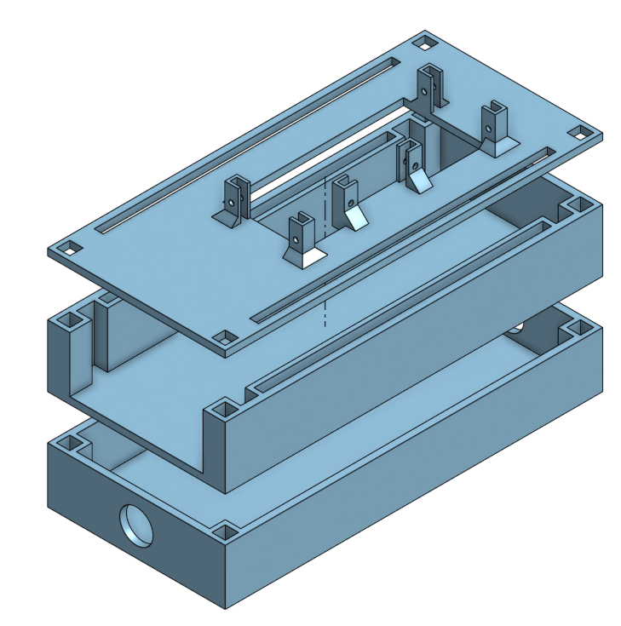
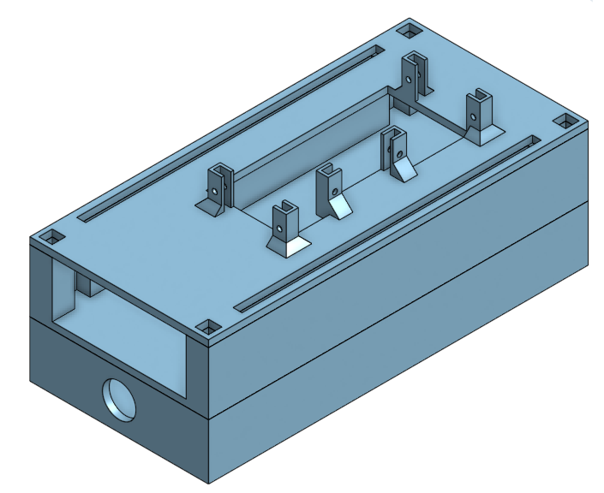
E.2.E Prototype Testing
Case and Servo Motors testing:
#​ | Test ​ | Purpose​ | Verified Product Assumption​ | Expected Result​ | Actual Result​
1​ | Position Test​ | Verify if the servo accurately reaches and maintains the desired positions.​ | Accuracy​ | Positioned over 2 buttons​ | Will be tested on July 1st to 2nd
2​ | Button Push/Resistance Test​ | Confirm if the servo successfully pushes the button / can overcome any resistance from the button mechanism.​ | Accuracy​ | Enough strength to push​ | Success​
3​ | Durability Test​ | Assess the servo motor's durability and longevity in repeatedly pushing the button.​ | Accuracy​ | Many years of pushes​ | Success​
4​ | Speed/Response Test​ | Evaluate the servo motor's speed and responsiveness in pushing the button.​ | Connectivity​ | Less than 1 second​ | Will be tested on July 1st to 2nd ​

Voice Recognition Module testing:
#​ | Test ​ | Purpose​ | Verified Product Assumption​ | Expected Result​ | Actual Result​
1​ | Speech Recognition Test​ | Validate the basic functionality of speech recognition.​ | Accuracy of speech recognition​ | Functional​ | Will be tested on July 1st to 2nd ​
2​ | Noise Tolerance Test​ | Evaluate the system's ability to filter out background noise.​ | Accuracy of speech recognition​ | Range of 2m​ | Will be tested on July 1st to 2nd ​
3​ | Speaker Independence Test​ | Determine if the voice recognition works for different speakers.​ | User accessibility​ | Should work for any speaker​ | Will be tested on July 1st to 2nd ​
4​ | Performance and Response Time Test​ | Measure the system's response time and overall performance.​ | User accessibility and Connectivity ​ | Less than 1 second​ | Will be tested on July 1st to 2nd ​
5​ | Longevity Test​ | Assess the program's stability and accuracy over an extended period.​ | Connectivity​ | Indefinitely​ | Will be tested on July 1st to 2nd ​

E.3 Wrike Snapshot
https://www.wrike.com/frontend/ganttchart/index.html?snapshotId=uu42431WtmLndWxGQnGHAWZhI4TgwGOY%7CIE2DSNZVHA2DELSTGIYA

Conclusion
In conclusion, the 3D printed remote control casing with button pushers prototype offers an innovative solution for enhancing convenience and accessibility. By incorporating custom design and mechanical mechanisms, this prototype enables users to remotely activate the buttons on a remote control, providing a hands-free and user-friendly experience. However, it is essential to consider design constraints when implementing this prototype. Some of the design constraints to keep in mind include compatibility, ergonomics, material selection, assembly, integration, and more. By acknowledging these design constraints, the prototype can be developed to meet the specific needs of users while ensuring compatibility, functionality, and user satisfaction.

