GNG1103 – Engineering Design
Deliverable H: Prototype III & Customer Feedback
November 26, 2023
Group 15
Objective:
Develop your third prototype. Get customer feedback on your prototype.
Instructions:
- Prototype Objective Questions
Develop a prototype which will be used to achieve the objectives your team has set out in the plan created in the last deliverable (i.e. you need to answer the “why”, “what” and “when” of prototyping).

What: A visual prototype of the unity environment we wish to place our users in. It showcases the surroundings and perspective of the user. As we approach design day, prototype 3 is likely the final prototype to be done, given time will as completely broad as can be before design day for our final concept to be detailed in the simulation space.

When: We will conduct testing throughout the design process to get a steady stream of feedback from a diverse range of voices we deem important. Prototype 3 as this is being typed is on-going, Saturday, November 25, was a day for troubleshooting inclusion of our reporting media, expanding the scope or span of our actual city to bring it closer to being analytical and comprehensive.

Why: We want to develop the best possible environment that is the most conducive to inspiring the user to demand change and advocate for a ban. This means we want them to feel concerned by what they see and how they feel; therefore, we must test to see if our ideas have the desired outcomes.

- Prototyping Test Plan of all deliverables: Prototype 3 Image
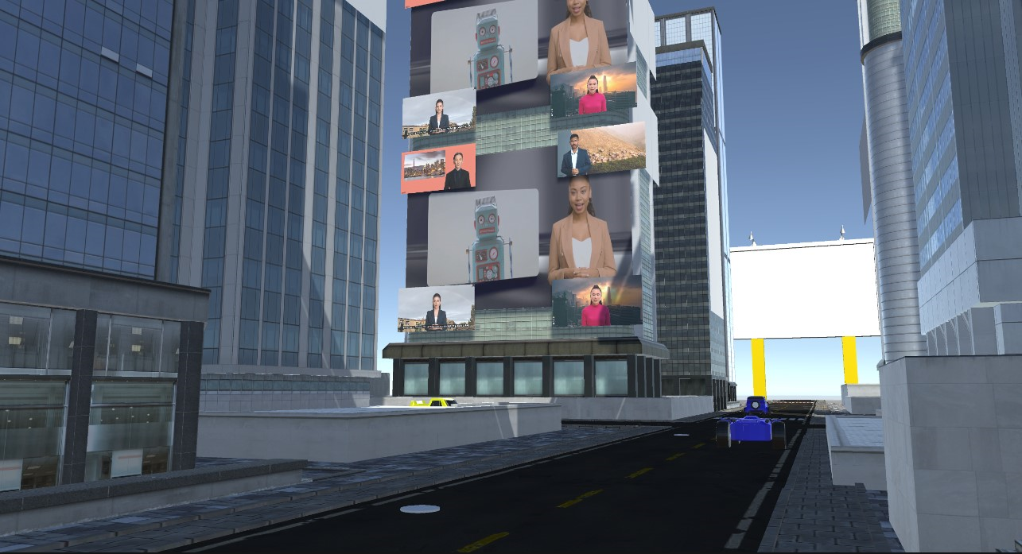
- Prototype 1
- Objectives
- Center times square city space developed
- Chosen assets in central space of city
- Inclusion of character in times square
- Reflection of final concept design
- Prototype 2
- Objectives
- Test interaction and other software based integrations
- Analyzing usability and functionality of critical subsystems
- Stopping criterion
- Video integration
- Interactions with intractable object function as defined
- Environment space established, including movement functionality
- Prototype 3
- Objectives
- Graphical fidelity work
- Test Performance
- Optimization
- Test the package on actual users to get feedback
- Stopping criterion - The whole team is satisfied with the work done
- The original vision is achieved to the extent of our original expectations
- Confirm comprehensive design so to be similar to final product
- Fully functional
- Greatest degree of fidelity
- Media scenes insertion
Analysis:
Constraints
1. | Noncomplex | = | Yes | N/A | Test – Qualitative Feeback
2. | Budget | < | 50 | CAD | Analysis
3. | Time For Simulation | < | 1 | Minute | Test (Measure Duration)
4. | VR Hardware | = | Yes | N/A | Test Compatibility

Non-Functional Requirements
Performance - Response time | < | 100 | Milliseconds | Test – Simulate | 1
Usability – Intuitive UI | = | Yes | N/A | Adhere to WCAG guidelines | 2
Hardware Compatibility | = | Yes | N/A | Test | 3

- Gather Feedback
Prototype 1:
Identified feedback providers: Eldest sister, youngest sister, young brother Commentary on brainstorming/ prototype/ progress:
● Deliverables are clear and precise
● Understood where the project is going and the approach for being convincing
● Called the design for the city accurate for the message we are giving
● Described the initial prototype as well done
● Could tell what all of us had in mind in our concepts just from the sketches
● Gave their thumbs up to proceed our course of action for this function
● Agreed automated robots capable of violence can be a threat to society in the future
● Identified the important aspects of the project to advocate for the ban The idea of banning autonomous killer robots is very creative, as they would be a threat to human society in the future.
The design of the robots and the city outline is accurate and well done. I understand where you are going with this project and your approach. The deliverable is clear and precise and thumbs up to proceed. – Verbatim
Prototype 2/Prototype 3:
- 10 seconds is an opportune total of time to wait before the screens turn on
- Test the video editor for all inclusion of video
- Brainstorm on what means will be used for the audio in our reporting for the screens
- Guage the expansion our city will have, what means for characters and movement
- Gather feedback before the vr application of our simulation is demonstrated officially
- Troubleshoot the sequence of our reporting in tandem to the audio when time
- Be mindful of the time of the broadcasting
- Have a timely message at the end of the simulation

- Update BOM:
There are no updates to our Bill of Materials from any of table, except the addition of a research style poster for Design Day of an estimated $40. Though as learnt in the lab, our team will be using a poster from the lab, rather than purchasing one to use.
- Tests are completed without further updates
- Test are analyzed without further updates
- BOM is updated
- Detailed Design to be updated (2nd final concept)
- No updates to target specifications N/A
Task Plan Updated: https://trello.com/b/R5QTrMG9/project-timeline
