GNG 2102 - A03

Inclusive Bike - Group 3

Deliverable G

University of Ottawa
Professor: Rubina Lakhani
November 20th, 2022

Josh Larocque 300239349
Kobe Belanger 300236085
Zhisheng Peng 300194928
Haonan Lin 300204423

Introduction 2
G.1 Business model 2
Business Model 2
G.2 Economics report 3
Variable Costs 3
Income Statement 3
Break-even Point 4
Cash Flow Diagram 5
Assumptions 5
Conclusion 5
Wrike Snapshot 5

Introduction
In this deliverable we will be making our detailed business model stating what we intend to sell to whom, what and how. We will lay out our bottom line business model along with our core assumption made. In the second part we will do some calculations on how much money we can make over a three year period. We will list our variable costs, complete an income statement and find the break even point.

G.1 Business model

Business Model
Our business would be the most successful under a “manufacturer” business model. This model consists of a manufacturer constructing products and then selling them to dealerships or retail stores, as well as selling directly to the public. We feel this would be the most advantageous because it would give our product a much greater reach. Also, it would mean we can sell the product for the most profit. The main way that we will generate earnings is through the sale of the main product, the wheelchair platform bike attachment. Once the product is proven to be successful, we would make products of the same type, but with different categories such as a premium version, an offload version, an electric version, etc. Though, once the company is established, it would be in our best interest to invest in other similar products focused on accessibility, but not only limited to wheelchair users. This brings us to our customers. We expect our main customers to be wheelchair users or other mobility-limited people. Another possible customer would be physical rehabilitation hospitals as well as assisted living communities. Because our product has a very limited number of potential customers, it is important that we build a good reputation for our company as well as diversify the product's uses to cover as many people as possible. Part of building a reputation could be by actively being involved with people with disabilities and potentially donating some of the sales profits. To ensure we have the most desirable product on the market, we will aim to have our product at a much more reasonable price than some of the products already on the market, as well as offer cleverly designed features ensuring the easiest and safest utilization of the device. In terms of our environmental impact, our product promotes the use of outdoor activity and transportation with zero emissions (i.e. cycling). Also, because this attachment is universal for virtually any bike, it promotes reusing bikes you already own instead of buying a whole new one. In terms of the carbon footprint of the business, shipping bikes in large orders to retailers and distributors cut down on emissions. We will also make it our priority to use ethically sourced materials as well as minimize our energy consumption.

G.2 Economics report

Variable Costs
Cost | Amount
Raw material cost per unit | $157.15
Development team salaries | $850,000
Manufacturing team salaries | $650,000
Building maintenance and upkeep | $85,000

Income Statement
Revenue/Income (3 years) | Amount
Revenue per unit | $222.15
Revenue per units sold (123,000/3 years) | $27,324,450
Total Revenue | $27,324,450
Goods sold expenses | Amount
Cost per unit | $157.15
Cost per units sold (123,000/3 years) | $19,329,450
Total expenses for goods sold | $19,329,450
Operating expenses (3 years) | Amount
Total development team salaries | $2,550,000
Total manufacturing team salaries | $1,950,000
Total building maintenance and upkeep | $255,000
Total operating expenses | $4,755,000
Gross profit (3 years) | $7,995,000
Operating income (3 years) | $3,240,000

Break-even Point
Period | Cash Flow Out | Units Sold | Net Present Value
Year 1 | 1,585,000+157.15 per unit | 25,000 | 5,513,750 out  5,5553,750 in
Year 2 | 1,585,000+157.15 per unit | 35,000 | 7,085,250 out  7,775,250 in
Year 3 | 1,585,000+157.15 per unit | 63,000 | 11,485,450 out  13,995,450 in
According to the chart it will break even by the end of the first year. If we sell 0 to 24,385 units we will not break-even. Once we sell more than 24,386 units we will gain money.
profit/loss per year=65x-1585000 x=units sold
108,416 units need to be sold to break even using the basic calculation.

Cash Flow Diagram
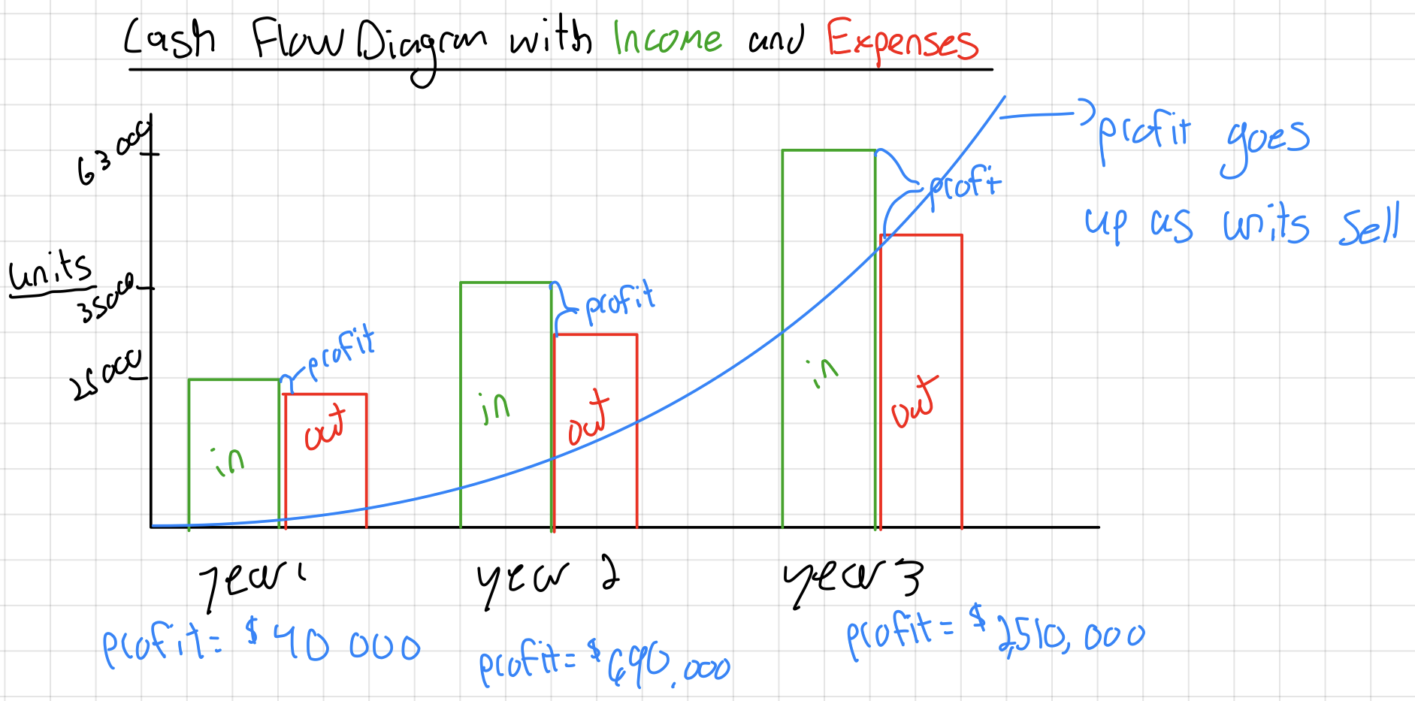

Assumptions
The estimated cost per unit is based on the cost per unit derived from our BoM (bill of materials). The development team salaries are based on an average salary of a team of engineers in Canada, and the manufacturing team salaries are based on overseas manufacturing labour costs. The revenue per unit was determined from a profit of $65/unit, as to offset operating costs. Assuming 123,000 units are sold over the 3 years. Assuming we will sell more units each year over the years

Conclusion
For this deliverable we made important decisions such as a business model which we can stand by. It states our type of business model, the triple bottom line model answering the how, what, and who. It also describes the core assumptions made. In the second part of the deliverable, the economics part we listed the variable costs of our business, developed a three-year income statement and we also determined the break-even point of our business. We also stated all the assumptions we made throughout this report.

Wrike Snapshot
https://www.wrike.com/frontend/ganttchart/index.html?snapshotId=oUP6moX8Nz50OHUzpKXiJGsMUIPZmkP3%7CIE2DSNZVHA2DELSTGIYA

Its not showing the name even throught I checked it to.

