GNG 2102 - A03

Inclusive Bike - Group 3

Deliverable F

University of Ottawa
Professor: Rubina Lakhani
November 6th, 2022

Josh Larocque 300239349
Numan Ozturk 300272549
Kobe Belanger 300236085
Zhisheng Peng 300194928
Haonan Lin 300204423

Introduction 2
Summary of Client Feedback 2
Client Meeting 2 Notes 2
Critical Product Assumption 3
Second Prototype 3
Latest Prototype and Document for Prototype 3
Testing, analyzing and evaluation 4
Conclusion 4
Wrike Snapshot 5

Introduction
In this project deliverable, we continue to work on the second prototype after gaining feedback from our clients during the client feedback meeting on Thursday. We learnt critical information to continue our development and testing for our prototype. We plan to get bikes this week to continue making our physical prototype.

Summary of Client Feedback
During the 3rd client meeting, we showed the clients our 3D CAD model so they could see what we are building. We talked about the important features of our design and how it would accommodate their wheelchairs. We learned that their wheelchairs can lock the wheels, which is helpful while on the platform and in motion. The clients liked our way of keeping the wheelchair still on the ramp. They approved our design as we met all their requirements.

Client Meeting 2 Notes
- Feel safe with our updated design
- Approved of using four hooks to hold their wheelchair down to the plate form
- Showed us how the wheelchair wheels can lock to prevent movement
- Liked the idea of a textured surface to eliminate wheelchair slippage
- Approved our new design prototype

Critical Product Assumption
The construction and finalization of our product prototype brings forward many challenges, but the main one that prevails is the actual physical construction of the prototype. When it came time to conceptualize and design our prototype, we understood what needed to be done and how we would do it. Still, now that it's time to start the final fabrication of our prototype, it is becoming more challenging. The first thing we face is time. We need to find a time and place that works for all of us to start building the product. Another factor is the tools and materials. While we have a general understanding of what is available to us, there may come a time when we meet a roadblock that only allows us to achieve the results we want. The last part of the construction that we face is starting. It is hard to know where to start on a project such as this, but the consensus is to start with the platform part of the frame and build on that. The assumption that we will have a completed prototype by design day rests on our ability to organize ourselves and start working.

Second Prototype

Latest Prototype and Document for Prototype
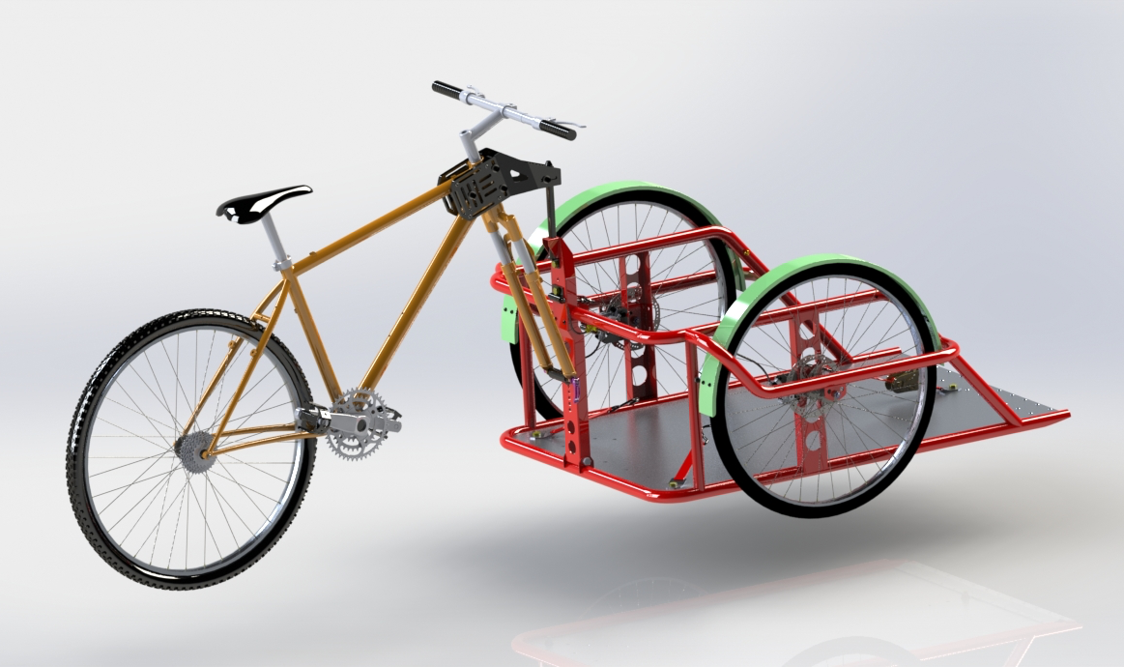

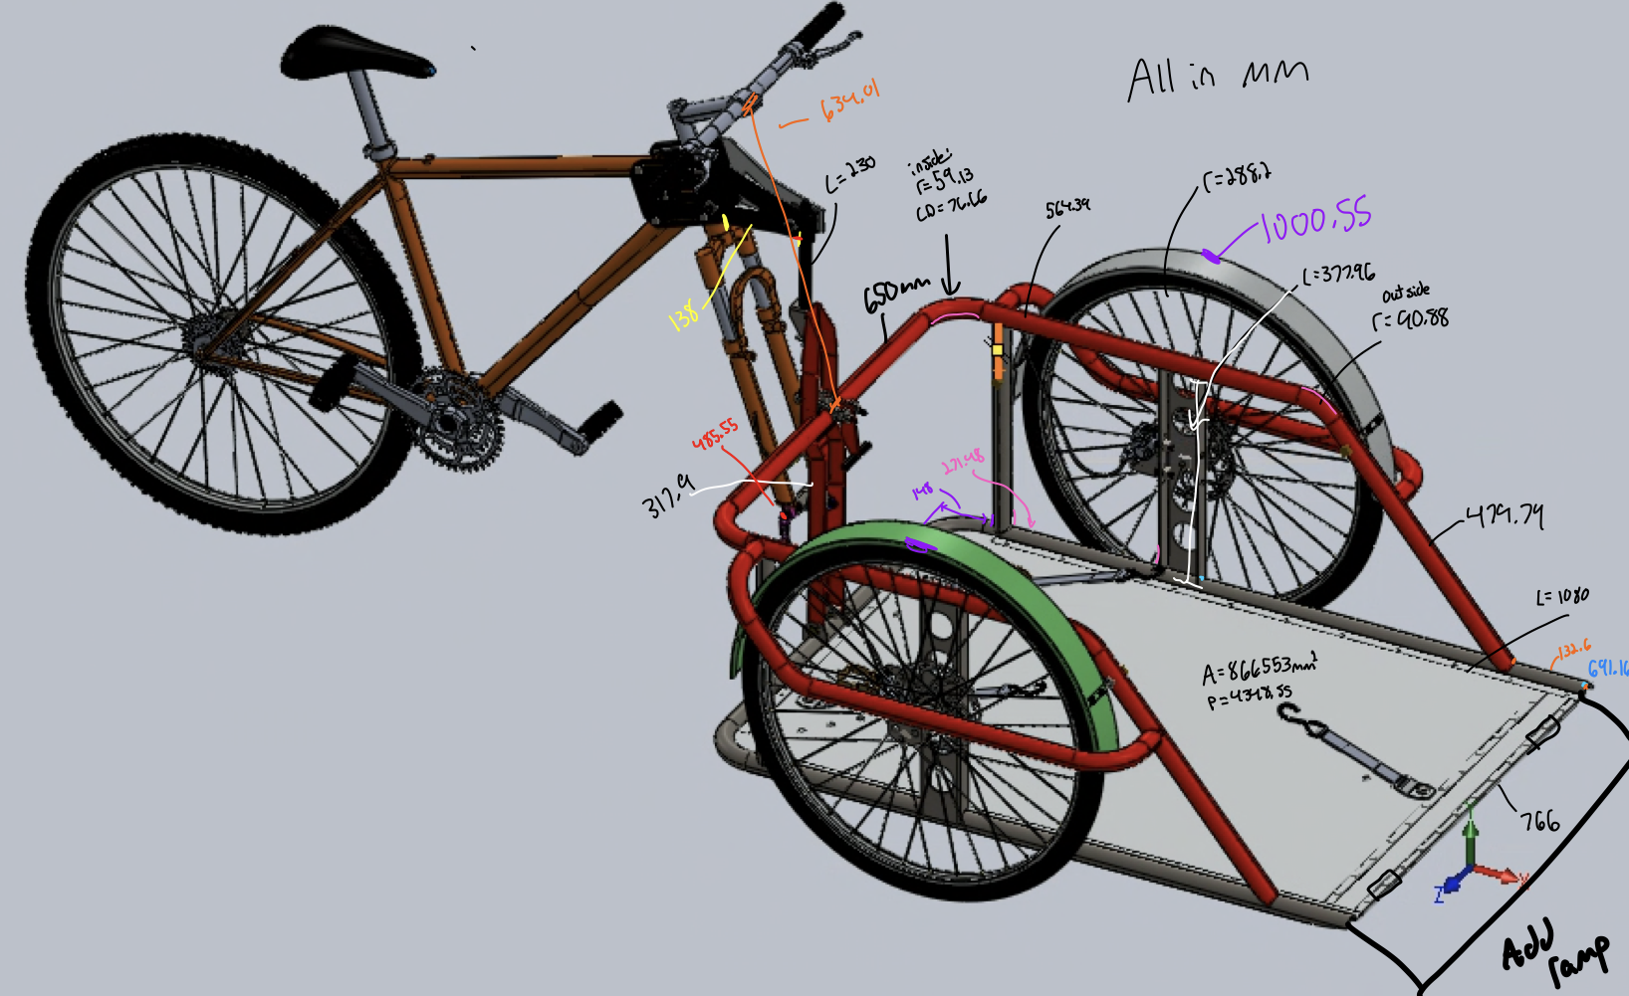
Figure 1: Rendered model of prototype Figure 3: Side view of prototype

Figure 2: Rendered model of prototype with measurements

At our current position, the prototype is an AutoCAD model. Our clients have approved the new design, so we will continue with the redesign, which consists of a platform on wheels placed at the frontal position of the bicycle. With the AutoCAD model, we know all the design details and can start the project's construction. Due to the difficulty of the structure of our project as well as uncertainty with the clients, we decided not to construct a physical prototype as we concluded that a prototype that is not full-scale would not be very useful for testing. Now that our design is approved, as is our bill of materials, we will start calculations for the project and the construction.

Testing, analyzing and evaluation

At our current position, the prototype is an AutoCAD model. Unfortunately, due to the scale of the final product, we have yet to decide to construct a physical, functional prototype. Fortunately, our design has now been approved and now we can commence the testing, analysis and evaluation of our design. We will use AutoCAD and its mathematical and calculation features to evaluate and analyze the project on a theoretical effort, which will aid in the final construction of our project so that we can keep any disruptions or problems to a bare minimum. After the initial testing, we will start building our design and testing certain important parks as we go, such as the strength of the hinges and the maximum weight the plate form can support.

Conclusion
Though our second prototype presents little in terms of physical change, we are now much more prepared to construct a solid prototype. The team has researched more information about the fabrication methods of the attachment, and we have organized a plan to start the manufacturing process. The updated model we showed to the clients now meets all of their wants and needs, and they have given us valuable information regarding the end product. We have also confirmed our “donor bike” that will be harvested for its parts that will be used in our prototype. In the coming weeks, our final prototype will begin to take shape, and we can start testing whether our basic simulations holds up in the real world.

Wrike Snapshot
https://www.wrike.com/frontend/ganttchart/index.html?snapshotId=KmZjVZuoBiYEo2esrRg7OY3Qf3dtYS6H%7CIE2DSNZVHA2DELSTGIYA

