GNG 2102 - A03

Inclusive Bike - Group 3

Deliverable B

Josh Larocque
Numan Ozturk
Kobe Belanger
Zhisheng Peng
Haonan Lin
Table of Contents
Introduction 3
Problem Statement 3
Need Statements 4
Metrics 5
Benchmarking 6
Target Specification 7
Conclusion 8
References: 8

Introduction
The purpose of this project is to create a fully functional inclusive bike to allow a wheelchair user to experience cycling with the help of their personal assistant. Thus far, we have come up with a team contract to avoid problems and promote improvement, started planning and organizing our project on wrike to keep us on track, and had our first meeting with the client where we had the opportunity to learn more about the problem we are going to solve as well as what features they would like to see in our design and have also had the opportunity to review some products and inventions that others have created in the past to solve this problem. In the following section, we will use what we learned at the client meeting to formulate a problem statement and use it to identify the individual needs for the end product. After ranking the needs in order of importance, a list of metrics will be created, so we can benchmark our needs with other products on the market. After we have an understanding of what our target specifications are, we can start our concepts in the next deliverable.

Problem Statement

Our device helps wheelchair users navigate Ottawa’s trails with ease. The newly designed bike holds a wheelchair while the user’s helper can then push them. The bike is easy to operate and makes the user feel safe with advanced safety features.

Need Statements

Importance | User Statement | Interpetated Need Statement | Group
4 | The device attaches to the bike or uses the user's mechanical wheelchair | An attachable item to the bike that the helper can push the user around. Or make a product to attach a regular bike to a mechanical wheelchair | Mechanical aspects
5 | Light to carry around and for the client to push | Must be light and durable so the helper can carry it around and be able to push it with the user on
4 | Easy for the helper to control | Lightweight steering with wider wheels and three wheels to distribute the weight
4 | Long use life with little to no wear and tear or maintenance | Simple and mechanically simple to reduce the maintenance needed
5 | Must feel safe while touring around | Needs to be a safe and secure ride, with straps to keep the user in place. Have locked breaks for when loading. | Safety features
3 | We would like it to be red and make it look good with a cool design | Visually appearance is important | User design Preferences
5 | Lights to be seen | Have front and back lights with reflectors around the bike frame so other people can see them
5 | Must be easy to get in and out of the bike | Easy for the user to get in and out of | Usability
3 | Use it when it's nice outside | Be durable and strong to withstand sunlight and road elements

Metrics

Metric # | Need # | Metric | Importance  (1-5) | Value | Units
1 | 1, 5, 9 | Overall mass | 4 | 15-68 | kg
2 | 3, 11, 13 | Maximum weight capacity | 5 | >200 | kg
3 | 13 | Max/min wheelchair wheel size | 4 | 91 cm tall, 81 cm long. | cm
4 | 4, 13 | Max/min wheelchair width | 4 | 64 cm wide | cm
5 | 2, 9, 13 | Time to “mount” wheelchair | 3 | <120 | s
6 | 3, 9 | Pedaling force | 5 | 200 | N
7 | 1, 3, 8 | Speed ratios | 4 | 2-26 | km/h
8 | 3, 7, 9 | Track width | 3 | 71-96 | cm
9 | 3, 4 | Strap length | 2 | 1 | m
10 | 9 | Bike steering angle | 3 | 64-69 | deg.
11 | 3, 9 | Braking distance at speed | 5 | <8-10 | m
12 | 3 | Suspension preload (maybe) | 1 | 2.54 | cm
13 | 3 | Suspension travel (maybe) | 1 | 100 | mm
14 | 6, 10, 12 | Looks good | 4 | #/10 | subj.
15 | 10 | Light brightness | 3 | 100-200 | lum.
16 | 3 | Reflector size | 2 | 4 | cm²
17 |  | Additional cargo space | 1 | 0-50 | cm³
18 | 9 | Steering force | 4 | >10 | N
19 |  | Operating temperature | 2 | 0-40 | ºC

Benchmarking
Inclusive bike: This is a bike that can be used by wheelchair users and the wheelchair users do not have to drive it themselves. At present, the customer's satisfaction with the product is high and the following are some of the advantages and disadvantages of the product

Advantages:
- Low price, wide audience scope, more potential users
- Simple mechanical structure, low cost of repair and maintenance

Disadvantages:
- Users will not experience too good the details of the function
- A low budget makes the product still requires human power rather than electricity

The following products are now available on the market:

Company | Clever Tricycle-Machinery Factory | Christiana | Riese & Mueller
Product | 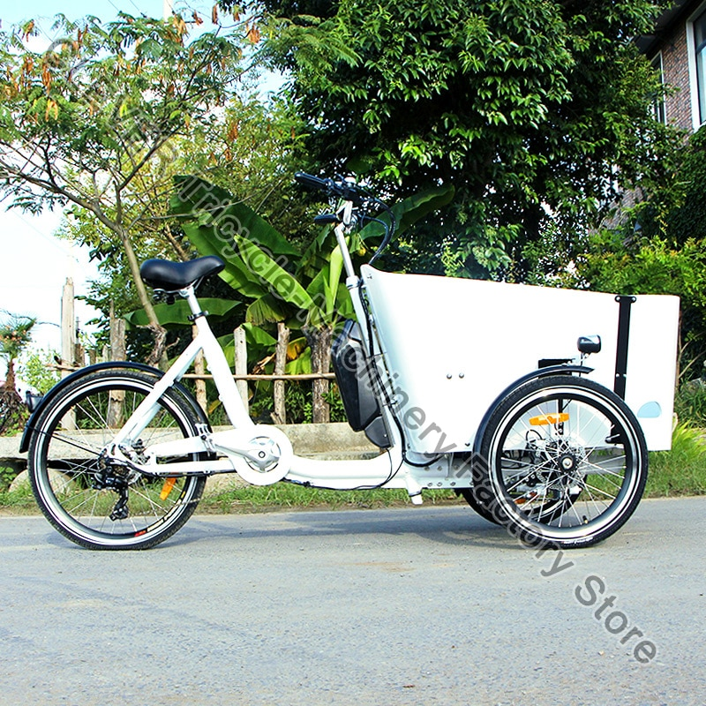 | 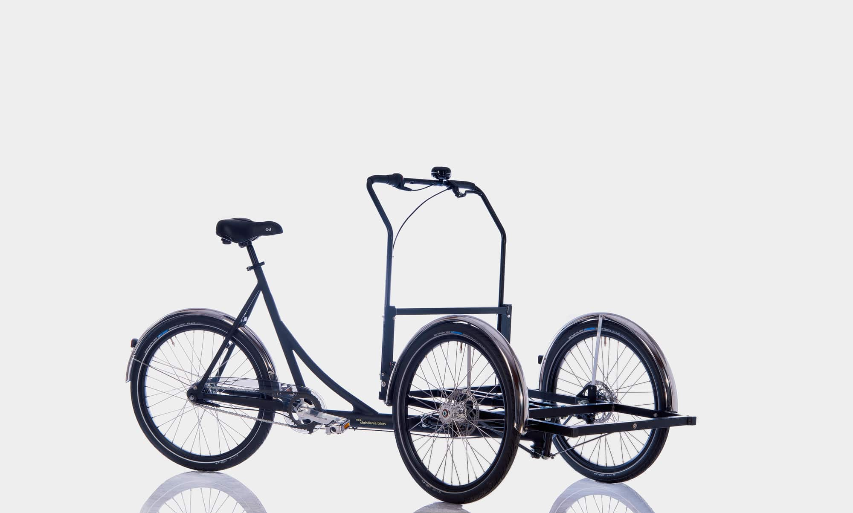 | 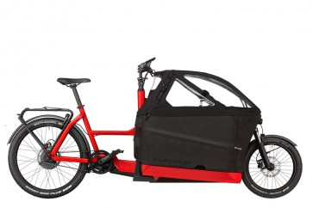
Price(CAD) | 1288.52 | 3190.00 | 12059.00
Dimensions(mm) | 2180*850*1100 | 2080*870*1170 | 2490*Width depends on the front box*590
Weight(KG) | 75 | 29 | 27.5
Power | Electric powered | Human powered | Electric powered
Material | Strong steel | Stainless steel | unknown
Wheels | 3 | 3 | 2
Website | “3 Wheel Family High Quality Cargo Bike Denmark Front ... - Aliexpress.com.” Alliexpress, https://www.aliexpress.com/item/1005004027407524.html. | “Christiania ‘Nobox’ Cargo Trike.” Plain Bicycle, https://plain-bicycle.myshopify.com/products/christiania-nobox-cargo-trike?variant=40766184915110¤cy=CAD&utm_medium=product_sync&utm_source=google&utm_content=sag_organic&utm_campaign=sag_organic. | “Packster 70 (2023).” Citrus Cycles, https://citruscycles.ca/rm-packster-70-cargo-ebike.

Target Specification
- Must be an attachment to a normal bicycle
- Must not require effort from wheelchair user while on a bicycle
- Must be made of durable material
- Must have an attachment which allows a wheelchair user to be in front of the bicycle
- Must have appropriate safety features
- Must allow bicycle rider to have full control of bicycle
- Must be lightweight and collapsible
- Can be more focussed for the summer/spring seasons
- Can have the colour red

Specification | Details
Attachable to bicycle | Must be able to latch onto a typical bicycle for easy usage
Wheelchair user will not participate in biking | Due to client disability, the client will not be able to participate in the biking and can only sit
Material must be durable | Material must be strong enough to support wheelchair + any other required parts
Must have sufficient safety features | Must include safety features as required, such as reflective bands, lights and restraining belts
Bicycle rider must have full control of bike | Bicycle rider must be able to turn and move bike efficiently
Must be lightweight and collapsible | The attachment must not be too heavy and should be collapsible for easy storage

The points stated are some of the base specifications of the project. We were unfortunately not able to obtain as much information from the client as we had wanted, so we will have to take a liberal approach to design the project and narrow down the needs and requirements as we continue to communicate with the client. The needs statement outlines the most important details of the project that must be followed, and the can statements outline less important aspects of the project.

Conclusion
People with mobility disabilities face many challenges on a daily basis, one of these challenges being recreation. Our goal for this project is to create a product that will allow those with disabilities to explore the city from a new, open-air perspective. Cycling is an activity that should be enjoyed by everyone, and our design will allow people in wheelchairs to participate and feel included. With the problem statement we formulated, and the needs we interpreted, we created a clear list of metrics and target specifications for our device. The information we’ve gathered and organized will be used for the entire duration of the project and will guide our progress because this deliverable serves as one of the many stepping stones of the design process. The specifications we set will be used as a foundation to start our conceptual design for the first prototype. Many of the key details such as the safety and ease of use of the product will be taken into consideration while creating concepts.

References:

“Dotsolutions. Bakfiets, https://www.bakfiets.com/.”
“Nihola Flex.” Nihola, 25 Aug. 2021, https://nihola.com/nihola-flex/.”
“VeloPlus.” Van Raam, https://www.vanraam.com/en-gb/our-bikes/wheelchair-bike/veloplus.”

