GNG5140: Engineering Design

Deliverable E: Revised Prototype Analysis & Test Results

Submitted by
Team Opioid Overdose
Ayham AlAkhras 300207406
Min Ju Kim 7296534
Varsha Srinivasan 300157999

March 21, 2021
University of Ottawa

Abstract
This report outlines the revised prototype functionality and test results of the opioid overdose monitor to reach a fully functioning final comprehensive prototype. First, the device is broken down to four sub-systems, each encompassing an essential aspect of the opioid overdose monitor system. They are the measurement system, the signal processing algorithm, the ergonomic casing, and the user interface. These sub-systems are then evaluated, and big-picture design decisions are made. These decisions include the software and hardware used, the ergonomic casing for the device, and the intended design and prototyping strategy. The team decided to use Arduino components and software for the measurement system, a machine learning artificial intelligence for the signal processing, a facemask to house all components and measurement devices, and a Kotlin powered Android application for the user interface. Once the design is outlined, the key prototypes for this timeframe are listed: the circuit simulation prototype, the revised user interface prototype, the ergonomic prototype, and the hardware circuit prototype. The four prototypes were developed by the team since the last deliverable and produced promising results. While there is still much to be done to complete these prototypes and integrate them into the final comprehensive prototype, the team has made excellent progress and is on track to complete this project on time.

Table of Contents
Abstract i
Table of Contents ii
List of Figures iv
List of Tables v
List of Acronyms vi
Introduction 7
Progress Update [2] 7
1. Revised Solution Concept 8
1.1 Circuit Diagram 9
1.2 Physical Circuit 9
1.3 Signal Processing 10
1.4 Ergonomic 10
1.5 UI Software 10
2. Revised Prototype and Test Results 11
2.1 Updated Hardware Circuit 11
2.1.1 Measuring of Bio-signals 12
2.2 Updated UI 14
2.2.1 Slide buttons 14
2.2.2 Call functionality 16
2.2.3 Additional Features 17
2.2.4 Testing 18
3. Updated Project Plan 18
Conclusions and Recommendations for Future Work 20
Bibliography 21
APPENDICES 22
APPENDIX I: Arduino Code 22
APPENDIX II: Prototype Test Results 28
APPENDIX III: UI 29

List of Figures
Figure 1. Hardware Circuit 11
Figure 2. Humidity Readout 12
Figure 3. PPG Data 13
Figure 4. SpO2 Output 14
Figure 5. UI Slider Mechanism 15
Figure 6. Emergency Contact Feature 17
Figure 7. Updated Project Plan 19

List of Tables
No table of figures entries found.

List of Acronyms
Acronym | Definition
IEDP | Iterative Engineering Design Process
OD | Opioid Overdose
SpO2 | Blood Oxygen Saturation Level
RR | Respiratory/Breathing Rate
UI | User Interface
PPG | Photoplethysmogram
BrPM | Breaths per Minute

Introduction
IEDP is an iterative designing process that continuously revises or optimizes the design of a project until the design performs the task “really well” [1]. Both problem statement and project design are improved with each iteration using IEDP. The revised prototype for this project is developed using IEDP and will be introduced later in this report.

Progress Update [2]
Back in Deliverable D, the initial prototype of an OD monitor was designed and tested. However, the hardware components for the prototype did not arrive until after Deliverable D was submitted. To compensate, substitute components were used on Tinkercad to simulate the circuit.
Now that they have arrived, the prototype using the actual components is built and tested. This report will specifically focus on the performance testing results of the prototype, which was omitted in Deliverable D.
Finally, this report updates the project plan reported in Deliverable D to show a more detailed and clearer plan for this project until the end of the design process.

1. Revised Solution Concept
According to the client, the proposed design must satisfy the following criteria [3]:
• Cost effective design (100 CAD budget)
• Monitors blood oxygen level and respiratory rate reliably
• Lightweight and small to be wearable on the user
• Discrete and compact package
• Editable emergency contacts
• Quick and accurate response to overdose indicators
• Long battery life
A few modifications were made in the ergonomic prototype and User interface. These modifications were based on the feedbacks from a survey created for each initial prototype. A hardware prototype was also created in this deliverable and results are presented in this report. The working of the monitor is still the same. The electrical measurement device was chosen as an Arduino processor with integrated sensors to cut down on costs and complexity. The Arduino device would then pair to a mobile application via Bluetooth, utilizing the built-in UI functionality and processing power of a smartphone to further cut down on costs. The mobile application developed for Android using Kotlin contains the UI and communicates with both the Arduino and AI algorithm. When enabled, the application detects an overdose then alerts the appropriate contacts according to the user’s choosing. The ergonomic unit was chosen to be a facemask due to its effectiveness and convenience as mentioned in deliverable D.

1.1 Circuit Diagram
The circuit structure has changed to compensate the actual sensors and to facilitate the signal processing. The efficiency of the circuit will determine the efficacy of the module and its parameters such as response time, data measurement, troubleshooting, etc. However, it must be connected to a mobile application for data processing and user interface. Initially, Tinkercad was utilized to generate the desired results with the basic components that the website can offer. Once the actual parts were received, a working circuit was created as shown later in the report. The circuit is aimed to integrate a sensor to measure the SpO2 and RR with an Arduino nano 33 BLE Sense as the monitor would send the data read by the sensors integrated to it to the smartphone.

1.2 Physical Circuit
A physical circuit prototype is needed to analyze the latency and the accuracy of the data that is being delivered to the smartphone. Although the circuit is simple, the readings of the sensor play a significant role in detecting OD and the response time for the data to reach the smartphone via Bluetooth should be within seconds as that could be crucial to save a life. The circuit is explained in detail in 2.1 Updated Hardware Circuit.

1.3 Signal Processing
The team decided to use Arduino components and software for the measurement system, a machine learning artificial intelligence for the signal processing. The data from the sensor will be deciphered and manipulated to be fed into the smartphone app. The app will then decide based on the received data on further actions that has to be taken for the user.

1.4 Ergonomic
One of the feedbacks received from Deliverable D was that the report did not mention the impact of the close proximity of the microcontroller on the comfortability. Since none of the ergonomic test participants mentioned any discomfort between their mouths and the microcontroller, the ergonomic design will remain as it is.

1.5 UI Software
The overall design concept for the UI from Deliverable D remains the same [2]. The only change is that the team is considering eliminating location tracking from the final prototype but allowing for scalability to add the feature later. Location sending was found to be complex, and the team has decided to focus on other features to implement, shown in 2.2 Updated UI. Furthermore, emergency services have the ability and rights (in some areas) to ping cell phone towers and determine the location of a caller; however, this feature should not be relied upon.

2. Revised Prototype and Test Results

2.1 Updated Hardware Circuit
With the hardware components finally arriving, a physical hardware prototype was made instead of using online software such as Tinkercad. Figure 1 shows the hardware prototype made using jumper wires and a breadboard. The Arduino code for this prototype is provided in Appendix I.
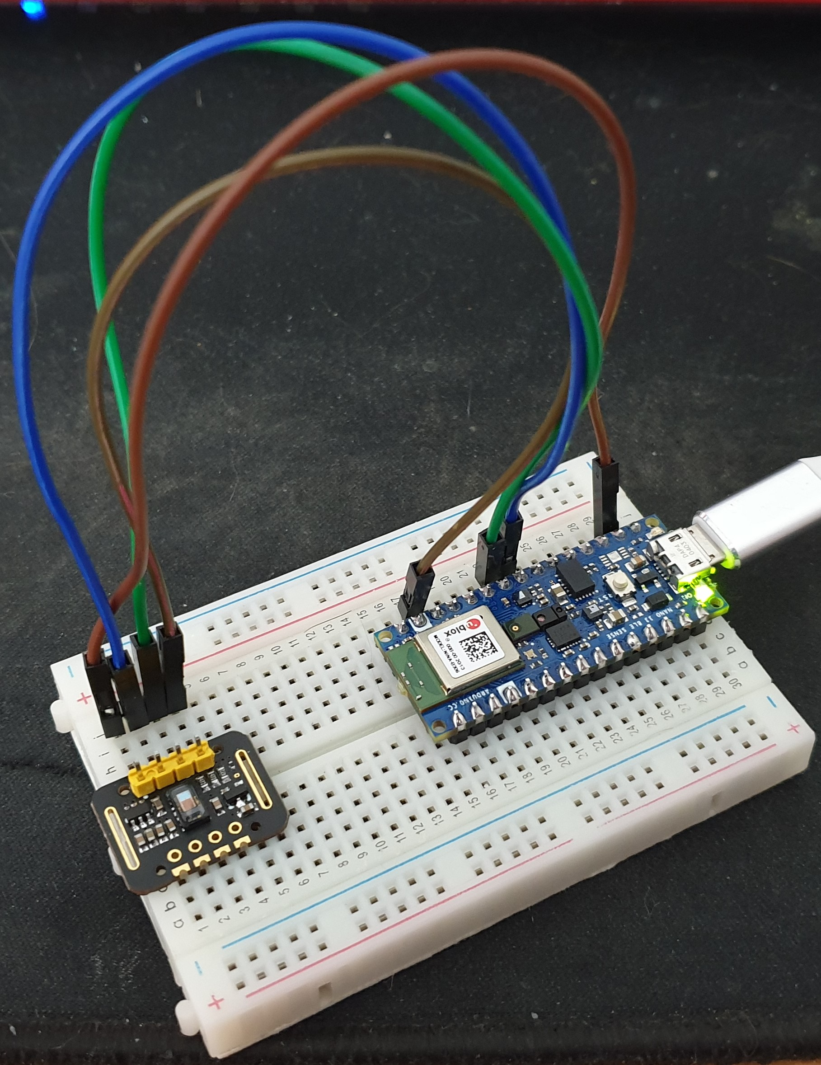
Figure 1. Hardware Circuit

2.1.1 Measuring of Bio-signals
As mentioned in previous deliverables, this OD monitor detects an OD by measuring two vital signs: RR and SpO2. The HTS221 temperature and humidity sensor embedded on the Arduino was utilized to measure the RR by measuring the fluctuations in the humidity level while the user is breathing. Figure 2 shows the humidity readout from the HTS221 under normal breathing pattern.
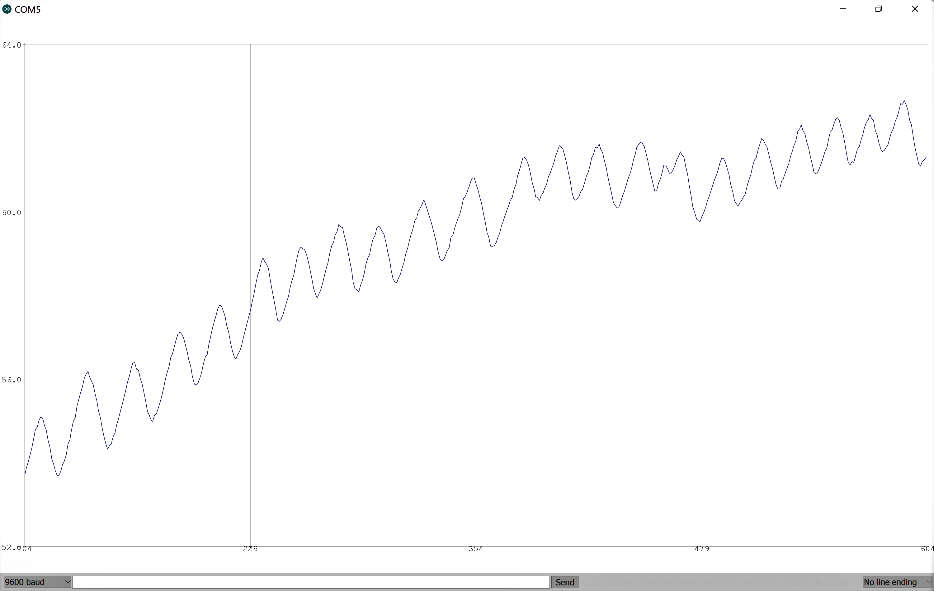
Figure 2. Humidity Readout
As it can be seen in Figure 2, the humidity level fluctuates in regular intervals while steadily increasing. The humidity reaches a valley, or local minima, when inhaling and a peak, or local maxima, when exhaling. With the humidity output, RR can be calculated by using:
$RR=\frac{60}{Δt}$ (1)
where Δt is the time taken between two peaks or valleys in seconds.
The MAX30102 pulse oximeter is used for measuring the user’s SpO2. The raw PPG data can be seen in Figure 3.
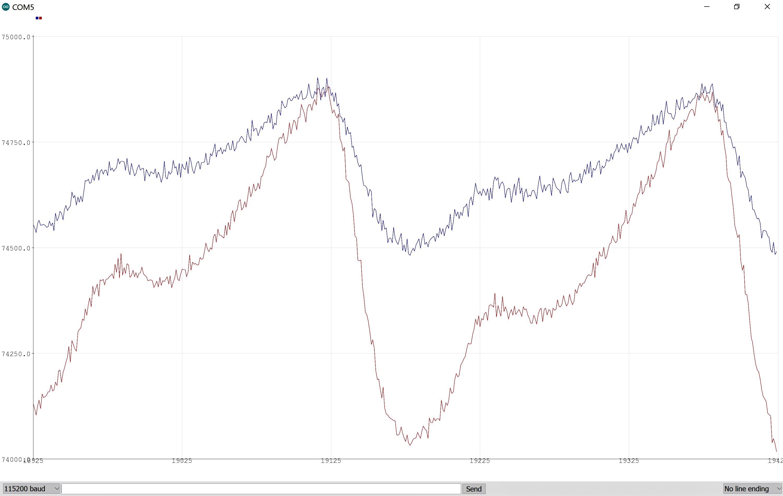
Figure 3. PPG Data
Along the raw PPG data, SpO2 was calculated by using an SpO2 algorithm available on GitHub [4]. Figure 4 shows the SpO2 readout on the Arduino Serial Monitor.
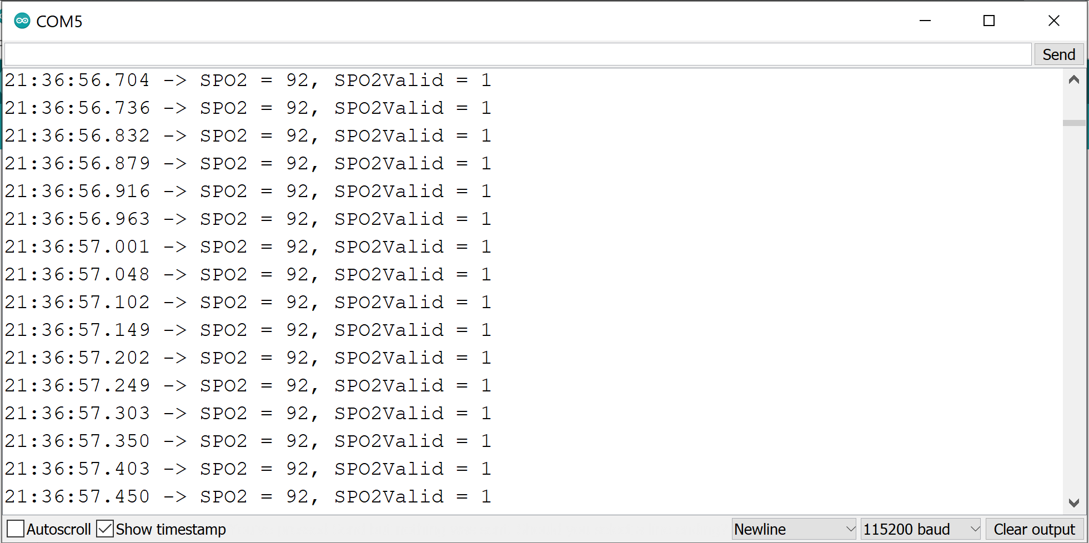
Figure 4. SpO2 Output
With these algorithms, the SpO2 of three participants were measured for 60 seconds. Their results are shown in Appendix II. It should be noted that the results in Appendix II show a lot of fluctuations in the SpO2 readings. Also, it should be noted that RR could not be measured due to the Arduino crashing.

2.2 Updated UI
In the last deliverable, multiple desired features were mentioned in user reviews and focus groups. As a result, the team reevaluated the user interface structure and identified the key sub systems required within the UI.

2.2.1 Slide buttons
To minimize inaccurate inputs, the team decided to implement slide to act buttons within the user interface. Unfortunately, Android Studio does not contain this feature as an easily selectable option. However, a key aspect of programming is the ability to outsource bits of code and implement within a larger project. A slide to act button was found on GitHub [5]. The GitHub file also includes an example application, showing the features of the widget and its customizability. Because the sample application was coded in Java, the example code was modified to work in Kotlin and within the previously developed user interface. This feature required much effort to implement due to its Java example app and the interactions between the slide button and the navigation functionality. Regardless, it was determined as a vital feature to prevent false inputs from the user and was used successfully.
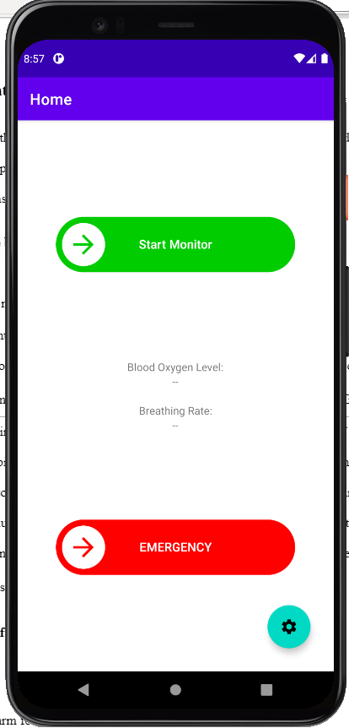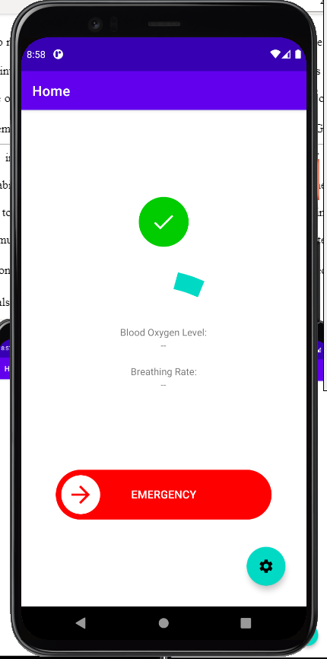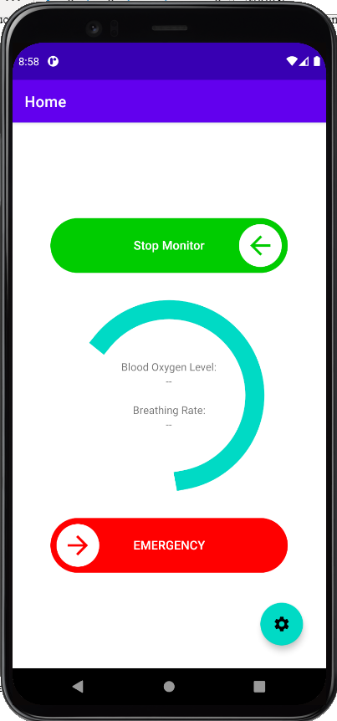
Figure 5. UI Slider Mechanism

2.2.2 Call functionality
The previous UI prototype did not include any functionality, but rather provided a base for the UI design to develop on. One of the most important features was the implementation of a call function, which automatically dials and calls a customizable number. The customizability of the number was added in the last deliverable and the emergency button is finalized in 2.2.1 Slide Buttons. These two aspects were brought together in the main UI code along with a Kotlin function that initiates a phone call after the application has user permission. A possible glitch was found, however, in that the application crashes if call permission is not granted to the application. This can be addressed later by either adding a warning/access request when launching the application or when initiating a call. Furthermore, a pre-recorded or text-to-speech message should be implemented to inform the person on the other end of the call of the user’s situation and possibly location.
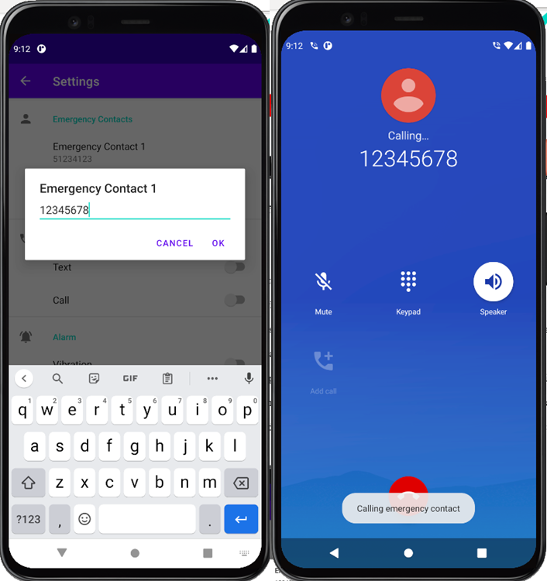
Figure 6. Emergency Contact Feature

2.2.3 Additional Features
Three more sub-systems were identified but not yet implemented:
  - Text functionality
  - Location sending
  - Alarm feature
Text functionality seems fairly simple and should not take long to implement according to its similarity to the call functionality. A pre-determined message will be sent to one or more customizable phone numbers. The text and call functionality could also be accompanied by a feature that communicates the user's current location using Android Studio’s implementation of Google Maps. This feature is complicated, however, and the team may include features to allow for the scalability of adding the location sending, but not implement it for the next deliverable. Lastly, while the call screen can visually call for the user’s attention, an alarm screen with a countdown timer could improve usability and allow users to cancel false positives. This feature is also fairly complicated but can be implemented soon. It is also prioritized over the other additional features.

2.2.4 Testing
User testing was not done yet as not enough features were implemented to facilitate the need for another focus group. Instead, the group utilized internal testing to quickly try the functionality of the application. Once the app is finalized, a client meeting will be held to evaluate the application design and features.

3. Updated Project Plan
3.1 Plan for Deliverable F
For Deliverable F, we plan to produce a comprehensive prototype and present the opioid overdose monitor as a product. User testing was performed as a part of this deliverable and a hardware prototype was also created and tested.
After creating all the prototypes and analyzing the results, various suggestions were made to improve the prototypes which were done as mentioned in the report. Also, different test cases were generated and simulated/tested in order to account for different situations that may arise while the device is in use. Figure below shows the detailed project plan from this deliverable, Deliverable E, to Deliverable H with milestones, dependencies, and task assignees. Tasks have been individually assigned to each member to increase accountability of each task.
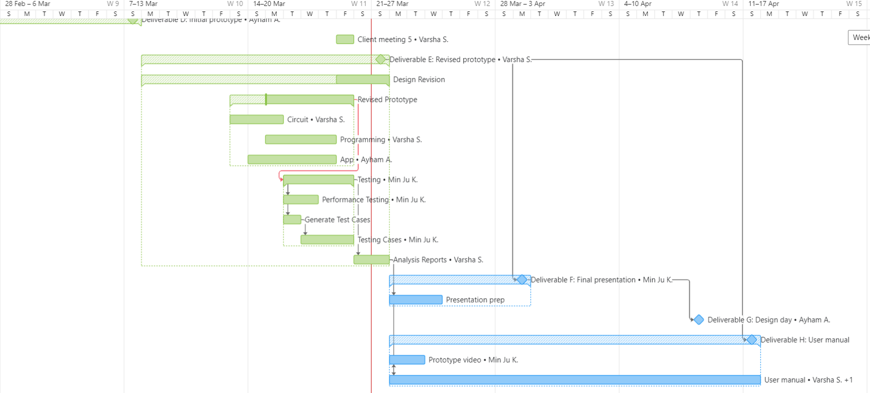
Figure 7. Updated Project Plan

Conclusions and Recommendations for Future Work
Using the user feedbacks and initial prototype results, some revised prototypes were designed, built, and tested as shown in this deliverable. The initial testing provided valuable data of how well the initial prototype performed with respect to the project requirements and revisions based on the same were made in this deliverable.
An updated project plan was also generated which includes the final prototype testing, task dependencies, and task assignees. This updated project plan provides a very clear roadmap of the step forward in this project and each team member’s responsibility.
Future works would involve testing the comprehensive prototype and prepare for the final product presentation. Also, various test cases helped to improve the performance of the device. Finally, the project is going as planned by following all the milestones. The team has updated the client on the current state of the project and will perform user tests with the client once the prototypes are more refined.

Bibliography

[1] Dumond, P., (2021). GNG5140 – Engineering Design: Online Modules: Engineering Design and Problem Definition Process [PowerPoint Slides]. Retrieved from https://uottawa.brightspace.com/d2l/le/content/212700/viewContent/3440144/View

[2] AlAkhras, A., Kim, M. J., Srinivasan, V., (2021). GNG5140: Engineering Design Deliverable D: Initial Prototype Analysis & Test Results.

[3] Cahill, T. (2020). Canada’s Overdose Crisis [PowerPoint slides]. Ottawa, ON.

[4] Seidle, N., (2016). SparkFun_MAX3010x_Sensor_Library. Retrieved from https://github.com/sparkfun/SparkFun_MAX3010x_Sensor_Library

[5] Corti, N., 2020. slidetoact v0.9.0, GitHub. Retrieved from https://github.com/cortinico/slidetoact ￼

APPENDICES

APPENDIX I: Arduino Code
/*
GNG5140 Engineering Design
Winter 2021

Opioid Overdose Monitor Code v1.0

Team Opioid Overdose
Ayham AlAkhas 300207406
Min Ju Kim 7296534
Varsha Srinivasan 300157999
*/

#include <ArduinoBLE.h>
#include <Wire.h>
#include <Arduino_HTS221.h>
#include "MAX30105.h"
#include "spo2_algorithm.h"

uint32_t irBuffer[100]; // Infrared LED sensor data
uint32_t redBuffer[100]; // Red LED sensor data
float humidity[100]; // Humidity sensor data

const int bufferLength = 100;
int32_t spo2; // SPO2 value
int8_t validSPO2; // Indicator to show if the SPO2 calculation is valid
int32_t heartRate; // HR value
int8_t validHeartRate; // Indicator to show if the heart rate calculation is valid
unsigned long brPM; // Respiratory rate value
unsigned long breathTime; // Number of breaths
unsigned long pastBreathTime;

MAX30105 particleSensor;

void setup() {
// Initialize serial communication
Serial.begin(115200);
while (!Serial) Serial.println("FAIL");;

// Initialize Bluetooth capabilities
// if (!BLE.begin()) {
// Serial.println("Failed to start BLE");
// while (1);
// }

// Initialize sensors
// if either sensor fails, alert the user
// by sending an error notification to the user's smartphone
if (!HTS.begin() || !particleSensor.begin(Wire, I2C_SPEED_FAST)) {
Serial.println("Failed to initialize sensor!");
while (1);
}

brPM = 0;
breathTime = 0;
pastBreathTime = 0;

// BLE.scan();

// Configure MAX30102
particleSensor.setup(55, 4, 2, 200, 411, 4096);

for (byte i = 0 ; i < 50 ; i++)
{
while (!particleSensor.available()) particleSensor.check(); //Check the sensor for new data

humidity[i] = HTS.readHumidity();
redBuffer[i] = particleSensor.getRed();
irBuffer[i] = particleSensor.getIR();
particleSensor.nextSample(); //We're finished with this sample so move to next sample
}
}

void loop() {
// Calculate heart rate and SpO2
rrCalc();
maxim_heart_rate_and_oxygen_saturation(irBuffer, bufferLength, redBuffer, &spo2, &validSPO2, &heartRate, &validHeartRate);

for (byte i = 25; i < 100; i++)
{
humidity[i - 25] = humidity[i];
redBuffer[i - 25] = redBuffer[i];
irBuffer[i - 25] = irBuffer[i];
}

// Take 25 sets of samples before calculating the heart rate.
for (byte i = 75; i < 100; i++)
{
// Do we have new data?
// Check the sensor for new data
while (!particleSensor.available()) particleSensor.check();

humidity[i] = HTS.readHumidity();
redBuffer[i] = particleSensor.getRed();
irBuffer[i] = particleSensor.getIR();

particleSensor.nextSample(); //We're finished with this sample so move to next sample

//send samples and calculation result to terminal program through UART
Serial.print(F("SPO2 = "));
Serial.print(spo2, DEC);

Serial.print(F(", SPO2Valid = "));
Serial.print(validSPO2, DEC);

Serial.print(F(", BrPM = "));
Serial.println(brPM);
}
}

void rrCalc() {
for (byte i = 2; i < 100; i++){
if (humidity[i - 2] < humidity[i - 1] && humidity[i - 1] > humidity[i]){
breathTime = millis();
brPM = 60000 / (breathTime - pastBreathTime);
pastBreathTime = breathTime;
}
}
}

APPENDIX II: Prototype Test Results

 | Participant 1 | Participant 2 | Participant 3
Time (s) | SpO2 (%) | SpO2 (%) | SpO2 (%)
0 | -999 | -999 | -999
2 | -999 | -999 | -999
4 | -999 | -999 | -999
6 | -999 | 61 | -999
8 | 62 | 61 | 64
10 | 62 | 70 | 64
12 | 67 | 70 | 72
14 | 67 | 78 | 72
16 | 97 | 96 | 98
18 | 97 | 96 | 98
20 | 69 | 67 | 98
22 | 44 | 45 | 61
24 | 44 | 45 | 41
26 | 47 | 43 | 41
28 | 56 | 43 | 41
30 | 57 | 58 | 55
32 | 59 | 61 | 55
34 | 59 | 93 | 61
36 | 59 | 93 | 78
38 | 94 | 70 | 93
40 | 77 | 65 | 93
42 | 75 | 65 | 74
44 | 75 | 41 | 63
46 | 45 | 41 | 63
48 | 45 | 68 | 48
50 | 72 | 73 | 48
52 | 72 | 73 | 65
54 | 95 | 94 | 65
56 | 95 | 94 | 96
58 | 68 | 94 | 96
60 | 68 | 69 | 96

APPENDIX III: UI
Kotlin project file can be found on Microsoft Teams files: https://uottawa.sharepoint.com/sites/GNG5140W00-Opioid_Overdose1/Shared%20Documents/Opioid_Overdose%201/UI%20Files%20Deliverable%20E.rar

