BEE SUSTAINABLE!
In-sight into the life-cycle analysis work done for our product.
Situation overview:
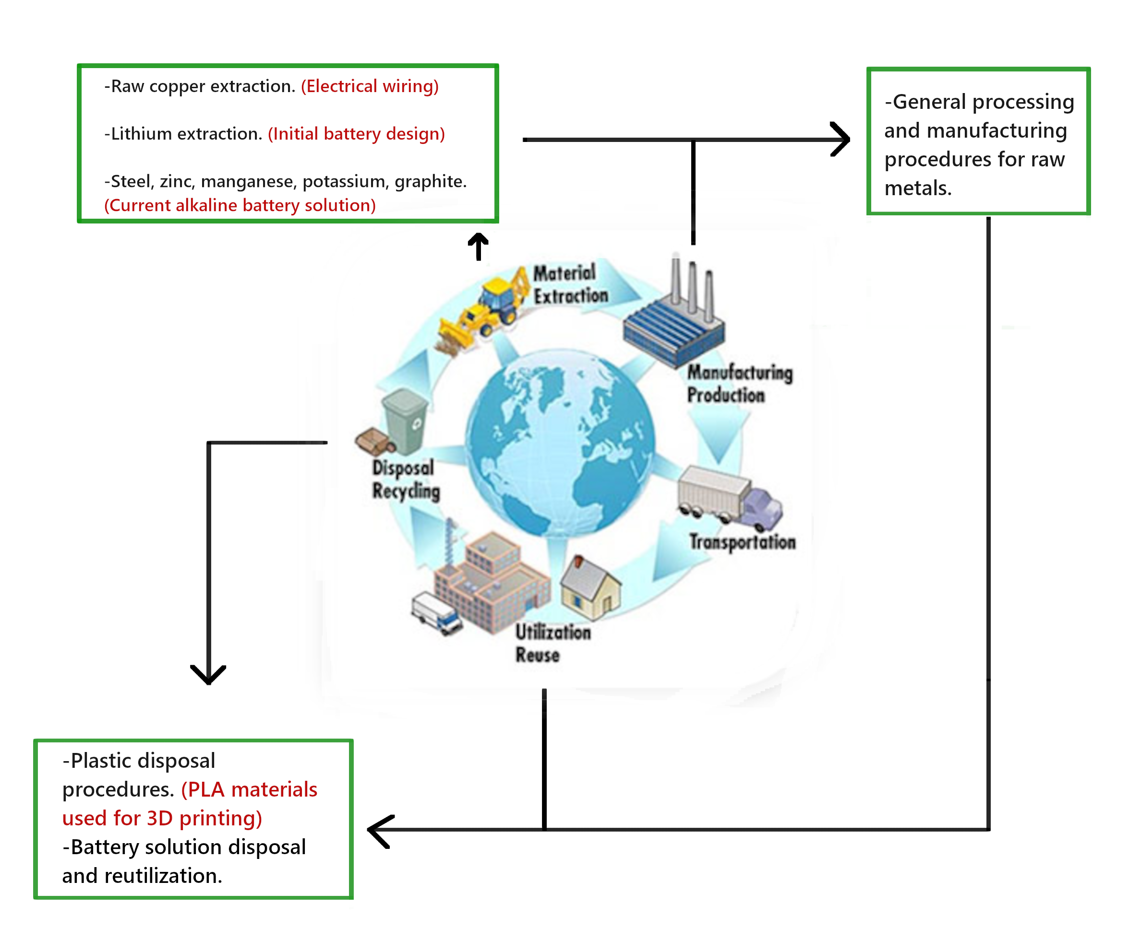
Above is a diagram showing the life-cycle diagram of a certain product. In the green boxes, are important cues that place our product’s most relevant inventory items in the context.
Highlighted in our analysis:
Elements of our project deemed essential to discuss in our life-cycle analysis, which define the scope of this analysis.
- Extraction of battery materials, CO2 footprint.
Impact assessment:
- Lithium-ion batteries:
In all of our preliminary prototypes, we’ve been attempting to use lithium-ion batteries as our first and primary source of power, in order to energize the system adequately and for an acceptable period of time. This was planned to be executed through the addition of 3x CR2032 (3V) Lithium coin cells. The main reasoning behind preferring the usage of this battery over alkaline counterparts is their small size.
-Metrics:
Battery type | CO2 footprint (KG per unit) | Energy used (MJ)
Lithium | 0.225 | 3
Alkaline | 0.0724 | 0.965

Source: Life Cycle Analysis of AA Alkaline Batteries, Ramsey Hamade et al. / Procedia Manufacturing 43 (2020) 415–422

