Deliverable G - Business Model and Economics Report

Submitted by
B2.1
Andrew Hill, 300233585
Amy Barnhill, 300250138
Meg Koshy, 300121824
El Hadj Samb, 300135700
Justin Bushfield, 300188318

November 20th, 2022
University of Ottawa

Table of Contents
List of Figures 3
List of Tables 4
1.0 Introduction 5
2.0 Business Model 5
2.1 The Buyer-Centric Model 5
2.2 Product Model 6
2.3 Core assumptions 6
2.4 Triple Bottom Line Business Model 7
3.0 Economics Report 7
3.1 List of Costs 7
3.1.1 Cost Justification 8
3.2 Unit Cost Breakdown 9
3.3 Three-Year Income Statement 9
3.4 Assumptions 10
3.5 NPV Analysis 11
3.5.1 Breakeven point 12
4.0 Conclusion 12
5.0 Wrike 12
References 13

List of Figures
Figure 1: Triple Bottom Line Business Model 7
Figure 2 11
Figure 3 11

List of Tables
Table 1: List of Costs 7
Table 2: Unit Cost Breakdown 9
Table 3: Three-Year Income Statement 9
Table 4: NPV Analysis 12

Introduction
In the past deliverable, the team developed a physical prototype that was shown to the client, who provided the feedback upon which changes were made. The team is prepared to implement the changes and undergo testing. Based on this, the next step for the team is to prepare the business model and the economics report showcasing the specifics of the product. The business model will include the chosen business model for our product, the required assumptions made for our business model and a triple bottom business model. The economics report will include a list of costs, unit cost breakdown, a three-year income statement, the assumptions made for our income statement, and an NPV analysis.

Business Model

2.1 The Buyer-Centric Model
One of the business models that suit our product best is the buyer-centric model. The buyer-centric model provides each customer with a unique tailored experience [H]. The reasons we chose the buyer-centric model are as follows. First, because our product is personalized to each client individually, in design and materials, our focus is on the client’s specific needs. To do this best, we must have direct contact with the client prior to and during manufacturing. Second, since we are providing such a tailored product, remaining in contact with clients after they have received their product is also crucial. The clients we will be working with are at an elevated risk of injury, if our product adds any risk or causes any injuries, the client can send it back to be re-tailored free of charge. Lastly, it is important to mention that our product is only available online. If we were available in store, any measurements and customizations could be measured and communicated in a single visit to our store. However, that is not the case. The only way for us to customize our product properly online is by having direct, constant communication with our clients.
After much deliberation, we decided our product will only be available online. We chose this firstly because we would like our product to be made available to everyone it caters to. A website is more readily available to clients than a store, which has limited availability to clients in various locations. And secondly because our product caters to a small population, if we did have a store, there would be little customers. Having an online presence allows everyone in the small number of potential clients to have access to our product.

2.2 Product Model
Another business model that suits our product well is the product model. The product model focuses on producing the product at low cost while maintaining a reasonable level of quality. Once the item is produced, the objective is to sell it as many units possible at a high price to maximize profit [C]. The reasons we chose the product model are as follows. First, because our products require staff to manufacture and speak to clients, we must spend a lot of money on salaries. The only way our business will make sufficient profit is if we minimize production costs and maximize the price. Lastly, our product is a wear and tear item regardless of its quality. Changing the foam in the cushion to a higher quality will not yield enough noticeable effects in how long or how well the cushion performs. The same goes for the other components of our product.

2.3 Core assumptions
The first assumption we have made is that our customer demographic will mostly be clients in wheelchairs. This is a feasible assumption because we are marketing our product as a wheelchair cushion. The second assumption we have made is that our customer demographic will also consist of clients with back pain or clients that must stay seated for prolonged periods. This is a feasible assumption because our product is a solution to any back pain, not just to individuals in wheelchairs. The third assumption we have made is that our clients are comfortable with frequent communication online. This is a feasible assumption because this is our only form of communication with clients. The fourth assumption we have made is that our only source of revenue is in sales. This is a feasible assumption because our business does not currently have any other significant sources of revenue. The fifth assumption we have made is that changing any components in our product to a higher quality will not yield enough noticeable effects to how long or how well the cushion performs. This is a feasible assumption because our solution is focused on the dimensions that are custom to each client, not the quality of the materials and components we are using.

2.4 Triple Bottom Line Business Model
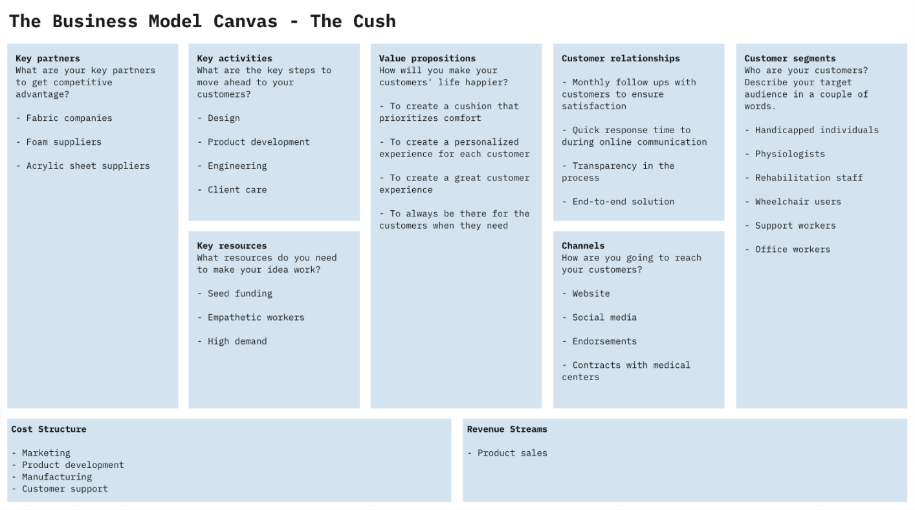Figure 1

Economics Report

3.1 List of Costs

Table 1: List of Costs
Cost | Variable/Fixed | Direct /Indirect | Amount | Description
Production | Variable | Direct | $70,000/year | Two employees paid $35,000/year to assemble cushions.
Consultation | Variable | Direct | $35,000/year | Employee responsible for client meetings and inquiries.
Online Store | Variable | Indirect | $360/year | Average price of hosting web domain on sites like Wix, Squarespace, etc.
Laser Cutter | Fixed | Direct | $3995 | Glow forge Basic [link]
Sewing Machine | Fixed | Direct | $360 | 2 Singer M1150 Mechanical Sewing Machines
Product materials | Variable | Direct | $27.65/unit | From BOM – includes all production tooling costs and materials expenses
Depreciation of laser cutter | Fixed | Indirect | 8% / year | Based on product advancement and efficiency reduction.
Depreciation of Sewing Machine | Fixed | Indirect | 15% / year | The average depreciation rate of a sewing machine.
Marketing | Fixed | Indirect | $2500 / month | Online presence and targeted ad campaign
Rent/Office | Fixed | Indirect | $3500 / month | Includes rent and utilities for a hybrid office space and production floor
Utilities | Variable | Indirect | $250/month | Based on [lk] and projected electrical usage for sewing machines and laser cutters. Includes electrical, water and insurance.

3.1.1 Cost Justification
Salaries: We have chosen to pay our workers $35,000.00 per year. For the production salary, the average salary of a manufacturer is around $32,000.00 [K]. For the consultation employee, the salary is currently lower than the average salary of an administration employee, which is around $46,480.00[F]. We are hoping that with more sales we will be able to raise this to $50,000.00.
Online Store: Hosting a web domain costs $27.99/month on GoDaddy [E], which comes to around $350/year.
Laser Cutter: We chose to use the Glow Forge basic edition because we do not need the extra capabilities on the more advanced models. When we need to replace the laser cutter, we will likely invest in one of the more advanced models [B].
Sewing Machine: We chose to invest in two of the Singer M1150 Mechanical Sewing Machines because it has very good reviews. In the future, we may choose to invest in a more automatic means of sewing the cushion covers [G].
Product Materials: Based off BOM.
Depreciation Rate of Laser Cutter: We couldn’t find a set rate online, so we asked one of the workers at the makerspace.
Depreciation Rate of Sewing Machine: The average rate of depreciation for sewing machines is 15% [J].
Utilities: Based on Ontario’s current electrical, water, and insurance rates [D].
Office: We have assumed that an 800 square foot office would be good and enough for the equipment and the employees to work peacefully. Based on our research, we saw the price of an office is based on how big the tenant wants it to be. An office space is approximately rented at $4.33/SQFT per month. And since we assumed that our office would be great with 800 square foot that’s why we assumed $3500 for the rent of the office [A].
Marketing: To promote and to give visibility to the company, we must have publicity. We decided that online advertising is the best way because it is cheaper than traditional/offline advertising and more efficient. The average cost to reach 1000 people with online advertising ranges from $3-$10 while for the same amount of people takes $22 and up for offline advertising. We set a goal of being seen by at least 250 people each month, and since online advertising could go from $3 to $10, we estimated our monthly cost for marketing to be 2500$ to be assured that we will have at least that number at the end of every month [I].

3.2 Unit Cost Breakdown

Table 2: Unit Cost Breakdown
Item Name | Quantity | Cost
Fabric | 0.5x0.5m | $4.00
Strap | 2 yards in length | $4.00
Buttons | 3 buttons | $0.15
Foam | N/A | $2.50
Acrylic Backing | 1 | $13.00
Snaps | 6 | $4.00
Total Unit Cost $27.65

3.3 Three-Year Income Statement

Table 3: Three-Year Income Statement
Profit | Annually | 3 Years
Sales ($149.99/unit) | $299,980.00 | $899,940.00 (6000 units)
Sales Profit | $299,980.00 | $899,940.00
Simple Interest Loan (10%)
Loan | $70,000
Unit Cost
Foam ($2.50/unit) | $5,000.00 | $15,000.00
Fabric ($4.00/unit) | $8,000.00 | $24,000.00
Buttons ($0.15/unit) | $300.00 | $900.00
Snaps ($4.00/unit) | $8,000.00 | $24,000.00
Straps ($4.00/unit) | $8,000.00 | $24,000.00
Acrylic Backing ($13.00/unit) | $26,000.00 | $78,000.00
Shipping and Packaging ($5.00/unit) | $10,000.00 | $30,000.00
Cost of Goods Sold | $65,000.00 | $195,000.00
Gross Profit of Sales | $234,980.00 | $704,940.00
Expenses
Salaries | $105,000.00 | $315,000.00
Online Store | $360.00 | $1,080.00
Sewing Machines (1 Time Purchase) | $360.00 | $360.00
Sewing Machine Depreciation | $54.00 | $138.9
Laser Cutter (1 Time Purchase) | $3,995.00 | $3,995.00
Laser Cutter Depreciation | $319.60 | $884.14
Marketing | $30,000.00 | $90,000.00
Rent | $42,000.00 | $126,000.00
Utilities | $3,000.00 | $9,000.00
Operating Expenses | $185,088.60 | $546,458.06
Operating Income | $49,891.40 | $158,481.94
Interest
Interest Expense | $7,000.00 | $21,000.00
Taxes
Tax Expense | $6,283.86 | $11,851.58
Net Income | $35,608.54 | $106,825.62
Note: All currencies in CAD
Note: Assuming 6000 units sold in 3 years

3.4 Assumptions
The assumptions related to our economic report are as follows:
- Expenses such as utilities, rent, marketing and salaries are monthly expenses and represents a total of $180000 a year
- A total cost of $4355 has been necessary for the equipment needed for production
- A 10% simple interest rate is assumed on the loan, which is compounded annually, and it is calculated over a period of 3 years
- There is only one income, and it comes from sales
- Based on benchmarking the product should be sold at $149.99 per unit

3.5 NPV Analysis

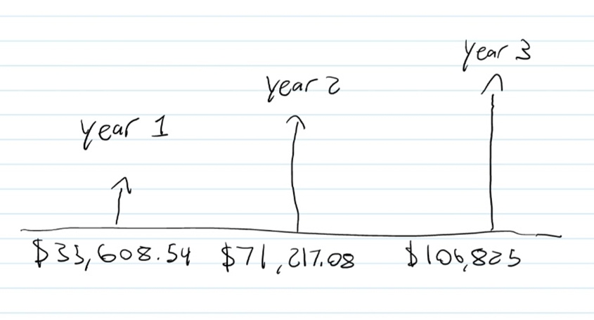
Figure 2
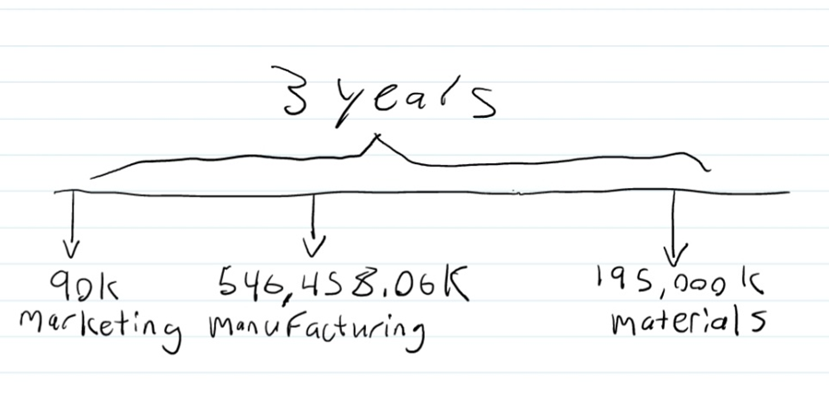
Figure 3

3.5.1 Breakeven point
According to the 3-year income statement, a minimum of 1551 units need to be sold a year to break even. If 2000 units are sold every year the breakeven point will be achieved in 9.3months.
Table 4: NPV Analysis
NPV
Income |  | Expenses (3 years)
Year 1 | $32,371.40 | Marketing | $67,618.33
Year 2 | $58,857.09 | Manufacturing | $410,562.03
Year 3 | $80,259.20 | Materials | $146,506.38

4.0 Conclusion

The team has assembled a triple bottom business chart that showcases the key partners, key activities, key resources, value propositions, customer relationships, channels, customer segments, cost structure, and revenue streams. The business models we have chosen to follow are the Buyer-Centric model and the Product model, the assumptions made for these models were mentioned as well. We have also chosen that our product will only be available online. Additionally, an economics report was prepared that identifies the costs as well as providing a breakdown of the materials needed to construct the product. There is a three-year income statement, and the assumptions required to create the income statement. Lastly, we have done an NPV analysis. Our plans for the next deliverable include getting ready for our final presentation, some finishing touches on our final prototype, and preparing for design day.

5.0 Wrike

Design Day Prep Plan: https://www.wrike.com/frontend/ganttchart/index.html?snapshotId=hgN2i6vpKWkuNN6GvD1kV52ea5DGBRT6%7CIE2DSNZVHA2DELSTGIYA
PD-J Plan: https://www.wrike.com/frontend/ganttchart/index.html?snapshotId=Kv2NmfrFdiW5oPZ4OTUlnBKD2i55rlae%7CIE2DSNZVHA2DELSTGIYA

References
[A] Carter, Brandon. “How Much Does It Really Cost To Rent An Office Space?” SquareFoot Blog, https://www.facebook.com/TheSquareFoot/, 4 May 2017, https://www.squarefoot.com/leasopedia/dollars-cents-much-cost-rent-office-space/
[B] Glowforge. “Choose Your Glowforge.” Your At-Home 3D Laser Printer | Glowforge, https://glowforge.com/order. Accessed 20 Nov. 2022.
[C] Healy, Patrick. “8 Types of Business Models & the Value They Deliver.” Business Insights Blog, 26 May 2016, https://online.hbs.edu/blog/post/types-of-business-models.
[D] Ontario Energy Board. “Electricity Rates | Ontario Energy Board.” Home | Ontario Energy Board, https://www.oeb.ca/consumer-information-and-protection/electricity-rates#current. Accessed 20 Nov. 2022.
[E] Plans and pricing for website builder. GoDaddy. (n.d.). Retrieved November 20, 2022, from https://www.godaddy.com/websites/website-builder/plans-and-pricing
[F] Salary: Office administrator (November, 2022) | glassdoor. Glassdoor. (n.d.). Retrieved November 21, 2022, from https://www.glassdoor.ca/Salaries/office-administrator-salary-SRCH_KO0,20.htm
[G] Singer M1150 Mechanical Sewing Machine | Canadian tire. (n.d.). Retrieved November 21, 2022, from https://www.canadiantire.ca/en/pdp/singer-m1150-mechanical-sewing-machine-0430173p.html
[H] Sweeney, James. “Product-Focused vs. Buyer-Centric | Gain, Inc.” Home - Gain, Gain, Inc., 1 Oct. 2018, https://acq.hellogain.com/productfocused-vs-buyercentric/#:~:text=Being%20buyer-centric%20means%20flipping%20your%20perspective%20to%20that,of%20what%20it%20can%20do%20for%20the%20user.
[I] Top Draw Team. “Online Advertising Costs In 2021 | Top Draw.” Top Draw Inc., https://www.facebook.com/topdrawinc, 12 June 2020, https://www.topdraw.com/insights/is-online-advertising-expensive/.
[J] V, James. “Life Expectancy: How Long Will My Sewing Machine Last?” SewingIsCool.Com, 30 Jan. 2020, https://sewingiscool.com/life-expectancy-how-long-will-my-sewing-machine-last/#:~:text=Sewing%20machines%20are%20no%20different%20and%20as%20the,figure%20out%20the%20value%20of%20your%20sewing%20machine.
[K] Zippia. “Manufacturer Salary (November 2022) - Zippia | Average Manufacturer Salaries Hourly And Annual.” Zippia - Find Jobs, Salaries, Companies, Resume Help, Career Paths and More, 18 May 2020, https://www.zippia.com/manufacturer-jobs/salary/.

