Deliverable D - Detailed Design, Prototype 1, BOM, Peer Feedback and Team Dynamics

Submitted by
B2.1
Andrew Hill, 300233585
Amy Barnhill, 300250138
Meg Koshy, 300121824
El Hadj Samb, 300135700
Justin Bushfield, 300188318

October 9th, 2022
University of Ottawa

Table of Contents

Table of Contents 2
Introduction 3
Summary of Client Feedback 3
Detailed Design 4
Bill of Materials (BOM) 7
Critical Product Assumptions 8
Prototype I 9
Documentation 9
Explanation of Prototype Subsystems 9
Prototype Testing 10
Wrike 10
Project Deliverable E Plan: 10
Project Deliverable F Plan: 10
Conclusion 10

List of Figures
Figure 1.....................................................................................................................................6
Figure 2.....................................................................................................................................7
Figure 3.....................................................................................................................................7
Figure 4.....................................................................................................................................10

List of Tables
Table 1...........................................................................................................................................5
Table 2............................................................................................................................................9

Introduction
In the last deliverable, each member of the team came up with multiple possible concepts for the product. All the concepts were examined, and it was discovered that the design that encompassed most of the client’s needs was a combination of multiple concepts. The design that was selected was a cushion that used Velcro to hold to hold it to the back of the chair while a piece of plastic is used to shape the cushion to the clients back. This idea was then presented to the client in a meeting and feedback was received.

Summary of Client Feedback

Clients Statements | Team Interpretation
“The thickness of the cushion works fine but it’s too big vertically” | The top half of the cushion is uncomfortable because it is pushing them forward
“Height is shoulders to midback” | The cushion should not push out the hips any more than needed
“The pressure is even” | The pressure should be uniform across the back.
“Chair is already customized to the back” | The chair is already contoured to her chair and the cushion slides right in.
“Velcro is okay” | The client is amenable to some changes to her chair but nothing too drastic
“Wants to use the cushion on other chairs too” | The client wants the product to be durable and versatile.
  - Table 1

Detailed Design

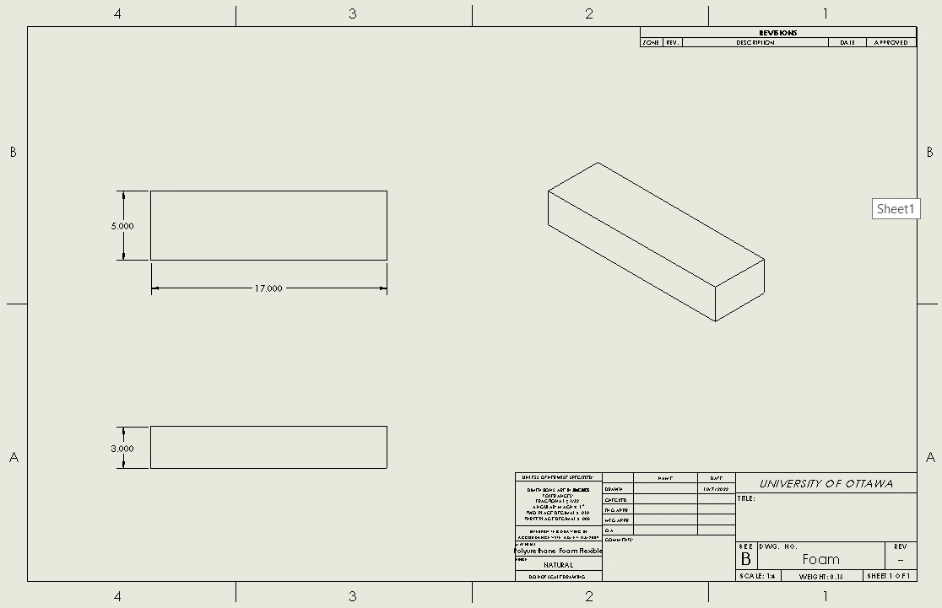Figure 1

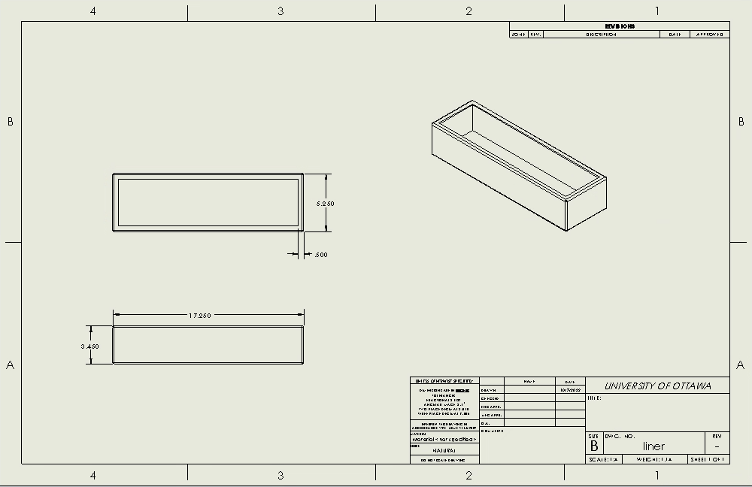Figure 2

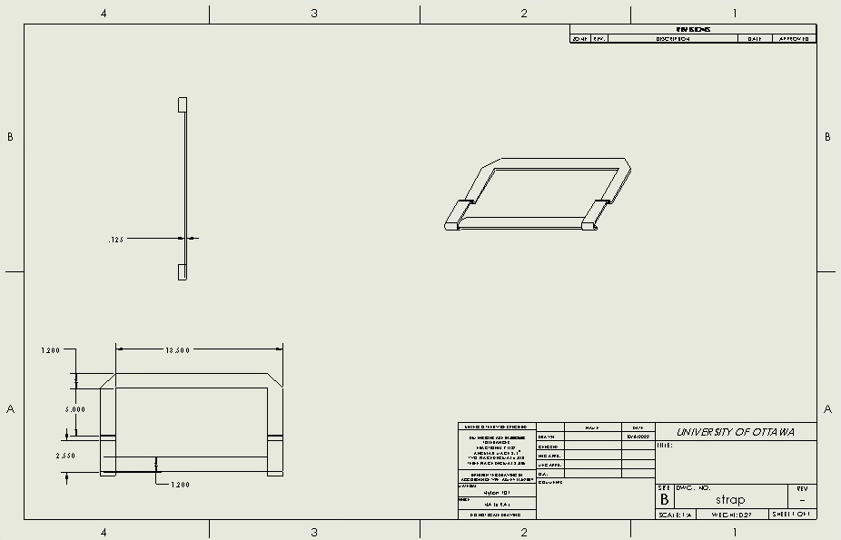Figure 3

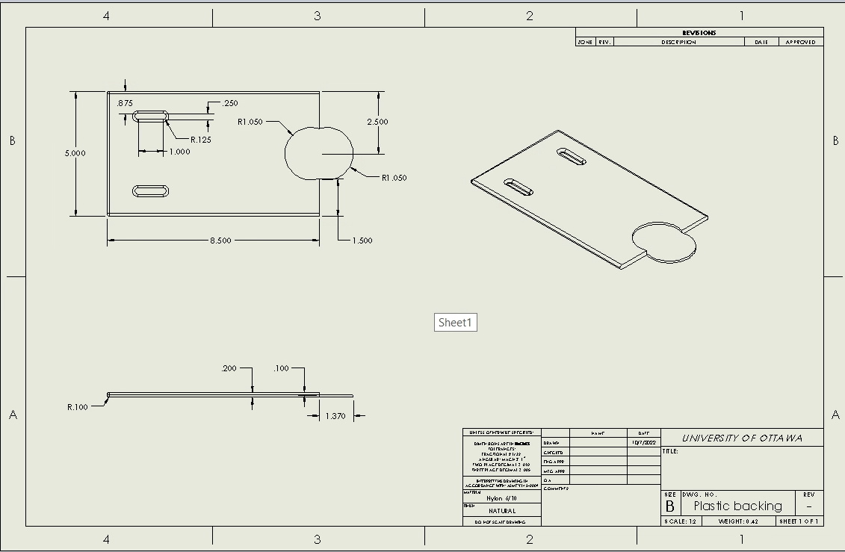Figure 4

Bill of Materials (BOM)

Item number | Part name | Description | Quantity | Unit cost | Extended cost
1 | Cover | Cotton-based cover sewn according to the dimensions of the cushion. | 1 | $10/yard | $10/yard
2 | Foam | Foam cushion | 1 | [$30; $60] | [$30; $60]
3 | Plastic backing | 3D printed plastic backing | 2 | $0 | $0
4 | Strap | Fabric straps with release buckles. | 1 | $20.00 | $20.00
5 | Buttons | Buttons that hold cover together | 6-8 | $1.25/button | $10.00
6 | Foam | Shredded Foam | 1 | $0 | $0
Total |  |  |  |  | [$70; $100] (CAD)
  - Table 2

As you can see in the table above, our prototype has five items; a cover, a foam cushion, a plastic backing, a strap, buttons and shredded foam. The cover will be sewn to fit the dimensions of the cushion, which will be determined in our next prototype. When the adequate dimensions are chosen, the foam will be purchased according to those dimensions, and holes will be made on the left and right sides of it for the strap. The plastic backing will be 3D printed in the MakerLab. The shredded foam will be used to create our second prototype, and if it proves to be a good solution, we may not need to purchase the other foam at all.
Regarding the price, the first item is sold at 10 dollars per yard, according to our needs we can assume that one yard should be enough. For the second item, the cushion will be purchased online or in a shop. Upon speaking with a shop owner, we have decided to allocate between 30 and 60 dollars towards the cushion. The plastic backing will be made thanks to the equipment present at the university and is of no cost. The strap will we purchased online on amazon and is included with release buckles. The buttons will cost around 10 dollars and will be purchased from Walmart. The shredded foam is of no cost because one of our team members had some. Based on our estimations our project cost, will be somewhere between 70 and 100 dollars, which respects the range given for this project.

Critical Product Assumptions

After meeting with our client and ranking our proposed ideas, we were able to have much more clarity on what our final product may look like, and make any important adaptations catered to our client’s needs.
- Upon viewing the client’s wheelchair, we have assumed that it would be better to strap the cushion to the chair, rather than using Velcro. Since the client’s wheelchair has a thick fabric backing, it would be too challenging to glue or sew the Velcro to the chair.
- Our client liked the idea of making the cushion strap to the chair, that way it can be re-used on their next wheelchair. We have assumed that this is our best means of attaching the cushion to the wheelchair.
- Assuming the client will most likely have to install the cushion themselves, the strap we attach to the cushion must be easy for our client to buckle and unbuckle by themselves.
- We have assumed that it would be best to make the cushion removeable from the cushion cover, this would allow the cushion to be replaced easily when if it loses its shape and allows the case to be washed and replaced when needed.
- We have assumed that the best material for the case of the cushion is cotton, because it is easy to sew with and is safe the washing machine. It will be sewn together with cotton fabric and will close around the cushion with buttons.
- Our client provided measurements of the wheelchair, and we have assumed that the cushions dimensions must be within …
- We have assumed that it would be best to use Medium 1006 foam. It is the type of foam that is typically used in chairs and cushions. It is form to the clients back, but it is firm enough that it will not thin over time.
- We have assumed that the easiest way to attach the strap to the cushion is by having an enforced hole on the right and left sides of the cushion. This is a sufficient way of attaching the strap to the cushion without having to cut any holes in the cushion and will be simple to sew.

Prototype I

Documentation
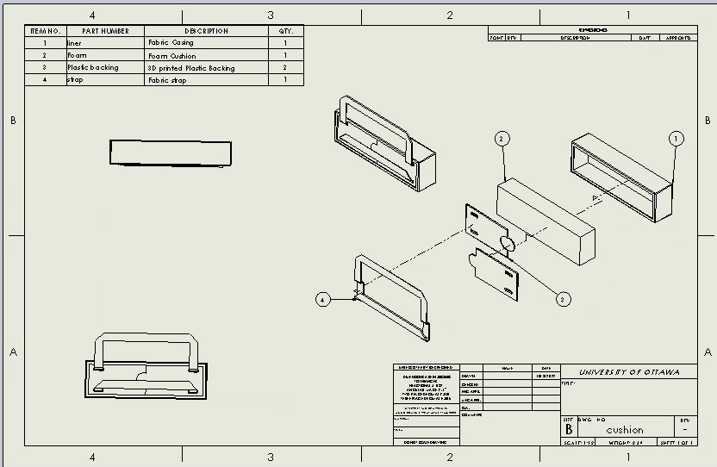Figure 5

Explanation of Prototype Subsystems

As seen in the design of prototype 1, there are 4 distinct subsystems: the strap, the backing, the cushion, and the cover. The backing includes the strap for easy attachment to the wheelchair. It is modular for ease of manufacturing, assembly, and installation. The cushion is not directly affixed to any other part, allowing the client to swap cushions at their convenience. Finally, the cover is provided to make the product comfortable, aesthetically pleasing, and durable.

Prototype Testing

Low Fidelity analytical prototype was used therefore the testing of the prototype will be mostly theoretical. From the prototype it can be determined that the cushion can be fully installed in one minute because of the strap that goes around the headrest. For ease of use the client will be able to install the cushion on the wheelchair themselves and not need assistance from another person. This prototype passes durability because it has the option to have cushion components swapped out for new ones after wear. Because we will be designing the cushion, we can make the fabric case the same colour or similar colour to the colour of the wheelchair seat.

Wrike

Project Deliverable E Plan: https://www.wrike.com/frontend/ganttchart/index.html?snapshotId=agErJTTOTgyWzoQCBJgZ7UJjLJmQze0V%7CIE2DSNZVHA2DELSTGIYA
Project Deliverable F Plan: https://www.wrike.com/frontend/ganttchart/index.html?snapshotId=UTOBYKJh8e9RRkmoGPpKJNcI8K6fA8hJ%7CIE2DSNZVHA2DELSTGIYA

Conclusion

Based on the client meeting, the client’s feedback was converted into a needs table. A detailed CAD design of the proposed cushion idea was provided. A bill of materials was created which contains five items; a cover, a foam cushion, a plastic backing, a strap, buttons and shredded foam. After this, the critical product assumptions were made. Based on the feedback provided, a new CAD model was designed and explained. The testing will be done through theoretical methods.

