Project Deliverable F
Business Constraints

GNG2101–INTRODUCTION TO PRODUCT DEVELOPMENT & MANAGEMENT FOR ENGINEERS & COMPUTER SCIENTISTS

Presented to:
Professor: Dr. Emmanuel Bouendeu
TA: Mohamed Bougader
PM: Cecilia Lou

Group #Z15:
Tristan Rodgers - 8680457
Usman Khan - 300185666
Ismail Mostafa - 300127711
Yahya Mostafa - 300127715

University of Ottawa
Submitted: June 25, 2023

Introduction

This project deliverable will include the business model that we will use for the commercialization of our project, an income statement based on the chosen business model, and two intellectual properties that could be used as legal constraints for the product. A brief business model and sustainability report will highlight some of the potential societal and environmental benefits and costs of the project. The economics report will outline some key financial components, such as income, profit, cost and more. Finally, we will need to research two possible intellectual properties related to our product, and the legal implications they may have for our product.

F.1.A Chosen Business Model

The business model type that we have chosen for our product is a manufacture oriented business model, similar to the “Brick and Mortar” business model presented to us in class. The manufacture business model is one which transforms raw materials into finished products by using internal labour, machinery and equipment. Our business will be similar to the “Brick and Mortar” model since we will operate out of a designated space where the product will be designed, machined, sold and distributed. Customers can visit in-person and interact with staff and salespeople in-house. Of course, it is 2023 and the importance of an online presence has never been greater. We will therefore ensure that our company does also cater to online consumers.

F.1.B Business Model Canvas

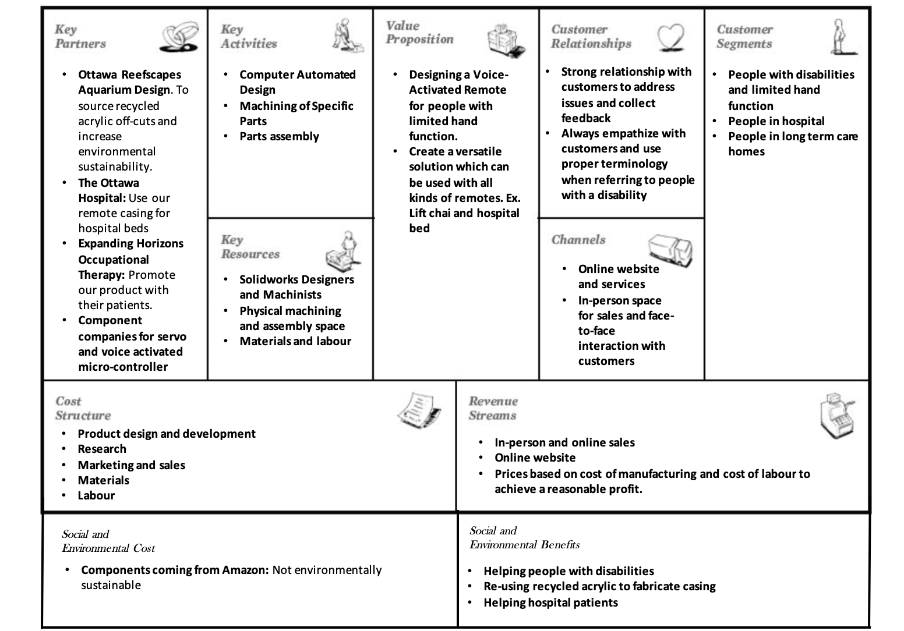

F.1.C Core Assumptions

- We assumed that we would be able to partner with companies in Ottawa to increase ecological sustainability by using recycled acrylic for the casing. We also assumed that we could partner with the Ottawa Hospital to provide them with our remotes for hospital beds since they will be designed to accommodate a wide range of remotes. Finally we assumed that we would partner with an Ottawa based occupational therapy clinic to promote our product to their clients with disabilities.
- We assumed that we would have a physical space to design and manufacture the product as well as interact face to face with customers.

F.1.D Sustainability Report

- Environmental Sustainability:
Environmental sustainability is paramount to creating a respectable business. With the effects of climate change making news headlines, it is increasingly important to consider environmental sustainability in the business model. The design changes were made during the last deliverable, however, this deliverable focuses on the business model and how we incorporated environmental sustainability to the marketing aspect of our product. First, we will ensure that it is advertised along with the products functions that it is made from recycled materials. By collaborating with companies which use acrylic, we can use the off-cuts to make our casing. Furthermore, we will collaborate with the companies which make the voice activated micro controller as well as the servos so that in the case where a part fails, we can send the part back to the company to fix and reinstall on the remote. These environmental initiatives will increase our sustainability by creating a respectable image for the brand
- Social Sustainability:
Social sustainability can be defined as a strategy to identify and manage a business's impact on the wellbeing of its employees, workers, customers and community. In our case, we will ensure that our business is socially sustainable by collaborating with the Ottawa Hospital to accommodate their patients and create a strong bond with the community through this partnership. Also, we are creating a business that can help the disabled community by giving them more independence and allowing them to use their accessible chairs independently. Finally, by creating a safe place of work in accordance with all building and manufacturing codes, we ensure the respect of our employees and staff.

F.2.1 Economics Report – List of Costs
Cost
Variable | - Increase/decrease of production  - Increased/decreased need of labour, raw materials, utility.
Fixed | - Lease/rental cost for building  - Insurance payments  - Manufacturing equipment  - Utilities
Direct | - Cost of building and selling the product
Material | - Raw material for 3D printing/laser-cutting  - Product components (remote, servos, microphone, microcontroller)
Labour | - Employee salaries  - Payments for contractors involved in
Indirect/Overhead | - Utilities (light, heating, AC)  - Furnishing and decor for store

F.2.2 Economics Report - 3 Year Income Statement

Year 1
Description | Cost
Sales | $ 625 000
Total Revenue | $ 625 000
Operating Expenses
Utilities (Electricity, Heating, Water, Inernet, etc.) | $ 48 000
Equipment & Materials | $ 350 000
Marketing | $ 5 000
Labour | $ 250 000
Overhead | $ 80 000
Rent | $ 210 000
Toral Operating Expenses | $ 943 000

Net Income for Year 1 = $ 625 000 – $ 943 000 = $ -318 000

Year 2
Description | Cost
Sales | $ 1 200 000
Total Revenue | $ 1 200 000
Operating Expenses
Utilities (Electricity, Heating, Water, Inernet, etc.) | $ 57 000
Equipment & Materials | $ 510 000
Marketing | $ 16 000
Labour | $ 310 000
Overhead | $ 50 000
Rent | $ 215 250
Toral Operating Expenses | $ 1 158 250

Net Income for Year 2 = $ 1 200 000 – $ 1 158 250 = $ 41 750

Year 3
Description | Cost
Sales | $ 3 750 000
Total Revenue | $ 3 750 000
Operating Expenses
Utilities (Electricity, Heating, Water, Inernet, etc.) | $ 143 000
Equipment & Materials | $ 1 620 000
Marketing | $ 75 000
Labour | $ 738 000
Overhead | $ 70 000
Rent | $ 220 635
Toral Operating Expenses | $ 2 866 635

Net Income for Year 3 = $ 3 750 000 – $ 2 866 635 = $ 883 365
Total Net Income for 3 Year Period = $ 5 575 000 - $ 4 967 885 = $ 607 115

F.2.3 Economics Report – NPV Analysis
The cost to produce one unit is $133.15. This price comprises of the prices of the necessary components that can be found in the BOM, plus the cost of some raw materials, utilities and labou. We aim to sell our product for $ 199.99. In the first year of production, we will have $295 000 in expenses not associated with production. Based on production and sales costs, we will make $ 66.84 on each unit we sell. According to this model, we would need to sell 4414 units in the first year to break even. However, according to the income statement, we do not expect to sell this many units in the first year. By considering the expenses and sales in all 3 years, we need to sell 14 092 total units to break even, which should occur sometime during the third year.

F.2.3 Economics Report – Assumptions
The expenses for the economics report were based on several assumptions:
- Sales and their growth from year-to-year were estimated by analyzing some of the sales of some existing products on the market. There was very limited data for sales, so these were mostly guessed.
- Rent values were based on the average rent rate for (1200 – 1800) sq ft commercial unit in Ottawa. The rent increase value was based on the yearly rent increase value – about 2.5%.
- Utility costs were also based on average rates for commercial units in Ottawa. Utilities would increase as production increases since more electricity would be needed.
- Labour costs comprised of employee salaries. We assumed to pay staff about $20/hr based on current hourly wages. This was then multiplied by the number of workers needed and how many hours they would work. This value increased as production increased.
- Material and equipment cost was calculated in the BOM, this also increases as more units are produced each year.

F.3 Intellectual Property Report

When designing a product, it is important to research existing intellectual properties for similar products on the market. In doing so, we ensure that our product is not copying an existing patented product. As this would mean that we are liable to legal action being pursued against us. We will list two intellectual properties and the legal constraints they could place on our product.

- Apparatus, system and method for directing voice input in a controlling device (US20220286317A1) - https://patents.google.com/patent/US20220286317A1/en?q=(voice+remote)&oq=voice+remote
- This intellectual property is for a system/method used for receiving voice commands used to operate smart appliances.

- Floating type servo pusher (CN107380533A) - https://patents.google.com/patent/CN107380533A/en?q=(servo+pusher)&oq=servo+pusher
- This intellectual property is for a system which includes the use of a servo motor to develop an apparatus capable of a mechanical pushing action.

These intellectual properties relate to some key components of our product. We intend to build a remote which uses voice commands from the user to trigger servo motors which push the desired button on the remote. In designing this, it is important to note existing intellectual properties for similar systems. The two intellectual properties mentioned above have very intricate details regarding the exact scope that they cover which can be found in the links above. If our design is too similar to these existing intellectual properties, it could affect the development of our product.
The two IPs mentioned above are pateneted, therefore it means that we are prohibited from creating and selling a product which copies these patents. Intellectual property constraints are vital when designing a product since they have heavy implications. Not respecting an existing patent could lead to possible legal action. If our product copied a patented design, we could face a lawsuit that would potentially cost us millions of dollars, which would very likely derail the development of the product due to the massive financial debt that would bring. For these reasons, it is essential that we ensure our product does not violate any existing intellectual property.
On the other hand, it is important to note that we should make sure that our own design is protected by intellectual property before it is taken to market. If our idea is new and innovative, other bigger and richer companies can copy our designs to manufacture and sell their own version of our product. Therefore, we would need to protect our product through intellectual property to maximize the growth of our business.

